## Attitude

“…an idea charged with emotion (positive or negative) which predisposes a class of actions to a particular class of social situation.” Triandis, 1971

Attitudes are learned through the social world and are direct responses to attitude objects.



Cognitive

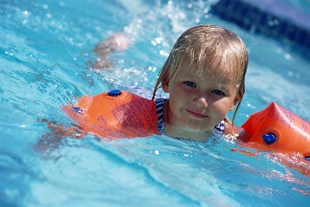

Behavioural

Affective

Attitude

The Triadic Model of Attitude

Identify four factors that have influenced your attitude



Using the examples above, what is your attitude towards swimming?

**Changing Attitude**

A psychologist called Festinger believed that if a person holds two ideas or attitudes that oppose and conflict with each other, that person will feel a kind of discomfort. He called this discomfort **Dissonance.**

A typical example in sport would be a player knows that training is important to play at the top level. However, the same player does not want to commit that extra time.Coaches, teachers and sports psychologists can use this dissonance as a method of changing an attitude and this theory is known as **Cognitive Dissonance Theory**.

To create dissonance, we can use the triadic model and change any one of the three components to bring about dissonance.

Use the boxes below to describe how you would create dissonance by changing one of the components below.

**Behavioural**

**Affective**

**Cognitive**

A second approach to changing attitude is known as **Persuasive Communication**.

The persuader

The message

**Persuasive Communication**

The recipient

The situation

Check your answers using the powerpoint provided later before completing the summary task below.

**Summary Task**

Create a cue card, for revision use, that covers the following topics:



If you do not have any cue cards, just make some out of paper