Name:
A-level PE
Paper 2
Ethics in sport

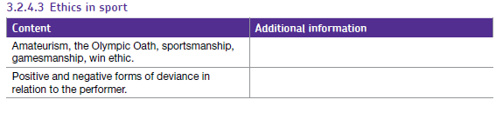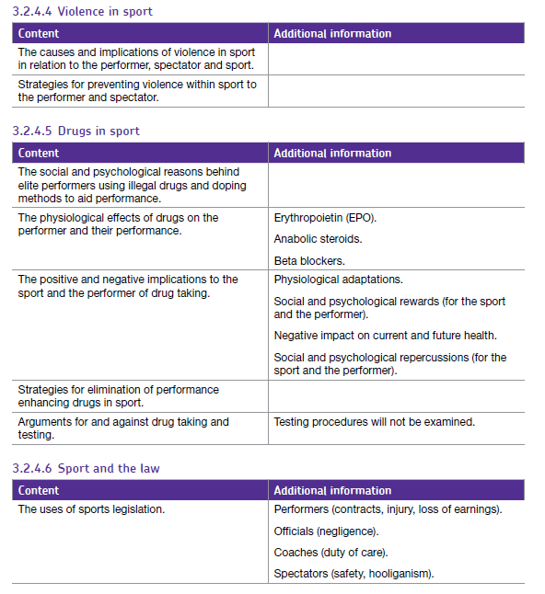

Key Terms:
1
Ethics
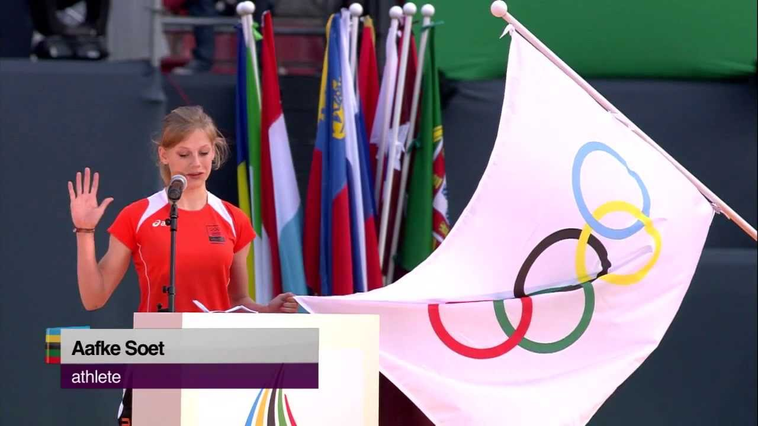

The Olympic Oath

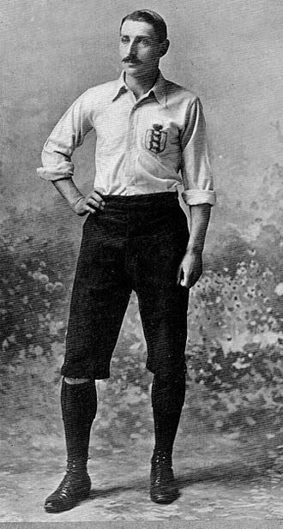

Amateurism

Sportsmanship


A player helps a fallen opponent to her feet after an accidental foul.

How can sportsmanship be encouraged in your sport?
………………………………………………………………………………………………………………………………………………………………………………………………………………………………………………………………………………………………………………………………………………………………………………………………………………………………………….
………………………………………………………………………………………………………….
………………………………………………………………………………………………………….
……………………………………………………………………………………………………………………………….…………………………………………………………………………………….

1
Ethics

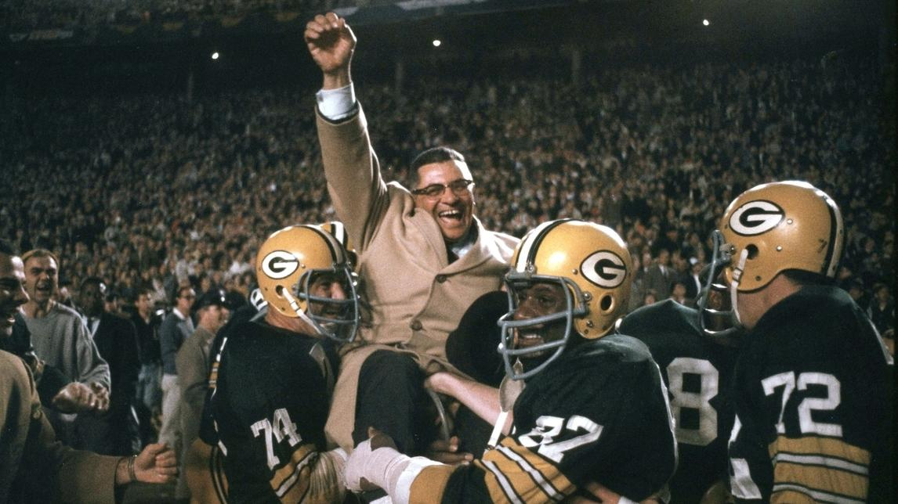
Win ethic

Gamesmanship


A tennis player deliberately makes grunting noises on every shot to try to put their opponent off during a rally.

1
Ethics

Forms of Deviance
Deviancy = behaviour which goes against the norms of society

Positive
Negative
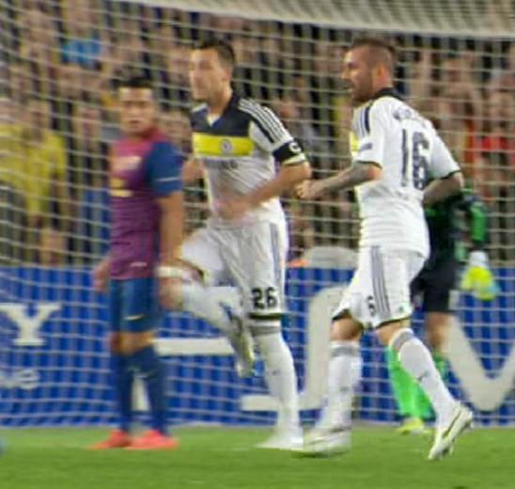
A footballer deliberately fouls an opponent.
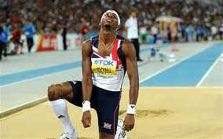
An athlete competes at 2012 Olympics despite suffering from a serious knee injury.

Task: Are there examples of positive and negative deviancy in spectators?
Positive
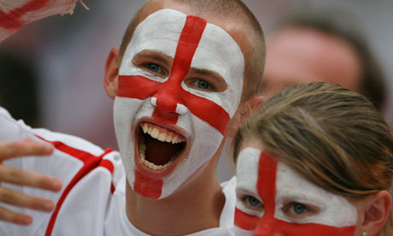
Negative

Positive or negative deviance?
Example  1  Ethics | Positive or negative deviance? | Why?
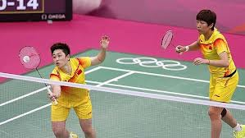
Chinese doubles pair deliberately lose to get favourable draw

Tennis player delays his opponents next serve
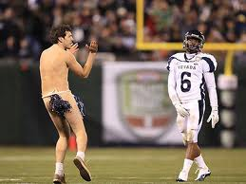
A ‘streaker’ runs on the field during an American Football game.
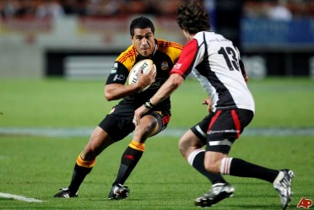
A rugby player decieves his opponent by faking to move one way before ‘side-stepping’.

Causes of violence in sport
2
Ethics

Task to tackle:
- Describe a time when you have experienced or witnessed deliberate violence in a sports situation. State what happened and why.

- What impact did the incident have on the game?

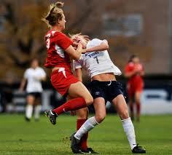
View the violence in the US Soccer game (clip in lesson) and suggest reasons for it below:
POSSIBLE CAUSES OF VIOLENCE BY PLAYERS


View the violence in the Panorama clip and suggests reasons for it below:
2
Ethics

1
2
10

3
9
POSSIBLE CAUSES
OF HOOLIGANISM

4
8

5

7

6

_________________________________________________________________________

Football Hooliganism – some general theories and how valid they are (NB It is multi-causal with no one single reason for it)
2
Ethics

General causes/reasons/theories | Validity of reasons given (i.e. how true are they?!)
- Young Working Class males releasing aggression/thrill seeking/alcohol | - No evidence Working Class males are any more or any less aggressive than other males
- Nationalism (see other countries’ fans as enemy – media hypes this up- e.g. Germany vs England) | - Not all international spectators/ other sports act like this
- Reaction by Working Class fans to take over of football by Middle Class spectators | - Hooligans come from a wide range of social backgrounds
- Lack of punishment by authorities | - Stricter punishments being given by ‘authorities’
- Violence on the pitch/actions by players | - Some ‘violent’ sports not linked to hooliganism (e.g. RL/RU); passions of fans under control

- Have you ever witnessed spectator violence at a sporting event? (this could include on television). Describe what happened and why.

- How did the violence impact on the sporting event?

Implications of violence in sport
2
Ethics

Player violence
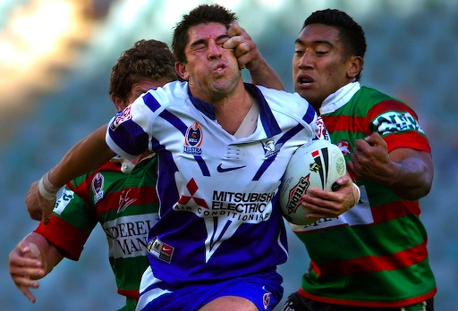
WHY IT SHOULD BE DISCOURAGED

STRATEGIES FOR PREVENTING IT

Performer violence
2
Ethics

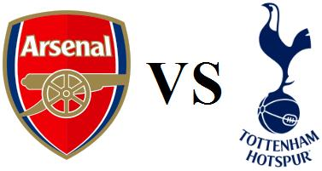
This Saturday sees the FA Cup replay between Arsenal and Tottenham. Tension around the game has been heightened due to –
- recent controversy surrounding Arsenal fans using the ‘Y-word’ in chanting
- two players sent-off in the violent last meeting between these two teams
- traditional rivalry between the two teams
Imagine you are in charge of security. What measures would you take to ensure that the game passes of without crowd violence?

6
1
5

POSSIBLE SOLUTIONS
TO THE PROBLEM

2
4

3

Drug taking in sport
3
Ethics
The Contemporary Issues syllabus mainly requires an understanding of the issues surrounding reasons why sports performers take drugs and ways in which it can be “eliminated”.
Psychological reasons:
Social
Reasons:

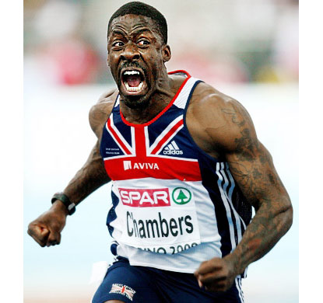
Why do athletes take performance enhancing drugs?

Ergogenic aids=
3
Ethics
Substances that improve performance are referred to as ergogenic aids.
In the table below is a list of illegal ergogenic aids that unfortunately some athletes feel the need to use:

Aid | Description | Reasons why this  method is used  (Benefits) | Which Athletes might use them | Negative impact on current/future health
Anabolic Steroids
Beta Blockers
EPO
3
Ethics
Task to tackle! Watch the e-stream clip:
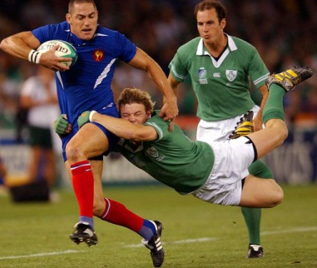
‘Panorama – Steroids in the UK’ (#9460) Answer the questions below:

- What reasons does the programme give for steroids use?

2.What negative health effects are given?

3.Are steroids illegal?



Be the umpire! Award a mark out of 3 using the mark scheme below

Some performers break the rules and use banned substances to enhance their performance. Describe the physiological reasons why a performer might use anabolic steroids [3].
Student answer:
Anaerobic performers e.g. sprinters might use them in order to gain muscle mass and bulk to make their contractions more forceful/powerful. Some performers might also use steroids to recover faster from injury and make sure that they can participate in big events despite injury.

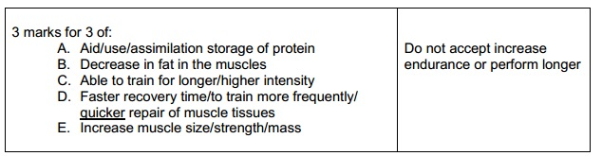
Let’s have a Drug Olympics?
3
Ethics
Some people believe that drugs use in sport should be legalised. Can you think of counters to their arguments:
They believe that..... | What do you think?
If properly monitored it is not a health risk – many drugs are naturally occurring

Drugs may be used for normal medical care/difficult to define line between nutritional substances and illegal drugs

Athletes don’t ask to be role models

Levels playing field between all performers

The time/millions of pounds spent annually on testing could be spent elsewhere—

In many cases testing has proved ineffective (ie not caught the cheats) unsound – jeopardising athletes’ careers (e.g. Diane Modahl).

Essay writing practice
3
Ethics
Addressing forms of deviance, such as the use of banned performance enhancing substances, are a key role of the sports authorities.
Discuss the arguments for and against drug taking [8]

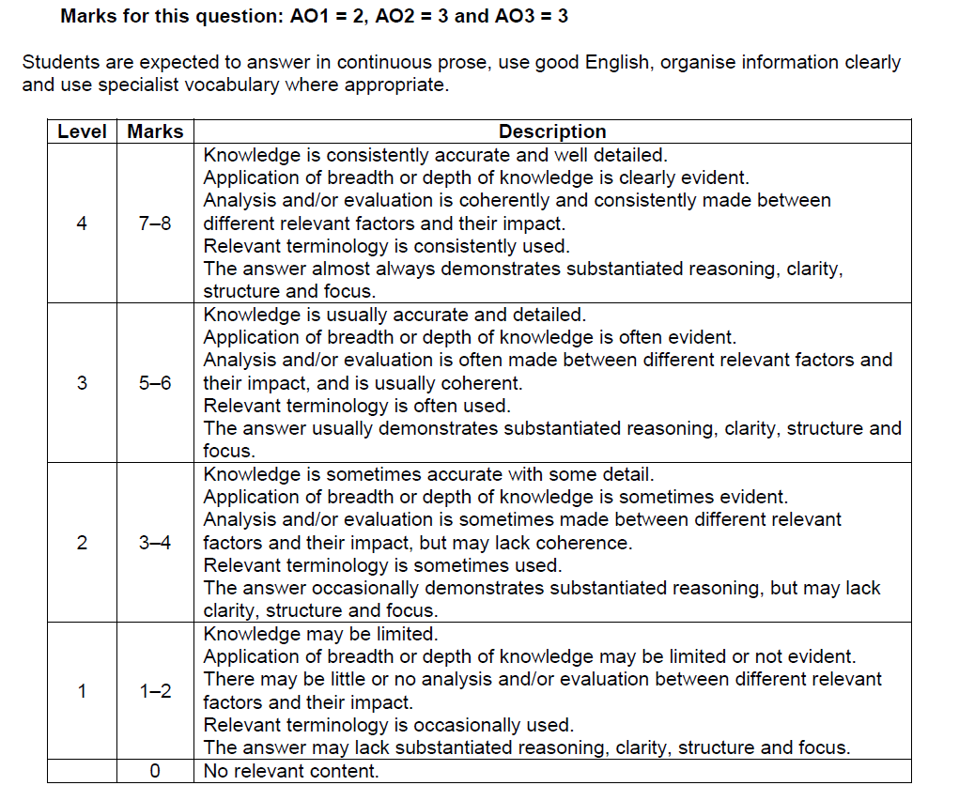
Sample from a student’s essay response:
Some athletes are able to dramatically increase their muscle size and therefore power and running speed. For example this can be done by sprinters who take anabolic steroids. These illegal steroids mimic the effects of testosterone and cause muscles’ repair and growth to increase thus allowing their muscle to store more protein which is the building block for hypertrophy. Assuming that the athlete is not caught he/she can win more competitions and prize money which also results in secondary income from fame and endorsements. However there may be short-term and long-term negative health effects to the performer and these include so-called ‘roid rage’ as well as heart attacks and a raised cancer risk.

Most people, however, feel the fight to discourage/eliminate drug-taking in sport should continue.
3
Ethics
Possible strategies used to prevent drug taking include:

Examples of problems in eradicating drugs in sport include:

Sport and the Law
4
Ethics
Identify relevant examples of sports law
Performers
Officials
Spectators
Task to tackle: What modern socio-cultural factors have led to the increase in legal action in sport?

Re-Cap Test
Q1
4
Sport & Society

…………………………………………………………………………………………………………………………………………………………………………………………………….
…………………………………………………………………………………………………………………………………………………………………………………………………….
…………………………………………………………………………………………………
Q2

………………………………………………………………………………………………….
…………………………………………………………………………………………………………………………………………………………………………………………………….
………………………………………………………………………………………………….
…………………………………………………………………………………………………
Q3

………………………………………………………………………………………………….
…………………………………………………………………………………………………………………………………………………………………………………………………….
Q4

…………………………………………………………………………………………………………………………………………………………………………………………………….

- Using examples from sport, explain what is meant by the terms sportsmanship and gamesmanship. (4 marks)

……………………………………………………………………………………………………………………………………………………………………………………………………

