Sports Development
Sport Development Continuum
Recreation
Characteristics:
Flexible – t_ _ _ / s_ _ _ _
Slightly o _ _ _ _ _ _ ed
– some pre-set rules
Non-serious
Benefits:
Adults _ _ _ _ _ _ reality
_ _ res _ - re_ _ _ f/cathartic
Sport
Characteristics:
E_ _ _ _ _ _ic rewards
Co_ _ _ _ _ _ _ _ e
Commitment
_ _ _ Rules
T_ _ _ _ _ s & high s_ _ _ l level
Amateur and professional
Benefits:
Achieve excellence/success
Possible c_ _ _ _r/ prize money
F_ _ _
Tr_ _ _ _ _ s

V

Similarities:
Physical activity
Choice

Similarities:
Social/friendship groups
Develop p_ _ _ _ _ _l skills
Develop health/_ _ _ _ _ _ _
I_ _ _ _ _ _ _ c rewards

School Sport
Characteristics:
E_ _ _ _ _ _ic rewards
Co_ _ _ _ _ _ _ _ e
Commitment
_ _ _ Rules
T_ _ _ _ _ s & high s_ _ _ l level
Sel_ _ _ _v_
Benefits:
Achieve excellence/success
Tr_ _ _ _ _ s
Talent Identified
Pathway to excellence/
s_ _ _ _ _ _ g

Social & cultural factors influencing progression:
P.E.
Characteristics:
C_ _ _ _ _ _ _ _ y (for all)
T_ _ _ _ _ r in Authority
Foundation level
Pre-_ _ _ n _ _ _ sessions
N_ _i_ _ a _ _ u _ ricu_u_

Benefits:
Understand impact of
exercise on health & fitness
Prepares for active l _ _ _ _ _ _
Qualify for career e.g. Physio

V
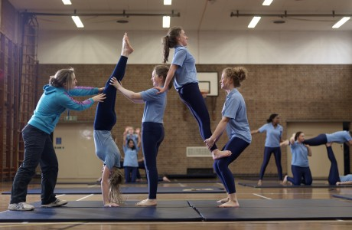

Similarities:
Highly s_ _ _ _ _ _ _ed
_ _ _ _ constraints

Similarities:
Improved health & fitness
Develop physical skills
L_ _ _ er_ _ ip skills
Increase self-esteem
Teamwork/s_ _ _ _ _ skills
Sportsmanship/fair play

Other factors influencing progression:

Provision - facilities/ resources/ coaching
- World Class Performance Programme
- attract major events to be hosted in UK
(G_ _ _ E _ _ _ _ S _ _ _ _ _ )
- develops new technology for training and equipment
- develops high quality coaches/leaders/
-Sports Science/Sports Medicine/
Athlete Lifestyle/Career Education
- distributes Lottery funding
Talent Identification
-testing at different age groups/ schools
-high quality coaches able to spot talent
-high quality testing facilities
- database kept for comparison
- co-ordination with NGBs
- Structured competition
- development squads
Olympic Ideal



Talent Identification

Co-ordinated approach with NGBs

UK Sport provides and oversees EiS

NGBs
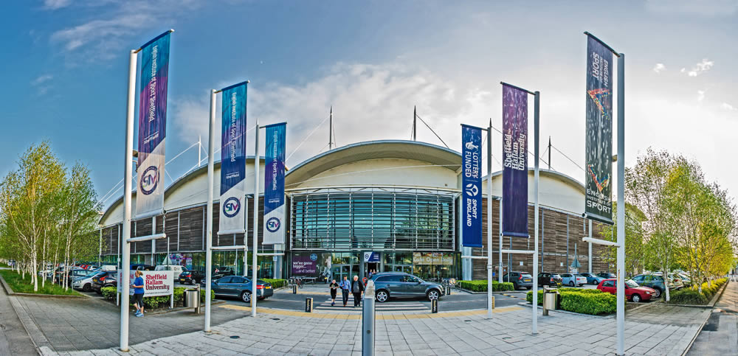
Provision - facilities/ resources/ coaching

Provision - facilities/ resources/ coaching
Research and innovation
‘Athlete Zone’
Sports science – e.g. psychologist
Sports medicine – e.g. physio
Regional or satellite centres/hubs
High quality facilities/coaches

Talent Identification
-Host centres for talent identification programmes

Whole Sport Plans

Whole Sport Plan =
Plan made by NGB and Sport England. Sets out targets for increasing participation in the sport. Funding to that sport depends on success of plan.
Benefits to the sport include:
Increases members/ c _ _ _ _
Targeted f_ _ _ _ _g for that sport
More v_ _ _ _ _eers/qualified coaches
Formation of school - _ _ _ _ links
Shared ‘b_ _ _ practice’

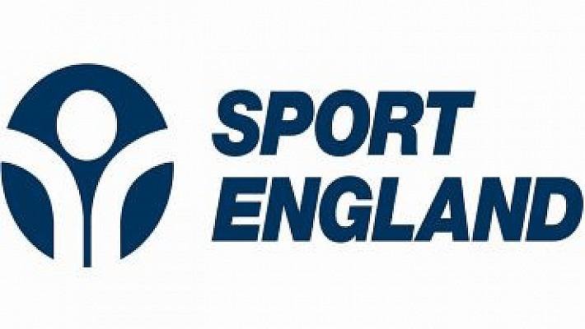

Whole Sport Plan =
Plan made by NGB and Sport England. Sets out targets for increasing participation in the sport. Funding to that sport depends on success of plan.
Benefits to the sport include:
Increases members/ c _ _ _ _
Targeted f_ _ _ _ _g for that sport
More v_ _ _ _ _eers/qualified coaches
Formation of school - _ _ _ _ links
Shared ‘b_ _ _ practice’

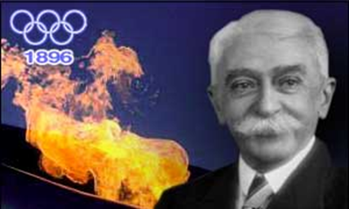
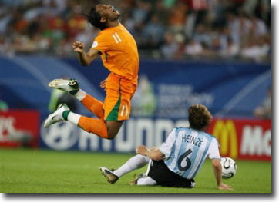
Ethics
Olympic Oath=

Gamesmanship =

E.g.
Amateurism
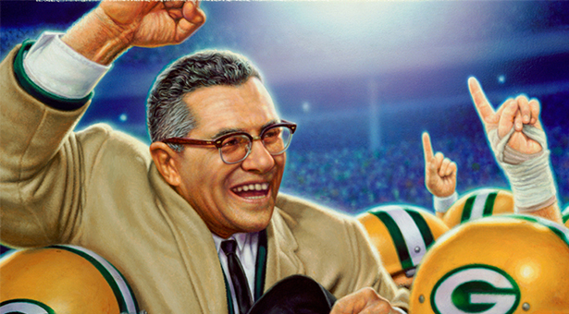
Win ethic =
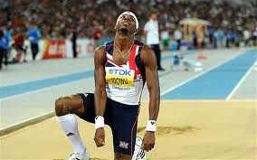
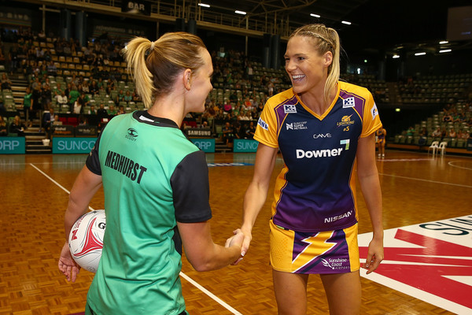
Deviance = behaviour which goes against the _ _ _ _ _ of society

Positive =

Negative =
Sportsmanship =

E.g.

 | Causes | Solutions | Impact on performer/sport?
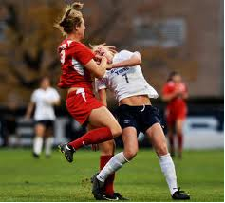  Performer violence | P_ _ _ _ _ _ _ from coach  W _ _ ETHIC  I _ _ _ _ _ _ _ _ _ of the event  F_ _ _ _ _ _ _ _ O_  F_ _ _ _ _ _ _ AL rewards at stake | 1  2  3 | Sport  Performer
  Spectator violence | Display of M _ _ _ ULI _ _ _ _  C_ _ _ _ mentality  N_ _ _ _ _ of the sport  e.g.  A_ _ _ _ _ l  L_ _ _ _ rivalry  e.g.  Race/religion  e.g.  A_ _ R_ _ _ _ _ _  P_ _ V_ _ _ T _ _ _  e.g.  M_ _ _ _ hype  Poor ST_ _ _ _ _ / Crowd control | 1  2  3  4  5  6  7 | Negative _ M _ _ _ of sport causes decline in participation  Spectator A _ _ E _ _ _ _ _ _ declines  Supporters _ _ NN_ _ from travelling/attending  All supporters treated as  _ OO _ _ _ _ _ S  T_ _ _ S banned / fined  S_ _ _ _ _ _ S/commercial deals withdrawn  Additional cost to P _ _ _ _ _ E events/provide more stewards  Poor Club-community relationship  Negative impact for H _ _ _ _ _ G future events

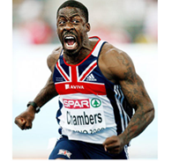  Drugs | Positive effects | Negative effects | Problems with testing | Strategies to stop drug use | Argument for drugs use in sport?
 | Steroids  EPO  Beta blockers | Steroids  EPO  Beta blockers | PED banned list –  Incorrect results -  Expensive –  Access - | 1  2  3  4 | 1  2  3  4

Sport and the Law
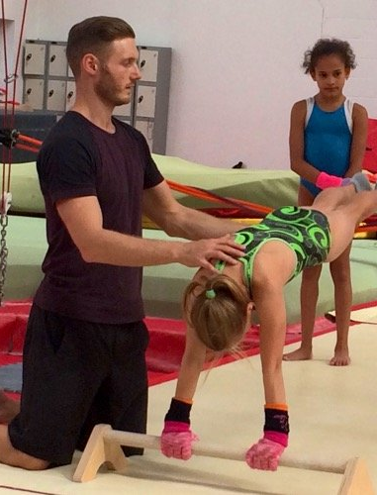
Coach
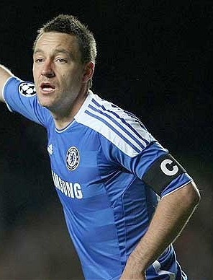
Performer
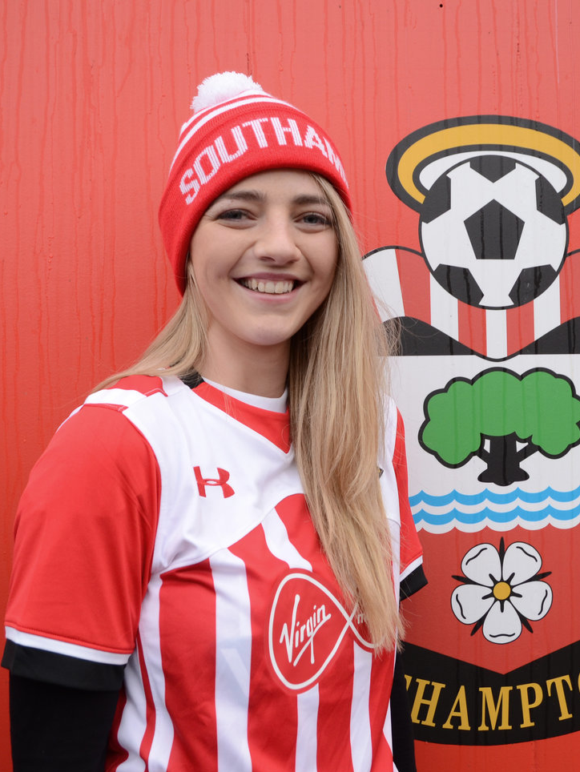

Spectator
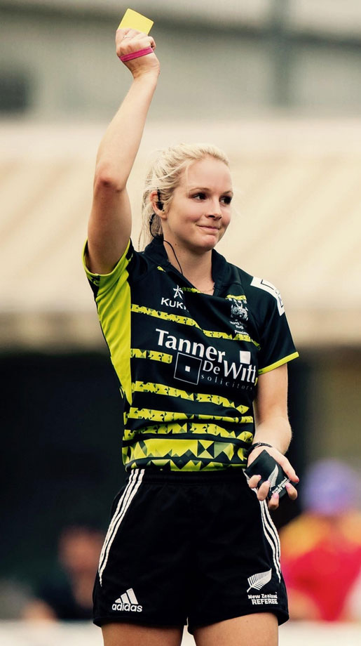

Official

Health & safety legislation relating to stadia design protects fans from injury

A Rugby ref can be charged if she fails to carry out pitch/post checks

Loss of earnings
Contracts
Safety
Hooliganism

Negligence
Duty of care
Injury
Doping

The law protects

The law prosecutes

Commercialisation of Sport

 | Performer | Coach | Official | Audience | Sport
Media | + | + | + | + | +
Media | - | - | - | - | -
Commercialisation & Sponsorship | + | + | + | + | +
Commercialisation & Sponsorship | - | - | - | - | -

