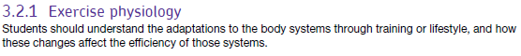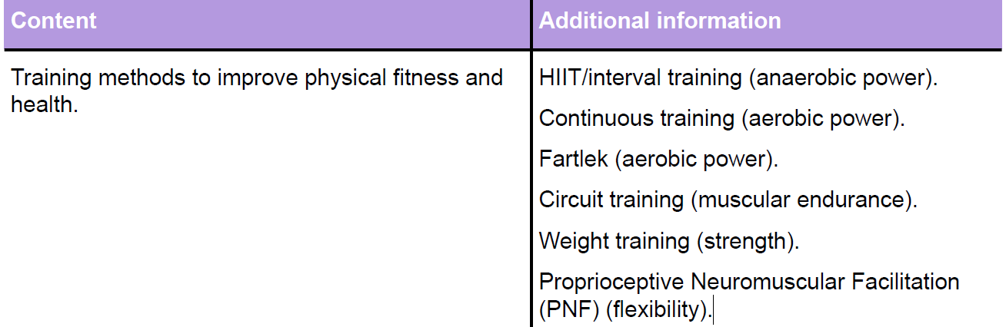
Training methods Revision: Continuous & Fartlek
Continuous

Fartlek

Aerobic
Endurance

How is breathing controlled during exercise?

Where | Adaptations | Effect
Lungs
Minute ventilation =
Define | Effect of exercise?
 | decreases
 | increases
 | decreases
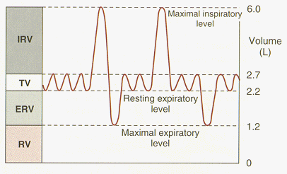

Diffusion at the muscles
Membranes involved: Muscle and capillary membranes

pO2 higher in blood/lower in muscles

pCO2 lower in blood/higher in muscles

So gases move as follows:

Oxygen moves into muscles (dissociates from haemoglobin to _ _ _ _ _ _ _ _ _ )
carbon dioxide moves into blood
(dissolves in _ _ _ _ _ _ / combines with haemoglobin/forms bicarbonate ion)

Diffusion = movement of gas from high to low partial pressures
What factors help oxygen dissociate from haemoglobin at the muscle during exercise?

- Increase in (_ _ _ _ _ /body) temperature
- Increase pCO2 in blood
- Leads to an increase in blood
_ _ _ _ _ _ _
- Results in ‘_ _ _ _ shift’

Resulting in…..
- less s _ t _ _ _ _ _ _ n/
af_ _ _ _ _ y of haemoglobin with O2
- So muscles receive more _ _

Diffusion at the lungs
Membranes involved: Alveolar and capillary membranes

pO2 higher in alveoli/lower in capillary

pCO2 lower in alveoli/higher in capillary

So gases move as follows:

_ _ _ _ _ _ from alveoli to capillary

Carbon dioxide from capillary to _ _ _ _ _ _ _

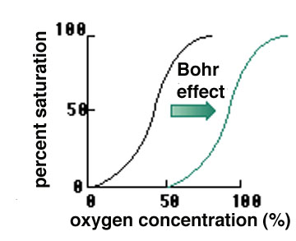

Bohr shift = curve shifts to the _ _ _ _ _
Impact of smoking on oxygen transport?

Where | What changes | Effect
Heart

This is how the heart controls its own rate (myogenic)
Draw the conducting system of the heart.

 | Definition | Resting Value | Maximal Value
Heart rate
(HR)
Stroke Volume (SV) | the volume of blood pumped from the heart in one beat
Cardiac Output (Q) | the volume of blood pumped from heart in one minute  (SV x HR)

Outline the stages of the cardiac cycle Link to Conduction?
Sketch a graph of HR response to both maximal and sub-maximal exercise

What is CV drift?
Starts after _ _ mins > Fluid lost as sweat > Reduces blood plasma & increases _ _ _ _ _ _ _ _ _ > Reduced venous return and therefore Stroke volume > (_ _ _ _ _ _ _ _ ’s law) > Heart rate increases > Q also increases due to more energy needed to _ _ _ _ the body

Heart rate can be regulated during exercise in two main ways:
- Neural – CO2 acidity, increased BP
- Hormonal - adrenaline

What does adrenaline do?

What is athlete’s heart?
More CO2 produced >
blood’s _ _ _ _ _ _ _ increases /pH lowers > This is detected by
C _ _ _ _ _ _ _ _ _ _ _ _ _ > which send _ _ _ _ _ messages to the medulla

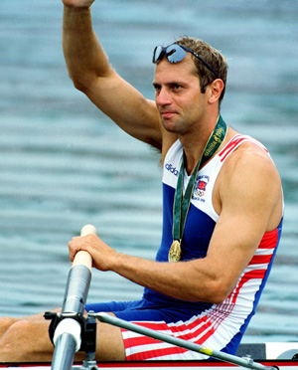

……this leads to Bradycardia (a resting HR of less than _ _ bpm)
Bradycardia is good because:
- Less _ _ _ _ _ _ needed for contractions of heart;
- More oxygen available for _ _ _ _ _ _ contractions;
- _ _ _ _ _ _ _ _ _ heart rate range

Higher blood pressure >
> This is detected by
_ _ _ _ _ _ _ _ _ _ _ _ _ > (in blood vessel walls) which send _ _ _ _ _ messages to the medulla

How is HR controlled after exercise has ended?

The medulla then uses the Sympathetic and Parasympathetic nervous system to control the SA node as follows:
Increased stimulation of
_ _ _ _ _ _ _ _ _ _ _ (Accelerator) nerve
Reduced stimulation of _ _ _ _ _ _ _ _ _ _ _ _ _ _ _ (Vagus) nerve

This results in:

How do you work out your heart rate range?

How does VR affect stroke volume during exercise? (Starling’s Law)

Increased _ _ _ _ _ _ return > so the heart fills with more blood during _ _ _ _ _ _ _ _ > meaning the cardiac muscle is _ _ _ _ _ _ _ _ _ > leading to greater force of contraction > Increased ejection fraction/ greater percentage of blood ejected > more SV
Training methods Revision: Continuous & Fartlek adaptations continued….
Where | What changes | Effect
Vascular system
Blood |  | How is venous return maintained during exercise?  1. Skeletal muscle pump  - contraction of leg muscles compresses _ _ _ _ _  2. One-way/ _ _ _ _ _ _ valves in veins  - prevent backflow of blood  3. Breathing mechanism/inspiration  - increases _ _ _ _ _ _ _ _ / compresses veins  4. Suction pressure of heart  - draws up blood
Venous return =

 | % of Q sent to muscles | % of Q sent to non-essential organs
At rest
At Exercise

Blood pressure =

During exercise:
_ _ _ _ _ receptors detect an increase in _ _ _ levels/ acidity
_ _ _ _ receptors detect an increase in _ _
And send _ _ _ _ _ messages to the _ _ _ _ _ _ _ _ _ centre in the Medulla

Blood velocity =

Why should you not eat immediately
before exercise?
1. During exercise, _ _ _ _ blood goes to the gut
2. But, blood/ oxygen needed in gut for
_ _ _ _ _ _ _ _ _ _ of food
3. Less blood available to _ _ _ _ _ _ _

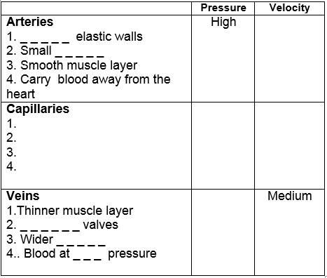

The _ _ _ _ _ _ _ then uses the
_ _ _ _ _ _ _ _ _ _ _ nervous system to control the P_ _ - C _ _ _ _ _ _ _ _ S _ _ _ _ _ _ _ _ _

How does it do this?
1. Vaso_ _ _ _ _ _ _ _ to areas needing blood/muscles
2. Vaso _ _ _ _ _ _ _ _ _ _ _ _ of areas not needing so much blood e.g. kidneys/liver/ _ _ _

The amount of blood sent to brain remains the same at rest and exercise – why?
1. Brain function maintained during exercise
2. Therefore, it requires oxygen /nutrients

How is oxygen carried around the body?

How is carbon dioxide carried around the body?

What factors determine blood pressure in arteries during exercise?
A. Stronger contractions of the heart (_ _ _ _ _ _ volume)
B. Increased blood flow
C. (Peripheral) resistance/ _ _ _ _ _ _ _ _ _ _ of walls;
D. Blood viscosity – increased due to s _ _ _ _ _ _ g
E. Distance of vessel from the heart
F. Size of lumen
G. Healthy lifestyle factors such as stress, _ _ _ _ and level of _ _ _ _ _ _ _
H. Age

A-V O2 diff = difference between oxygen content of arterial and venous blood
Reasons for increase during exercise:

Where | What changes  (due to fartlek & continuous training) | Effect
Muscle
PNF (for flexibility)
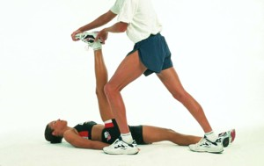

P _ _ _ _ _ _ stretch
At least _ _ seconds
_ _ _ _ of lengthening muscle detected by
M _ _ _ _ _ S _ _ _ _ _ _
Nerve _ _ _ _ _ _ _ s send to CNS
S _ _ _ _ _ _ R _ _ _ _ _ occurs
In order to _ _ _ _ _ _ _ muscle

Where | What changes  (due to PNF training) | Effect
Muscle & Connective tissues
Circuit training
(for muscular endurance)

Applied
Principles of Training

S -

PO – Progressive overload (FITT principle)

Eg When weight training, increase intensity of training by working at a higher % of 1RM

R -

R -
Where | Adaptations | Effect
Muscle
Other?
HIIT/Interval
(for anaerobic power)

Where | Adaptations | Effect
Muscle

Other?

Weight training
(for strength)
EG

- 5 - 10 Reps
- 3 – 6 Sets
- Dumb bells weighing >80% 1RM
- 3 Min rest between sets
- Rest days to allow micro tears to repair
- Set systems include single sets, super-sets, pyramid sets, inverse pyramids

Where | Adaptations | Effect
Muscle

Weight training

