AS Physical Education Revision Day | Skill Acquisition
 | This section focuses on how skill is acquired and the
 | impact of psychological factors on their performance.
 | • Characteristics and definitions of skill
 | • Difference between motor and perceptual abilities
 | • Difference between skill and ability
 | • Types of skill
 | – cognitive, perceptual and psychomotor
 | • Classification of skill
 | – use of skill continua (open – closed, discrete
 | – serial – continuous, gross – fine, self paced –
 | externally paced).
 | • Information processing
 | – input – senses, receptors, proprioception,
 | perception, selective attention
 | – memory – functions and characteristics of
 | short-term sensory store, short-term memory
 | and long-term memory; strategies to improve
 | memory, chunking, chaining, mental rehearsal
 | and practice
 | – decision making – reaction time, simple
 | reaction time, choice reaction time, response
 | time, movement time and the relationship
 | between them
 | – anticipation temporal and spatial
 | – factors affecting reaction time, Hick’s law,
 | psychological refractory period, single channel
 | hypothesis
 | – motor programmes and sub routines
 | – open and closed-loop control
 | – factors affecting the efficiency of the
 | components of the information processing
 | system and strategies for improvement.
 | • Learning and performance
 | – learning – stages of learning, use of guidance,
 | how feedback differs between the different
 | stages of learning
 | – learning plateaus – causes and solutions
 | – motivation – intrinsic, extrinsic, tangible and
 | intangible
 | – learning theories – operant conditioning,
 | positive and negative reinforcement and
 | punishment
 | – cognitive/insight theories
 | – Bandura’s observational model of learning,
 | social learning theory
 | – motor learning –Schmidt’s schema theory
 | (recall, recognition, initial conditions, response
 | specifications, sensory consequences,
 | response outcomes)
 | – transfer of learning (positive, negative, zero,
 | bilateral, proactive and retroactive)
 | – impact of practice on improving learning
 | – goal setting – benefits and types, principles of
 | effective goal setting.
AS Physical Education
Skill Acquisition Revision Day Notes
Skill |  | Ability
So what’s the main difference?

Motor Ability | Perceptual Ability
Types of Skill | Description & Example
Cognitive

Perceptual

Psychomotor

Classification | Description | Example
Open

Closed

Self-Paced
Externally-Paced
Gross
Fine
Discrete
Serial
Continuous

Topic | /
Characteristics and definitions of skill
Difference between motor and perceptual abilities
Difference between skill and ability
Types of skill – cognitive, perceptual and psychomotor
Classification of skill (open–closed, discrete–serial–continuous, gross–fine, self paced–externally paced).
Notes

Information Processin

Inputs

Senses / Receptors
Proprioception

Perception | D
 | C
 | R
Selective Attention
Memory Store | Characteristics | Functions
Short Term Sensory Store

Short Term Memory

Long Term Memory

Strategies to Improve memory | Description
Chunking

Chaining

Mental Rehearsal

Practice

Decision making
Reaction Time |  | Simple Reaction Time  Choice Reaction Time
Movement Time

Response Time

Relationship
Factors affecting reaction time

Types of Anticipation
Spatial

Temporal

Psychological Refractory period | Hick’s Law

Motor Programmes and Subroutines

Motor Programme
When does Open loop control seem to work best? | When would Closed loop be a better explanation?
Whats wrong with both of these ideas?

What about memory and perceptual trace?

Topic | /
input – senses, receptors, proprioception, perception, selective attention
memory – functions and characteristics of short-term sensory store, short-term memory and long-term memory; strategies to improve
memory, chunking, chaining, mental rehearsal and practice
decision making – reaction time, simple reaction time, choice reaction time, response time, movement time and the relationship
between them
anticipation temporal and spatial
factors affecting reaction time, Hick’s law, psychological refractory period, single channel hypothesis
motor programmes and sub routines
open and closed-loop control
factors affecting the efficiency of the components of the information processingsystem and strategies for improvement.
Notes
Learning & Performance
Stages of Learning

Stages of Learning and Feedback
Feedback for the Cognitive Learner | Feedback for the Autonomous Learner

Learning Plateaus
Causes | Solutions
 | 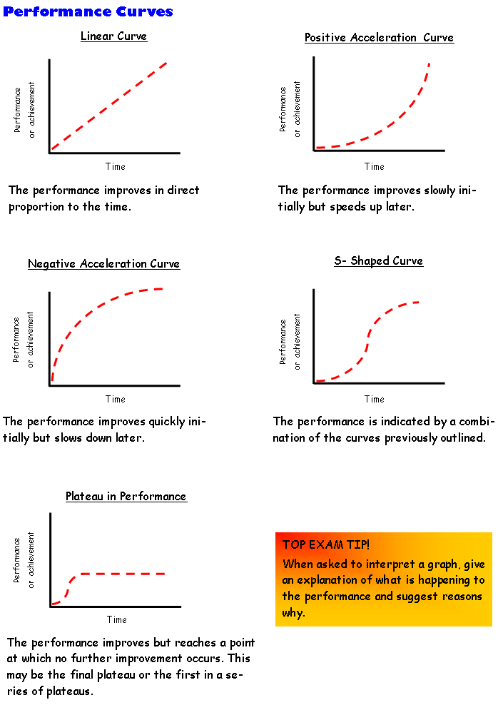

Motivation
Intrinsic

Extrinsic | Tangible | Intangible
Goal Setting
Benefits

Process

Performance

Product (Outcome)

S
M
A
R
T
E
R

Theories of Learning
Operant Conditioning | CognitiveLearning Theory | Observation learning
Example

Positive Reinforcement
Negative Reinforment

Punishment

Type of Transfer | Examples
Positive

Negative

Proactive

Retroactive

Bi-lateral

Zero

Topic | /
learning – stages of learning, use of guidance, how feedback differs between the different stages of learning
learning plateaus – causes and solutions
motivation – intrinsic, extrinsic, tangible and intangible
learning theories – operant conditioning, positive and negative reinforcement and punishment
cognitive/insight theories
Bandura’s observational model of learning, social learning theory
motor learning –Schmidt’s schema theory (recall, recognition, initial conditions, response specifications, sensory consequences,
response outcomes)
transfer of learning (positive, negative, zero, bilateral, proactive and retroactive)
impact of practice on improving learning
goal setting – benefits and types, principles of effective goal setting.
Notes

