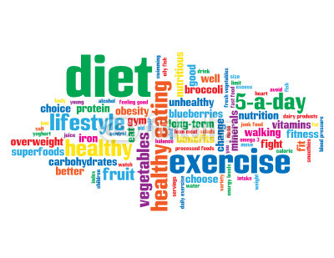**Unit 14: Exercise, Health & Lifestyle**

**Task 1**

Submission Date: Monday 23rd September 2019

**Task 1 ‘The importance of lifestyle factors in the maintenance of health & wellbeing’**

You must include the following:

Describe what the national recommended physical activity guidelines are for 5-18 year olds and 19-64 year olds

Describe the benefits of physical activity – reduce the risk of coronary heart disease, strokes & type 2 diabetes, helping to maintain a healthy weight, helping the ability to perform everyday tasks, improving self-esteem and reducing the symptoms of depression and anxiety.

Explain why physical activity has each of the benefits to health.

Describe what alcohol is and the recommended guidelines for alcohol consumption for both men and women

Describe the health risks of excessive drinking - stroke, cirrhosis, hypertension and depression

Explain why excessive alcohol consumption causes strokes, cirrhosis, hypertension, depression and cancer.

Explain the effects of excessive alcohol consumption on lifestyle.

Describe what smoking is

Describe the health risks of smoking - coronary heart disease, cancer and lung infections

Explain why smoking causes coronary heart disease, cancer, emphysema, bronchitis and pneumonia.

Describe what stress is

Describe the health risks of high stress levels - hypertension, angina, stroke, heart attack and ulcers

Explain why high stress levels cause hypertension, angina, strokes, heart attacks and stomach ulcers.

Explain the effects high stress levels can have on lifestyle.

Describe what a diet is

Describe the benefits of a healthy diet

Describe the risks of an unhealthy diet - nutritional deficiencies, coronary heart disease, obesity and type 2 diabetes

Describe the recommendations and guidelines for a healthy diet through the Eatwell plate

Explain why an unhealthy diet can cause nutrient deficiency, coronary heart disease, obesity and type 2 diabetes.