**Group Dynamics of Sports Performance**

**ASSIGNMENT 4 HOME SCH CONTENT.**

‘**Two or more people who are interacting in such a manner that each person influences and is influenced by each other person’**

M. E. Shaw (1976)

**‘Groups are those social aggregates that involve mutual awareness and potential interaction’**

McGrath (1984)

According to these definitions, what is the key defining characteristic of a group?

‘**Interaction is the key defining characteristic of a group**.’

McGrath (1984)

**What is a group?**



Which of the following is a group? Why?

Volleyball team Fire-fighter red watch

Crowd at a football match People shopping

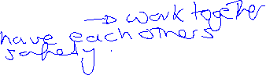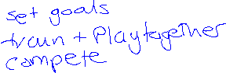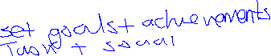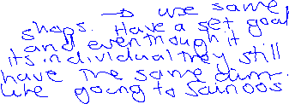

The following features turn a number of people into a group or team:

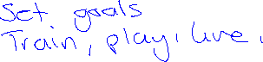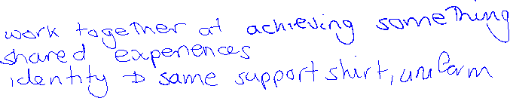

**Stages of Team Formation tuckaman**

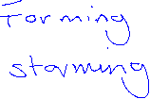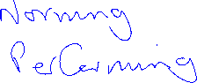

**Steiner (1972) Model of Group Performance**

‘The best performance can only be achieved when all social/cohesive problems are resolved.’

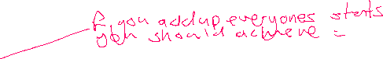

Losses due to faulty process

Potential Productivity for Success

-

Actual Productivity (success how the team performs)

=



Potential for Success

*This refers to……*

Losses due to faulty process

*This refers to……*

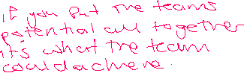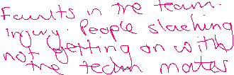

***Steiner’s Model – Actual Productivity = Potential Productivity – Losses due to faulty Processes (AP=PP-FP)***

***Actual Productivity is the team performance at given time during the game or event and refers to the extent of successful interaction. Potential productivity is the maximum capacity of the group when cohesiveness id strongest. Faulty process relate to the factors that can go wrong in team performance, which will impede or even prevent group cohesion and detract from the collective potential of the team.***

***There are two faulty processes that bring about losses in potential productivity.***

1. ***Co-ordination losses – When the operational effectiveness of the group as a unit cannot be sustained for the duration of the game. Any break down in teamwork is regarded as a co-ordination loss and is termed the Ringlemann effect. Ringlemann stated that as numbers increased in teams problems will occur. Like the tug of war example!***
2. ***Motivation losses – relate to an individual who suffers a reduction of motivation during performance causing the player to withdraw effort and coast through a period of the game. This relation of effort is called social loafing. This would detract from the cohesiveness of the team. A feeling that others in the team are not trying and when the effort of the individual are not recognised causes social loafing. A player with low self confidence or one that has suffered a negative experience will tend to be a loafer. A motivation loss if the task is perceived to hard can be linked to avoidance behaviour.***

##### Motivational Faults/ losses and Coordinational Faults/loses

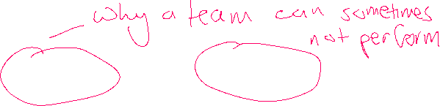

##### Loses in team performance are normally due to two main areas, Motivational Faults/ losses and Coordination Faults/loses.

* Motivational – occur when some members of the team do not give 100% effort



* Coordination – occurs when players do not connect with their play or activity, the team interacts poorly or ineffective strategies used to achieve.



**Task - Complete the case study**

**Activity: Motivational and coordination losses in volleyball: Motivational**

In a volleyball team, two players seem to be putting in little effort. When they are setting, they don’t appear to be on the same wavelength as the other players on the team, and when they are blocking they don’t seem to be putting a great deal of effort into their jumps. The other players on the team appear to be working harder to try to make up forthis. However, despite their efforts, there is little interaction between spikers and setters.

1. Where are the coordination losses in this scenario?
2. Where are the motivational losses in this scenario?

3. What do you think would be your role as the coach to improve these faults?

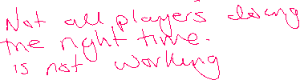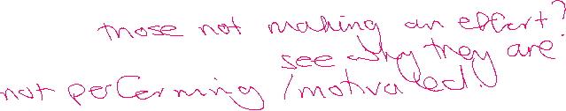

##### The Ringlemann EFFECT!

##### Loss of performance due to co-ordination problems: The Ringlemann Effect

Using tug of war in the late 1800’s, Ringlemann investigated the effect of size of group on performance. He studies contained the following conditions:

1 v 1 2 v 2 3 v 3 8v 8

What do you think he found IN the amount of productivitiy of the group as it got bigger?



**Loss of performance due to loss of motivation:**

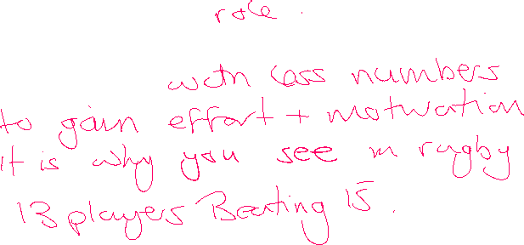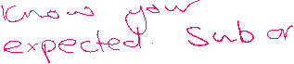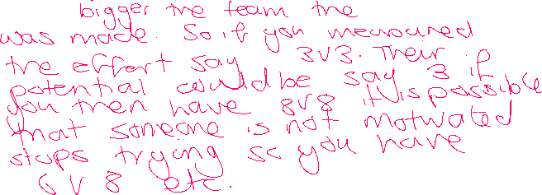

How could a coach reduce the Ringlemann effect? What would you do as a coach to help stop it?

**Social Loafing - Latane (1979)**

**Task -** Quickly describe what is meant by Social Loafing………………………………………………………………………………………………………………………………………………………………………………………………………………………………………………………………………………………………………………………………………………………………………………………………………



Latane’s study was based on an audience clapping a live performance in situations where they thought they were the only members of the audience and in situations when they thought they were part of a much larger audience.

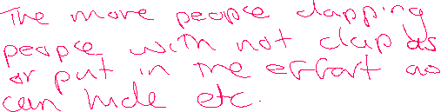

Take this example and explain how could a coach reduce social loafing of players?

What do you think happened? To the levels of effort?

**Group Cohesion**

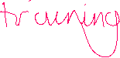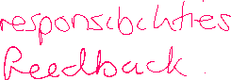

*‘Measure of the forces that bind a group together’*

**Festinger, Shacter and Back** **(1950)**

*‘Dynamic process that is reflected in the group’s tendency to stick together while pursuing its goals and objectives’*

**Carron (1982)**

***1970-80’s research examined 2 categories of cohesion***

***Task Cohesion*** *– degree to which group members work together and are committed to a common goal.*



***Social cohesion*** *– degree to which group members like each other and get on well, trust and support each other*



**Carron identified two types of cohesion: two areas that a team can work best, if the have task cohesion or social cohesion. Task fill out the boxes.**

**Task Cohesion define and positives of a team having this is??**



**Social Cohesion define and positives of a team having this is??**

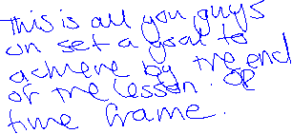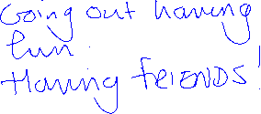

Negative impact on the team?

Negative impact on the team?



**Interactive and coactive groups/teams**

**Interactive teams** require **team** **members to work directly with each other** in order to achieve a successful performance. Their performance is **dependent on interaction and coordination between members** for performance to be successful.

**Task – give an example of a team that are classified as a Interactive team and why**



##### Coactive teams require individuals to achieve success in their individual games, events or performances in order to achieve overall team success. There is no direct interaction between team members during the performance.

**Task – give an example of a team that are classified as a Coactive team and why**

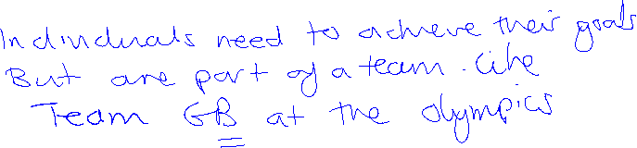

**Creating an effective team climate.**

**The team climate is a term that is used to describe how well the different player is getting on with each other. The key part about team climate is that it is how the players perceive the relationship within the team that will ultimately determine how effective the team climate is.**

**Coaches have an important role to play in building an effective team climate, but the first stage of doing so is to assess it. Task how would each of those shown in the boxes have an effect on how a team works together;**



**Stability**

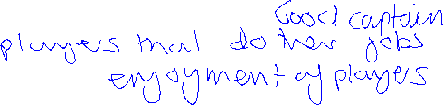

**Satisfaction**



**Size of the group** **(Ringlemann Effect)**

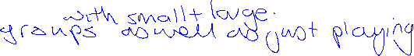

**Success**



**External threats**

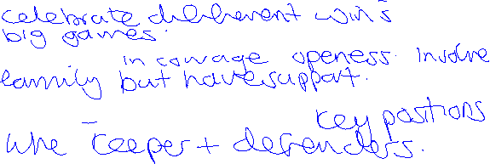

**Similarity**



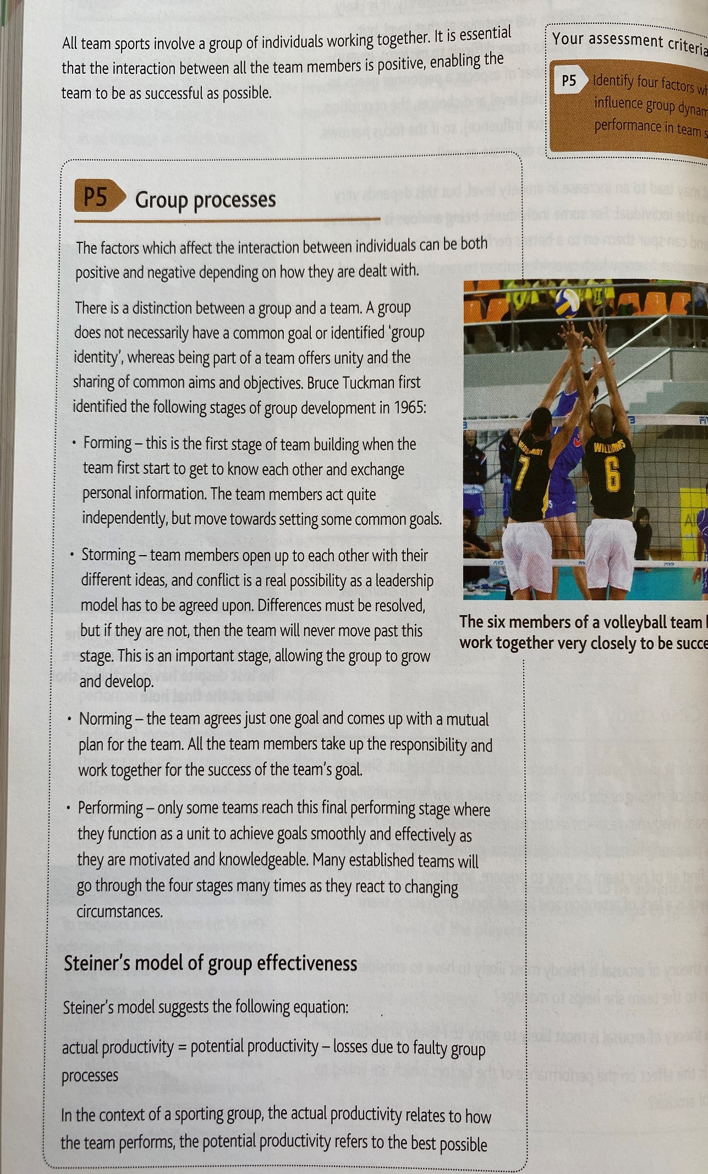

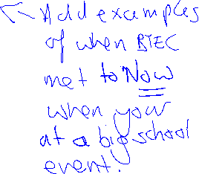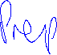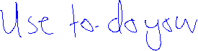

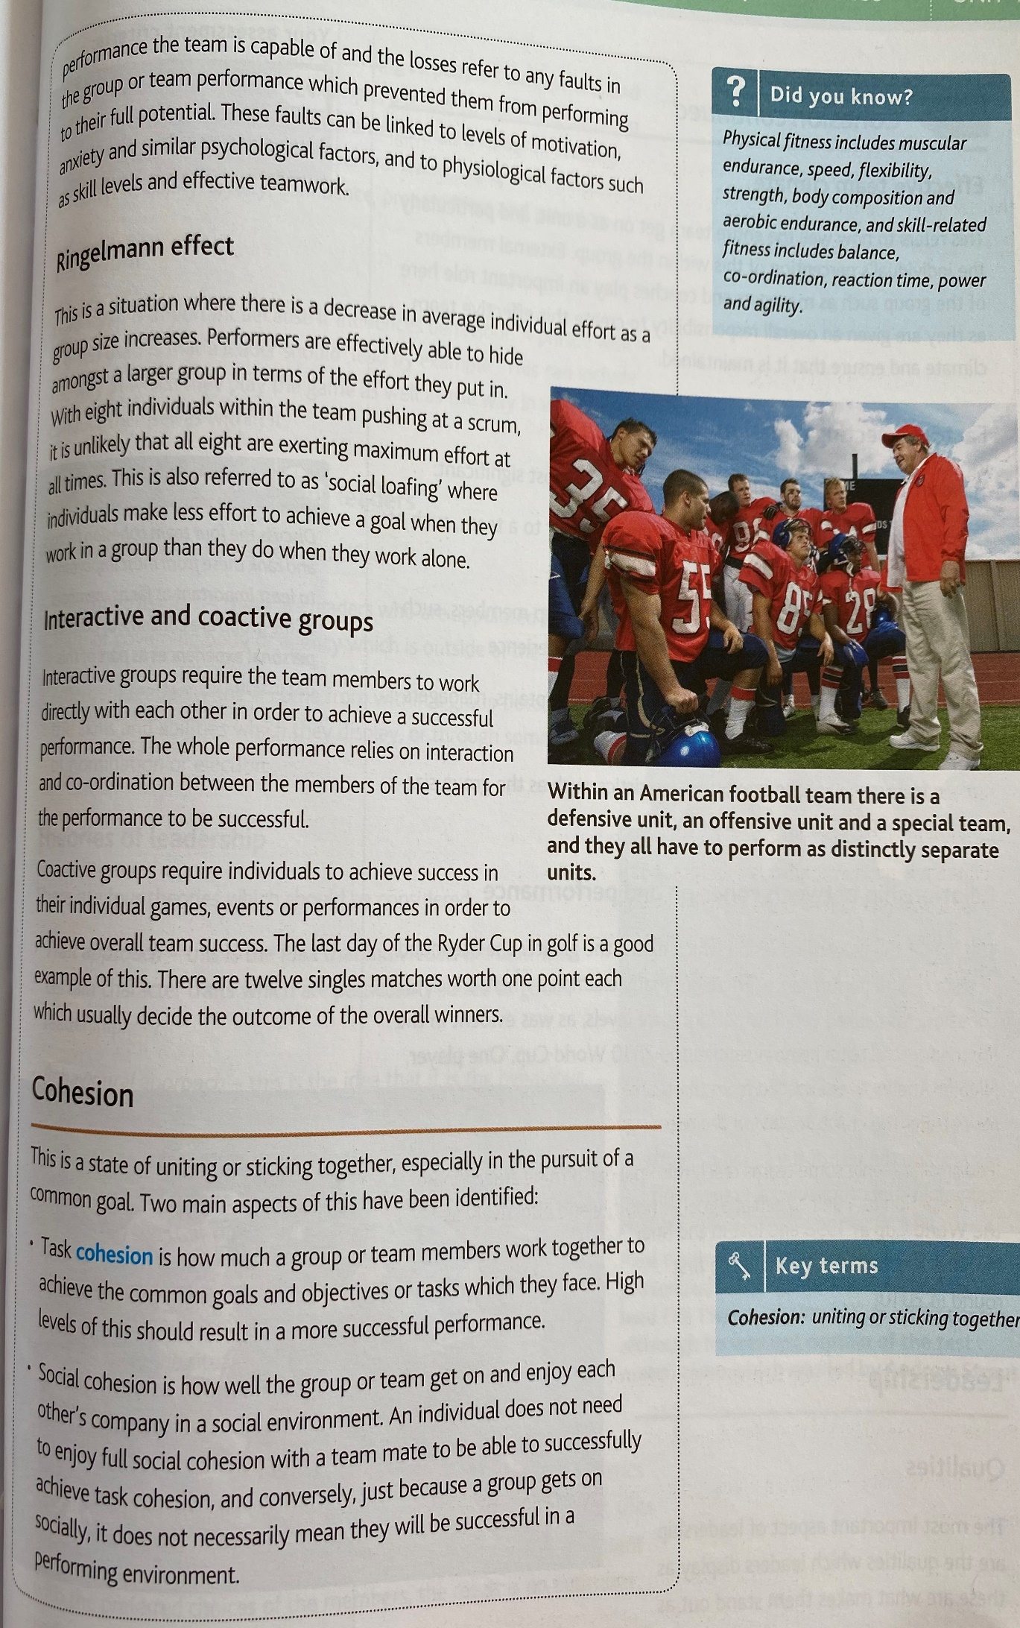

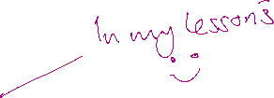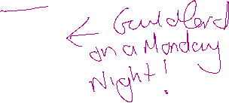

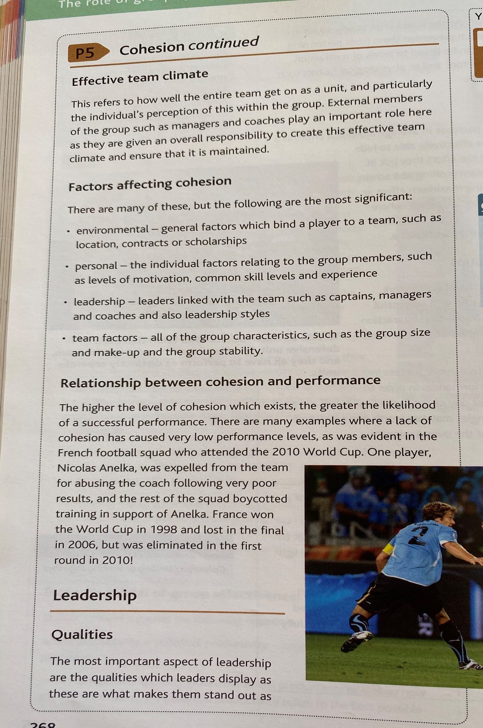

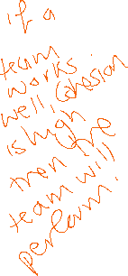

**ACTIVITY PREP 1 & 2**

**Assignment 4 Prep – Team and group cohesion**

Task 1 - Answer all the questions in the table for A team OF YOUR CHOSING.

|  |
| --- |
| Questions; Answer all shown in the boxes.  ***Explain, describe and give examples from what you have found or think about your team’s performance AT A TIME YOU CAN REMEMBER.*** |
| Explain each stage of a group’s development. Forming. Storming norming and performing. |
| Describe the Ringleman effect and social loafing. |
| Inter-active and co-active groups. ( describe and explain) |

**Assignment 4 Prep 2– Team and group cohesion**

***PUT YOUR ANSWERS IN THE TABLE. USE THE BTEC GROUP OR A SPORTS TEAM.***

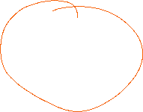

|  |  |
| --- | --- |
| **Using Steiner’s model explains the actual productivity of a team’s performance at given time during a game/tournament or gym challenge. You must describe and explain each element of Steiner’s model** |  |
| **What is task and social cohesion for the team?** |  |
| **How do you create an effective team climate?** |  |
| **Factors that affecting cohesion;**  **Environmental,**  **Personal,**  **Leadership**  **Team factors** |  |
| **Relationship between cohesion and performance that really showed.** |  |