**Leadership in sport.**







***“The behavioural process of influencing individuals and groups towards set goals” Barrow***

|  |  |  |
| --- | --- | --- |
| ***Characteristics of an effective leader*** | ***Why is that so?*** | ***Example*** |
|  |  |  |
|  |  |  |
|  |  |  |
|  |  |  |
|  |  |  |
|  |  |  |
|  |  |  |

***How are leaders made?***

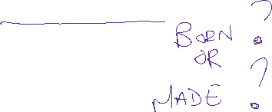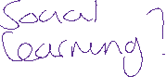

***Making Leaders the theory!***



|  |  |
| --- | --- |
| ***Theory*** | ***What I think!*** |
| ***Trait Approach – certain personality characteristics that predispose an individual to being a good leader. Leaders are born, not made. Leadership is innate and a good leader will be a good leader in any situation. Highly unlikely. Great man theory of leadership! Which suggests that the necessary qualities are inherited by sons (not daughters) whose fathers have been successful in the field?*** |  |
| ***Social learning – good leader is made, not born, and suggests that anyone can be taught to be a good leader. Have its roots in social learning theory. For example role models, remembered and then copied. The imitating of skills of a successful behaviour that with experience develops.*** |  |
| ***Interactional Approach – Leadership competencies emerge because of inherited abilities and learned skills. Give a more realistic explanation of human behaviours in sport.***  ***It focuses on the points that;***   * ***Effective leaders cannot be predicted on solely personality*** * ***Effective leadership fits specific situations, as leaders function better in certain circumstances than others*** * ***Leadership style needs to change to match the demands of the situation.*** |  |
|  | |

Carron (1981) suggests an individual can become a leader in one of two ways:

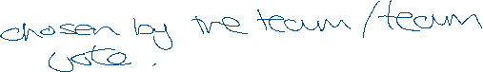

**Emergent Leader**: comes from within the group, often because they are skilful or the rest of the team has selected them. E.g.

**Prescribed Leader**: is appointed from an external source to a team. E.g.

**Styles of Leadership**

There are many different types but can fall into two rough groups:

**Task Oriented**: task demands of the group.

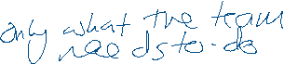

**Person Oriented**: interpersonal behaviour of the group members.



**Lewin** (1935) divided leadership into three main styles:

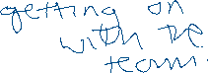





* **Authoritarian Style**: task oriented and dictatorial. They make all the decisions and command the group with little regard for the interests of the group members.

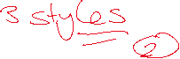



* **Democratic Style**: people oriented and value the views of other group members. They tend to share decisions and show a good deal of interest in the individuals of the group.



* **Laissez Faire Style**: take very few decisions and give very little feedback. Individual group members do as they wish.



**The style I think is best is……………………………………**

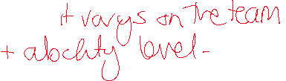

**https://www.leadershipandsport.com/leadership-styles-in-sports-coaching/**

**Research Cards.**

|  |  |
| --- | --- |
| **Leadership style** | |
| **Sporting Examples** |  |
| **Practical example and demonstration**  **( what the coach would say and the drill or presentation you would use to demonstrate)** |  |
| **Advantages** | **Disadvantages.** |

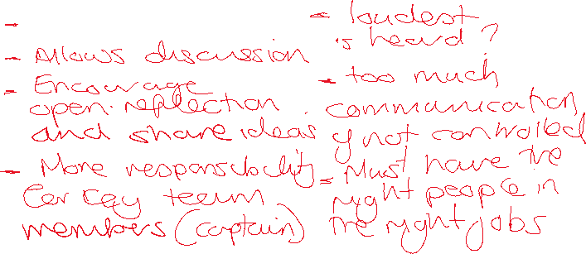

|  |  |
| --- | --- |
| **Leadership style** | |
| **Sporting Examples** |  |
| **Practical example and demonstration**  **( what the coach would say and the drill or presentation you would use to demonstrate)** |  |
| **Advantages** | **Disadvantages.** |

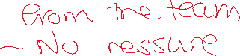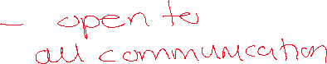

|  |  |
| --- | --- |
| **Leadership style** | |
| **Sporting Examples** |  |
| **Practical example and demonstration**  **( what the coach would say and the drill or presentation you would use to demonstrate)** |  |
| **Advantages** | **Disadvantages.** |

READINGS TO HELP YOU OUT!

