Unit 4 | Electromagnetic Induction
Lesson 21
Learning Outcomes | To know how emf and current are induced
Learning Outcomes | To know Faraday’s Law and be able to use it to describe the induced emf
Learning Outcomes | To know Lenz’s Law and be able to use it to describe the induced emf | N. DWYER

Making Electricity (Also seen at GCSE Physics 3)
An e.m.f. can be induced across the ends of a conducting wire in two ways:
1) Move the wire through a magnetic field or 2) Move a magnet through a coil of the wire
In both cases magnetic field lines and wires are cutting through each other. We say that the wire is cutting through the magnetic field lines (although it is fair to say that the field lines are cutting through the wire).
If the conductor is part of a complete circuit a current will be induced through it as well as an e.m.f. across it.
There are two laws that describe the induced e.m.f...

Faraday’s Law – Size of induced e.m.f.
The magnitude of the e.m.f. induced in a conductor equals the rate of change of flux linkages or the rate at which the conductor cuts a magnetic flux.
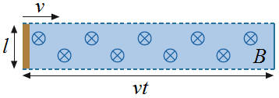
Straight Wire
Imagine a straight piece of wire of length l is moved through a magnetic field at a velocity v. If the wire is moving at right angles to the field lines an e.m.f. is induced (because field lines are being cut).
The size of the e.m.f. is given by the equation:
$ε=\frac{NΔφ}{Δt}$

For one loop of wire $ε=\frac{Δφ}{Δt}$ and the flux is given by $φ=\text{BA}$ which are combine to become $ε=\frac{Δ\text{BA}}{Δt}$
B is constant so $ε=\frac{BΔA}{Δt}$. ΔA is the area the wire cuts through in a time t and is given by$A=l\text{.}\text{vt}$ so we get: $ε=\frac{BΔl\text{.}\text{vt}}{Δt}$ The length of the wire and velocity are constant so it becomes$ε=\frac{\text{Blv}Δt}{Δt}$ which cancels to: $ε=\text{Blv}$
Rotating Coil of Wire
If we have a coil of wire with N turns, each of which has an area of A and placed it a magnetic field of flux density B nothing would happen. If it was rotated with an angular speed of ω it would cut through the magnetic field lines and an e.m.f. would be induced. The size of the e.m.f. is given by:
Since $ε=N\frac{Δφ}{Δt}$ and $φ=\text{BA}\text{cos}ωt$ we get $ε=N\frac{Δ(\text{BA}\text{cos}ωt)}{Δt}$ and if we differentiate it: $ε=\text{BAN}ω\text{sin}ωt$
This is why the Mains supply is alternating; the rotating coil cuts the field lines in one direction on the way up and the other direction on the way down.

Lenz’s Law – Direction of induced e.m.f.
The direction of the e.m.f. induced in a conductor is such that it opposes the change producing it.
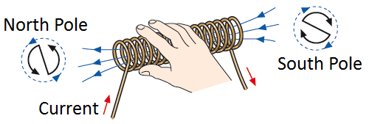
Solenoid (Right Hand Grip Rule)
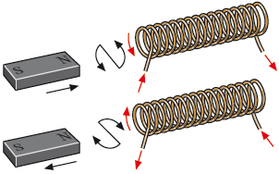
A solenoid with a current flowing through it produces a magnetic field like that of a bar magnet. We can work out which end is the North Pole and which is the South by using the Right Hand Grip Rule from our force on a wire lesson. If our fingers follow the direction of the current through the coils our thumb points out of the North Pole.
*When we push the North Pole of a magnet the induced current in the solenoid flows to make a North Pole to repel the magnet.
*When we pull the North Pole out of the solenoid the induced current flows to make a South Pole to attract the magnet.
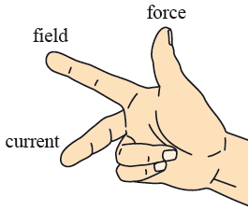
Fleming’s Right Hand Rule
If we are just moving a straight wire through a uniform magnetic field the direction of the induced current can be worked out using Fleming’s Right Hand Rule.
Your first finger points in the direction of the field from North to South, your thumb points in the direction the wire is moved and your middle finger points in the direction of the conventional current.

