[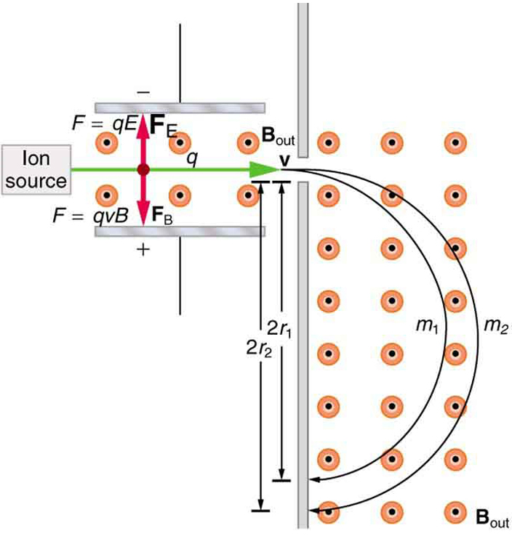](http://www.google.co.uk/url?sa=i&rct=j&q=mass%20spectrometer%20particle%20paths&source=images&cd=&cad=rja&docid=RzExdMygs50IeM&tbnid=xDIN1De3A3n8KM:&ved=0CAUQjRw&url=http://cnx.org/content/m42388/latest/&ei=1F04UpyZA_Db7Aa5wYDAAg&bvm=bv.52164340,d.ZGU&psig=AFQjCNEwu419FicY9LC56UA_M2Pb33SYZA&ust=1379512133633574)