A-level Physics required practical No 12

Investigation of the inverse-square law for gamma radiation

NB This worksheet gives full details of the experiment, primarily for use by teachers and technicians who may be unfamiliar with the experiment. The worksheet would normally be adapted for student use to provide opportunity for students to make procedural decisions.

It is important that any ‘student version’ of this worksheet takes due account of any relevant safety issues. It is the responsibility of the centre to ensure that the apparatus they provide is used safely.

Materials and equipment

- gamma source (e.g. 185 kBq (5 µCi) Cobalt 60 ‘closed’ source)
- source holder or retort stand, boss and clamp
- scaler with integral power supply for GM tube
- geiger muller tube suitable for gamma detection
- metre ruler
- stopclock

Technical Information
- Teachers, technicians and students must be familiar with the regulations for the use and handling of radioactive materials. Document L93, “Managing Ionisation radiations and radioactive substances in schools and colleges” is publically available on the CLEAPSS website. (You do not have to be a member to download this document).This gives details of every aspect in the use of radioactive sources in schools, and we strongly recommend you refer to it for advice before doing this or other similar experiments.
- The most commonly used closed/sealed gamma source is Cobalt 60. This has a half life of approximately 5 years. A (nominally) 185 Bq (5µCi) source kept in school for 15 years would only have an activity of around 23 kBq (0.6µCi), which may be too low to obtain satisfactory results.
- The Scaler must be compatible with the GM tube used – i.e. it has the appropriate socket and voltage supply for the GM tube.
- When taking count readings the longer the count, the lower the uncertainty. It can be shown that the uncertainty in a total count of N is + √N. A total count of 400 will have an uncertainty of + 20 or + 5%.

Clamps and source holder not shown. (Some stands with integral source hold, GM tube holder and mm scale are available.)

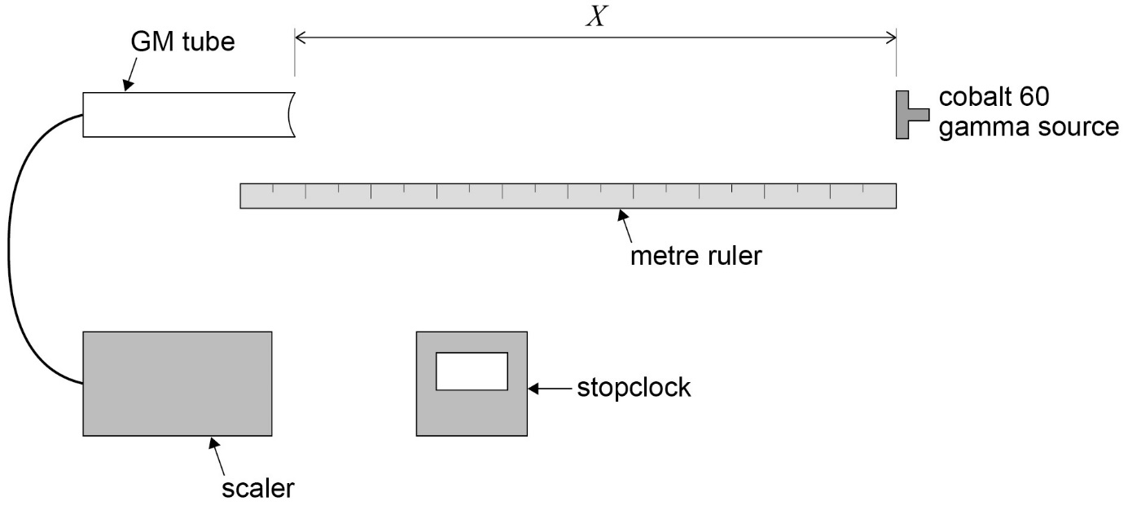

Method

- Plug the GM tube into the scaler and set at the appropriate voltage (according to manufacturer’s instructions). Start the scaler to check it is counting - there will be sufficient background radiation to register a count.
- Before bringing the source into the laboratory, a background count must be taken. Simultaneously start the scaler and stopclock. Stop the scaler after 20 minutes. Record the time, t, and the total count, N, on the scaler.
- Set up the arrangement as shown in the diagram.
- Put the source in its holder (observing safety procedures).
- A few preliminary readings would be advantageous at this point, to establish the maximum distance at which a meaningful count can be taken – a count significantly above background is required to give useful data. Additionally, a count rate taken near to the source will enable counting times to be decided for smaller source-detector distances..
- Set the distance from the front of the source to the front of the GM tube window, x, to 600 mm. (Assuming this distance gives a satisfactory count rate.)
- Simultaneously start the timer and scaler, and take the count, N, after t = 5 minutes. (or 10minutes if the total count is below 400).
- Re-set the source position so that X = 500mm from the GM tube and take the new total count after t = 5 minutes.
- Repeat for source- GM tube distances X of 400mm, 300mm, 200mm, 100mm.(As the source is placed closer to the detector, a shorter timed counts will be satisfactory).
- Record N, t, X in a suitable table, allowing columns for count rate C = N/t and corrected count rate C’ (obtained by subtracting background count rate from C) and a final column for 1/√C’.
- Plot a graph with 1/√C’ on the y-axis and X on the x-axis.

A straight line graph would verify the inverse square law relationship for gamma rays. The data is plotted this way around (rather that plotting C’ against 1/x²), to eliminate the systematic error in distance measurement. The exact position of the gamma material inside the sealed source and the position inside the GM tube where ionisation takes place is not known .Actual distance between source and detector, d, is given by d = x + e , where e is the systematic error in the distance measurement. This distance e can be found from the intercept on the x-axis of the graph.

