Contents

History 2

Radiation Physics 4
X-radiography 4
CT 5
Nuclear Medicine 6
PET 7
Radiotherapy 8
Radiation Protection 9

What is Medical Physics?

Medical physics is the application of physics to medicine. A large part of medical physics concerns the use of radiation to examine and treat the body. Other areas include medical ultrasound, endoscopy and MRI scans.
History

Most people think that Medical Physics started in 1895 when Wilhelm Roentgen discovered x-rays but, in practice, physics has been used to investigate the body for much longer than this.

Hippocrates (460-377 BC), the “Father of Medicine”, may have been the first medical physicist. Over two thousand years ago, he wanted to know where an infection was on a patient’s back. He smeared mud over the patient’s back as he knew that infected tissue is warmer and would therefore dry the mud faster.

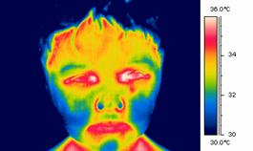
Technology has improved since then, and modern thermography, which looks at heat coming from the body using an infrared camera, is very different from Hippocrates' methods.
When doctors wanted to be able to see inside the stomach and intestines, they first simply used a thin tube with light provided by a candle. In 1868 a metal tube was passed down the throat into the stomach. This was an early prototype of an endoscope. Large early models were tested on sword swallowers, and were very intimidating, with one man quoted as saying 'I'll swallow a sword, but I'll be damned if I’ll swallow a trumpet'. Modern endoscopes are smaller and more flexible, making endosopy a less unpleasant examination.

In the future, we will use camera pills that can be swallowed and travel all the way through the digestive system without any discomfort.

The most common medical imaging examination today is an x-ray, or radiograph. X-rays were discovered in 1895 by Wilhelm Roentgen, who was passing an electric current through a glass tube with a vacuum inside, when he noticed a screen nearby start to glow. He realised that some invisible rays from the tube were causing the glow, and called them x-rays as he didn't know what they were. He set to work, trying to find out more about these strange rays.
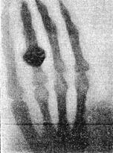
His wife became worried that he was spending so much time in his lab, and wasn't eating properly or talking to anyone. She finally persuaded him to tell her what he was working on, and he took her into the lab. She tried out his equipment by putting her hand in the x-ray beam for fifteen minutes, and saw an image of her hand appear on film behind it. This was the first medical x-ray image. Roentgen was awarded the first ever Nobel prize in Physics in 1901.

Soon after Roentgen’s discovery, Henri Becquerel, a Frenchman, was experimenting with salts that fluoresced when exposed to sunlight to see if they would emit x-rays. One cloudy day he left a photographic plate and a uranium compund in a drawer, and when he developed the film he found that it had been exposed to something, even though it hadn’t seen any light. He realised that uranium gave off invisible rays that could ionise atoms and blacken film. He called this radioactivity.

Marie Curie, along with her husband Pierre, continued the research into radioactive materials, discovering new radioactive elements Polonium (named after her homeland, Poland) and Radium. Bequerel and the Curies shared a Nobel prize for their work.

For a while radiation was hugely fashionable, with people putting radium in water and thorium in toothpaste. This health craze was dangerous though, and ill effects were soon noticed. The girls who painted radium onto the dials of watches developed thoat and mouth cancers from licking their brushes, while people using radioactive products suffered symptoms such as burns, hair loss, bone diseases and various types of cancer. Marie Curie herself died from a blood disease linked to radiation exposure (Pierre, though suffering from radiation sickness, died when run over by a horse and cart) .

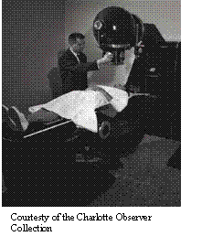
By this time, it had been realised that, although harmful in large doses, small amounts of radiation could be used to treat diseases such as cancer. The radioisotope cobalt-60 became used in radiotherapy machines (see left) and today radiotherapy uses high energy x-ray beams to treat tumours.

Radiation Physics

Ionising radiation can be either alpha or beta particles, or high energy electromagnetic waves with enough energy to completely remove an electron from an atom.

How does radiation affect the body?

In large doses, ionising radiation can be dangerous and can cause burns to the skin and sickness. In medical imaging radiation doses are too low to cause serious damage, though there are still risks. Radiation can damage the DNA in cells. Sometime the cells can repair the damage, though sometimes they cannot and die. This fact is useful in the treatment of cancer where radiotherapy is used to kill the cells in a tumour. Another problem is that radiation can change the DNA without the cell dying. This is called a mutation, and mutations can lead to the person being more likely to develop cancer later in life, or can be passed on to their children, sometimes leading to genetic abnormalities.

X-Radiography

X-ray radiography is one of the most commonly used methods of diagnosis. It can be used to examine broken or fractured bones, teeth, the digestive system, the lungs and to detect breast cancer.

X-rays are produced when electrons hit a metal, which in hospital x-ray tubes, is usually tungsten. The x-rays then pass through the body and onto either a film cassette or digital detector (like in a digital camera).

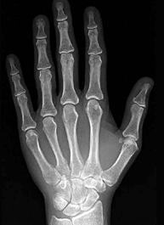
Structures in the body like bones are very dense and contain elements such as calcium that have a high atomic number. This makes bone absorb a high proportion of the x-rays. Soft tissues like fat and muscle allow more x-rays to pass though. The body casts an x-ray shadow onto the film. Where the x-rays have passed though bone, the film is less exposed so it looks white; where they have not passed though anything the film is exposed and turns black; and where the x-rays have passed through soft tissues the film has different levels of grey.

In order to make some parts of the body show up better, contrast media with a high atomic number can be used. This can be a 'barium meal', where the patient drinks a liquid containing barium (atomic number 56) which makes the digestive tract show up clearly on x-rays, or the patient can have an injection of iodine (atomic number 53) which makes the blood vessels stand out (this is called angiography).

CT (computed tomography)

A CT scan (sometimes called computed axial tomography, or a CAT scan) also uses x-rays.
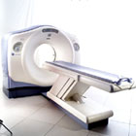
In a CT scan the patient lies on a table and is moved though a doughnut-shaped machine. It creates images that are slices through the patient.

It does this by moving the x-ray tube and detector in a circle taking x-ray images of the slice from all angles around the body.

A computer then processes these images to produce a cross sectional image (a picture of a slice through the body).

CT scans are useful as they can show a range of very different tissue types clearly: lung tissue, bone, soft tissue and blood vessels.
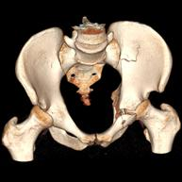

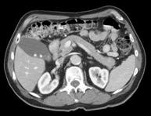

By adding together CT slices, 3-D images can be generated.

They are often used to plan radiotherapy treatments.

CT is useful for diagnosing internal inuries in trauma victims. Because a scan takes only a couple of minutes it can find problems quickly and save their lives.

One problem with x-ray CT is the radiation dose to the patient. A scan of the abdomen gives a dose of 10mSv, which is equivalent to the natural background radiation exposure over 4 years. This is about 100 times more than a standard chest x-ray.

Nuclear Medicine
Nuclear medicine uses radioactive isotopes (radioisotopes) to image the body. X-ray images show only the structure of the body, so they can be used to see things like broken bones and some tumours. Unlike x-ray images, nuclear medicine can show the function of the body. It follows what happens to certain chemicals so it can be used to see if an organ is doing its job properly. The chemicals, called tracers, are 'labelled' with a radioactive isotope and their path followed through the body.
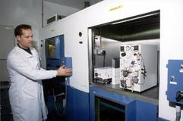

The radioisotopes are produced in generators where isotopes with long half-lives (e.g. molybdenum-99, half-life 67 hours) decay to isotopes with shorter lives (e.g. technetium-99m, half-life 6 hours). The shorter half-lives are necessary so that the radioactivity of the patient does not remain much above its normal background level for longer than necessary.
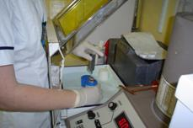
The isotope with the shorter half life is drawn out of the generator in a solution and can be made into a range of different drugs (radiopharmaceuticals) that are absorbed by different parts of the body. The radiopharmaceutical is drawn up into a syringe shielded with lead and its dose checked before it is injected into the patient.

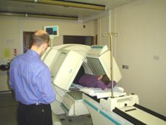
The gamma rays given off by the radioisotope are detected by a gamma-camera (a detector that takes images with gamma rays) which is connected to a computer and gives an image of where the isotope is in the patient. The image shows where the drug is absorbed.

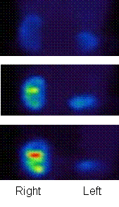

If several pictures are taken over a period of time it can also show how quickly the isotope is absorbed.

These three images show the build up of a tracer in the kidneys over time. We can tell that the left kidney is blocked, as the tracer hasn’t been able to reach it.

PET (Positron Emission Tomography)

Positron Emission Tomography (PET) scanning uses beta+ emitting isotopes.

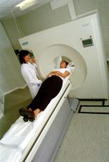
The isotope decays emitting a positron (which is a positive electron, also called a beta+ particle, and is a particle of antimatter). The positron can only travel about 1mm before losing its energy and slowing down. When it slows down enough, it will meet a negative electron from a nearby atom, and they will 'annihilate', leaving no particles. Their energy is converted into two gamma rays which travel in opposite directions so that momentum is conserved.

A PET scanner has a ring of detectors so that both gamma rays are seen, and is connected to a computer which can work out where the gamma rays came from and produces an image.
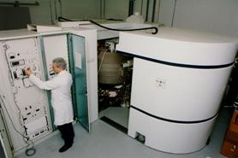
Not all hospitals have PET scanners as they need large, expensive machines called cyclotrons nearby to produce the positron-emitting isotopes. The isotopes have a shorter half-life than the gamma emitters used in traditional nuclear medicine (e.g. Carbon-11, which has a half-life of 20.5mins).

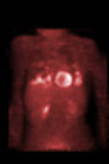
PET imaging is often used to detect tumours. As cancers are growing quickly they need a large supply of energy, which they get from glucose. A chemical called fluoxyglucose can be labelled with positron emitting fluorine-15, which then collects in the tumour and shows up as a bright spot in the PET scan (like in the rib in the picture on the right).

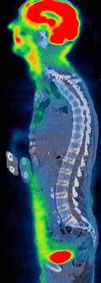
Some PET scanners now have a CT scanner next to them so both types of scan can be done at the same time. This can easily be done as both types of scanner are shaped.

This image is a combined PET/CT image. The excellent contrast from the PET scan, in which the brain and bladder show up as bright red, is combined with the anatomical detail from the CT (shown in grey).
Radiotherapy

Radiation is not just used for diagnosis, but for treating cancer as well. This is called radiotherapy.

Radiotherapy uses the fact that ionising radiation damages cells, and high enough doses can kill them. The cells in cancerous tissue divide very rapidly. This makes them more susceptible to damage by radiation than healthy cells, so there is a higher chance that they will be killed. Even so, care has to be taken to ensure that only the malignant cancer cells, and not the surrounding healthy tissue, receive a high dose.

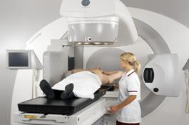
This is done by mounting the system on a ring so it can rotate around the patient, with the tumour at the centre of the rotation. In this way the tumour gets a higher dose of radiation than the surrounding healthy tissue.

Originally, radiotherapy machines consisted of a cobalt-60 source which emitted gamma rays which irradiated the tumour. Modern hospitals use linear accelerators (linacs for short) instead to produce very high energy x-ray beams, with a higher energy than the Cobalt-60 gamma rays. In the UK, medical physicists are required by law to calibrate the linacs to ensure that the best possible treatment is given.
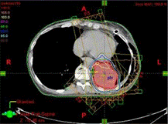
Each treatment requires careful planning. This involves deciding which directions to irradiate the tumour from, what dose to give and, in new machines, what shape region to expose.

The size, shape and location of the tumour are worked out using CT or MRI scans. Isodose curves, which join points that will receive the same dose, are drawn onto this CT scan.

Brachytherapy

In Brachytherapy (meaning short-distance therapy), radioactive material is inserted into the body, inside or near to the tumour. This means the tumour receives a high dose while the surrounding tissues have a smaller exposure.
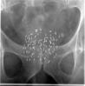
Here, tiny pellets of radioactive iodine-125 have been implanted into the prostate gland.

These pellets will not be removed, but have a fairly short radioactive half-life so that after a while they will become inactive.
The Gamma Knife
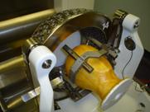
The gamma knife is not really a knife, but a way of performing brain surgery without cutting through the skin, muscle or skull. It uses 201 radioactive cobalt-60 sources to irradiate the brain. Cobalt-60 emits gamma rays and has a half-life of 5.26 years.

The first stage in treatment is to fit a metal frame to the skull, which is done using four screws under local anaesthetic. The rigid frame allows the radiotherapy to be performed very precisely.

Then, the treatment is planned using CT or MRI images, so that the sources are correctly targeted, to irradiate the tumour and avoid healthy tissue, especially sensitive regions around the eye and cochlea.

The Cobalt-60 sources are positioned in a hemisphere. The patient’s head, held in the frame, is held inside a helmet with 201 holes to precisely target the radiation. When treatment starts, the patient’s head is moved inside the unit.

The gamma knife is used to treat benign and malignant tumours, blood vessel malformations, some pain conditions and some movement and psychiatric disorders. In 2006, there were three in the UK (two in London and one in Sheffield).

Radiation Protection

Why do we use radiation?

The doses of radioactivity used in medicine are small, and the benefit of being able to find out what is wrong with a patient and then treat them often outweighs the increased risk of possibly developing cancer later in life.

We all receive a dose of radiation from background sources such as radioactive rocks, radon gas and cosmic rays. This can be between 1.5 and 7.5 mSv per year on average, depending on where you live. Compare this to the dose from a dental x-ray, which is about 0.01 mSv, the equivalant of about 1½ days background radiation.

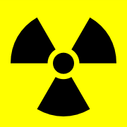
A chest CT scan gives a radiation dose of about 8 mSv, which is about the same as 3½ years background exposure, but you would receive the same dose from a four hour flight, about the time it takes to fly to Greece from London, as you are higher up and have less atmospheric protection from cosmic rays. This dose increases your risk of developing cancer by one in 2500, though your risk without ever having had an x-ray is already 1 in 3.

How can we protect ourselves?

There are many ways to reduce the dangers from radiation. The first is only to use it when necessary. Before people realised it was dangerous, shoe shops used to x-ray people’s feet to check that new shoes fitted properly. This no longer happens as the benefit did not justify the risk. However, the benefits of seeing where a bone is broken so it can be safely and properly mended are considered worth the small extra risk.

Every x-ray examination has a strict controls about the maximum radiation dose a patient can be given, and the patient can be covered with lead-rubber shield to protect the parts of them not being examined from the radiation. This is especially used to protect reproductive organs so there is less risk of a mutation being passed on.

People such as radiographers and nurses who work with radiation every day will leave the room or stand behind a lead shield when a procedure takes place, as the risk of developing problems due to radiation exposure increases with total dose. They also wear film badges which are developed regularly to check the dose they have recieved.

What jobs do medical physicists do?

Medical physicists work in many areas of the hospital. They are often responsible for maintaining and calibrating sophisticated equipment like MRI scanners and linear accelerators. They may develop new ways of using equipment to diagnose and treat unusual conditions. They may also be responsible for hospital computer systems. In general, they ensure that all the high-tech equipment needed in a modern hospital is working well so patients can be diagnosed safely and quickly.

Many medical physicists also work in research in universities, industry and hospitals, improving existing techniques and developing completely new ones. People such as Sir Godfrey Hounsfield and Sir Peter Mansfield have won Nobel prizes for their work in CT and MRI respectively.

Who does medical physics?

Roughly half of medical physicists are women and half are men. If you’re considering a career in medicine, physics or engineering, then medical physics may appeal to you.

Medical physicists use a wide range of skills including writing computer programs, inventing new equipment, and working with patients.

