Radioactivity
National Curriculum requirements (KS4, Physical Processes)
Students should be taught:
- that radioactivity arises from the breakdown of an unstable nucleus (6a)
- about some sources of the ionising radiation found in all environments (6b)
- the characteristics of alpha and beta particles and of gamma radiation (6c)
- the meaning of the term ‘half-life’(6d)
- the beneficial and harmful effects of ionising radiation on matter and living organisms (6e)
- some uses of radioactivity, including radioactive dating of rocks. (6f)

What is radioactivity?

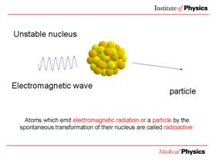 |  | 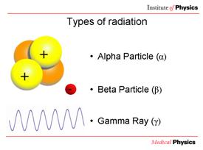

Table of properties of different types of radiation (not in the presentation)
name | Alpha (α) | Beta (β) | Gamma (γ)
 | 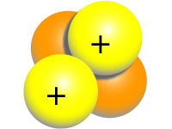 | - | 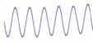
What is it? | A helium nucleus (2 protons and 2 neutrons) | An electron | Electromagnetic wave
mass | Heavy | Light | Zero
charge | +4 | -1 | None
penetration | Poor | Quite good | Highly penetrating

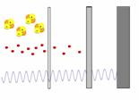 | Alpha particles can be stopped by a few centimetres of air, or a piece of paper.  Beta particles need a few millimetre of aluminium to stop them.  Gamma rays can only be stopped completely by several centimetres of lead.

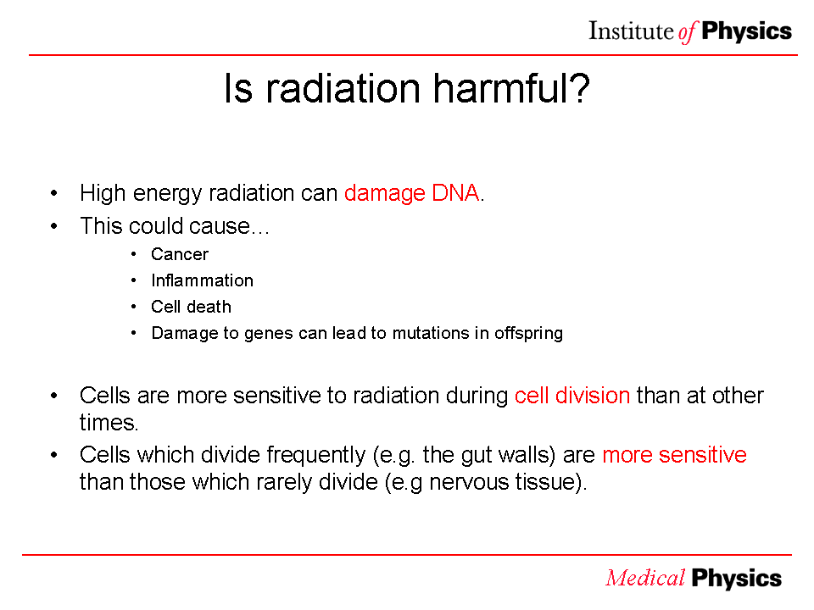

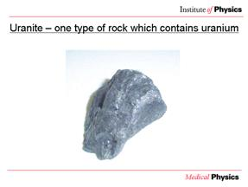 | Uranite  Uranite ore contains uranium, a radioactive element. It looks the same as a non-radioactive rock.

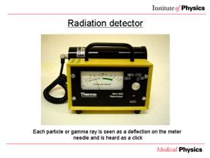 |  | 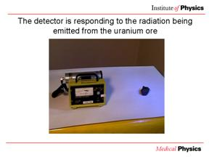

Radiation can be detected by a Geiger counter. These click every time either an alpha or beta particle, or a gamma ray, is detected.

Nuclear medicine

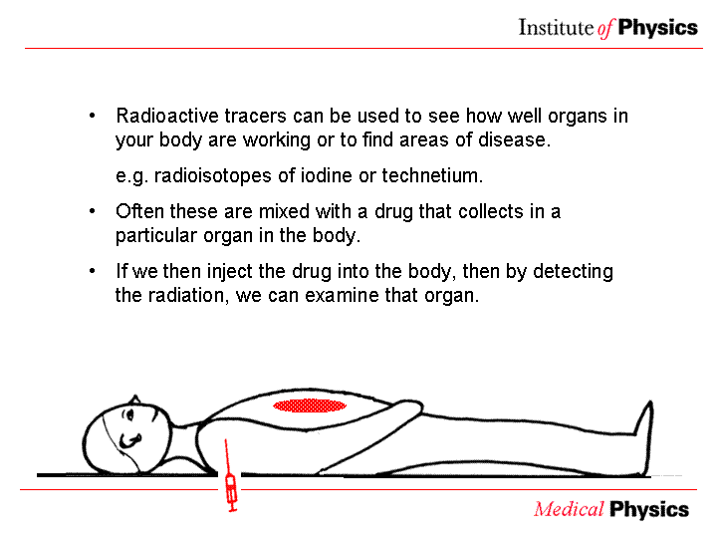 | Nuclear medicine uses radioisotopes to investigate the function of the body. It works by following what happens to certain chemicals so the doctor can see if an organ is doing its job properly. The chemicals, called tracers, are 'labelled' with a radioactive isotope and their path followed through the body.

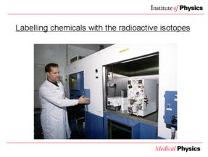 | The radioisotopes are produced in generators where isotopes with long half-lives (e.g. molybdenum-99, half-life 67 hours) decay to isotopes with shorter lives (e.g. Technetium-99m, half life 6 hours).  The Technetium-99m is drawn out of the generator in a solution and can be made into a range of different drugs (radiopharmaceuticals) that are absorbed by different parts of the body.

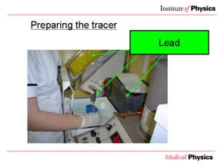 | In the image you can see the lead glass used to shield the face of the medical physicist.  Q: What material is this?  A: Lead.  Q: Why?  A: Because lead can absorb all types of radiation, even gamma rays.

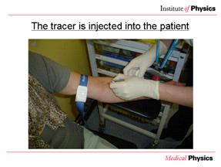 | The radiopharmaceutical is drawn up into a syringe shielded with lead and its dose checked before it is injected into the patient.

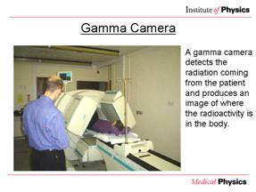 | The gamma rays given off by the radioisotope are detected by a gamma-camera (a detector that takes images with gamma rays) which is connected to a computer and gives an image of the distribution of the isotope in the patient.

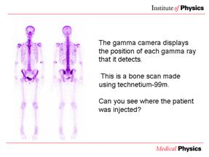 | The image shows where the drug is absorbed, and if several pictures are taken over a period of time it can also show how quickly the isotope is absorbed.  This is a bone scan made using technetium-99m.
Q: Can you see where the patient was injected?
A: By the elbow joint in the patient’s left arm.

You can tell this as some of the radioactive technetium-99m has remained there.

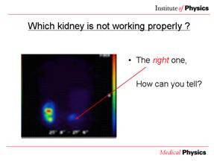 | The images show the build up of the tracer in the kidneys over time. The left kidney is healthy, but there is a blockage stopping the isotope from reaching the right kidney. In the PowerPoint presentation these images fade in after each other with only one mouse click.

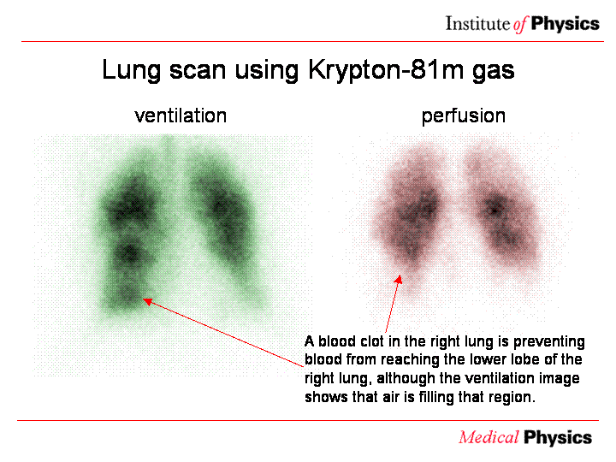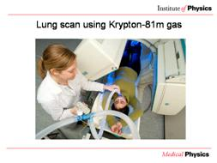 | Ventilation/perfusion scan. This involves two tests which may be done together or separately. The patient is injected with a radioactive drug which remains in the bloodstream around the lungs. An image of the distribution of this drug (on the right) shows the blood perfusion in the lungs. This should be uniform. A light area may show a blockage where the blood is not adequately perfusing the lung.  The second test is a ventilation scan, where the patient breathes radioactive xenon or krypton gas. This shows those parts of the lungs which are adequately ventilated.  Combining both scans allows a doctor to work out whether the lung is functioning properly, and allows operations to be designed so as to reduce long-term damage.

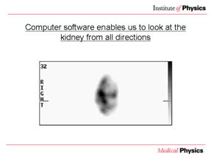 | Computer software enables us to look at the kidney from all directions. This image of a kidney rotates in the PowerPoint presentation.

PET

Positron Emission Tomography (PET) scanning uses beta+ emitting isotopes.

The isotope decays emitting a positron (which is a positive electron, also called a beta+ particle, and is a particle of antimatter). The positron can only travel about 1 mm before losing its energy and slowing down. When it slows down enough, it will meet a negative electron from a nearby atom, and they will 'annihilate', leaving no particles. Their energy is converted into two gamma rays which travel in opposite directions so that momentum is conserved.

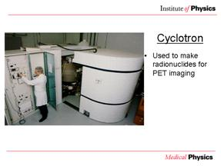 | This is used to make the radionuclides used in PET imaging by bombarding atoms with accelerated protons. It must be near to the PET scanner as the radionuclides used only have a short half-life (e.g. 2 mins for Oxygen-15).

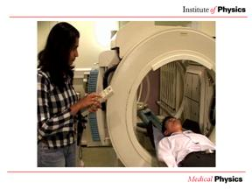 |  | 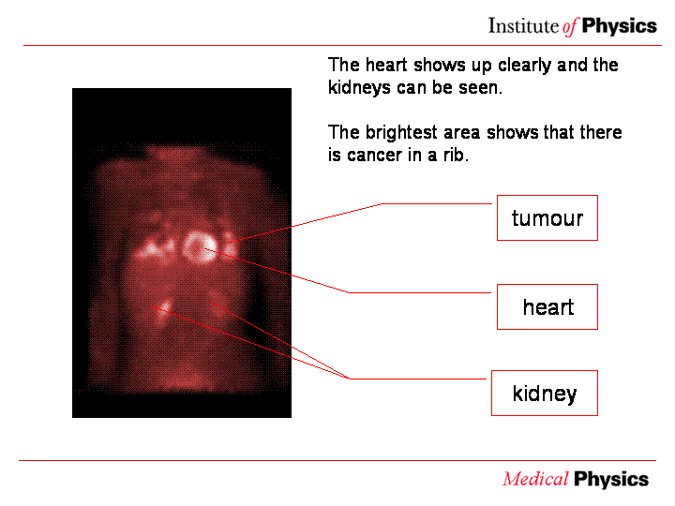

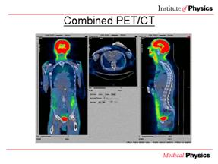 | The information from the PET scan (in colour on slide) can be superimposed on an x-ray CT image (grey/blue on slide). In this way, doctors get the benefit of high contrast from the PET scan and good spatial resolution from the CT image.

Radiotherapy
For more information see radiotherapy in the electromagnetic spectrum section (pg 9-10).
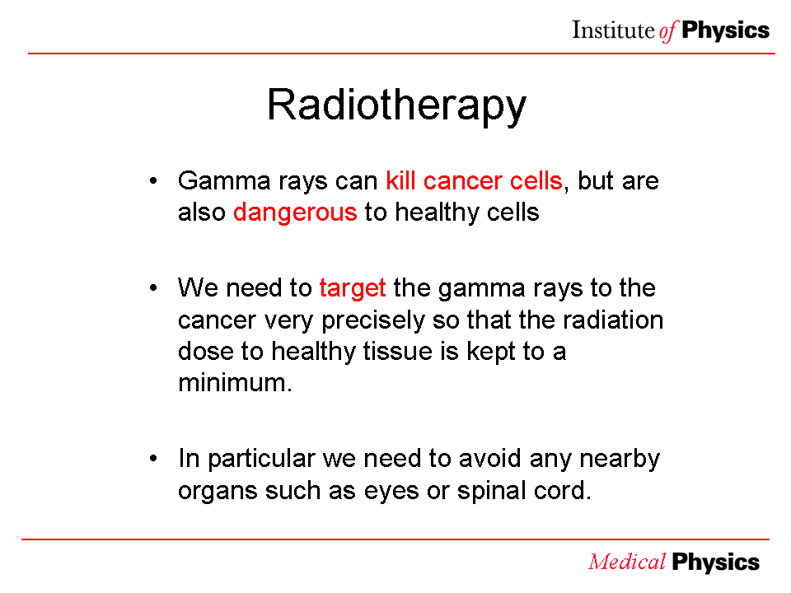 | Modern radiotherapy units use linear accelerators (linacs for short). These produce very high energy x-ray beams. The head rotates around the patient with the centre of the circle in the centre of the area to be treated. Older units worked in a similar way but used a single cobalt-60 source which emitted gamma rays. A more modern approach to radiotherapy using cobalt-60 is with a Gamma Knife.

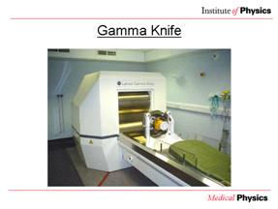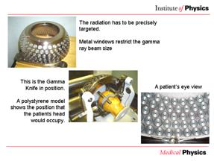 | Gamma knife  The gamma knife is used for brain surgery, but is non-invasive (it is performed without cutting the skin or muscles and the skull does not need to be opened), though a frame needs to be attached to the skull using 4 screws (fitted under local anaesthetic).  The gamma knife has 201 cobalt-60 sources, which emit gamma rays and have a half-life of 5.26 years. The sources are positioned in a hemisphere inside the unit. The patients head, held in the frame, is held inside a helmet with 201 holes to precisely target the radiation. When treatment starts, the patients head is moved inside the unit.

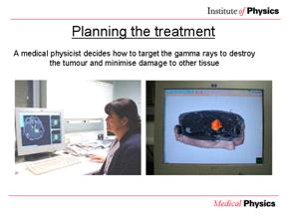 | The treatment is planned using CT or MRI images, so that the sources are correctly targeted to irradiate the tumour and avoid healthy tissue, especially around the eye and cochlea.  The gamma knife is used to treat benign and malignant tumours, blood vessel malformations, pain, and some movement and psychiatric disorders. There are currently three in the UK (two in London and one in Sheffield).

Nuclear Medicine

- Sort these sentences into the correct order

- Patient injected with radiopharmaceutical
- Computer reconstructs image
- Drug labelled with radioisotope | 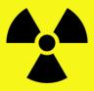
- Patient imaged with Gamma camera | 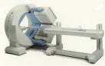
- Drug moves through bloodstream to organ | 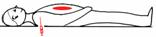

- a) Which of these isotopes would be suitable for use as a tracer?
Circle your choice.

¹⁴C Carbon-14 half-life: 5730 years
⁵⁷Co Cobalt- 57 half-life : 271 days
^{99m}Tc Technetium-99m half-life: 6hours
¹⁵O Oxygen-15 half-life : 2mins

b) Why did you choose that radioisotope? ………………………………………………………………………………………
………………………………………………………………………………………………………………………………………………………………………………………………………………………………………………………………………

- Sort the following statements into those that suggest radioactivity is Beneficial those that suggest it is Harmful, and those that suggest it could be Either
Radiation can kill cells
Radiation most affects cells that are dividing
Radiation damages DNA and can cause mutations
Exposure to radiation can lead to sickness and burns
Gamma
rays can only be completely stopped
by lead
Radioactive isotopes can be used as tracers in the body
Radiation can cause cancer but is also used to cure it

PET

1) A cross section of a PET scanner is shown below. The detectors shaded in show gamma rays which were detected at the same time.
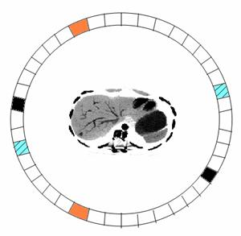

By drawing lines between the pairs of detectors that detected gamma rays, can you draw where you think the tumour is?

- What does PET stand for?
- What type of radiation do the isotopes used in PET scans emit?
- What happens when this particle meets an electron?
- What is then produced?
- What is the name of the machine used to produce the isotopes?
- Which of the following isotopes are used in PET scans (circle the correct answers)
Carbon-10 Oxygen-15 Fluorine-16
Carbon-11 Oxygen-16 Fluorine-17
Carbon-12 Oxygen-17 Fluorine-18

- Which of these is a PET scanner?

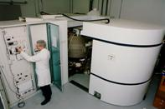 | 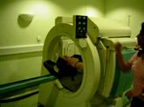 | 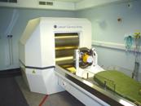

- What are PET scans often used to detect?

Nuclear Medicine- Answers
- Drug labelled with radioisotope
Patient injected with radiopharmaceutical
Drug moves through bloodstream to organ
Patient imaged with Gamma camera
Computer reconstructs image

- a) Technetium-99m
b) It has a suitable half-life, Carbon-14 and Cobalt-57 decay too slowly and Oxygen-15 decays too quickly, though O-15 is used in PET imaging.

- Exposure to radiation causes sickness and burns – bad
Radioactive isotopes can be used as tracers in the body – good.
Radiation can cause cancer, but is also used to treat it - either
Others, arguments for both

PET- Answers
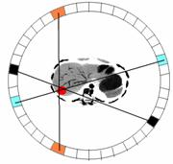
- Positron emission tomography
- Beta-+, positrons, positive electrons
- They annihilate
- Two gamma rays, travelling in opposite directions
- A cyclotron
- C-11, O-15, F-18
- A)a cyclotron b) PET scanner c) gamma knife
- tumour

