# Derivation of Kinetic Theory equation

There are two equations that describe the behaviour of gasses. You need to be able to understand the derivation of both from first principles!

## Kinetic Energy of Gas

## Kinetic Theory Equation

## Assumptions

Before we can start the derivation there are 5 assumptions about the gas molecules

1. **R** - Random motion. (molecules continual moving with random motion)
2. **A** – Do not Attract each other.
3. **V** - Volume of the molecules is negligible
4. **E** - Elastic collisions (between container walls and molecules, and each other)
5. **D** - Duration of collisions (is negligible compared to the time between impacts)

## Other resources

The Nelson Thornes AQA A2 Textbook has this derivation on page 216→ 218.   
The Hodder AQA A2 Textbook has the derivation on pages 76→77

Antonine Education has a webpage devoted to it

S-Cool doesn’t derive the equations but explains the topic simply here: <http://www.s-cool.co.uk/a-level/physics/kinetic-theory>

## Instructions

You have the derivation overleaf but with key bits missing… On the last page there are all the “bits” you should be able to fit the right bits into the correct gaps…

This full derivation is complete on GoL…

### NOTATION

vy

vz

y

y

z

x

x

z

vx

X

There are some gas molecules on a **cubic** box.

N= The number of molecules in the box  
m = mass of each molecule

The box has dimension Length = x , y , z as shown   
(I know it doesn’t look cubic! But it is!)

The shaded face is called X

To start with we make life easy   
and only have 1 molecule  
ONLY moving in one dimension (x)

### Using simple mechanics what is the pressure on face X?

3 steps:

1. Find change in momentum and time taken
2. Use Newton’s second law to calculate force
3. Use Pressure = Force/ Area

### Find change in momentum

If the molecule is heading towards the face with velocity vx  and mass m then:

* momentum of molecule before collision = mvx
* as it is a elastic collision and momentum of molecule after collision = -mvx
* (change in momentum) = (momentum after) – (momentum before)

### Find Time Taken

We usually use the **time taken during an impact** to calculate the force BUT if there are lots of impacts one after another. AND each impact is of negligible time then the **time between impacts** can be used. →

The molecule travels all the way to the face opposite “X“and back again =

### C:\DOCUME~1\jmh\LOCALS~1\Temp\msohtmlclip1\01\clip_image002.pngC:\DOCUME~1\jmh\LOCALS~1\Temp\msohtmlclip1\01\clip_image002.pngUse Newton’s Second Law to Calculate Force

### Pressure = Force/Area

As it’s a cube the area of the face = x2 ( x3 = volume of the cube)

## C:\DOCUME~1\jmh\LOCALS~1\Temp\msohtmlclip1\01\clip_image003.pngC:\DOCUME~1\jmh\LOCALS~1\Temp\msohtmlclip1\01\clip_image003.pngUse average velocity and geometry to find pressure on cube as a whole

3 steps

1. Take account of many molecules and find “average” velocity.
2. Take account of 3 dimensions
3. Combine to find the general equation

### Take account of many molecules

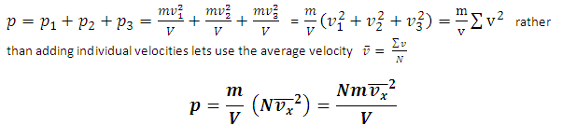The total pressure is simply the sum of all the pressures from individual molecules:





### Take Account of 3 dimensions

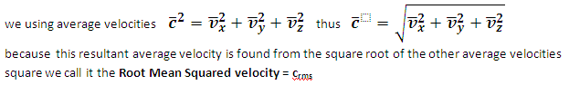We can use **Pythagoras** to calculate the resultant velocity (NB we now use c = resultant velocity) as

C:\DOCUME~1\jmh\LOCALS~1\Temp\msohtmlclip1\01\clip_image007.pngC:\DOCUME~1\jmh\LOCALS~1\Temp\msohtmlclip1\01\clip_image007.pngIn the equation the velocity is squared ANYWAY… also as motion is random it is irrelevant which direction we derived for 1D so we’ll assume that the average velocity is the same in all dimension..

thus

### Find the general equation

Substituting the rms speed back into the 1D equation gives:

Usually written as

Now we can use **pv=nRT** to write the above solution as

**!!!!ALERT!!! Big N = number of molecules, little n = number of moles**

Just to double check write down what the other quantities are:

**P = pressure**

**V = volume**

**m = mass**

**crms = root mean squared velocity**

# Finding Kinetic energy

OK !! What about Kinetic energy so if we can rearrange the above equation to get on one side we have found Kinetic energy

3 steps :

1. Sort the fractions out
2. Rearrange
3. Sort out the constants

### Sort the fractions out

C:\DOCUME~1\jmh\LOCALS~1\Temp\msohtmlclip1\01\clip_image009.pngTo convert 1/3 to a half we need to multiply by 3 and divide by 2 (obviously to both sides)

Thus we now have

### C:\DOCUME~1\jmh\LOCALS~1\Temp\msohtmlclip1\01\clip_image010.pngRearrange

Ohhh we now have ½ mv2 on oneside J

### Sort Constants out

Thus Substituting this back in gives



There is another constant called the Boltzman Constant

**Kinetic Energy (for one molecule) =**

Phew!!!!!!!! Both equations Derived… there are lots of other specific solutions but they are normally for a mole of Gas or such like

**Clippings to fill in the blanks**

C:\DOCUME~1\jmh\LOCALS~1\Temp\msohtmlclip1\01\clip_image002.png

C:\DOCUME~1\jmh\LOCALS~1\Temp\msohtmlclip1\01\clip_image009.pngC:\DOCUME~1\jmh\LOCALS~1\Temp\msohtmlclip1\01\clip_image009.pngC:\DOCUME~1\jmh\LOCALS~1\Temp\msohtmlclip1\01\clip_image007.pngC:\DOCUME~1\jmh\LOCALS~1\Temp\msohtmlclip1\01\clip_image007.pngC:\DOCUME~1\jmh\LOCALS~1\Temp\msohtmlclip1\01\clip_image010.pngC:\DOCUME~1\jmh\LOCALS~1\Temp\msohtmlclip1\01\clip_image007.pngC:\DOCUME~1\jmh\LOCALS~1\Temp\msohtmlclip1\01\clip_image007.png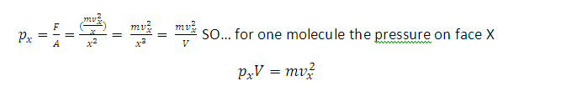C:\DOCUME~1\jmh\LOCALS~1\Temp\msohtmlclip1\01\clip_image002.png

-mvx - mvx  = -2mvx