**A-level Physics required practical No 8**

**Investigation of Boyle’s (constant temperature) law and Charles’s (constant pressure) law for a gas**

NB This worksheet gives full details of the experiments, primarily for use by teachers and technicians who may be unfamiliar with the experiment. The worksheet would normally be adapted for student use to provide opportunity for students to make procedural decisions.

**Boyle’s law**

**Materials and equipment**

* Stand and clamp
* 10ml syringe with 0.5ml divisions
* 5cm length of thin-walled rubber or silicone tubing to fit nozzle of syringe
* Pinch clip
* 2kg mass
* Loop of string
* 9 x 100g masses on a 100g mass holder
* Micrometer

**Technical Information**

* The syringe should be the type with a rubber seal on the plunger which is less likely to stick. The type with an O ring seal on the end of the plunger are better, and tend to stick less than the type where the end of the piston is made of solid rubber.
* The rubber tubing should fit tightly onto the nozzle of the syringe. It can then be folded over and clamped with the pinch clip to produce an airtight seal.
* The clip should be as close as possible to the nozzle. There will be a little air in the nozzle, but this has negligible volume compared to the volume of air in the barrel of the syringe.
* A loop of string should be tied to the end of the plunger so that the mass holder can be hung on it.
* The 2kg mass is used as a counterweight to ensure the stand does not topple over (an alternative would be to clamp the stand to the bench using a G-clamp).

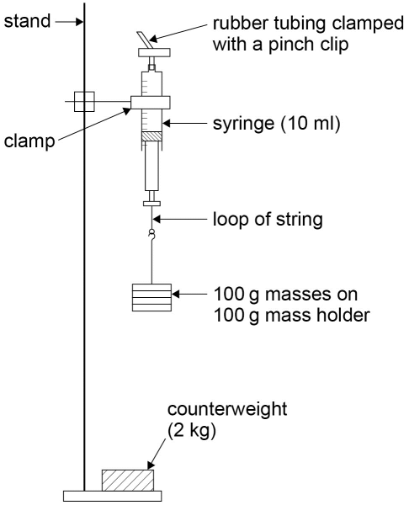

**Method**

* Remove the plunger from the syringe and measure the diameter of the rubber seal, *d*, using the micrometer. Convert this into metres.
* Calculate the cross-sectional area of the seal *A* = π*d*2/4 in m2.
* Replace the plunger and draw in 4.0ml of air.
* Fit the rubber tubing over the nozzle, fold the tubing over and clamp it with the pinch clip as close to the nozzle as possible.
* Set up the apparatus as shown in the diagram initially with the 100g mass holder carrying one 100g mass. Ensure that the string is securely attached to the plunger handle. The clamp should be above the plunger so that the scale can be read. Clamping the syringe barrel can distort it, making it more difficult for the plunger to move freely. Consequently ensure the clamp is high enough on the barrel above the position where the plunger moves. There should be sufficient room below the masses so that the plunger can move down as masses are added.
* Gently move the plunger up and down a few millimetres to ensure it is not sticking.
* Read the new volume on the syringe scale (fractions of a division should be estimated).
* Repeat the procedure with an extra two 100g masses added to the holder each time, up to a total mass of 1000g.
* The whole experiment should then be repeated to obtain a second set of results, and the mean volumes found.
* The force exerted by the masses can be calculated using where *m* is the mass in kg and *g*, the gravitational field strength, is 9.81Nkg-1.
* The pressure exerted by this force on the air sample is then *F*/*A* in Pascals (Pa). Convert this into kPa.
* This should be subtracted from standard atmospheric pressure, 101kPa, to obtain the pressure of the air sample, *P*. (Note: the initial volume of the air with no masses hung on the loop will be at standard atmospheric pressure).
* A graph of 1/*V* against *P* should then be plotted (where *V* is the mean volume of the air sample for each value of *P*).
* Provided care has been taken to ensure the plunger does not stick, a reasonable straight line through the origin should be obtained. (Any slight sticking could result in a graph which curves slightly and/or does not pass through the origin.)

**Charles’s law**

**Materials and equipment**

* 25cm length of glass capillary tubing (eg outer diameter 5mm and bore 1mm, but other sizes will work perfectly well)
* 5cm length of thin-walled rubber tubing to fit over the end of the capillary tubing
* Contact adhesive
* Concentrated sulphuric acid
* 30cm ruler
* 2 elastic bands
* Thermometer (eg -10 to 1100C)
* 2 litre beaker
* 250ml glass beaker
* Paper towels
* Kettle

**Technical Information**

As concentrated sulphuric acid is being used, safety spectacles or goggles must be worn. Lab coats and gloves could also be worn. The technician should prepare the capillary tubing with a small drop of concentrated sulphuric acid about half way down its length, with the lower end sealed using contact adhesive. This can be achieved as follows:

* Pour a little concentrated sulphuric acid into a 250ml glass beaker.
* Attach the length of rubber tubing to one end of the capillary tubing.
* Place the other end into the acid.
* Pinch the rubber tubing, then place a finger over the end and release the tubing to draw a drop of acid into the capillary tube.
* Remove the capillary tube from the acid, and use the same pinch and release technique to move the drop of acid to about half way along the tube.
* Holding the capillary tube horizontally, remove the rubber tubing from the end, and apply a small amount of adhesive to this end of the capillary tubing (see diagram below).
* Using a paper towel, wipe off any surplus acid from the other end of the capillary tubing.
* Leave the tube for the contact adhesive to dry.
* Attach the capillary tubing to a 30cm ruler using the elastic bands, with the end sealed with contact adhesive at the zero mark.
* The drop of concentrated sulphuric acid will dry the air as well as trap the sample of air in the capillary tubing.

The method suggests adding hot water to the beaker and allowing it to cool to produce the required variation in temperature. This is safer than heating a large beaker of water using Bunsen and tripod. If a plastic 30cm ruler is used, the boiled water should be allowed to cool a little before pouring it into the beaker in order to avoid the plastic softening. Students must be told that the apparatus contains concentrated sulphuric acid, and to treat it with care. If dropped or broken it should be reported immediately, and cleared up by someone wearing safety goggles.

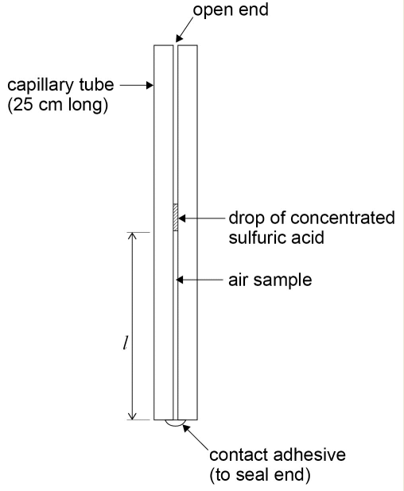

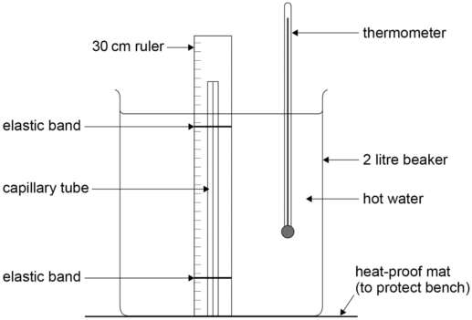

**Method**

* Set up the apparatus as shown in figure 8.3 with the open end of the capillary tube at the top. Allow the boiled water from the kettle to cool a little before pouring it into the beaker. The hot water should cover the air sample.
* Stir the water well using the thermometer, read the value of its temperature, *θ*, and the length of the air sample, *l*, on the 30cm ruler (see figure 8.2).
* Allow the water to cool by 50C and repeat the procedure until room temperature has been reached. (The cooling process can be speeded up by pouring a little water out of the beaker and topping it up with cold water.)
* Plot a graph of *l* against *θ*. Start the axes at a convenient value, and use a scale which will give a spread of points over at least half the graph paper in both directions.
* Draw the best straight line of fit though the points and find the gradient, *m*.
* The form of the graph is *l* = *mθ* + *c*, where *c* is the value of *l* when *θ* = 00C.
* The value of *c* can be found by reading a pair of values for length and temperature for a point on the straight line (*l*1 and *θ*1, say). Then *c* = *l*1 - *mθ*1.
* An estimate of the value of absolute zero, *θ*0, can then be found by substituting *l* = 0 into the equation for the form of the graph: 0 = *mθ*0 + *c* so *θ*0 = -*c*/*m*.