# Boyle’s Law

Your lab report will be specifically assessed for

CPAC4b: Correctly tabulating sufficient data

CPAC5b: Referencing standard values. (but other CPAC evidence will be recorded if found)

### Apparatus and diagram

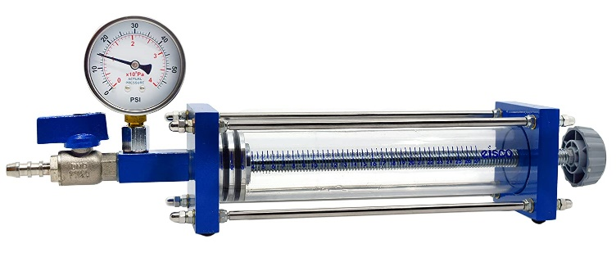

Boyle’s Law apparatus

Thermometer

**SAFETY NOTE:  
DO NOT OPEN THE TAP WITH EXCESS PRESSURE IN THE SYSTEM**

**1 Atm = ~1x105 kPa**

### Theory

Boyle’s law states that for a fixed mass of gas at constant temperature

Where P is the pressure, V is the volume and k is a constant.

k = nRT, where; n is the number of moles of the gas, R is the molar gas constant, and T is the temperature in Kelvin (T/K = /oC + 273).

Thus if a number of corresponding values of P and V are found for a fixed mass of gas at constant temperature then a graph of P against 1/V should be a straight line.   
The gradient of the line will be nRT. If T is known a value for n can be calculated.

### Method

* Take a reading of the laboratory temperature.
* You are now going to take readings for pressure as you change the Volume of the fixed mol of gas in the tube.
* It is up to you to decide what measurements to record and the format of the table. (CPAC4)
* You should choose the least sensitive scale as the independent variable.

**Open the tap on the apparatus:** Move the plunger to 10 (100cm3). Close the Tap.

* Decrease the volume for the tube recording suitable pressure and volume measurements

**DO NOT TAKE THE PRESSURE PAST 3.4x105 Pa**

* Now increase the volume of the tube you may go as far as 27 (270cm3)mark.
* If you think carefully you can take a set of repeat readings.
* Now reduce the volume of the tube back to 10 (100cm3) If you intend to take further repeat readings do not open the tap.

### Analysis

* Tabulate your results!
* Take care to ensure you use the correct: Header format, Units and Sig Figs.
* Plot a graph of P against 1/V.
* Calculate n from the gradient of your graph using the information provided in the theory section and the value of R, which you can find in a data book.

Estimate the number of moles in 100 cm3 of gas.

1 mole of a gas at room temperature and atmospheric pressure occupies a known volume. Research this and calculate n for your gas by ratio, based on the volume occupied by the enclosed gas at room temperature and standard atmospheric pressure and 1 mole of a gas **at room temperature** and standard atmospheric pressure. (NOT Standard temp and pressure!)

### Uncertainties and percentage difference

The tube volume is marked every 5cm3 and therefore has an absolute uncertainty of 5 cm3

A reading would have half this 2.5 cm3. A measurement comprises of 2 readings and is therefore ***dV*= 5cm3**

The pressure gauge is graduated every 0.1x105 Pa and is assumed to be perfectly calibrated with no zero error (according to AQA) so the absolute uncertainty is 0.1x105 Pa you use half this value to calculate the % uncertainty (%U) ***dP* = 0.05x105 Pa**

The what is the smallest graduation on the thermometer? The absolute uncertainty is the resolution BUT to calculate the %U for a single reading you use half the resolution.

Choose a representative value of Volume to calculate the uncertainties (usually the median value unless it is obviously anomalous). If you took repeats check to see if the half range is greater than the instrument uncertainties.

Calculate the %U for Pressure

Calculate the %U for Volume

Calculate the %U for Temperature

As the formula for n = PV/TR we can simple add all the %U. Find the combined %U

Calculate the percentage difference between the value for n from your gradient and the estimate of n you made.

As these are both experimental value use the formula:

Is your % diff bigger that your combined %U

Looking at the data points on your graph were you expecting a good result?