Godalming College Physics Department

Inverse square law with lamp and LDR

Theory

The intensity of waves from a point source is proportional to the inverse square of the distance from the source:
$I∝\frac{1}{r^{2}}$

To test this relationship, a graph of I against 1/r² could be plotted and a straight line should result. However, you are going to plot a log graph to investigate the form of the relationship. If we assume that the power of r is an unknown, n, we could rewrite the equation as:

I = k r^{n}

where k is a constant. Taking logs of both sides gives:

log (I) = n log(r) + log(k)

A graph of log (I) against log (r) should now be a straight line of gradient n, which should equal -2.

Apparatus required

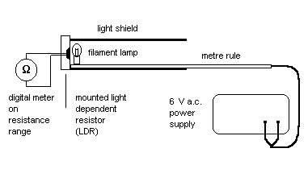

Method

Measure the distance of the centre of the lamp filament from the end of the metre rule. This should be the closest distance when the rule is pushed right up against the mounted LDR.

With the lamp closest to the LDR, switch on the lamp and note the resistance reading. Now take a series of values of resistance as you move the lamp away from the detector. By noting the position of the end of the tube against the rule, or otherwise, work out the total distance between the lamp and the LDR.

Think carefully about the range of values to use. Remember you are plotting a log graph, so equal distances will not result in an evenly spaced graph. If you are unsure as to how this will affect your graph, try calculating some values of log(r). Also it is wise to leave your apparatus set up until you have processed your results in case you wish to take additional readings.

Processing of results

Draw up a table of values of r and R, and from these calculate the values of log(r) and log(R/kΩ).

The values of log(I/lux) can be calculated from the resistance of the LDR with the following relationship, which is also logarithmic:

log(I/lux) = -1.47 log(R/kΩ) + 2.43

Note that the value of the resistance should be in kΩ.

Use this equation to calculate and tabulate the corresponding log(I/lux) values.

Now plot a graph of log(I/lux) v log(r), measure the gradients and see if it agrees with the prediction.

Discussion and Conclusion

Were your results as expected?

Include in your discussion a consideration of any error introduced by ignoring the background light intensity.

