Godalming College Physics Department

#### Investigation of a parallel plate capacitor

### Theory

The capacitance of a parallel plate capacitor is given by the equation: 

where A is the area of the plates

d is the distance between them

ε0 is the permittivity of free space ( 8.854 x 10-12 F m-1 )

εr is the relative permittivity of any material between the plates ( ~ 1 for air ).

A number of investigations can be carried out:

1. Variation of C with distance (constant A and air spaced capacitor) 

A graph of C against 1/d can be plotted and ε0 found from the gradient (ε0A).

1. Effect of a material medium. The capacitance can be found for a capacitor made with a plastic sheet separating the plates, and for an air spaced capacitor separated by spacers cut from the same sheet. You can see from the parallel plate capacitor equation that the relative permittivity is the ratio of the two capacitances.
2. Variation of C with area of overlap (constant d) 

A straight line should be produced if C is plotted against A.

### Apparatus required

The diagram shows a commercial apparatus of circular cross section, which can be used for the first two investigations. To vary the area of overlap it is easier to use a homemade capacitor made from rectangular metal sheets. You will also need a micrometer to measure the thickness of the spacers.

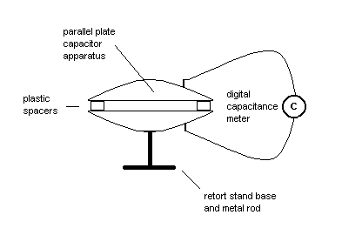

### Method

For the first investigation, a number of thin acetate spacers should be used, which can be piled up to vary the separation of the plates. To find the thickness of the acetate spacers, measure the thickness of a pile with a micrometer. Calculate the value of d for each capacitance arrangement. The capacitance is to be found from a direct reading capacitance meter, which is simply connected across the plates.

For the second investigation, measure the capacitance for a capacitor made with a plastic sheet separating the plates, and for an air spaced capacitor separated by spacers cut from the same sheet.

For the third investigation, make your own capacitor out of rectangular metal plates separated by a large acetate sheet. You will need to place boards on top of the arrangement to keep the layers in contact, and use crocodile clips to connect to the exposed edges of the plates. Obtain a series of values for the capacitance for different areas of overlap.

### Processing of results

For the first and third investigation you will need to tabulate your readings. For the plastic sheet investigation you simply need to record values of the capacitance with and without the sheet.

For the first investigation, plot a graph of C against 1/d and measure the gradient. Using the area calculated from the diameter of the metal plates (ignore the hole!) calculate a value for ε0.

For the second investigation calculate a single value for the relative permittivity of the plastic sheet.

For the third investigation, plot a graph of C against A.

### Discussion and Conclusion

Why should you not measure the thickness of a single spacer?

Do your graphs support the equation?

How does the value of ε0 compare with the expected result?

Calculate the percentage difference between your result and the expected value and see if you can account for any discrepancies from the uncertainties in your experimental measurements.