Godalming College Physics Department

Measurement of specific heat capacity of liquids

N.B. This sheet is for reference only – DO NOT remove it from the laboratory.

Apparatus

Copper calorimeter
6 V immersion heater
Power Supply
Ammeter
Voltmeter
Thermometer
Wires
Heat-proof mat
Lagged box
Stopwatch
Water
Cooking Oil

Diagram
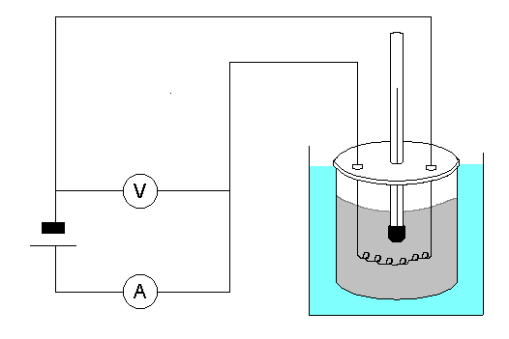

Theory

Assuming that the transfer of energy is 100% efficient:

Electrical energy supplied = energy gained by the + energy gained by the liquid calorimeter

VIt = m_{liquid} c_{liquid} ΔT_{liquid} + m_{calorimeter} c_{calorimeter} ΔT_{calorimeter}

So: specific heat capacity of liquid = VIt - m_{calorimeter} c_{calorimeter} ΔT_{calorimeter}
M_{liquid} ΔT_{liquid}

Method

For water:

Assemble the apparatus as indicated in the diagram. Determine the mass of the calorimeter using a balance. Place sufficient water in the calorimeter to cover the immersion heater.
Determine the mass of the calorimeter + water using a balance. Calculate the mass of water used. Switch on the power supply and start the stopwatch. Note the temperature of the water at the beginning. Record the voltmeter reading.
Record the ammeter reading. When the water has been heated for at least 6 minutes, turn off the power supply. Continue to record the temperature of the water until the temperature has reached its maximum value. Determine the rise in temperature using the maximum recorded value.

For cooking oil:

For convenience and to avoid mess, a calorimeter has already been filled with cooking oil, the heater inserted and placed in a lagged box. Do not remove the heater or calorimeter. Be careful not to spill the oil.

Determine the mass of the complete calorimeter arrangement and oil using a balance. The mass of the calorimeter and the total mass of the arrangement are written on the box. Use this information to calculate the mass of the oil. Repeat the procedure to obtain the other readings necessary to calculate the specific heat capacity of the oil.

When you have finished, carefully remove the thermometer and place it in the washing up tray.

Results and Analysis

There is no graphical analysis for this experiment, but you should record all of your results in a logical format with an appropriate unit. Make sure you record all the original data and not simply values calculated from that.

Calculate the specific heat capacity of water and cooking oil from your results. You will need to use the s.h.c. of copper (for the calorimeter) in your calculations. Take this to be 390 J kg⁻¹ K⁻¹.

The value obtained for the s.h.c. of water should be compared with the standard value and the percentage difference found.

How does the specific heat capacity of cooking oil compare with water?

Evaluate the percentage uncertainties for both of your values. The percentage uncertainties for each of the measurements of p.d., current, time, temperature and mass should be evaluated so that you can discuss their relative importance in contributing to the total uncertainty.

