Godalming College Physics Department

Measurement of specific latent heat of vaporisation of water

Apparatus and diagram

12 V immersion heater Boiling tube Balance Voltmeter
Lagged polystyrene box PC computer Water Ammeter
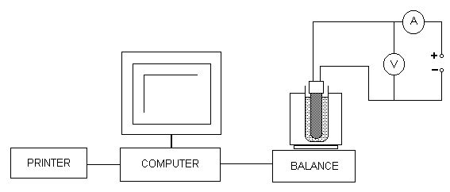

Theory

Assuming that the transfer of energy is 100% efficient :

Electrical energy = energy gained by the water vaporising

VIt = m_{water} l_{water}

So: specific latent heat of vaporisation of water, l_{water} = VIt
m_{water}

The graph from the computer printout will give you the rate of mass loss with time, i.e. m_{water} / t. Hence

l_{water} = VI
gradient

Method

Set up the apparatus as indicated. Using a beaker place sufficient water in the tube to cover most of the heater. Turn on the heater. Once the water is boiling, you may need to turn down the heater settings to avoid it boiling too vigorously. Record the ammeter and voltmeter readings once the water is boiling steadily.

Run the data logging program, ScienceScope – Datadisc Pt. from the start button. You should select Record from the Measure drop down menu. You want to take a regular recording and should set a duration of a few minutes.

Make sure that the water is boiling before you begin taking readings, and tare the balance (this avoids having to adjust the axes after you have taken your readings).

Do not jog the apparatus. If the water boils too vigorously and spits out, the readings will jump. When you are satisfied with your results you should keep this data. You can then use Fit on the Data menu to calculate a ‘best-fit’ line and equation for your data.

Repeat this several times.

Analysis

You should print an example graph from the data logging program to include in your report. There is no need to print out the table view for this experiment – this will lead to great wastage of paper and printer credit!

By using the software to produce a straight line fit, you should be able to obtain values for the gradients of your graphs of mass against time. Write these values down and make sure you know what the units are.

Calculate the latent heat of vaporisation for each of your runs. The values obtained should be averaged and then compared with the standard value – look in a data book.

Calculate the percentage error in the value you obtain. Evaluate the percentage uncertainties in your measurements and discuss which is the most significant contributor to the percentage error.

