**Blended Learning Practice Question Pack**

**Q1.**

This question is about the determination of the resistivity of a wire.

**Figure 1** shows a micrometer screw gauge that is used to measure the diameter of the wire.

**Figure 1**

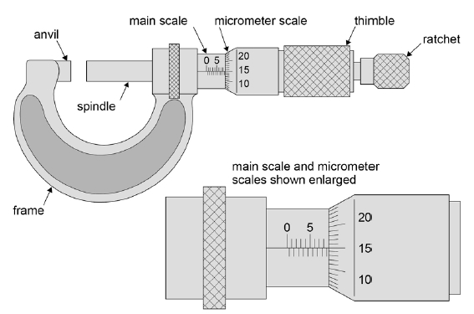

(a)     State the resolution of the **main scale** on the micrometer in **Figure 1**.

resolution = __________________mm

**(1)**

(b)     Determine the distance between the anvil and the spindle of the micrometer in **Figure 1**. State any assumption you make.

distance = ___________________mm

**(2)**

(c)     A student must also determine the length *L* of the wire between clips P and Q that will be connected into a circuit.

**Figure 2** shows the metre ruler being used to measure *L*.

**Figure 2**

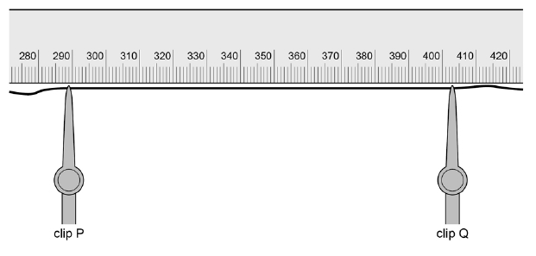

Determine *L*

*L* = ________________________ mm

**(1)**

(d)     Calculate the percentage uncertainty in your result for *L*.

percentage uncertainty = ___________________ %

**(2)**

(e)     State and explain what the student could have done to reduce uncertainty in the reading for *L*.

___________________________________________________________________

___________________________________________________________________

___________________________________________________________________

**(1)**

(f)     The student intends to make measurements that will allow her to determine the resistance of one metre of the wire. She uses an ohm-meter to measure the resistance *R* for different lengths *L* of the wire. The student’s measurements are shown in the table below.

|  |  |  |  |
| --- | --- | --- | --- |
|  | ***L/cm*** | ***R*/Ω** |  |
| 81.6 | 8.10 |  |
| 72.2 | 7.19 |  |
| 63.7 | 6.31 |  |
| 58.7 | 5.85 |  |
| 44.1 | 4.70 |  |

Determine the value that the student should record for the resistance per metre of the wire.

Use the additional column in the table above to show how you arrived at your answer.

resistance of one metre of wire = ________________ Ω

**(2)**

(g)     Determine the resistivity of the wire. Give a suitable unit for your answer.

mean diameter of the wire = 0.376 mm

resistivity = ________________  unit = ____________

**(4)**

**(Total 13 marks)**

**Q2.**

**Figure 1** shows the apparatus used by a student in an experiment to measure the acceleration due to gravity, *g*.

**Figure 1**

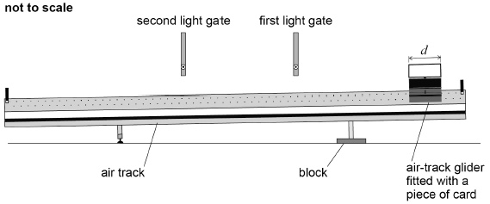

In the experiment:

•        a block is used to raise one end of the air track as shown in **Figure 1**

•        an air-track glider is released from rest near the raised end of the air track and passes through the first light gate and then through the second light gate

•        a piece of card of length *d* fitted to the air-track glider interrupts a light beam as the air-track glider passes through each light gate

•        a data logger records the time taken by the piece of card to pass through each light gate and also the time for the piece of card to travel from one light gate to the other.

(a)     **Table 1** gives measurements made with the light gates as shown in **Figure 1**.

**Table 1**

|  |  |  |
| --- | --- | --- |
| **Time to pass through first light gate / s** | **Time to pass through second light gate / s** | **Time to travel from first to second light gate / s** |
| 0.50 | 0.40 | 1.19 |

The length *d* of the piece of card is 10.0 cm

Assume there is negligible change in velocity while the air-track glider passes through a light gate.

Determine the acceleration *a* of the air-track glider.

*a* = ____________________ m s–2

**(3)**

(b)     Two further sets of readings, **A** and **B**, are taken each with the light gates in different positions along the air track.

Assume the acceleration is the same in each set.

**Table 2** shows these additional sets of results.

**Table 2**

|  |  |  |  |
| --- | --- | --- | --- |
| **Set** | **Time to pass through first light gate / s** | **Time to pass through second light gate / s** | **Time to travel from first to second light gate / s** |
| **A** | 0.61 | 0.42 | 1.77 |
| **B** | 0.55 | 0.37 | 2.11 |

Explain how the data in **Table 2** show that the distance between the light gates in set **B** is greater than in set **A**.

Assume there is negligible change in velocity while the air-track glider passes through a light gate.

___________________________________________________________________

___________________________________________________________________

___________________________________________________________________

___________________________________________________________________

___________________________________________________________________

**(2)**

(c)     Additional values for the acceleration of the air-track glider are obtained by further raising the end of the air track by using a stack consisting of identical blocks.

Adding each block to the stack raises the end of the air track by the same distance.

**Figure 2** is a graph of these results showing how *a* varies with *n*, the number of blocks in the stack.

**Figure 2**

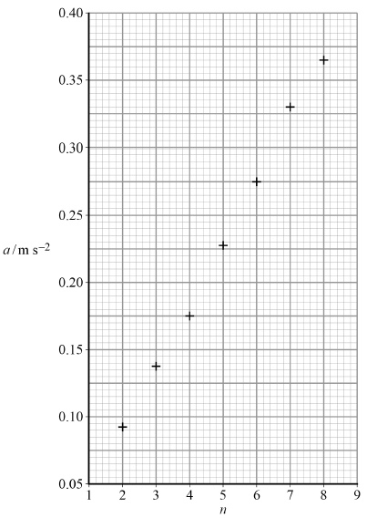

Draw a suitable best-fit straight line on **Figure 2** and determine *G*, the gradient of your line.

*G* = ____________________

**(2)**

(d)     It can be shown that, for the apparatus used by the student, *g* is equal to   where *h* is the thickness of each block used in the experiment.

The student obtains a value for *g* of 9.8 m s–2

Calculate *h*.

*h* = ____________________ m

**(1)**

(e)     Explain how you could find out, without drawing another graph, whether the data presented in the graph in **Figure 2** support the suggestion that *a* is directly proportional to *n*.

___________________________________________________________________

___________________________________________________________________

___________________________________________________________________

___________________________________________________________________

___________________________________________________________________

**(1)**

**(Total 9 marks)**

**Q3.**

A temperature sensor is connected to a data logger to monitor how the temperature *θ* of a fixed mass of recently−boiled water varies with time *t*, over an interval of 600 s. These data are processed to produce the graph shown in **Figure 1**.

**Figure 1**

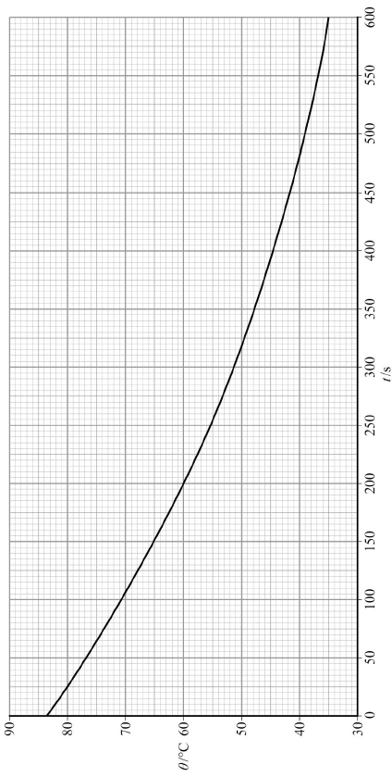

(a)     Determine the temperature *θ*1 of the water when *t* is 190 s.*θ*1 = ___________________ °C

**(1)**

(b)     Determine the gradient *G*1 of the graph at *t* is 190 s. *G*1 ______________________

**(3)**

(c)     When *t* = 370 s the temperature *θ*2 = 46.6 °C and the gradient *G*2 = − 0.0645.

The room temperature *θ*R is given by 

Evaluate *θ*R.

*θ*R = ___________________ °C

**(1)**

(d)     It can be shown that when a hot object at a temperature *θ* is allowed to cool in a draught, the rate at which the temperature decreases is directly proportional to the temperature difference (*θ* − *θ*R) between the object and the surroundings.

A student realises that (*θ* − *θ*R) will decrease exponentially with time and designs an experiment in which two temperature sensors are connected to a data logger.

•        Sensor 1 is placed in a beaker of recently−boiled water.

•        Sensor 2 measures the air temperature in the room.

•        The data logger is programmed to record the output from the sensors as the water cools for 600 s.

The output data from the sensors are processed to produce the graph shown in **Figure 2**.

**Figure 2**

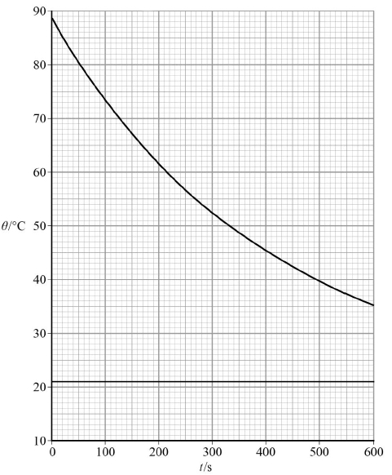

(*θ* − *θ*R) will decrease exponentially in the same way that the potential difference (pd) across a discharging capacitor decreases with time.

When a capacitor discharges, the pd across the capacitor falls to  of an initial value in a time called the **time constant**. Electronic engineers assume that a capacitor becomes fully discharged in a time equal to **5 time constants**.

Estimate the time taken for the water to cool down to room temperature.

time taken = ___________________ s

**(4)**

(e)     Another student carries out the experiment using the same mass of recently−boiled water and beaker as before.

The output data for sensor 1 from this student’s experiment are shown in **Figure 3**.

**Figure 3**

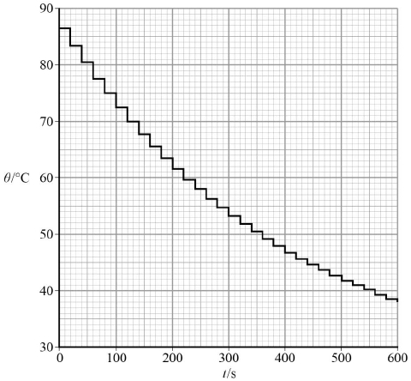

Account for the differences between these results and the way they are displayed, with those shown in **Figure 2**.

You should include appropriate quantitative detail in your answer.

___________________________________________________________________

___________________________________________________________________

___________________________________________________________________

___________________________________________________________________

___________________________________________________________________

___________________________________________________________________

___________________________________________________________________

___________________________________________________________________

___________________________________________________________________

___________________________________________________________________

___________________________________________________________________

___________________________________________________________________

___________________________________________________________________

___________________________________________________________________

___________________________________________________________________

**(5)**

**(Total 14 marks)**

**Q4.**

A lens has a flat surface and a curved surface. An experiment is carried out to determine the radius *R* of the curved surface of the lens. The lens is placed on a rectangular glass block with its flat surface upwards. The lens is illuminated with monochromatic light reflected from a glass plate as shown in **Figure 1**.

**Figure 1**

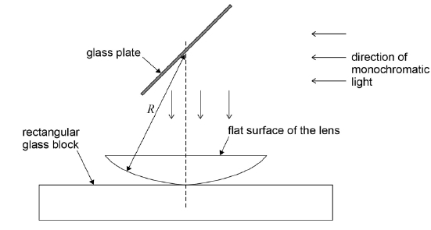

When the apparatus is viewed from above an interference pattern consisting of concentric dark and bright rings is seen. A travelling microscope positioned as shown in **Figure 2** is used to measure the diameter of the **bright** rings.

**Figure 2**

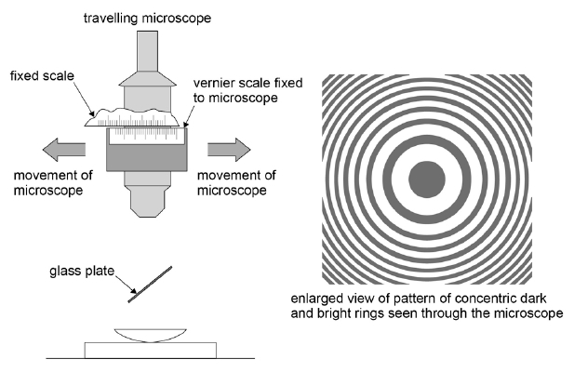

(a)     A student chose a particular bright ring (not at the centre of the pattern) and measured its diameter. He called this ring number 0. Counting outwards from the centre, he measured the diameter of every tenth ring.

Below is a graph of ring number *b* against ring diameter *d*.

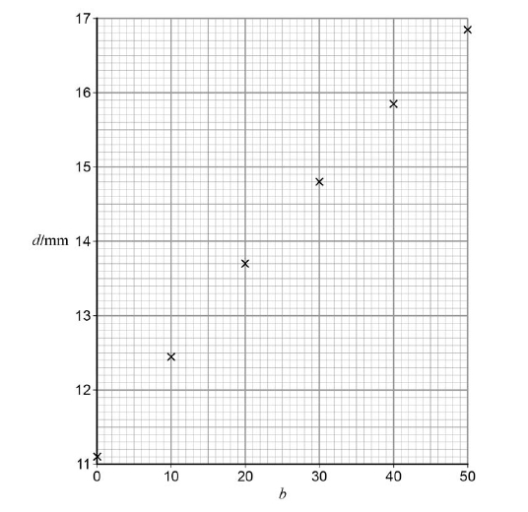

Draw a line of best fit on the graph above.

**(1)**

(b)     Determine the gradient *G* corresponding to *b* = 25.

*G* = ______________________

**(3)**

(c)     The radius of curvature *R* of the lens can be calculated using any point on the graph together with the formula

*R* = 

where *λ* = 589.3 nm.

Determine *R*.

*R* = _____________________ m

**(3)**

**(Total 7 marks)**

**Q5.**

This question is about an experiment with a linear air track.

A block is used to raise one end of the track.

A bumper fitted with a rubber cord is attached at the lower end of the track.

The air track has a length of 2 m and there is a scale with major divisions marked in centimetres along the side; the zero of the scale is at the lower end, as shown in **Figure 1**.

**Figure 1**

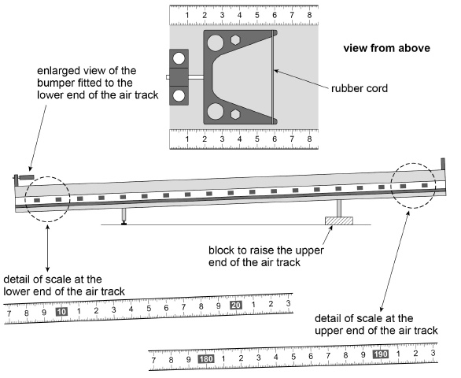

A glider is placed in contact with the rubber cord on the bumper at the lower end of the track. The position of the glider relative to the fixed scale can be determined using **Figure 2**.

**Figure 2**

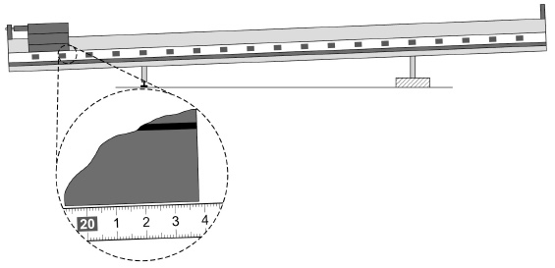

The glider is then moved to the position shown in **Figure 3**.

**Figure 3**

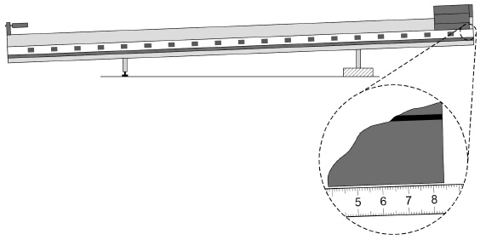

The air supply to the track is turned on and the glider is released.

The glider accelerates down the track, strikes the rubber cord on the bumper and rebounds back up the track.

The glider is allowed to bounce off the rubber band 20 times before it is stopped.

A student reads and records the highest position *p* of the glider after each rebound *n*.

Some of the student’s data are shown in the table.

Additional columns have been provided to allow you to complete question (b) and question (c).

|  |  |  |  |
| --- | --- | --- | --- |
| ***n*** | ***p***/**cm** | ***x***/**cm** | **In**(***x***/**cm**) |
| 0 |  |  |  |
| 2 | 157.0 |  |  |
| 4 | 125.4 |  |  |
| 6 | 101.3 |  |  |
| 9 | 75.4 |  |  |
| 13 | 53.8 |  |  |

(a)     The value of *p* corresponding to *n* = 0 is the glider’s initial position at the top of the track.

Deduce this value of *p* using **Figure 1** and **Figure 3**.

Write this result in the table.

**(1)**

(b)     As it travels from the lower end of the track to each position *p* the glider moves through a distance *x*.

Deduce *x* for **all** the values of *n* using **Figure 2**.

Write these results in the table.

**(1)**

(c)     Plot on **Figure 4** a graph of ln(*x*/cm) against *n*.

Record your values of ln(*x*/cm) in the table.

**(3)**

(d)     Explain why the graph you plotted confirms that *x* decreases exponentially with *n*.

___________________________________________________________________

___________________________________________________________________

___________________________________________________________________

___________________________________________________________________

**(1)**

**Figure 4**

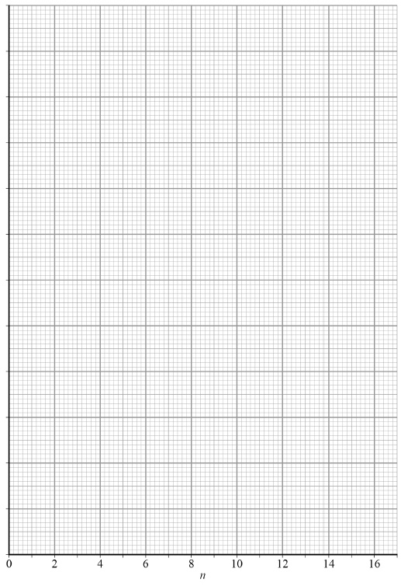

(e)     Determine, using your graph in **Figure 4**, the value of *x* when *n* is 20.

*x* when *n* is 20 = ____________________ cm

**(3)**

(f)      Describe and explain **two** procedures the student should take to reduce uncertainty in the measurements of *p*.

procedure 1 _________________________________________________________

___________________________________________________________________

___________________________________________________________________

___________________________________________________________________

___________________________________________________________________

___________________________________________________________________

___________________________________________________________________

procedure 2 _________________________________________________________

___________________________________________________________________

___________________________________________________________________

___________________________________________________________________

___________________________________________________________________

___________________________________________________________________

___________________________________________________________________

**(4)**

**(Total 13 marks)**

**Q6.**

This question is about an experiment to estimate absolute zero.

**Figures 1a to 1d** show the stages in the procedure carried out by a student.

An empty flask fitted with a tube and an open valve is placed in water bath **H** containing hot water. The air inside the flask is allowed to come into thermal equilibrium with the water.

The valve is then closed, trapping a certain volume of air, as shown in **Figure 1a**.

**Figure 1a**

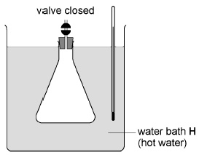

The flask is inverted and placed in water bath **C** in which the water is at room temperature.

The air inside the flask is again allowed to come into thermal equilibrium with the water, as shown in **Figure 1b**.

**Figure 1b**

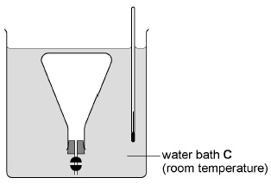

The valve is opened and some water enters the flask, as shown in **Figure 1c**.

**Figure 1c**

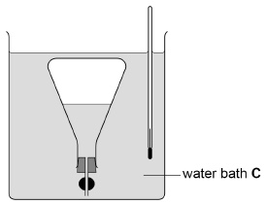

The depth of the inverted flask is adjusted until the level of water inside the flask is the same as the level in the water bath.

The valve is then closed, trapping the air and the water inside the flask, as shown in **Figure 1d**.

**Figure 1d**

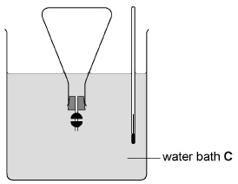

(a)     Explain why the volume of the air in the flask in **Figure 1c** is less than the volume of the air in the flask in **Figure 1d**.

___________________________________________________________________

___________________________________________________________________

___________________________________________________________________

___________________________________________________________________

**(2)**

(b)     Explain why Charles’s Law can be applied to compare the air in the flask in **Figure 1a** with the air in the flask in **Figure 1d**.

___________________________________________________________________

___________________________________________________________________

___________________________________________________________________

___________________________________________________________________

**(2)**

(c)     The flask is removed from water bath **C** and the valve and stopper are removed.

The volume of the water in the flask is *V*1

The flask is then completely refilled with water and the valve and stopper replaced.

The volume of the water now in the flask is *V*2

The volumes *V*1 and *V*2 are shown by the shaded parts in **Figure 2**.

**Figure 2**

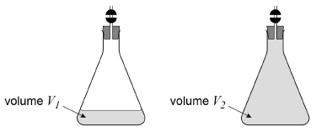

Explain how *V*1 and *V*2 can be determined.

In your answer you should

•        identify a suitable measuring instrument

•        explain a suitable procedure to eliminate possible systematic error.

___________________________________________________________________

___________________________________________________________________

___________________________________________________________________

___________________________________________________________________

___________________________________________________________________

___________________________________________________________________

___________________________________________________________________

**(3)**

(d)     Plot on **Figure 3** points to show the volume *V* and the temperature *θ* of the air in the flask when

•        the flask is as shown in **Figure 1a**

•        the flask is as shown in **Figure 1d**.

The temperature of the hot water bath is 86 °C

Room temperature is 19 °C

*V*1 = 48 cm3

*V*2 = 255 cm3

**Figure 3**

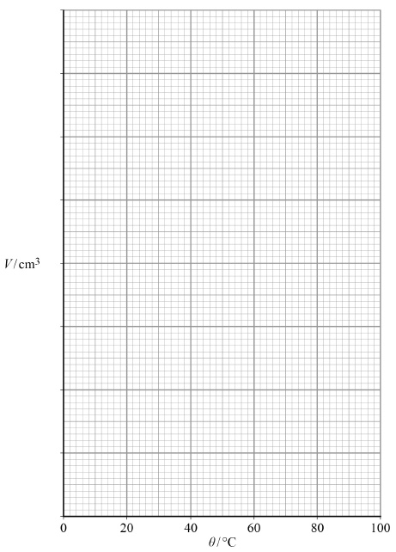

**(3)**

(e)     Add a best fit line to your graph in **Figure 3** to show how *V* should vary with *θ* according to Charles’s Law.

**(1)**

(f)      Determine the value of absolute zero in °C using your graph in **Figure 3**.

value of absolute zero = ____________________ °C

**(3)**

**(Total 14 marks)**

**Q7.**

This question is about an experiment to measure the wavelength of microwaves.

A microwave transmitter **T** and a receiver **R** are arranged on a line marked on the bench.

A metal sheet **M** is placed on the marked line perpendicular to the bench surface.

**Figure 1** shows side and plan views of the arrangement.

The circuit connected to **T** and the ammeter connected to **R** are only shown in the plan view.

**Figure 1**

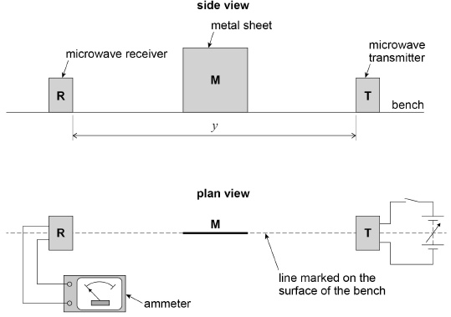

The distance *y* between **T** and **R** is recorded.

**T** is switched on and the output from **T** is adjusted so a reading is produced on the ammeter as shown in **Figure 2**.

**Figure 2**

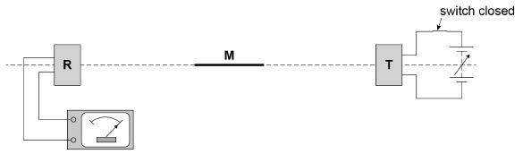

**M** is kept parallel to the marked line and moved slowly away as shown in **Figure 3**.

**Figure 3**

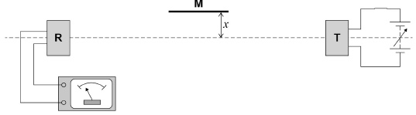

The reading decreases to a minimum reading **which is not zero**.

The perpendicular distance *x* between the marked line and **M** is recorded.

(a)     The ammeter reading depends on the superposition of waves travelling directly to **R** and other waves that reach **R** after reflection from **M**.

State the phase difference between the sets of waves superposing at **R** when the ammeter reading is a **minimum**.

Give a suitable unit with your answer.

___________________________________________________________________

**(1)**

(b)     Explain why the minimum reading is **not** zero when the distance x is measured.

___________________________________________________________________

___________________________________________________________________

___________________________________________________________________

**(1)**

(c)     When **M** is moved further away the reading increases to a maximum then decreases to a minimum.

At the first minimum position, a student labels the minimum *n* = 1 and records the value of *x*.

The next minimum position is labelled *n* = 2 and the new value of *x* is recorded.

Several positions of maxima and minima are produced.

Describe a procedure that the student could use to make sure that **M** is parallel to the marked line before measuring each value of *x*.

You may wish to include a sketch with your answer.

___________________________________________________________________

___________________________________________________________________

___________________________________________________________________

___________________________________________________________________

___________________________________________________________________

___________________________________________________________________

___________________________________________________________________

___________________________________________________________________

**(2)**

(d)     It can be shown that



where *λ* is the wavelength of the microwaves and *y* is the distance defined in **Figure 1**.

The student plots the graph shown in **Figure 4**.

The student estimates the uncertainty in each value of  to be 0.025 m and adds error bars to the graph.

Determine

•        the maximum gradient *G*max of a line that passes through all the error bars

•        the minimum gradient *G*min of a line that passes through all the error bars.

*G*max = ____________________

*G*min = ____________________

**(3)**

(e)     Determine *λ* using your results for *G*max and *G*min.

*λ* = ____________________ m

**(2)**

**Figure 4**

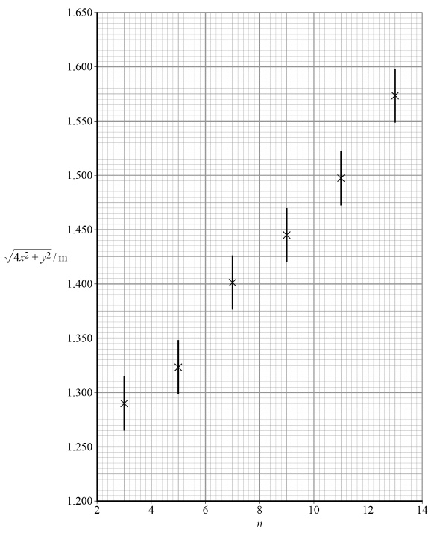

(f)     Determine the percentage uncertainty in your result for *λ*.

percentage uncertainty in *λ* = ____________________ %

**(3)**

(g)     Explain how the graph in **Figure 4** can be used to obtain the value of *y*.

You are **not** required to determine *y*.

___________________________________________________________________

___________________________________________________________________

___________________________________________________________________

___________________________________________________________________

___________________________________________________________________

___________________________________________________________________

___________________________________________________________________

___________________________________________________________________

___________________________________________________________________

**(2)**

(h)     Suppose that the data for *n* = 13 had not been plotted on **Figure 4**.

Add a tick (✔) in each row of the table to identify the effect, if any, on the results you would obtain for *G*max, *G*min, *λ* and *y*.

|  |  |  |  |
| --- | --- | --- | --- |
| **Result** | **Reduced** | **Not affected** | **increased** |
| *G*max |  |  |  |
| *G*min |  |  |  |
| *λ* |  |  |  |
| *y* |  |  |  |

**(4)**

**(Total 18 marks)**

**Q8.**

Identical ring magnets **A** and **B** are arranged on a cylindrical wooden rod. The magnets’ magnetic poles are on their largest faces. When placed with like poles in opposition, the magnets repel one another as shown in **Figure 1**.

The plan and sectional views in **Figure 1** identify the dimensions of these magnets.

Each magnet has a circular cross-section and the central hole is circular.

**Figure 1**

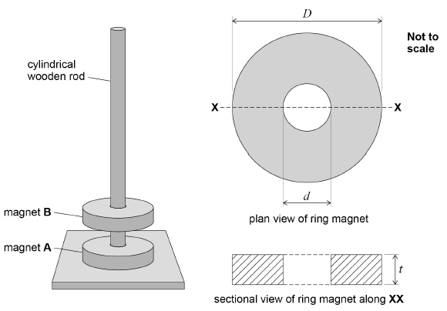

(a)     A student uses digital vernier calipers to find the external diameter *D* of magnet **B**, as shown in **Figure 2**.

**Figure 2**

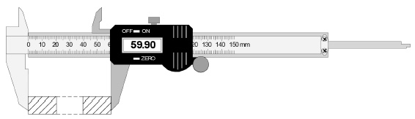

State precautions the student should take to reduce the effect of systematic and random errors when making this measurement.

Precaution to reduce effect of systematic error:

___________________________________________________________________

___________________________________________________________________

___________________________________________________________________

Precaution to reduce effect of random error:

___________________________________________________________________

___________________________________________________________________

___________________________________________________________________

**(2)**

(b)     **Figure 3** shows the reading on the calipers as the internal diameter *d* is measured.

Draw the sectional view of magnet **B** on **Figure 3** to indicate how *d* is measured.

**Figure 3**

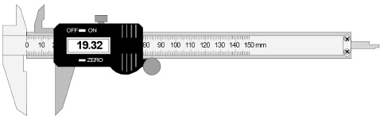

**(1)**

(c)     **Figure 4** shows the reading on the calipers when the thickness *t* of magnet **B** is measured.

**Figure 4**

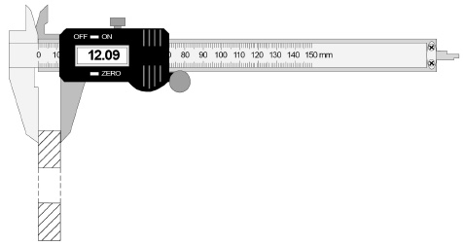

The readings that correspond to the dimensions of magnet **B** are shown in **Figures 2**, **3** and **4**.

Calculate the volume of magnet **B**.

volume = ____________________ m3

**(3)**

(d)     The student measures the mass *m*B of magnet **B** and then positions the magnet so it is in equilibrium above magnet **A** as shown in **Figure 5**.

The student measures the distance *h*.

**Figure 5**

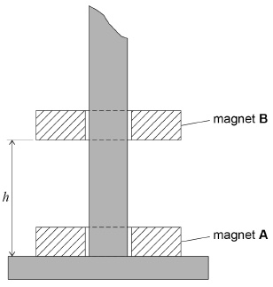

The student adds modelling clay to magnet **B** to reduce *h* by 50%

She measures the mass *m*C of this clay.

She concludes that the force *F* exerted on magnet **B** by magnet **A** is given by  where *k* is a constant.

Describe an experiment to test the student’s conclusion that 

Your answer should include:

•        the procedure that could be used

•        how the data produced could be analysed by a graphical method

•        how the value of the constant *k* could be determined.

___________________________________________________________________

___________________________________________________________________

___________________________________________________________________

___________________________________________________________________

___________________________________________________________________

___________________________________________________________________

___________________________________________________________________

___________________________________________________________________

___________________________________________________________________

___________________________________________________________________

___________________________________________________________________

___________________________________________________________________

___________________________________________________________________

___________________________________________________________________

___________________________________________________________________

___________________________________________________________________

___________________________________________________________________

**(5)**

**(Total 11 marks)**

**Q9.**

This question is about an experiment with a retractable steel tape measure.

The tape measure is placed at the edge of the bench and about 1 m of the steel tape is extended so that it overhangs the bench.

The tape is then locked in this position to stop it from retracting.

A student measures the dimensions *x* and *y*, the horizontal and vertical displacements of the free end of the tape, as shown in **Figure 1**.

**Figure 1**

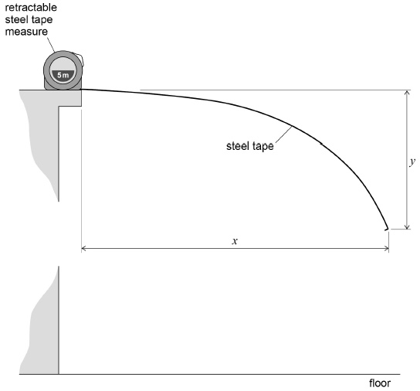

(a)     Describe a suitable procedure the student could use to measure *y*.

You may add detail to **Figure 1** to illustrate your answer.

___________________________________________________________________

___________________________________________________________________

___________________________________________________________________

___________________________________________________________________

___________________________________________________________________

___________________________________________________________________

**(2)**

(b)     By changing the extension of the tape, the student obtains further values of *x* and *y*.

These data are shown in the table.

|  |  |
| --- | --- |
| ***x* / cm** | ***y* / cm** |
| 132.4 | 61.2 |
| 116.8 | 33.7 |
| 105.1 | 24.3 |
| 94.5 | 15.6 |
| 84.3 | 11.0 |
| 73.2 | 5.7 |

Suggest why the student chose to make **all** measurements of *x* greater than 70 cm

___________________________________________________________________

___________________________________________________________________

___________________________________________________________________

___________________________________________________________________

**(1)**

(c)     The data from the experiment suggest that *y = Axn* where *n* is an integer and *A* is a constant.

These data are used to plot the graph in **Figure 2**.

Determine *n* using **Figure 2**.

*n* = ____________________

**Figure 2**

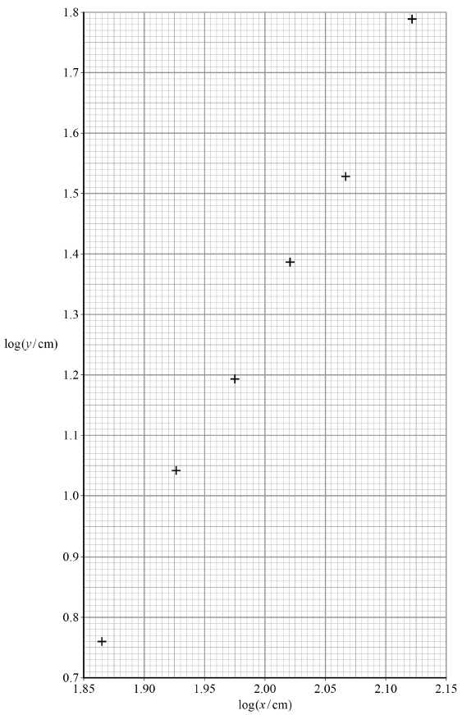

**(3)**

(d)     Explain how the numerical value of *A* can be obtained from **Figure 2**.

___________________________________________________________________

___________________________________________________________________

___________________________________________________________________

___________________________________________________________________

___________________________________________________________________

___________________________________________________________________

___________________________________________________________________

___________________________________________________________________

**(3)**

(e)     Estimate the order of magnitude of *A*.

You should use data for *x* and *y* from any **one** row in the table above.

Give your answer with an appropriate unit.

order of magnitude of *A* = ____________________ unit ___________

**(3)**

**(Total 12 marks)**

**Q10.**

This question is about using a digital balance to investigate the force on a wire placed in a magnetic field when there is an electric current in the wire.

A student carries out the procedure shown in **Figure 1** and **Figure 2**.

A metre ruler is pivoted at the 1.0 cm mark and a prism is placed on a digital balance. The free end of the ruler is raised and the balance is turned on and then set to zero, as shown in **Figure 1**.

**Figure 1**

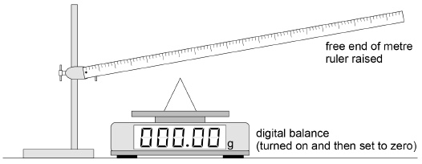

The ruler is then supported by the prism with the apex of the prism at the 30.0 cm mark as shown in **Figure 2**. The height of the pivot is adjusted so that the ruler is horizontal.

**Figure 2**

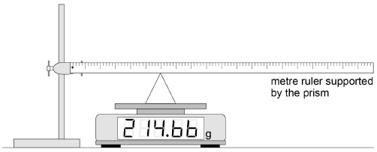

(a)     Deduce the mass of the ruler.

State **one** assumption you make.

mass of ruler = ____________________ g

assumption _________________________________________________________

___________________________________________________________________

**(3)**

(b)     The student attaches a uniform wire to the upper edge of the ruler, as shown in **Figure 3**.

The ends of the wire are connected to terminal blocks **P** and **Q** which are fixed firmly to the bench. A power supply and an ammeter are connected between **P** and **Q**.

These modifications cause the balance reading to increase slightly.

A horizontal uniform magnetic field is applied, perpendicular to the wire, between the 85 cm and 90 cm marks, as shown in the close-up diagram in **Figure 3**.

**Figure 3**

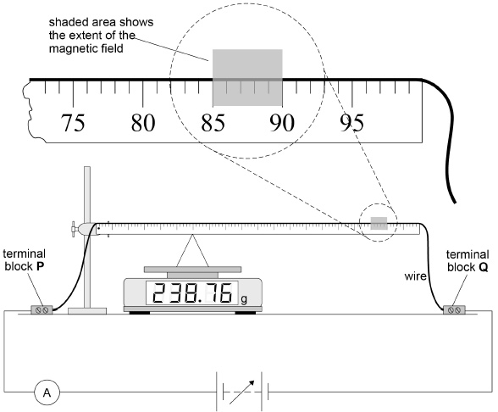

The balance reading *M* is recorded for increasing values of current *I*.

A graph of these data is shown in **Figure 4**.

**Figure 4**

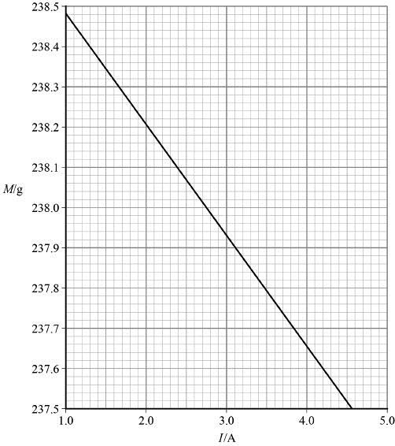

State and explain the direction of the horizontal uniform magnetic field.

___________________________________________________________________

___________________________________________________________________

___________________________________________________________________

___________________________________________________________________

___________________________________________________________________

___________________________________________________________________

___________________________________________________________________

**(3)**

(c)     It can be shown that *B*, the magnitude of the magnetic flux density of the horizontal uniform magnetic field, is given by



where

*σ* = change in force acting on the prism per unit current in the wire

*L* = length of the region where the magnetic field cuts through the wire.

Determine *B*.

*B* = ____________________ T

**(3)**

(d)     The experiment is repeated with the ruler pivoted at the 99.0 cm mark.

Nothing else is changed from **Figure 3**.

This arrangement is shown in **Figure 5**.

**Figure 5**

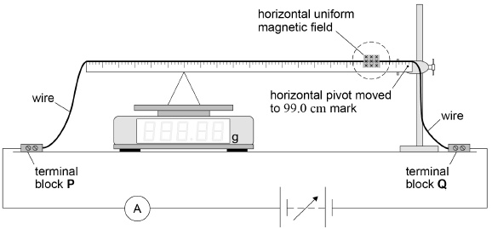

Tick (✔) **one** box in row 1 and **one** box in row 2 of the table to identify the effect, if any, on the magnitude of the forces acting on the apparatus as a certain current is passed through the wire.

Tick (✔) **one** box in row 3 and **one** box in row 4 of the table to identify the effect, if any, on the graph produced for this modified experiment compared with the graph in **Figure 4**.

|  |  |  |  |  |
| --- | --- | --- | --- | --- |
|  |  | **Reduced** | **No effect** | **Increased** |
| 1 | Force acting on the current-carrying wire due to the horizontal uniform magnetic field |  |  |  |
| 2 | Force acting on the prism due to the pivoted ruler |  |  |  |
| 3 | Gradient of the graph |  |  |  |
| 4 | Vertical intercept of the graph |  |  |  |

**(3)**

(e)     **Figure 6** shows the balance being used to measure the forces between two wires.

The connections joining these wires to the power supply are not shown.

The pan of the balance moves a negligible amount during use and it supports a straight conducting wire **X** of horizontal length *L*.

Terminal blocks are used to connect **X** into the circuit. The weight of these does not affect the balance reading.

A second conducting wire **Y** is firmly supported a distance *d* above **X**.

Show, by adding detail to **Figure 6**, the wire connections that complete the circuit.

The currents in **X** and **Y** must have the same magnitude and be in the directions indicated.

**Figure 6**

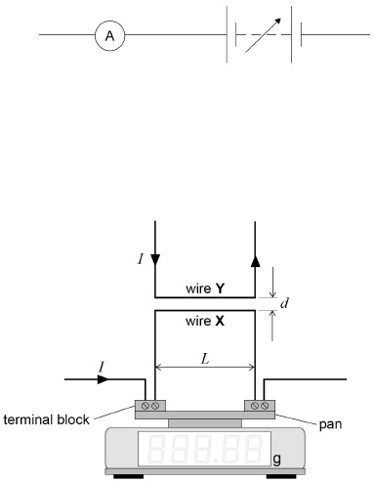

**(2)**

(f)      The vertical force *F* on wire **X** due to the magnetic field produced by wire **Y** is given by



where

*k* is a constant

*d* is the perpendicular distance between **X** and **Y**

*I* is the current in the wires

and

*L* is the horizontal length of wire **X**.

A student wants to measure *k* using the arrangement in **Figure 6**.

The student is told that the following restrictions must apply:

•        *L* is fixed

•        *I* must not exceed 5.0 A

•        the result for *k* must be obtained using a **graphical method**

•        the experimental procedure must involve **only one** independent variable.

Explain what the student could do to find *k*.

___________________________________________________________________

___________________________________________________________________

___________________________________________________________________

___________________________________________________________________

___________________________________________________________________

___________________________________________________________________

___________________________________________________________________

___________________________________________________________________

___________________________________________________________________

___________________________________________________________________

___________________________________________________________________

**(5)**

**(Total 19 marks)**

Mark schemes

**Q1.**

(a)     0.5 mm [0.05 cm, 0.0005 m] ✔

*only acceptable answers*

**1**

(b)     8.65 mm [0.865 cm, 0.00865 m] 1✔

the micrometer reads zero when the jaws are closed 2✔

*only 3sf answers are acceptable for 1✔*

*accept no zero error for 2✔*

**2**

(c)     L = (403 − 289 = ) 114 mm ✔

**1**

(d)     absolute uncertainty = 1 mm 1✔

percentage uncertainty =  × 100 = 0.88%2✔

*accept 2 mm for ab. uncertainty 1✔*

*allow ecf for wrong L and / or wrong ΔL*

*accept 1.75%*

**2**

(e)     should move wire directly over / closer to scale on the ruler to avoid parallax error ✔

*both statement and explanation required for this mark*

**1**

(f)     five values of *R*/*L* correct, recorded to 3 sf [last row to 3sf or 4sf]; accept values in Ω cm−1 ✔

mean based on first four rows only; result 9.94 Ω m−1 [9.94 × 10−2 Ω cm−1] ✔

|  |  |  |
| --- | --- | --- |
| *L/cm* | *R/Ω* | *(R/L)Ωm−1* |
| *81.6* | *8.10* | *9.93* |
| *72.2* | *7.19* | *9.96* |
| *63.7* | *6.31* | *9.91* |
| *58.7* | *5.85* | *9.97* |
| *44.1* | *4.70* | *10.66 (10.7)* |

**2**

(g)     cross-sectional area =  1✔

resistivity from  × *A*, correct substitution of result from 01.6 2✔

1.10 × 10−63 ✔

Ω m 4✔

*resistivity from  ×  earns 12✔✔*

*allow 2✔ if  value is not based on mean or on a mean from all five rows of table in 01.6*

*condone 1.12 × 10−6 for 3✔ if fifth row in 01.6 was not rejected*

*withhold 3✔ for POT error*

**4**

**[13]**

**Q2.**

(a)     (*u* = )0.2(0) or 20 or 200 **and** (*v* =)0.25 or 25 or 250 1✔;

***Both*** *velocities seen / allow seen in  / condone (possible) powers of ten (POT) error for 1st mark and 2nd mark in their v and u and any substitution v and u into *

*Where t3 has been substituted must be t3 = 1.19 (s)*

substitution of their *u* and *v* in   ✔

Where *t*3 has been substituted must be *t*3 = 1.19 (s)

*Values for:*

*u (0.20 (m s–1) or 20 (cm s–1)200 (mm s–1) ) and*

*v (0.25 (m s–1) or 25 (cm s–1) or 250 (mm s–1))*

*Correctly combined with t3 (1.19) will earn 1st and 2nd marks*

*Where u and v are not correct, they must be identifiable as their u and v ( 2nd mark is only mark available except where error is POT)*

*Allow their  (= a) where clear it is their ∆v*

*a* = 4.2 × 10–2 (m s–2) 3✔

*Correct result for a will earn three marks;*

*Accept 420 mm s–2 or 42 cm s–2 if m s–2 has been replaced on the answer line*

*2 sf answer only*

**3**

(b)     (set **B** because) it has a greater time / takes longer (to travel between gates) (hence distance between gates is larger) 1✔

(and ) set **B**’s average velocity is greater / set **B**’s velocity at gate 1 is greater / Set **B**’s velocity is greater at both gates

*Two calculations for gate separation s using either*

OR

(and ) set **A**’s average velocity is smaller / set **A**’s velocity at gate 1 is smaller/ Set **A**’s velocity is smaller at both gates 2✔

Alternative Method

values of *u* and *v* are calculated (condone POT error) and corresponding values for each *s* determined; 1✔

a comparison of ***their*** distances leading to conclusion that set **B** produced when *s* is largest

OR

ratio  is proportional to distance s and **B**’s ratio is greater 2✔

***OR*** *****OR*** **

|  |  |  |  |  |
| --- | --- | --- | --- | --- |
|  | *u*/ms–1 | *v*/ms–1 | *s*/m | *v*2 − *u*2/ *m*2*s*–2 |
| Set A | 0.164 | 0.238 | 0.356 | 0.0297 |
| Set B | 0.181 | 0.270 | 0.476 | 0.0401 |

|  |  |
| --- | --- |
|  |  |
| Set A | 7.12 |
| Set B | 9.54 |

*Allow ecf for acceleration where used to find s*

*Using a = 0.042: sA = 0.354 and sB = 0.478*

*Treat a larger change in velocity as neutral*

**2**

(c)     Continuous, ruled straight best fit line through 1st and last points 1✔

*n=4 point below and n=7 above, other points cut by line of best fit*

*Line must not be thicker than half a square grid*

*Line must have no variation in thickness*

*Do not accept more than one line drawn, do not accept discontinuities*

Gradient from  **seen**

**and**

*G* = 0.045 range (0.042 to 0.053) 2✔

*Steps at least half the height and half the width of the grid; (at least 3 squares horizontally and at least 5 squares vertically)*

*Allow  where points are on line and are at least half drawn line apart (∆𝑥 ≥ 3 and ∆y ≥ 0.175)*

*Ignore any units given for G*

*Allow 1 sf answers of 0.04 or 0.05 where correct working is shown*

**2**

(d)      ✔

(*h* = 9.2 × 10–3 m)

*Ecf from part* ***(c)***

***Expect 2 sf normally****. Penalise 3 or more sf*

*Condone 1 sf answers where correct working is shown in part* ***(d) and*** *where their G is quoted to 1sf*

*In this case, allow use of their rounded G or full carry value*

**1**

(e)     idea that the intercept can be found by calculating *a* – *Gn* where *a* and *n* are values read-off (from a point on the line) and *G* is the gradient ; intercept compared to 0, 0 (OWTTE in a general y=mx +c description)

*Simply explaining how to find the intercept does not fully answer the question and gets no credit must describe the comparison aspect; do not accept idea of extrapolation off the grid or re-plotting on axes that include (0, 0)*

OR

Read-off points (of line of best fit for) x1 and x2 compare with corresponding y1 and y2 , compares the ratio of the x terms to the ratio of the y terms; if equal then directly proportional

OR

Determine the constant of proportionality for at least two points (on line of best fit) and compare, where constant exists then directly proportional ✔

*Idea that a and n will share a common factorial increase*

**1**

**[9]**

**Q3.**

(a)     *θ*1 = 61.0 ± 0.5 °C ✔

*reject 2 sf θ1*

**1**

(b)     sensible tangent drawn at *t* = 190 s; correct read-offs for points (± 1 mm) from triangle with step sizes at least 8 × 81 ✔

G1 = −9.57 × 10−2 3✔

*for 3✔ insist on correct sign and POT; accept result in range 1.05 × 10−1 to −9.0 × 10−2*

**3**

(c)     substitution correct leading to *θ*R = 17.3 ± 2.0 °C ✔

*allow ECF*

**1**

(d)     *θ*0 − *θ*R correctly evaluated to ± 1 °C for *θ*0 at suitable reference time 1 ✔

evaluates  2✔

evaluates *θ* from  + *θ*0 ; time constant deduced from graph with evidence of working (read offs to both axes are required) 3✔

time for object to reach room temperature in range 1900 to 2000 s 4✔

*example for 1✔: θ0 = 89 °C at t = 0 gives θ0 −θR = 89 − 21 = 68 °C*

*allow ecf for failure to take account of θR in 1 ✔*

*example for 2✔:  ; allow ecf for failure to take account of θR in 1✔*

*example for 3✔ : θ = 25 + 21 = 46; time constant = 390 s*

*example for 4✔ : time to reach room temperature = 5 × 390 = 1950 s; no ecf for errors in 1✔ or in 3✔*

**4**

(e)     the starting temperature was lower 1✔

the starting temperature was 86.5 °C compared to 89.0 °C 2✔

the room temperature was higher 3✔

the draught was less 4✔

the water had only cooled to 38.0 °C after 600 s 5✔

the sample rate of the data logger was lower 6✔

samples were recorded every 20 s (rate for original experiment was much higher) 7✔

*other approaches are possible*

*allow ± 0.3 °C for any temperature quoted for 2✔ or for 5✔*

**MAX 5**

**[14]**

**Q4.**

(a)     smooth curve of decreasing positive gradient through all 5 points ✔

*shaky or fuzzy line does not gain mark*

**1**

(b)     sensible tangent drawn at *b* = 25; correct read−offs for points (± 1 mm) from triangle with step sizes at least 8 × 8 1✔

substitution correct 2✔

*G* = 0.11(2) 3✔

*change in d divided by change in b for 3; don’t penalise if change in d is given in m ✔*

*acceptable range if d is in mm 0.109 to 0.116 for d in m adjust accordingly; accept only 0.11 for 2 sf; accept ≥ 3 sf for 3✔*

**3**

(c)     *d* in range 14.25 to 14.30 mm 1✔

substitution correct 2✔

*R* in range 1.34 to 1.38 m 3✔

*accept result for R in mm; no ecf for incorrect or out of range G*

**3**

**[7]**

**Q5.**

(a)     *p*0 = 198.4 (cm) ✔

*only acceptable answer*

**1**

(b)     all *x* values correct and recorded to nearest mm ✔

|  |  |  |
| --- | --- | --- |
| *n* | *p*/cm | *x*/cm |
| 0 | 198.4 | 174.6 |
| 2 | 157.0 | 133.2 |
| 4 | 125.4 | 101.6 |
| 6 | 101.3 | 77.5 |
| 9 | 75.4 | 51.6 |
| 13 | 53.8 | 30.0 |

*allow ecf for x = p – 23.8 if p0 ≠ 198.4*

*penalise 2 sf x = 30 for n = 13*

**1**

(c)     six values of ln(*x*/cm) recorded consistently i.e. all to (minimum) 2 dp; confirm that value of ln(*x*) for *n* = 6 corresponds to tabulated value of *x* 1✔

vertical axis labelled ln(*x*/cm) i.e. bracket required;

suitable vertical scale (points should cover at least half the grid with a frequency of not less than 5 cm) 2✔

points plotted for *n* = 0, 2, 4, 6, 9 and 13;

check *n* = 6 point is plotted within half a grid square of tabulated position;

suitable continuous ruled line of negative gradient from *n* = 0 to (at least) *n* = 13 3✔

*expected data:*

|  |  |  |  |
| --- | --- | --- | --- |
| *n* | *p*/cm | *x*/cm | ln(*x*/cm) |
| 0 | 198.4 | 174.6 | 5.162 |
| 6 | 101.3 | 77.5 | 4.350 |

*for n = 0, x = 0, ignore missing or incorrect ln(x) and ignore missing/wrongly-plotted point*

*for 2✔ vertical axis should be labelled ln(x/cm) (note that bracket is essential); expect vertical scale to start at 3 with major divisions of 0.2*

*for 3✔ a suitable line must pass through all points if these have been correctly calculated;*

*for any errant plotted points the line must be the best line in the opinion of the marker;*

*line must not be thicker than half a grid square and width must not vary;*

*points must not be thicker than half a grid square (reject any dots or blobs)*

**3**

(d)     graph is linear and has negative gradient ✔

*allow ‘straight line’ for ‘linear’; statement must be confirmed by* ***Figure 4***

*allow ‘negative slope’ or ‘slopes downwards’ for ‘negative gradient’*

*no ecf for non-linear graph*

**1**

(e)     gradient triangle for **Figure 4;**

correct read offs (± 1 mm) for all points or for both steps in triangle 1 ✔

expected gradient result is –0.135

for gradient between –0.139 to –0.133 (allow this intermediate answer shown as a fraction)

award two marks for minimum 3 sf *x* when *n* = 20 in range 11.2 to 12.2 (cm) 23 ✔✔

OR

one mark for *x* when *n* = 20 in range 10.8 to 12.7 (cm) 23 ✔

OR (if gradient out of range)

marker uses candidate’s gradient (which must be negative) and (marker must read off) intercept on Figure 4 to calculate *x* when *n* = 20

minimum 3 sf result in range ± 4% 23 ✔✔

OR

1 mark minimum 3 sf result in range ± 8% 23 ✔

(theoretical result for *x* when *n* = 20 is 11.7(3) cm)

*for 1 ✔*

*allow 1 mark for sufficient evidence of working and a valid calculation of the gradient of a linear graph even if graph has a positive gradient*

*for 2 ✔ and 3 ✔*

*give no credit if graph drawn has a positive gradient*

*allow 1 mark for using a positive value for the (negative) gradient in the calculation for x when n = 20 (this leads to 2592 cm); result must be in range ± 4% 23 ✔*

*allow ‘similar triangles’ method;*

*eg  1 ✔*

*ln x20 = 2.46 2 ✔; x20 = 11.7(0) cm 3 ✔*

*allow ecf x when n = 20 based on Figure 4 if scales used enable value to be read directly using an extrapolated line; do not allow such working to extend beyond the grid into the margin 1 ✔; value in range 11.2 to 12.1 cm 23 ✔ = 1 MAX*

**3**

(f)      valid procedure 1

described 1 ✔

explained 2 ✔;

valid procedure 2

described 3 ✔

explained 4 ✔

*explanation mark (2 ✔) is only awarded when it is relevant to a correct procedure (1✔); one procedure/explanation allowed per response*

*no credit for conflicting statements or wrong physics*

*any two from:*

*repeat experiment and average calculated (p) 1✔*

*to reduce (impact of) random [human] error 2✔*

*and/or*

*repeat readings to detect anomalies 1✔*

*so these can be discarded (before averaging) 2✔*

*and/or*

*view air track at right angles [at eye level] 1✔*

*to reduce [eliminate] (impact of) parallax error 2✔*

*and/or*

*repeat experiment with track direction reversed and average calculated (p) 1✔*

*to account for the effect of non-level bench 2✔*

*and/or*

*use video (camera) technology [or a motion sensor linked to a data logger or laser ranger] to view [record] the position of the glider as it reaches the top of the track 1✔*

*to reduce (impact of) random [human] error [to identify and eliminate anomalous results] 2✔*

*reject any suggestion that involves changing the glider, its initial position on the track or the air track itself including the position of the scale*

**4**

**[13]**

**Q6.**

(a)     pressure (of air) in **Figure 1c** is greater than (pressure of air) in **Figure 1d**

**OR**

pressure in **Figure 1d** is lower than pressure in **Figure 1c** 1✔

(since) temperature is the same

**OR**

Boyle’s Law applies

**OR**

*PV* = constant; 2✔

any suggestion that pressure is constant **OR** the volume is constant **OR** the temperature changes **OR** the amount of air in the flask increases as flask is raised loses both marks

*for 1✔ must refer to either of the relevant figures or give other detail, eg ‘when flask is lifted’ so their meaning is unambiguous;*

*allow ‘when volume decreases pressure increases’ but must be comparing* ***1c*** *with* ***1d***

*allow ‘water pressure decreased in* ***1d****’*

*treat ‘air was compressed’ (in* ***1c****) as neutral*

*reject ‘pressure released (in* ***1d****)’*

*for 2✔ allow mean KE of molecules is the same*

*accept   ;*

*allow nRT = constant;*

*reject PV = k (unless k = constant is also seen)*

**2**

(b)     same (air) pressure 1✔

same mass of air 2✔

any suggestion that temperature is constant **OR** that volume is constant **OR** that pressure has changed **OR** the amount of air in the flask decreases as flask is moved from H to C loses both marks

*for 1✔ and 2✔ accept constant/unchanged = same and condone ‘assume same pressure/mass of gas’*

*for 2✔accept same (number of) moles or same amount of gas*

*no credit for stating ‘volume increases as temperature increases’*

*‘temperature is in equilibrium’ is neutral*

**2**

(c)     relevant quantity and instrument seen:

volume(s) (of liquid) measured using a measuring cylinder **OR** graduated beaker 1✔

reject ‘measuring beaker’ and ‘burette’

eye level with the bottom of the meniscus (allow suitable sketch showing eye) 2✔

‘measure at eye level’ **OR** ‘eye level with graduation’ **OR** ‘eye perpendicular to graduation’ are not enough to avoid parallax error 3✔

see alternative opposite; if both approaches are given record the mark to whichever scores most

*alternative*

*for 1✔mass (of liquid/flask) measured using a balance*

*reject ‘scales’ and reject ‘weigh/find weight/weigh the mass’*

*for 2✔valid method to account for the mass of flask eg tare/zero balance (ECF ‘scales’) with (same) empty flask on balance and then measure mass of flask with liquid* ***OR***

*subtract mass of empty flask from mass of flask containing liquid; don’t penalise ‘weigh’ twice* ***OR***

*ensure the balance is on a horizontal surface for 3✔find volume(s) using   ; V must be subject*

**3**

(d)     suitable vertical scale for their data points covering at least half the grid;

false origin on the vertical scale correctly marked;

vertical scale marked at sensible intervals, based around intervals of 1, 2, 4 or 5 etc; graduations no further than 2 major divisions apart 1✔

19, 207 plotted to nearest ½ grid square 2✔

86, 255 plotted to nearest ½ grid square 3✔

*for 1✔ the two correct data points a suitable scale is 10 cm3 for each major division*

*an unmarked origin is be assumed to be (0, 0); if a broken scale symbol is not used and the V scale becomes non-linear, withhold the mark*

*award 23✔ = 1 MAX for thick or poorly-marked points eg thicker than half a grid square;*

*reject blobs, dots and circles*

**3**

(e)     **continuous ruled** best-fit line of positive gradient through intersection of cross-hairs of their points ✔

*apply same criteria for judging line quality as in part (c); don’t penalise thick line if thick points are penalised in part (d)*

**1**

(f)      legitimate method to calculate horizontal intercept

eg gradient calculated from *∆V* divided by *∆θ* ie numerical evidence of 2 steps required; don’t penalise read off errors or small steps

reads (to within 1 grid square) **OR** uses a point on the line to calculate (with correct use of *y = mx + c*) the vertical intercept; sensible values are shown on the right 1✔

correct use of their vertical intercept and their gradient to calculate the horizontal intercept using –1 × vertical intercept divided by gradient 2✔

**OR**

similar triangles, eg

 or similar seen 1✔

minimum *∆θ* = 86 – 19 (= 67as in example above) 2✔

result in range –260°C to –285°C 3✔

withhold mark for missing sign; no credit for unsupported answer

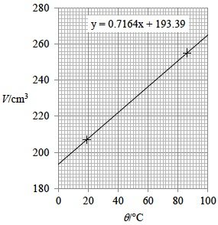

*in 1✔ condone V changed to m3 when calculating gradient and finding intercept values*

*for a graph with a negative gradient allow credit for 1✔ only = 1 MAX*

*no credit for non-linear graph = 0 MAX*

*data which may be seen in working include*

*V = 193 cm3, θ = 0 °C; V = 265 cm3, θ = 100 °C;*

*V = 207 cm3, θ = 19 °C; V = 255 cm3, θ = 86° C*

**3**

**[14]**

**Q7.**

(a)     180 degrees

*accept ° for degrees*

OR

*π* radians ✔

*condone c or ‘rad’ for radian*

*reject ‘half a cycle’*

*treat ‘π radians in phase’ as talk out*

**1**

(b)     (idea that) sets of combining waves do not have the same amplitude ✔

*condone ‘waves do not have same intensity’ or ‘same energy’ or ‘some energy is absorbed on reflection’ or ‘same power’ or ‘same strength’ or idea that non point source or non point receiver would lead to imperfect cancellation*

*condone the idea that the waves may not be monochromatic*

*ignore ‘some waves travel further’ or ‘waves do not perfectly cancel out’*

*reject ‘waves may not be 180° out of phase’*

**1**

(c)     valid use of a set square or protractor against TR (to ensure perpendicular) 1 ✔

measure *x* at two different points [at each end of M] **and** adjust until [make sure] both distances are the same 2 ✔

OR

use of set square to align M with the perpendicular line earns 2 ✔

if method used does not allow continuous variation in *x* then award maximum 1 mark

OR

align graph paper with TR 1 ✔

align M with grid lines on graph paper 2 ✔

*both marks can be earned for suitable sketch showing a viable procedure involving one or more recognisable set squares or protractors; the sketch may also show a recognisable ruler, eg*

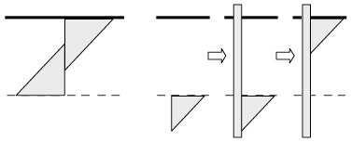

*allow use of scale on set square to measure the perpendicular distances don’t penalise incorrect reference to the set square, eg as ‘triangular ruler’, as long as the sketch shows a recognisable set square*

**2**

(d)     Gmax line ruled through bottom of *n* = 3 error bar and through top of *n* = 11 error bar 1✔

Gmin line ruled through top of *n* = 5 error bar and through bottom of *n* = 13 error bar 2 ✔

Gmax and Gmin calculated from valid *y* step divided by valid *x* step; both *n* steps ≥ 6 3 ✔

*allow 1 mm tolerance when judging intersection of gradient lines with error bars*

*ignore any unit given with Gmax or Gmin; penalise power of ten error in 01.5*

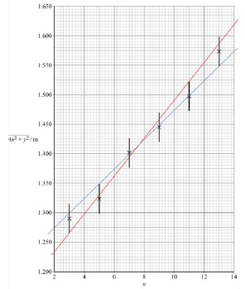

*12 ✔= 1 MAX if (either) line is thicker than half a grid square or of variable width or not continuous;*

*expect Gmax = 3.2(1) × 10–2 and Gmin = 2.5 (2.49) × 10–2*

**3**

(e)     

AND

result in range 2.8(0) to 2.9(0) × 10–2 (m) 1 ✔ 2 ✔

OR

award one mark for

2.7(0) to 3.0(0) × 10–2 (m) 12 ✔

*penalise 1 mark for a power of ten error*

*reject 1 sf 3 × 10–2 (m)*

*if a best fit line is drawn between the Gmax and Gmin lines and the gradient of this is calculated award 1 mark for λ in range 2.8(0) to 3.0(0) × 10–2(m)*

**2**

(f)      uncertainty in *λ* = Gmax – *λ*

OR

*λ* – *G*min

OR

 1 ✔

percentage uncertainty = (uncertainty/*λ*)×100 2 ✔

result in range 11(.0) % to 14(.0) % 3 ✔

*1✔ can be earned by showing a valid uncertainty then dividing by λ*

*ecf their λ, Gmax and Gmin for 1 ✔ and 2 ✔*

*allow λ found from best fit line*

* 12 ✔*

*allow  × 100 where ∆λ is any plausible uncertainty for 2 ✔*

*numerical answer without valid working can only earn 3 ✔*

**3**

(g)     (states) calculate the (vertical) intercept 1 ✔

OR

outlines a valid calculation method to calculate *y* 1 ✔

determine the intercept for both lines and calculate average value 2 ✔

OR

determine the (vertical) intercept of the line of best fit (between Gmax and Gmin) 2 ✔

*draw the line of best fit (between Gmax and Gmin); perform calculation to find intercept earns 12 ✔*

**2**

(h)

|  |  |  |  |
| --- | --- | --- | --- |
| result | reduced | not affected | increased |
| *G*max |  | ✔ |  |
| *G*min | ✔ |  |  |
| *λ* | ✔ |  |  |
| *y* |  |  | ✔ |

***general marker question***

*allow any distinguishing mark as long as only one per row*

*for ✔ and X in same row ignore X*

*for ✔ and ✔ in same row give no mark*

*ignore any crossed-out response*

**4**

alternative approach: single best fit line drawn on **Figure 4**

(d)     *G* calculated from *y* step divided by *x* step;

*n* step ≥ 6 3 ✔

**MAX 1**

(e)     *λ* in range 2.8(0) to 2.9(0) × 10–2 ✔

**MAX 1**

(f)     percentage uncertainty in *λ* =  × 100

AND

result in range 11(.0) % to 14(.0) % ✔

**MAX 1**

(g)     calculate intercept

OR

outlines a valid calculation method to find *y* ✔

**MAX 1**

(h)     as main scheme

*no ecf possible*

**4**

alternative approach: non-crossing lines for Gmax and Gmin on **Figure 4**: includes lines that meet but do not cross

(d)     Gmax and Gmin calculated from *y* step divided by *x* step; both *n* steps ≥ 6 3 ✔

**MAX 1**

(e) to (h)     as main scheme

**1**

**[18]**

**Q8.**

(a)     to reduce the impact of systematic error: tare [zero] the callipers before use

**OR**

take reading with callipers fully closed (at some stage) and subtract from readings 1✔

to reduce the impact of random error: take measurement several times for different diameters/directions and calculate mean

**OR**

take measurement several times for different diameters to check for anomalies 2✔

**2**

(b)     use of inside jaws on callipers required: must have a clear drawing with inside jaws in contact internal diameter1✔

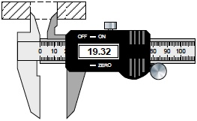

*A* ***sectional*** *view of the magnet must be given*

*Jaws must be inside cavity (as here)*

**1**

(c)     Determines a cross-sectional area: (larger A=) 2.82

× 10–3 or (smaller area =) 2.932 × 10–4

**OR**

states that the cross sectional area from ∆



**OR**

Calculates one volume correctly 1✔

*Allow POT error 1✔ and 2✔*

*Where r is used must have an additional statement on how r relates to D (in the case where there is no correct substitution and no correct answer)*

substitution of *D* = 59.90, *d* = 19.32 and *t* = 12.09 into



**OR**

*V* = their ∆*A* × 12.09

**OR**

Correctly finds difference in ***their*** volumes 2✔

*Or equivalent*

*Correct substitution into*

**

*receives the first two marks (allow POT)*

*Expect values:*

*VD = 3.41 × 10–5 (m3)*

*Vd = 3.54 × 10–6 (m3)*

3.1 × 10–5 / 3.05 × 10–5 / 3.053 × 10–5 (m3) 3✔

*no limit on maximum sf*

*Correct answer scores 3*

*Allow 3rd sf round error where*

*answer rounds to 3.1 × 10–5*

*when correct method seen*

**3**

(d)     ***Procedure:***

**MAX 2**

Take more measurement(s) of *h* for additional / different masses (of clay) ✔

*More than one added mass, allow varies amount of clay*

Convert (total) mass into weight (and equal to the repulsive force of magnet **A** on magnet **B**) ✔

Describe method to measure *h* using ruler or set square ✔

*(in this case determination of k must be consistent with graph)*

***Analysis:***

Plot a graph of *F* against 1/*h*3✔

*Condone 1/h3 against F or equivalent*

Should be a straight line of best fit ✔

*This mark can be awarded if seen by drawing of straight line with positive gradient on sketch of graph*

***Determination of k*:**

**MAX 1**

Measure gradient and set equal to *k* ✔

*Allow one mark for plot of F against h3 and statement that area under graph is k. Mark* ***Procedure*** *as scheme*

Substitute (total) weight into formula and rearrange to find *k* ✔

*Must be consistent with graph*

**5**

**[11]**

**Q9.**

class="var"

(a)     technique:

at least one instance seen where a metre ruler is made vertical using a set-square in contact with the floor 1✔

strategy:

(use a metre ruler to) measure the height of the free end of the tape (above the floor) and the height of the tape at the bench [height of the bench];

*y* = difference between these heights 2✔

**OR**

use a metre ruler or straight edge placed alongside the tape measure and overhanging the (horizontal) bench, eg

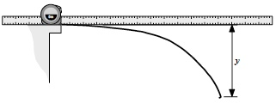

*y* is measured directly using this method using **additional** ruler 1✔

using **additional** ruler made vertical (as before) or using set-square placed against horizontal ruler 2✔

*for 1✔ allow use of plumb line or spirit level;*

*don’t insist on the set-square being used against two mutually perpendicular faces of the metre ruler*

*the floor is assumed to be horizontal if the deflection is found from the difference between two vertical measurements*

*for 2✔ allow metre ruler B made horizontal by use of set-square against vertical ruler A; ruler B establishes vertical position of free end of tape; ruler A is used to measure y directly*

*either or both marks can be earned for suitable annotation to* ***Figure 1***

*reject suggestions that y can be found without making at least one vertical measurement*

**2**

(b)     (for *x* ≤ 70 cm *y* is small so) percentage/fractional uncertainty in *y* is (too) large **OR**

(for *x* > 70 cm) percentage/fractional uncertainty in *y* not (too) large ✔

*percentage or fractional and in y are essential;*

*accept ‘error’ for ‘uncertainty’;*

*reject ‘small distances are hard to measure’*

**1**

(c)     **continuous ruled** best-fit line drawn (at least) between 1st and 6th points;

line **must** pass below 2nd point and above 5th point;

line **must** pass above 1st point and below 6th point 1✔

gradient calculated from their best-fit line;

result, minimum 2 sf, in range 3.5 to 4.7 2✔

result for *n* correctly rounded from their gradient to the nearest integer (expect *n* = 4) 3✔

*for 1✔ ‘pass below’ is taken to mean below the intersection of the cross-hairs defining the position of a point; a line that intersects (any of) the cross-hairs of the 1st, 2nd, 5th or 6th points loses this mark*

*for 1✔ the line must not be thicker than half a grid square, must not vary in thickness and must not be too faint; do not allow two lines unless these are drawn to calculate maximum and minimum gradients from which an average is then calculated*

*for 2✔ accept answers to greater than 2 sf which round to 2 sf in range 3.5 to 4.7*

*do not penalise for small steps or read off errors*

*for 3✔ it must be clear that final result is for n if this is not on the answer line*

*allow ecf for unexpected gradient result that is then correctly rounded to the nearest integer*

*if no line is drawn (losing 1✔ and 2✔) allow 3✔ if n given as nearest integer to a gradient result obtained using two points on* ***Figure 2***

**3**

(d)     log *A* = (*y*) intercept seen

**OR**

log *A* = log *y* when log *x* = 0

**OR**

log *y = n* log *x* + log *A* (or correctly rearranged) seen 1✔

indirect method to find (vertical) intercept described, eg

using (values for) a point on line;

substitute into equation (for the line); allow ‘into *y = mx + c*’;

find log *A* (don’t penalise incorrect algebra) 2✔

*A* = 10(y intercept)

**OR**

*A* = 10(log *y* – *n* log *x*) 3✔

treat ln *A* = (*y*) intercept in 1✔ as a slip and don’t penalise but then insist that following work is consistent, eg insist on use of ln *y = n* ln *x* + ln *A* (if seen) to earn 2✔

and

*A = e*(y intercept) to earn 3✔

*for 1✔ allow sensible use of y = mx + c idea;*

*reject ‘log A is where line crosses y axis’*

*for 2✔ allow ‘use a point on line to find x and y then sub into equation etc’;*

*accept valid similar triangles idea;*

*reject anything such as extrapolating the line to suggest that the intercept can be found directly;*

*for 3✔ accept ‘(take/find) anti-log of (log y) intercept’;*

*condone ‘inverse log of (log y) for anti-log’; reject ‘convert’*

*accept A = 10(log A) providing 1✔ awarded*

*accept substitution of n, eg A = 10(log y – 4 log x)*

*reject A = 10(–y intercept)*

*alternative method:*

*using a point on line find log x, log y;*

*anti-log to find x, y 1✔*

*use   (equation seen with A the subject or equivalent description of process) 2✔*

*repeat (to find A) using a different point on line;*

*calculate average (A) 3✔*

*reject averaging of x and y or of log x and log y*

**3**

(e)     *A* evaluated using  **OR** using *A* = 10(log *y* – *n* log *x*) ;

correct substitution of *n* (from part (c)) and of *y* and *x* in cm from any row in the table (likely values shown opposite),

*A* evaluated correctly to minimum 2 sf and correct POT 1✔

order of magnitude of *A* = –7 **OR** 10–7 (accept index or of power of ten) 2✔

cm–3 3✔

**OR**

cm(1 – *n*) where *n* is result given for part (c)

*for 1✔ ECF for non-integer n*

*values that may be seen in working:*

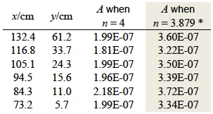

*\*equation of best-fit line gives vertical intercept = 3.879*

*for 2✔ accept 1 × 10–7 (cm–3) but reject 1.0 × 10–7 or 2 × 10–7 etc;*

*ECF order of magnitude correct for their value of A;*

*POT must be consistent with unit given eg if cm–3 is converted into m–3;*

*for 3✔ CAO;*

*use of non-integer, eg n = 3.6 requires A in cm–2.6*

*withhold 2✔ and 3✔ if A is not evaluated*

alternative approaches:

*A* evaluated from   **OR** from A = 10(log *y* – *n* log *x*) ;

correct substitution of *n* (from part (c)) and of *y* and *x* in (in m) etc;

*A* evaluated correctly to minimum 2 sf and correct POT 1✔

order of magnitude of *A* = –1 **OR** 10–1 2✔

m–3 3✔

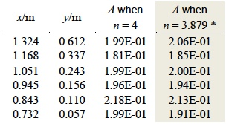

alternative approaches:

*A* evaluated from   **OR** from *A* = 10(log *y* – *n* log *x*) ;

correct substitution of *n* (from part (c)) and of *y* and *x* in (in mm) etc;

*A* evaluated correctly to minimum 2 sf and correct POT 1✔

order of magnitude of *A* = –10 **OR** 10–10 2✔

mm–3 3✔

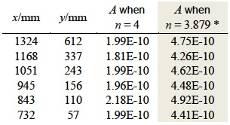

*ecf for wrong or non-integer value of n, ie for cm(1 – n)*

**3**

**[12]**

**Q10.**

(a)     attempt to apply principle of moments either about pivot or (LH) end of ruler 1✔

mass = 127(.04) (g) 2✔

assumption is that ruler is uniform / mass evenly distributed **OR**

weight acts at the centre/mid-point/middle **OR**

centre of mass / gravity is at the centre/mid-point/middle 3✔

*for 1✔ for evidence of moments taken expect clockwise and anticlockwise moment;*

*for moment about pivot expect to see either 29 or 49; for use of LH end of ruler expect 30 or 50*

*don’t insist on seeing masses in kg, distances in m or the inclusion of 9.81 or g in the working; condone g seen on one side only*

*rounding to 127 g earns 1✔ and 2✔*

**3**

(b)     force on wire is upwards **OR** ↑ 1✔

current is from **P** to **Q** **OR** rightwards **OR** (left) to (the) right **OR** → 2✔

states direction of force and direction of current (or 3✔= 0) and makes a suitably justified deduction, eg

using left-hand rule **OR** LH rule

**AND**

*B* is into the page **OR** into plane of **Figure 3 OR** ⊗ 3✔

*for 1✔ condone ‘motion is upwards’*

*for 2✔ ‘towards Q’* ***OR*** *‘positive to negative’ are not enough*

*allow logically correct (using LH rule) 3✔ for either downwards force with correct current* ***AND/OR*** *upwards force with wrong current*

*increased flux density below wire is acceptable alternative to LH rule*

**3**

(c)     gradient calculated from *∆M* divided by *∆I*, condone read off errors of ± 1 division; minimum *I* step ≥ 2.0 A 1✔

evidence of g = 9.81 or 9.8 correctly used in working for *σ* or *B* 2✔

|*B*| in range 1.76 × 10–2 to 1.87 × 10–2 or 1.8 × 10–2 (T) 3✔

*for 1✔ expect (–)0.28 (g A–1); do not penalise for missing – sign*

*for 2✔ look for σ = their gradient × 9.81 (× 10–3 N)*

***OR*** * ; condone POT*

*errors*

*for 3✔CAO by correct method only; ignore – sign if provided; no limit on maximum sf*

**3**

(d)

|  |  |  |  |
| --- | --- | --- | --- |
|  | **Reduced** | **No effect** | **Increased** |
| Force acting on wire |  | 1✔ |  |
| Force acting on prism | 2✔ |  |  |
| Gradient of graph | 3✔ |  |  |
| Vertical intercept | 4✔ |  |  |

*1✔ = 1 mark*

*2✔ = 1 mark*

*3✔ and 4✔= 1 mark*

*allow any distinguishing mark as long as only one per row*

*for ✔ and ✗ in same row ignore ✗*

*for ✔ and ✔ in same row give no mark*

*ignore any crossed-out response unless only distinguishing mark on row*

**3**

(e)     any complete circuit connecting the power supply in **Figure 6** to **X** and to **Y** that produces currents in **X** and in **Y** that travel left to right 1✔

wiring correct so that **X** and **Y** are in series (see below) 2✔

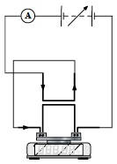

*allow parallel circuit for 1✔ but reject use of additional power supply*

*if* ***X*** *and/or* ***Y*** *is/are short-circuited award no marks;*

*for impractical circuits eg voltmeter added in series, award no marks*

*ignore any current arrows added to diagram*

**2**

(f)      strategy:

states that readings of *M* (as the dependent variable) will be measured for different values of independent variable, *I* or *d* only 1✔

clearly identifies the correct control variable, *d* or *I* only;

condone  = constant if *I* varied **OR** *I*2*L* OR *IL* = constant if *d* varied;

it must be clear how the value of the control variable is known 2✔

states that *L* will be measured or gives value eg *L* = 5.0 cm 3✔

use of *g* to convert *M* reading to *F*; evidence may be found in expression for *k* 4✔

*for 1✔ condone F identified as the dependent variable or as the balance reading;*

*reject ‘measure change in mass / change in F’*

*failure to make M or F the dependent variable cannot score 1✔ or 2✔*

*for 2✔if d is being varied and I = 5.0 A is stated, this can be taken to mean I is the control variable and the value is known*

*for 1✔ and for 3✔ insist that M and L are being read* ***OR*** *measured* ***OR*** *recorded*

*for 4✔ ‘work out force’ is not enough; reject ‘acceleration’ for g*

**MAX 3**

analysis:

suggests a plot with *M* or *F* [by itself or combined with another factor] on the vertical axis and some valid manipulation of their independent variable on the horizontal axis 5✔

identifies correctly how *k* can be found using the gradient of their graph; *k* must be the subject of the expression given 6✔ **OR**

if suggesting a plot with log *M* or log *F* on the vertical axis etc identifying correctly how *k* can be found from the graph intercept 6✔

**OR**

suggesting a plot with *M* or *F* on the vertical axis etc and identifying correctly how *k* is found using the area under the line 56 ✔ = 1 MAX

*the intention to plot M against I2 is taken to mean that M is the dependent variable and is plotted on the vertical axis*

*examples: plot M against I2 will earn 5✔*

*and then  will earn 6✔*

*or plot F against  will earn 5✔ and then*

* will earn 6✔ (note that when F is the dependent variable g will not appear in the expression for k)*

**2**

**[19]**