**Trajectory of a sphere projected off a bench**

**The focus of this exercise is assessing CPAC 2c and 2d**

|  |  |  |
| --- | --- | --- |
| CPAC 2c | Identifies and controls variables, plans approaches taking into account variables that cannot be controlled |  |
| CPAC 2d | Selects appropriate equipment and measurement strategies in order to ensure accurate results |  |

The apparatus in the diagram would have been set up for you and you also have a marble.

The following apparatus is also available for you to use to carry out the experiment.

Stopwatches * Set squares * Metre rules * Half-metre rules * 30 cm rules * Marker pens * Dusting cloths * Blu-tak * Protractors *

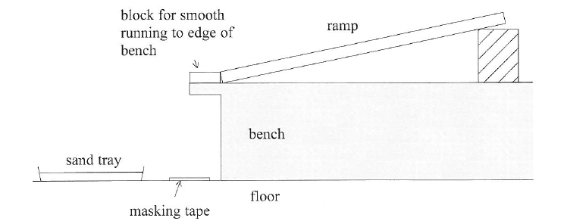

When carrying out such an experiment, you would roll a marble from rest down the ramp so that It would be projected off the edge of the bench and land in the sand tray.

The marble is to roll a known distance, s, to the bottom of the slope and the mean time *t* taken for this motion determined. The mean horizontal distance *x* travelled by the marble after leaving the bench is also to be found.

The speed of the marble as it leaves the bench is *v.*

Theory suggests that the horizontal distance travelled, *x,* is directly proportional to the speed it leaves the bench, *v.*

That is, *x = k v*, where *k* is a constant of proportionality.

*v* can be calculated using *v* = 2*s* / *t*.

Show how this is derived from s = ½ (u + v)t

……………………………………………………………………………………………………………………………………………………………….………………….

…………………………………………………………………………………………………………………………………………………….……….……. (1 mark)

**You are now going to write an experiment plan to investigate the suggested relationship of** *x = k v***.**

How could you ensure that the glass sphere could roll freely down the slope without falling off the side of the ramp?

……………………………………………………………………………………………………………………………………………………………….………………….

…………………………………………………………………………………………………………………………………………………….……….……. (1 mark)

Explain clearly how you would use a vertical metre rule to make a mark on the masking tape of the point that is aligned vertically with the edge of the bench. You can add to the diagram to show how you would ensure that the vertical metre rule was set correctly.

……………………………………………………………………………………………………………………………………………………………….………………….

…………………………………………………………………………………………………………………………………………………….……….……. (1 mark)

* How will *v* be determined?

You should state *exactly* what quantities you would measure, the apparatus you would use to do it, whether you would need to repeat any readings and say how you would calculate *v* from your data.

…………………………………………………………………………………………………………………………………………………………………….……………

…………………………………………………………………………………………………………………………………………………………….……………………

…………………………………………………………………………………………………………………………………………………………………….……………

…………………………………………………………………………………………………………………………………………………………….……………………

…………………………………………………………………………………………………………………………………………………………………….……………

* How will *x* be determined?

You should state *exactly* what quantities you would measure to obtain the data required for *x*, the apparatus you would use to do it, whether you would need to repeat any readings.

…………………………………………………………………………………………………………………………………………………………….……………………

…………………………………………………………………………………………………………………………………………………………….……………………

……………………………………………………………………………………………………………………………………………………………….…………………

* How many sets of data will you obtain?

……………………………………………………………………………………………………………………………………………………………….…………………

……………………………………………………………………………………………………………………………………………………………….…………………

……………………………………………………………………………………………………………………………………………….………………. (6 marks)

* State how what graph you would plot including what you would expect it to look like if the relationship was correct.

……………………………………………………………………………………………………………………………………………………….…………………………

.……………………………………………………………………………………………………………………………………………………….………………………..

……………………………………………………………………………………………………………………………………………………….………. (2 marks)

* Use ‘y = mx + c’ in relation to your graph to explain how to determine an experimental value for *k* from it.

……………………………………………………………………………………………………………………………………………………………………….…………

………………………………………………………………………………………………………………………………………………………………… (2 marks)

For teacher use: Method Modified: Y / N CPAC award level R / O / G Marks Awarded □ /10