A circuit consists of a cell of emf 1.6 V in series with a resistance 2.0 Ω connected to a resistor of resistance 3.0 Ω in parallel with a resistor of resistance 6.0 Ω. Determine the total current drawn from the cell and the potential difference across the 3.0 Ω resistor.

Q1.The cells in the circuit shown in the figure below have zero internal resistance. Currents are in the directions shown by the arrows.
R₁ = 0 − 10Ω R₂ = 10Ω
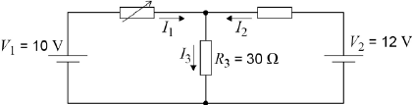
R₁ is a variable resistor with a resistance that varies between 0 and 10 Ω.
(a) Write down the relationship between currents I₁, I₂ and I₃.
........................................................................................................................
(1)

(b) R₁ is adjusted until it has a value of 0 Ω.
State the potential difference across R₃.

potential difference = ........................ V
(1)

(c) Determine the current I₂.

current = ........................ J
(2)

(d) State and explain what happens to the potential difference across R₂ as the resistance of R₁ is gradually increased from zero.
........................................................................................................................
........................................................................................................................
........................................................................................................................
........................................................................................................................
........................................................................................................................
(3)
(Total 7 marks)

Q2.The circuit diagram below shows a 6.0 V battery of negligible internal resistance connected in series to a light dependent resistor (LDR), a variable resistor and a fixed resistor, R.
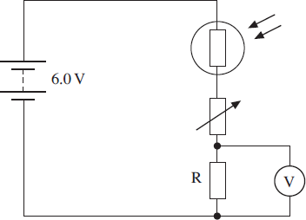
(a) For a particular light intensity the resistance of the LDR is 50 kΩ. The resistance of
R is 5.0 kΩ and the variable resistor is set to a value of 35 kΩ.
(i) Calculate the current in the circuit.

current...........................................A
(2)

(ii) Calculate the reading on the voltmeter.

voltmeter reading ...........................................V
(2)

(b) State and explain what happens to the reading on the voltmeter if the intensity of the light incident on the LDR increases.
........................................................................................................................
........................................................................................................................
........................................................................................................................
(2)

(c) For a certain application at a particular light intensity the pd across R needs to be 0.75 V. The resistance of the LDR at this intensity is 5.0 kΩ.
Calculate the required resistance of the variable resistor in this situation.

resistance ........................................... Ω
(3)
(Total 9 marks)

Q3.(a) The cell in Figure 1 has an emf of 3.0 V and negligible internal resistance.
Figure 1
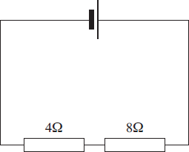
Calculate the potential difference across the 8 Ω resistor.

potential difference ............................................... V
(2)

(b) Figure 2 shows the same circuit with a voltmeter connected across the 8 Ω resistor.
Figure 2
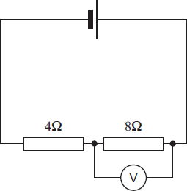
The voltmeter reads 1.8 V. Calculate the resistance of the voltmeter.

resistance ...............................................Ω
(3)
(Total 5 marks)

Q4. The circuit in the diagram below contains four identical new cells, A, B, C and D, each of emf 1.5V and negligible internal resistance.
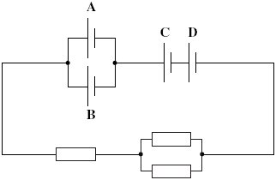
(a) The resistance of each resistor is 4.0 Ω.
(i) Calculate the total resistance of the circuit.

answer = ...................................... Ω
(1)

(ii) Calculate the total emf of the combination of cells.

answer = ....................................... V
(1)

(iii) Calculate the current passing through cell A.

answer = ....................................... A
(2)

(iv) Calculate the charge passing through cell A in five minutes, stating an appropriate unit.

answer = ......................................
(2)

(b) Each of the cells can provide the same amount of electrical energy before going flat.
State and explain which two cells in this circuit you would expect to go flat first.
......................................................................................................................
......................................................................................................................
......................................................................................................................
......................................................................................................................
......................................................................................................................
......................................................................................................................
(3)
(Total 9 marks)

Q5.In each of the following circuits the battery has negligible internal resistance and the bulbs are identical.
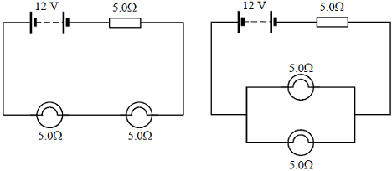
Figure 1 Figure 2
(a) For the circuit shown in Figure 1 calculate
(i) the current flowing through each bulb,
...............................................................................................................
...............................................................................................................
(ii) the power dissipated in each bulb.
...............................................................................................................
...............................................................................................................
(2)

(b) In the circuit shown in Figure 2 calculate the current flowing through each bulb.
........................................................................................................................
........................................................................................................................
........................................................................................................................
(3)

(c) Explain how the brightness of the bulbs in Figure 1 compares with the brightness of the bulbs in Figure 2.
........................................................................................................................
........................................................................................................................
(2)
(Total 7 marks)

