THE PHOTOELECTRIC EFFECT VIDEO

1. Who produced the electromagnetic waves that had been predicted by Maxwell?

2. He set up two coils. He found that a spark jumping across the gap in the first coil produced a spark across the gap in the second coil.
Was there any physical connection between the two coils used for the transmission of electromagnetic waves in this experiment?

3. Fill in the gaps.

A spark (which is electrons on the …………………) leads to a changing ………………… field which leads to a changing………………… field which leads to a changing electric field etc.

4. What did Hertz find made sparks occur more easily?

5. Give a simple definition of the photoelectric effect.

6. What experiment clearly demonstrates the wave nature of light?

7. What monochromatic source was used in this experiment?

8. This is a simplified diagram of Lenard’s apparatus. Add to the diagram to show where the light was incident and the direction of electron flow.

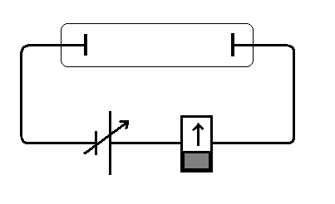

9. How does the direction of electron flow differ from the direction of conventional current.?

10. Was a potential difference between the plates required for a current to be registered?

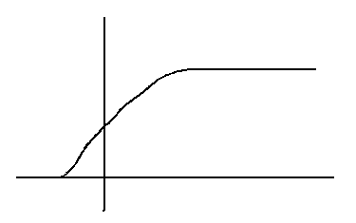
11. Complete the graph by labelling the axes and the main features.

12. Fill in the gaps
Light shining on the metal surface gives …………………….. sufficient energy to escape. An electron needs a certain amount of energy in order to escape the …………………… force from the positive ions in the metal lattice. Not all the escaping electrons have the same kinetic energy. Some lose energy in ……………………… before they reach the surface. If an electron does not have enough energy it cannot escape from the metal surface. No current will flow when there are no electrons escaping. No current also flows when the electrons have …………… just enough energy to reach the surface of the metal and go no further.

13. Why doesn’t the gravitational pull on an electron stop it reaching the collector plate?

14. What does a negative potential applied to the collector plate do?

15.Which electrons would travel the furthest?

16. What are the equations for the electrical potential energy of the electron and the kinetic energy of the electron? All symbols must be defined.

17. Fill in the gaps.
Electrons leaving the metal surface have a range of kinetic energies and therefore a range of ……………….. The cut-off potential corresponds to the kinetic energy of the …………………. electrons.

18. What did Lenard expect to find if he used a brighter light source?

19. What did he actually find?

20. What happened when he used light of different frequencies?

21. Complete the graph by labelling it appropriately.

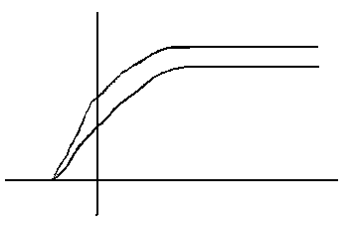

21. What was the relationship that he found between the maximum kinetic energy of the electrons and the frequency of the light?

22. In what way did his results conflict with the wave theory of light? (Give the prediction of wave theory and the conflict)

22. What is a black body?

23. Sketch the shape of a typical black-body spectrum.

24. What happens to the peak as the temperature increases.

25. What did Max Planck assume about the way atomic oscillators emitted energy?

26. In the equation E = hf what do each of the symbols stand for?

27. Which is more energetic – red light or ultraviolet?

28. Who used Planck’s formula to explain the photoelectric effect?

29. How do you convert an energy in Joules into an energy in electronvolts?

30. How many photons are needed to liberate an electron?

31. What is the name given to the energy needed to escape the metal surface?

32. Rewrite this equation in words.

E_{K max} = hf – W

33. What shape would you expect to get if you plotted a graph of E_{K max} against f?

What would be the significance of the gradient?

What would be the significance of the x intercept?

What would be the significance of the y intercept?

