Experiments to Determine (i) the Refractive index of Glass
and (ii) the Critical Angle of Perspex
Your lab report will be assessed for CPAC5: Referencing standard values.
Apparatus

Rectangular glass block Power pack Converging lens (optional)
Semicircular perspex block Slits and support block A4 sheets of plain paper
12V lamp Light shield

Part (i) the Refractive index of Glass
Theory

Light travels in straight lines in a particular transparent material. When light passes from one material (medium) to another it changes direction. Refraction is the name given to the bending of light as it passes from one medium to another.
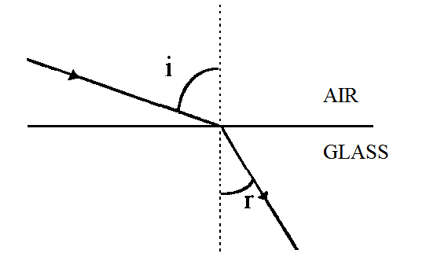
The diagram represents a ray of light passing from air to glass. The normal is a line drawn at right angles to the boundary between the two media. The incoming ray of light is called the incident ray. The angle of incidence, i, is the angle between the incident ray and the normal. The refracted ray is the ray after refraction at the boundary. The angle of refraction, r, is the angle between the refracted ray and the normal. There is a relation, first discovered by Snell, between the sines of the angles:

sin i = n where n is a constant, known as the refractive index of the second
sin r medium with respect to the first.

Diagram
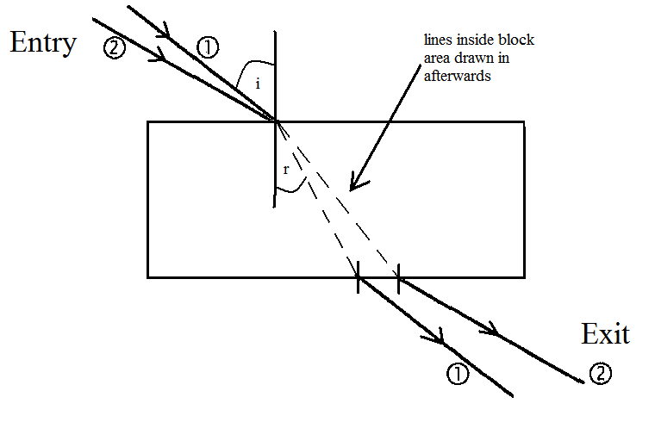

Method

Assemble the apparatus so as to produce a narrow beam of light which is still visible after passing through the rectangular block. Place the rectangular block on a sheet of white paper. Mark the outline and a point approximately one third of the way along the longer side. (See sketch). Premark a set of entry paths from 10° to 80° at 10° intervals and number them. Line the ray up with each path and mark the exit paths of each of the beams (put two crosses with their centres on the beams along the path) and number them appropriately. Remove the block. Draw in the path of the exit ray to where it left the block.

Results and Analysis

- THE SHEETS WITH THE RAYS MARKED ON IT ARE YOUR RESULTS AND MUST BE STUCK INTO YOUR BOOK.
- Join the entry and exit points to show the path within the block.
- Draw in the normal to the point of incidence and measure i and r.
- Tabulate your results.
- Calculate the values of sini and sinr.
- Plot a graph of sini against sin r.
- Determine the gradient, which will give the value of the refractive index.
- Look up a value for the refractive index of glass in a data book or online. State the name of the data book, the value you found and what sort of glass it is for. For a web resource quote the URL and the date accessed.
- Calculate your value as a percentage of this value
- Hence determine the percentage difference between your value and the data book value.
- Discuss where errors can arise in the experimental procedure.
- Quantify these errors i.e. state the error in measuring the angles.
- Explain why it is better to find the refractive index value by plotting a graph rather than by calculating all the individual values and averaging.
- Discuss whether your graph has the shape expected (straight line with positive gradient passing through the origin.
- Random errors show when values obtained are not identical and vary, this gives rise to points not lying exactly on the line of best fit. Systematic errors affect all results in the same way.
- Do your results show random error?
- If your graph had not gone through the origin as expected, what kind of error would this suggest was present?

Conclusion

State the value you obtained for the refractive index of glass.
Part (ii) the Critical Angle of Perspex
Theory

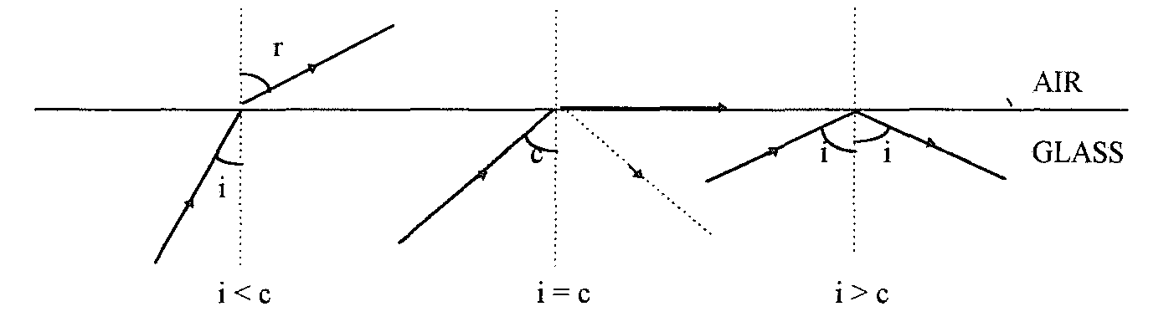
When light is travelling from an optically more dense medium such as glass to an optically less dense medium such as air, there is in general a strong refracted ray and a weak reflected ray. At a certain angle of incidence, called the critical angle, c, the angle of refraction is 90⁰. For angles greater than c, the refracted ray disappears and all the incident light is reflected inside the denser medium, the light is totally internally reflected. At the critical angle the incident angle is in the more dense medium so,

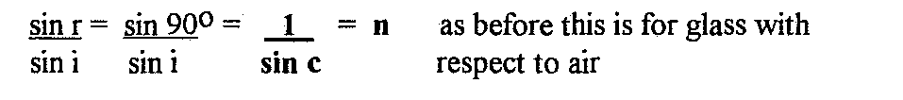

Diagram

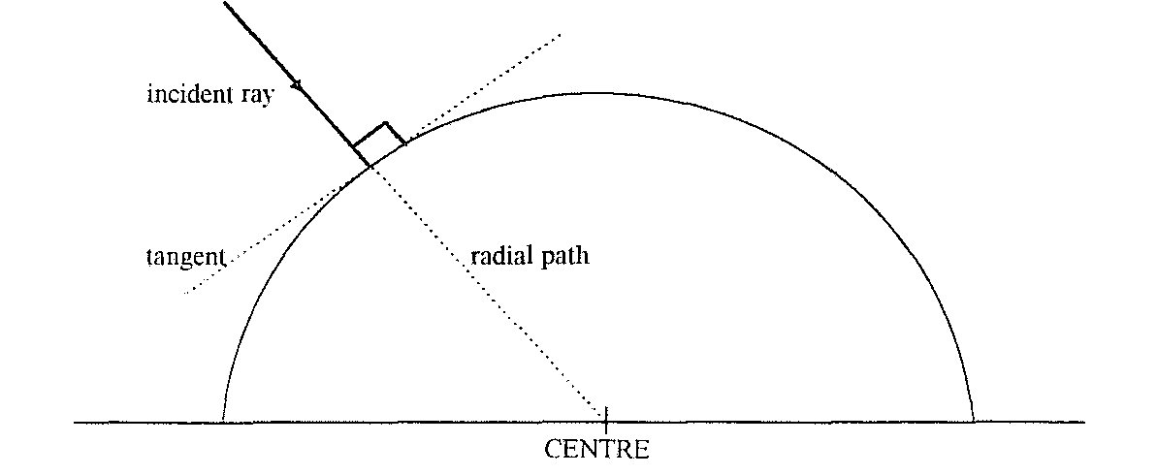

Method

Use the semicircular block to determine the critical angle for perspex. You will be making a number of direct single measurements for this, rather than plotting a graph. The ray should enter the curved face normally (i.e. along a radial path, so you should mark the centre of the straight edge - see sketch). This is so that no refraction occurs when the ray enters the block. The ray should meet the back edge at the midpoint at all times. Keeping the incoming ray hitting the midpoint of the side rotate the block until the exit ray is just grazing the boundary. You should then clearly see a ray reflected from the straight boundary. Mark the position of the incident ray’s entry to the block and the position where the reflected ray exits the block, the midpoint of the block’s straight edge and the outline of the block. Repeat this three times.

Results and Analysis

- THE SHEETS WITH THE RAYS MARKED ON IT ARE YOUR RESULTS AND MUST BE STUCK INTO YOUR BOOK.
- Join the entry and exit points to the midpoint of the back to show the path of the ray within the block each time.
- Measure the angle between the entry and exit rays.
- Average the values obtained and then divide by 2 to obtain a value for the critical angle.
- State what you observed happen to the refracted ray as the angle at which it exited the block approached the 90° required.
- What problem does this give you?
- Why were you asked to repeat the measurements?
- Why were you instructed to measure the angle between the entry and exit and divide by two rather than by drawing in the normal line (line perpendicular to the straight edge)?
- What aspects of the procedure are most likely to lead to errors?
- Look up the refractive index of Perspex in a data book or online, stating the source as before. Use it to calculate what the critical angle should be. (critical angle, c = sin⁻¹(1/n))
- Calculate your value as a percentage of this value
- Hence determine the percentage difference between your value and the data book value.

Conclusion

State the value you obtained for the critical angle of Perspex.

