# *Godalming College Advanced Level Physics*

**Measurement of wavelength with a Diffraction Grating**

Your lab report will be assessed for CPAC4: Correctly tabulating sufficient data. **Read the instructions below carefully.**

### Theory

The diffraction grating equation is: d sin θ = n λ

where n is the order number of the spectrum

θ is the angle from the normal to the grating

λ is the wavelength of the light used

d is the slit separation (calculated from 1/N in mm, where N is the number of lines per mm on the grating)

### Apparatus

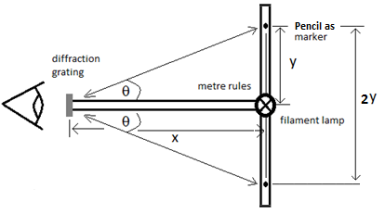

Filament lamp

Lab pack

Diffraction grating

(300 lines / mm)

2 metre rules

Pencil

Blu-tack

### Method

Set up the metre rules in a ‘T’ arrangement and position the filament lamp where the rules meet. The filament should be vertical and close to the surface of the rulers. Position the diffraction grating at the other end of the middle ruler. This should be close to the bench so that you can comfortably view the lamp and the spectra through the grating.

Using the pencil as a marker, you should find by trial and error the positions of the main colours (blue, green, yellow/orange, red) for both the first 2 orders (complete spectra) you can see either side of the centre of the pattern.

**For each colour in each spectrum record the position of the markers and use this to calculate the distance from one maximum to the corresponding position on the other side of the lamp (2y).**

### Analysis

Firstly calculate d, the distance between the lines on the grating, for a 300 lines / mm grating. Don’t forget to convert this value into S.I. units for the wavelength calculations.

For each ‘line’ you have observed, calculate θ from the values of x and y using the equation for tan θ.

Now use the diffraction grating equation to calculate the wavelength for each ‘line’ taking care to use the appropriate value for n, the order number of the spectrum.

Present your results in a summary table showing the wavelength values obtained for each colour (in nanometres) for the different orders and an average wavelength for each colour.

### Discussion

How much variation in wavelength values do you get for the same colours? Is this variation consistent with the measurement uncertainties in this experiment?

Look up typical values of the wavelength of light for the colours you have measured. Clearly, it will be difficult to know if the light you observed was exactly of the same wavelength, but are your values in agreement within the range of experimental uncertainty.

**Why do you think you measured 2y? There are 2 reasons for this.**

### Conclusion

You should state the average wavelength of light for each of the colours measured.