## Properties of Stationary Waves on a Taut String – Part 2

While conducting this experiment, you will be assessed for CPAC1: Following written instructions.

Your lab report will be assessed for CPAC5: ‘y=mx+c’ analysis.

### Apparatus

Signal generator Mass hanger and masses Metre rules wires

Vibration generator Large sheets of white paper Pulley clamp

### Diagram

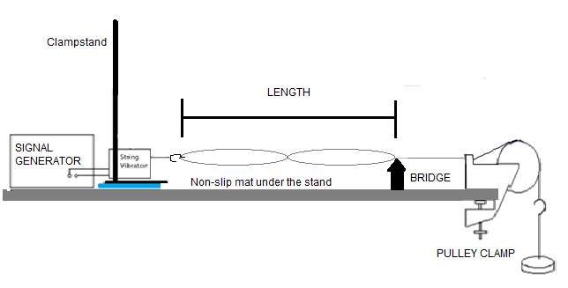

### Method

**NB: Safety Goggles must be worn**

* Set up the apparatus as indicated in the diagram using the black fishing line.
* Set the length to be between 1.5m and 2.0m
* You now need to decide the mass required. In order to collect a range of measurements you want a tension that will produce a clear 2 loop pattern at about 20-30 Hz.
* **(DO NOT GO ABOVE 500g).**  Fiddle with the mass and frequency to get a good pattern!
* Record the mass and calculate the tension on the wire.

**INVESTIGATION 1: Frequency vs Loops**

* Find the frequency of the first 8 harmonics for the black fishing line.

Create a suitable table to record your results.

**Investigation 2: Frequency vs Mass per Unit Length of Wire (µ)**

* Keep the tension and length constant
* Obtain a 2 loop pattern for at least 5 lines of different **µ**
  + **Be careful of the fishing hooks on the ends of the lines and do not detach them**
  + **Be careful not to “kink” or tangle the lines**
  + **Return each colour of line back to the spool in the correct bag**
* The **µ** for each line is written on each of the bags.

Create a table to record frequency, µ and

### Analysis: Frequency vs Loops

or (N.B. **T = Tension** NOT time period!)

* Plot a graph of frequency vs number of loops.
* Calculate the gradient, and from that a value for **µ**
* Find the % difference between your experimental value for **µ** and the one stated on the bag.

### Analysis: Frequency and mass per unit length of string

1. Sketch what shape you expect the graph to be and label your axes. Think about what value you would expect the intercept to be
2. Plot a graph of frequency on the y axis against on the x axis.
   1. Determine the gradient of the graph.
   2. The gradient has units – what are they?
3. Is the intercept the expected value?

*If you used a false origin then calculate the intercept as follows:*

* 1. c = y – mx
  2. Select a point ON THE LINE NOT IN THE TABLE.
  3. Substitute in the values of y, m and x in the equation).

1. Is your graph the shape you expected? If not, can you suggest why?
   1. Is random error very evident in your table and on your graph?

*Hint:*

* + 1. Are the points very close to the line of best fit?
    2. If you repeated the readings are they identical?
  1. Is a systematic error evident in your graph?

*Hint:*

* + 1. Is the intercept the one expected?

1. Calculate the percentage difference between your measured gradient and the expected value calculated using n, T and l.
2. Compare this with the percentage uncertainties in your readings of frequency and length (use a middle value in the table).

### Conclusion

State the relationships found between (i) frequency and the number of loops and (ii) frequency and the mass per unit length.