Godalming College Physics Department

Conservation of linear momentum – motion sensor

Theory

For a system of colliding bodies, the total momentum remains constant providing no external forces act. In this collision, a trolley of mass m₁ moving with an initial speed v₁ sticks to an initially stationary trolley of mass m₂. After the collision, both move with a combined velocity of V. By conservation of momentum we can write:
m₁ x v₁ + m₂ x 0 = (m₁ + m₂) x V

This can be re-arranged to give: v₁ = (m₁ + m₂) V
m₁

If the collision is repeated for various different initial velocities, a graph of v₁ against V should give a straight line through the origin.

Apparatus required
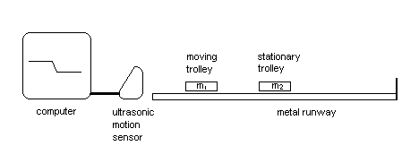

Use the ‘PASCO passport’ blue sensor. The software will start when the sensor is plugged in (USB connection). The software option is ‘Datastudio’ followed by selecting ‘Create Experiment’. If the graph covers the sensor settings, move it. Select position (displacement) and velocity. Maximise the graph screen. When you record data the position graph displays by default. To see the velocity graph drag velocity from the left-hand side onto the graph area. If you right-click on a plotted line you can use ‘Remove’ to send it back to the left-hand side. To delete unwanted data select it on the left-hand side and press delete. (Doing this to the position data also removes the associated velocity).

Note that the data-logger is only being used to record the velocities. You will plot the graph by hand!

Method

Set up the apparatus as shown above. When the system is set up and you are satisfied with the alignment of the motion sensor (N.B. you may need to keep other objects, such as files and boxes, out of the way to avoid unwanted reflections), take a reading with a single metal trolley. Examine this to check that the track is level, and adjust the track and repeat if necessary.

The metal trolleys have Velcro connectors and should stick together on impact. If they don’t, then put a small amount of blu-tak on the end as well. Position the second stationary glider on the track, start the sensor and push the first glider towards it. From the software record the velocities before and after the collision. Repeat the experiment, trying to obtain as wide a range of pairs of velocities as possible. Print one set of the position graph and its corresponding velocity graph. Repeat the experiment with the target trolley loaded with additional masses. Don’t forget to measure the mass of all the trolleys used.

Processing of results

Plot graphs of v₁ against V for all the combinations of trolleys that you used.

What should the gradient equal? By weighing the trolleys this can be confirmed.

Measure the gradient of each graph and compare it with the value predicted from the masses of the trolleys.

Should these quantities have a unit?

Discussion and Conclusion

On the printout of the position-time graph and velocity-time graph indicate where the collision occurred.

Are your results as expected? Can you identify the main sources of error? Don’t forget in your discussion that you are investigating conservation of momentum and not conservation of energy!

If you feel that your results confirm the principle of conservation of momentum for the collisions you have investigated, then state this in your conclusion.

