Godalming College Physics Department

Conservation of Momentum in ‘Explosions’

Aim

The purpose of this experiment is to demonstrate conservation of momentum for two carts pushing away from each other.

Theory

When two carts push away from each other and no net force exists, the total momentum of both carts is conserved. Because the system is initially at rest, the final momentum of the two carts must be equal in magnitude and opposite in direction.

m₁ v₁ + m₂ v₂ = 0

or m₁ v₁ = (-) m₂ v₂

Therefore, ignoring the minus sign, the ratio of the final speeds of the carts is equal to the ratio of the masses.

v₂ = m₁
v₁ m₂

To simplify this experiment, the starting point for the carts at rest is chosen so that the two carts will reach the end of the track simultaneously. The speed, which is the distance divided by the time, can be determined by measuring the distance travelled since the time travelled by each cart is the same.

Hence x₂ = m₁
x₁ m₂

Apparatus required

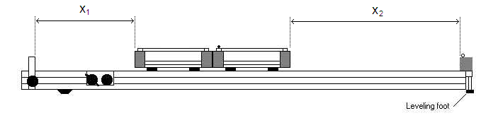
Note that the distances are measured from the outer edges of the two trolleys, not the point where they join! In addition to the trolleys and track, you will also need:

Additional Masses
Balance
Metre rule

Method

Level the track by setting a trolley on the track to see which way it rolls. Adjust the levelling feet to raise or lower the ends until a trolley placed at rest on the rack will not move.

Place two trolleys together with the catapult plunger fully depressed. Tap the plunger release button and watch the two trolleys move to the end of the runway. Find by trial and error the starting position for the two trolleys to reach their respective ends of the track at the same time. Once you have found this position, record the two distances x₁ and x₂.

Using the additional masses, repeat the procedure for a range of values of m₁ and m₂, tabulating your results.

Processing of results

Draw up a table of values of x₁ , x₂ , m₁ and m₂ for every combination of masses you have used.

Now calculate and tabulate the ratios x₂ / x₁ and m₁ / m₂

Plot a graph of x₂ / x₁ against m₁ / m₂. What should you expect to obtain for the gradient of this graph?

Discussion and Conclusion

Are your results as expected? Can you identify the main sources of error?

If you feel that your results confirm the principle of conservation of momentum for the collisions you have investigated, then state this in your conclusion.

