Godalming College Physics Department

Microwave experiments

Theory

Polarisation: The microwave source produces plane-polarised waves. By rotating the receiver, the signal will vary according to the component of the wave amplitude along the plane of the receiver. This can be represented by $a=a_{0}\text{cos}θ$. Where a₀ is the amplitude of the wave, a is the detected amplitude and θ is the angle between the planes of the transmitter and receiver. As the current detected is dependent on the intensity of the wave, and for all waves it is known that intensity α (amplitude)², we can write for Intensity (or current!):
$I=I_{0}{\text{cos}}^{2}θ$

Two graphs can be plotted to test the form of this relationship. I v θ should give a curve. A graph of
I v cos²θ should give a straight line.

Stationary waves: If a standing wave arrangement is created, the average inter-node separation can be found. This is known to equal λ / 2, from which the wavelength can be found. This value can be compared with the standard value of 2.8 cm

Apparatus required

Microwave transmitter Microwave receiver Half meter rule
Mains adaptor Stand for the Microwave receiver Lab jack
Basic grey meter Various sheets, boards and stands

Method

For the polarisation experiment you use the angular scale which is attached to the barrel of the receiver. This can be read off against the edge of the receiver stand as shown in the diagram. Find by trial and error the position of the receiver where you get a maximum reading. This can be subtracted from all subsequent reading to find the angle of rotation. Now take a series of readings of current against angle as you rotate the receiver through a complete circle.
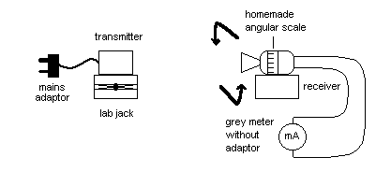

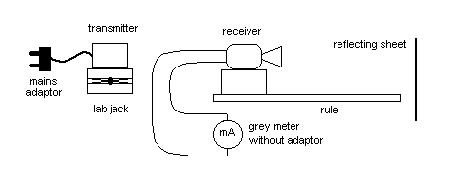
The standing waves experiment requires a board to reflect the microwaves back upon themselves. You should find a variation in intensity recorded as you move the receiver slowly along the line between the transmitter and the sheet. Note you will not obtain complete cancellation in the standing wave pattern. Measure the total distance over several maxima and minima, and use this to calculate the average distance between successive maxima or minima.

.

Results

For the polarisation experiment, first record an angle at which you get a maximum reading on the meter.

You should then record a table of angular reading, angle rotated (angle – initial reading) and current.

For the standing waves investigation, you DO NOT need to record the position of every maximum and minimum (anti-node and node). Simply record the position of the receiver for one maximum and then move the receiver through a series of maxima and minima, counting carefully as you go. Record the position of another maximum after moving through about 10 intervals.

Analysis

For the polarisation experiment, plot the 2 graphs identified in the theory section:

- A graph of I v θ which should give a curve.

- A graph of I v cos²θ which should give a straight line.

For the standing waves experiment, divide the difference between your two measurements by the number of intervals to find the average inter-node separation. This can then be doubled to give a value for the wavelength.

Explain why it is better to find the average inter-node separation by this method rather than by measuring several inter-node separations directly and taking an average.

Why do you not get complete cancellation at the nodes?

Discussion and Conclusion

Did you obtain a suitable straight-line graph for the polarisation investigation?

Did your value for the wavelength of the microwaves agree with the stated value?

Can you identify the main sources of error in these experiments?

State appropriate conclusions about the wave phenomena investigated.

