Temperature coefficient of resistance for copper and iron

Theory

You are going to use a potential divider circuit to measure the changes in resistance of a coil of wire as it is heated from room temperature to 100ºC.

The arrangement of decade box and coil forms a potential divider across the power supply. Since the same current passes through both, the resistances are in the ratio of the voltages.

i.e. R_{Coil} = V_{C}
R_{D} V_{D}

Hence R_{Coil} = V_{C} x R_{D}
V_{D}
This can be used to calculate values of R_{Coil} at each temperature.
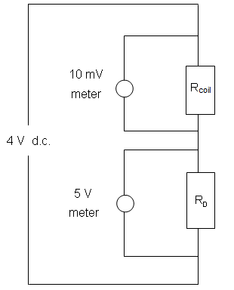

The temperature coefficient of resistance, α, is the change in resistance per unit resistance for one degree temperature rise.

α = ΔR , where R₀ is the resistance of the coil at 0° C
R₀θ
If a graph of R_{Coil} is plotted against temperature then the gradient is ΔR/θ and the intercept is R₀.
Thus
α = gradient
intercept

Apparatus

Coil of resistance wire (copper or iron) Clamp x 2 Bunsen
Decade box Boss x 2 Voltmeters x 2
50 ml beaker Tripod 20 V digital
Cooking oil Gauze 200 mV digital
0 - 250° C thermometer Heatproof mat Smoothed power pack

Method

Place the beaker on the tripod. Clamp the coil and the thermometer so that they are close together and not touching the bottom of the beaker. Pour in enough oil to just cover the coil completely. Note which coil you are using.

Set up the circuit shown. Set the decade box to 200 Ω, and note the value of its resistance, R_{D}. Make sure that the meters are set on the correct ranges. With power on, measure the p.d., V_{D}, across the decade box and the p.d., V_{C}, across the coil.

Using a small flame, heat the oil slowly, taking the Bunsen away from time to time. At about 5° C intervals, record the potential difference across the coil and the decade box. Do not exceed 120°C. Then allow the oil to cool, taking a second set of readings as it does so. (You may not have time to get back down to room temperature). Do not pour hot oil back into the container.

Treatment of results

- Calculate the resistance of the coil at each temperature and tabulate the values. (N.B. Don’t forget to convert the coil potential differences from mV to V).

- Plot a graph of resistance against temperature. (Use a large scale; you should use a false origin on the resistance axis, but you must start from 0°C on the temperature scale).

- Draw a best fit straight line.

- Measure the gradient of the graph and determine the value of the y intercept.

- Calculate a value for α.

- Look up the data book value for the metal you used.

- Verify that the unit for α is K⁻¹

Discussion

Evaluate a representative value for the uncertainty in your measurements of each of the potential differences and temperature for a mid-value in the results you obtained. Hence evaluate the total percentage uncertainty in the value you have calculated.

Calculate the percentage difference between your value and the data book value. Discuss whether your percentage uncertainty is sufficient to account for this.

Discuss random and systematic errors that may be present. Discuss any problems/difficulties that arose. Comment on your graph.

Conclusion

State the metal and the value found with its uncertainty.

