Variation of resistance with temperature for a thermistor (PC + 3 sensors)

Theory

A thermistor is a device containing a semiconductor. Its resistance falls with temperature as more charge carriers are released.

Apparatus

Thermistor in waterproof bag
Bunsen, gauze, tripod
250 ml beaker
Temperature sensor
Voltmeter sensor
Millameter sensor
3 x blue box sensor connecting leads
Computer with interface attached
Smoothed (TOPS) power supply
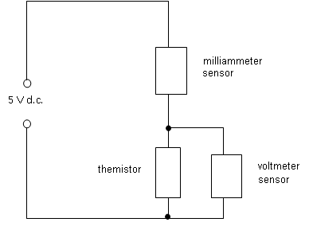

Method

Set up the thermistor and the temperature sensor in a beaker of water, using a clamp to hold both close together and away from the sides and base of the beaker. Make sure that they are both fully immersed.

Set up the circuit shown, and connect the sensor units to the specified channels of the interface unit with the following ranges set:

Channel 1 – temperature, 0 - 100°C range
Channel 2 – voltmeter, 0 – 5 V range (make sure you have the polarity correct!)
Channel 3 – milliammeter, 0 – 200 mA

Switch on the sensor units. On the computer open the programme “ScienceScope Datadisc Pt.” You should be presented with a calibration dialogue box – if not, click on “Set-up/Calibrate” from the drop down menus. Follow the instructions to select the appropriate sensor and range for each channel and perform a battery check. When you have calibrated all three channels select “Close”.

Set the power supply to about 5 V, and switch on. As a preliminary check, click on “Measure” then “Meter” then “OK”. The screen should display the values of the three variables: T, V and I. Check that they are reasonable values - If you get zero readings, or obviously false ones, ask for help.

To start datalogging, click on “Measure” then “Record”, then “Regular”. Choose a recording interval of about 15 minutes. Then click on “Go”. A graph will appear with all three values on separate different coloured y axes plotted against time on the x axis.

Heat the water bath slowly, and press the green “Start” button to start recording. All three variables will appear separately in different colours on the graph. Continue heating slowly up to boiling point.

If the results look sensible, press “Finish”, then “Keep this data”. Maximise the table data.

Treatment of results

To get the resistance values for each temperature, we need to divide the channel 2 readings by the channel 3 ones and multiply by 1 000.

From the “Data” menu, select “Calculate” then “Function” and then “a/b”. Use the drop-down menus to set “a” to be “channel 2 :p.d.” and “b” to be “channel 3 : mA” and click on “calculate”. A new column headed “Ch4” will appear.

Select “Calculate” then “Function” again, and then “a x k”. Set k to 1 000 and “a” to Ch 4, and click on “Calculate” again. A new column, Ch5, appears with the values of resistance, R.

To plot a graph of resistance against temperature, go to the “Graph” menu and select “Set axes”. Choose Channel 1 as the x-axis, and channel 5 as the y-axis. Go to “Plot all data” and the final graph should appear.

Discussion

One main source of systematic error is the fact that, if the water temperature rises rapidly, the temperature of the thermistor will lag behind that of the probe, by anything up to 30 seconds. Suggest ways of modifying the experiment to overcome this.

Conclusion

State how the resistance of the thermistor varied with temperature.

