|  |  |  |
| --- | --- | --- |
| Unit 1 | Kirchhoff and Potential Dividers | |
| Lesson 19 |
| Learning Outcomes | To know Kirchhoff’s laws and be able to apply them to questions | |
| To know what a potential dividers is and be able to calculate the output voltage | |
| To be able to explain an application of a potential divider | N. DWYER |

# **Kirchhoff’s Laws**

Kirchhoff came up with two (some may say rather obvious) laws concerning conservation in electrical circuits.

***Captain Obvious’ First Law***

Electric charge is conserved in all circuits, all the charge that arrives at a point must leave it.

Current going in = current going out.

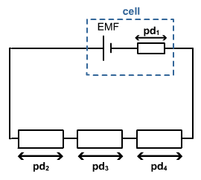In the diagram we can say that: *I*1 *= I*2*+ I*3 *+ I*4

***Captain Obvious’ Second Law***

Energy is conserved in all circuits, for any complete circuit the sum of the emfs is equal to the sum of the potential differences.

Energy givers = energy takers.

In the diagram we can say that: *ε* = pd1 + pd2 + pd3 + pd4.

# **Potential Dividers**

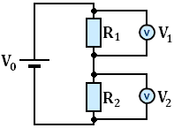A potential divider is used to produce a desired potential difference, it can be thought of as a potential selector.

A typical potential divider consists of two or more resistors that share the emf from the battery/cell.

The p.d.s across *R*1 and *R*2 can be calculated using the following equations:

 

This actually shows us that the size of the potential difference is equal to the input potential multiplied by what proportion of *R*1 is of the total resistance.

If *R*1 is 10 Ω and *R*2 is 90 Ω, *R*1 contributes a tenth of the total resistance so *R*1 has a tenth of the available potential. This can be represented using:

 The ratio of the resistances is equal to the ratio of the output voltages.

# **Uses**

In this potential divider the second resistor is a thermistor. When the

temperature is low the resistance (*R*2) is high, this makes the output voltage

high. When the temperature is high the resistance (*R*2) is low, this makes the

output voltage low. A use of this would be a cooling fan that works harder

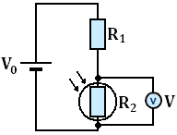when it is warm.

In the second potential divider the second resistor is a Light Dependant Resisitor.

When the light levels are low the resistance (*R*2) is high, making the output voltage

high. When the light levels increase the resistance (*R*2) decreases, this makes the

output voltage decrease. A use of this could be a street light sensor that lights up

when the surrounding are dark.