**EMPA Style Data Analysis Question (Modified from 2013 EMPA)**

The diagram shows an experiment to find the resonant frequency of a standing wave on a wire vibrating in its fundamental mode (one loop).

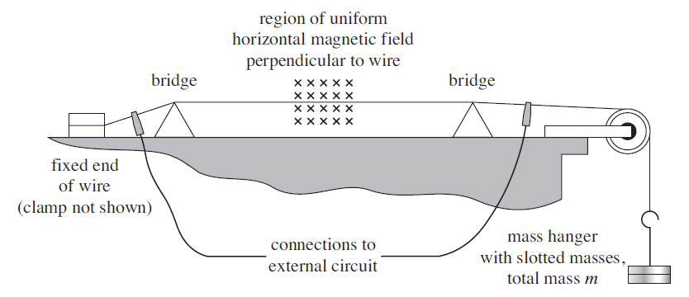

The diameter of the wire was measured several times with a micrometer and the following readings were obtained: 0.37 mm, 0.37 mm, 0.37 mm 0.37 mm and 0.37 mm.

For different masses, *m* on the end of the wire, the length between the bridges at resonance, *l* was found.

|  |  |  |  |
| --- | --- | --- | --- |
| *m* / g | *l* / mm | / kg½ | *l* / m |
| 100 | 333 |  |  |
| 150 | 407 |  |  |
| 200 | 462 |  |  |
| 250 | 514 |  |  |
| 300 | 564 |  |  |
| 350 | 601 |  |  |

Complete the table with values of the square root of *m* in kg ½ and *l* in metres.

Now plot a graph with *l* on the y-axis and on the x-axis.

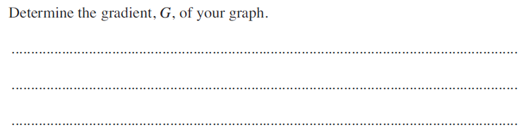

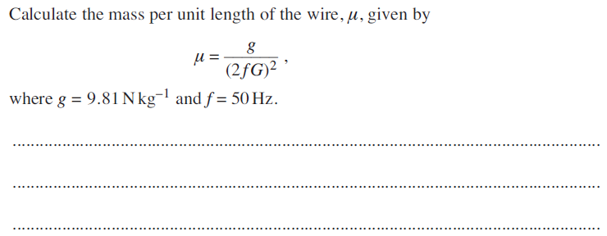

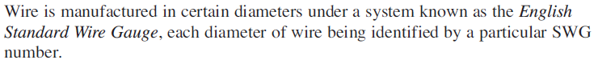

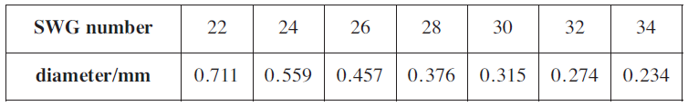

Use the SWG table to work out the SWG number of the wire used. SWG Number = …………………………..

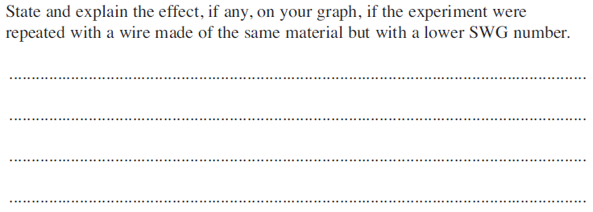

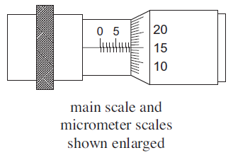The diameter of the wire was measured with a micrometer screw gauge with scales as shown.

What is the precision of the **main scale** of the micrometer screw gauge?

………………………………………………………………………………………………………

