**EMPA Style Data Analysis Question (Modified from 2009 Section B)**

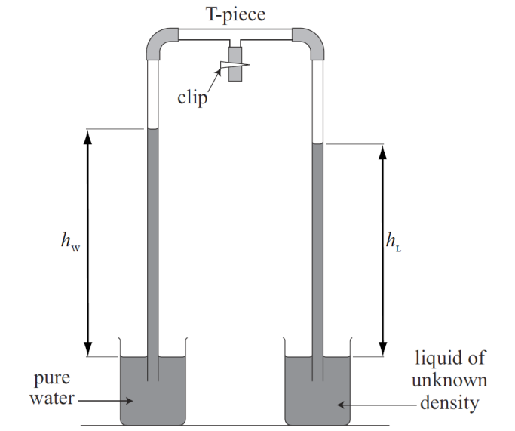The diagram shows a method known as ‘Hare’s apparatus’ to measure the density of an unknown liquid relative to water. Air is sucked out of the tube and the liquids rise up the tubes. The densities are related by the formula:

*Density of water x hW = Density of liquid x hL*

The following results were obtained by a student with an unknown liquid:

|  |  |
| --- | --- |
| *hL* / cm | *hW / cm* |
| 70.9 | 74.3 |
| 66.0 | 68.8 |
| 51.2 | 53.5 |
| 40.9 | 42.9 |
| 37.7 | 36.0 |
| 24.2 | 25.2 |

The density of water is 1000 kg m-3.

The student suspects that one row contains unreliable data. State and explain which row that is.

……………………………………………………………………………………………………………………………………………………………….

……………………………………………………………………………………………………………………………………………………………….

Ignoring the unreliable data, calculate the density of the liquid for each of the other rows and record the results in the table below:



|  |
| --- |
| *ρL* / kg m-3 |
|  |
|  |
|  |
|  |
|  |

Calculate the average density in your table and estimate the uncertainty in this measurement from the range of values in the table.

……………………………………………………………………………………………………………………………………………………………….

……………………………………………………………………………………………………………………………………………………………….

Readings of h were taken once to the nearest millimetre. For the third row in the table calculate the percentage uncertainty in hL and hW. Then use these values to calculate the percentage uncertainty in this single measurement.

……………………………………………………………………………………………………………………………………………………………….

……………………………………………………………………………………………………………………………………………………………….

Using your percentage uncertainty value, calculate the range of values for this single measurement. How does this compare with the range of results in your table?

……………………………………………………………………………………………………………………………………………………………….

……………………………………………………………………………………………………………………………………………………………….

Now plot a graph of *hW* on the y-axis against *hL* on the x-axis for all six results in the table.

How does the unreliable result show up on the graph?

……………………………………………………………………………………………………………………………………………………………….

Ignoring the unreliable result, draw a line of best fit through the other 5 points and measure the gradient of the line.

……………………………………………………………………………………………………………………………………………………………….

……………………………………………………………………………………………………………………………………………………………….

How is the density of the liquid related to the gradient of your graph and what is the density of the liquid?

……………………………………………………………………………………………………………………………………………………………….

……………………………………………………………………………………………………………………………………………………………….

Calculate the percentage difference between the average density value from the table and the value obtained from your graph.

……………………………………………………………………………………………………………………………………………………………….

……………………………………………………………………………………………………………………………………………………………….

Why is the graphical method a better way to analyse the results?

……………………………………………………………………………………………………………………………………………………………….

……………………………………………………………………………………………………………………………………………………………….