Dear Parents and Students,

# Extra resource materials for language learning

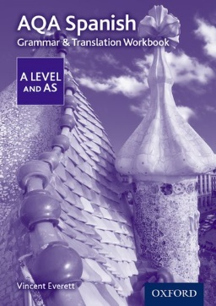*¡Bienvenidos! Welcome to the Spanish Department!*

Each year, we ask all our students to buy their own copy of the grammar and translation workbook we use in class so they can write in them. The book covers the AS and A Level course and costs **£8.50**. The Department will order the books if you pay online via the College payment system on the Parent Portal by **Monday 27th September 2021**.

[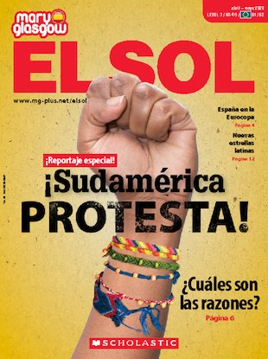](https://es.maryglasgowplus.com/magazines/issues/El-Sol-abril-mayo-2020-134114)We would also like to encourage our students to subscribe to the magazine ***El sol*** which provides valuable extra reading and listening material for students on the course. Five issues are published each year and each copy contains news articles on a wide range of examination topics, as well as exercises suitable for independent study. The ***El sol*** subscription comes with Audio files you can listen to online with transcripts, offering listening material linked to the topics and a website access with extra resources. <https://es.maryglasgowplus.com/magazines/El-Sol-78124>

The subscription for ***El sol*** magazine costs **£10.** If you would like to subscribe, please pay online through the Parent Portal also by **Monday 27th September 2021**.

Yours sincerely,



Jenny Pyburn

Course Leader for Spanish

**…………………………………………………………………………………………………**

1. [**AQA A Level Spanish: Grammar & Translation Workbook**](https://global.oup.com/education/product/9780198415558?region=uk) **£8.50 🞎**
2. ***El sol* SpanishMagazine subscription £10.00 🞎**