**IT BTEC Level 3**

**Preparation work: Pre-course Reading, Research and Tasks**

We hope that in the coming weeks and months you might have some time to familiarise yourself with BTEC IT and engage with the following preparatory work. The information given below will allow you to make a start on preparing for BTEC IT and make you feel confident and excited about joining our Department.

**Awards and Specifications:**

There are several qualifications under the heading BTEC Level 3 IT. The main two that we offer are the Diploma, which is equivalent to 2 A levels and the Extended Certificate, which is equivalent to 1 A level. Both are run over 2 years and you will find more details in the diagram below and the Pearson website link:

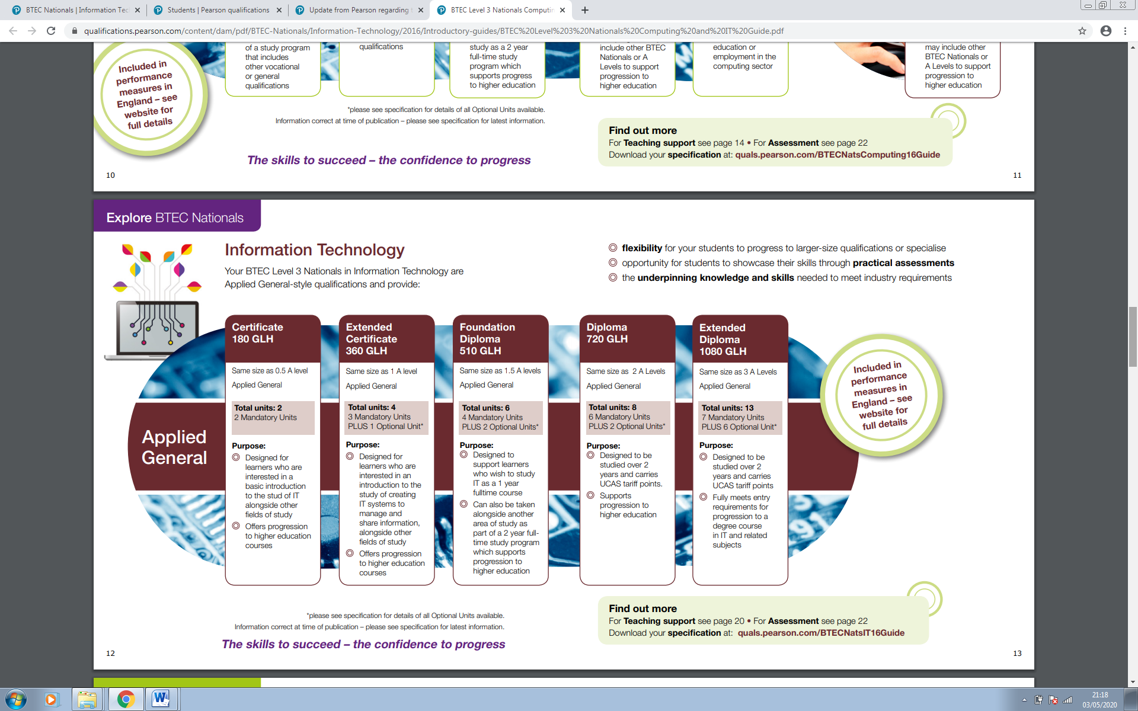

**Pearson website link:** <https://qualifications.pearson.com/en/qualifications/btec-nationals/information-technology-2016.html>

Should you have any questions about the specification or the following pre-enrolment tasks please do not hesitate to contact: [JoeMcCarthy-Holland@godalming.ac.uk](mailto:JoeMcCarthy-Holland@godalming.ac.uk)

**Task 1: Work Experience and Digital Badge Challenge**

Our course consists of one week of compulsory work experience, preferably within an IT area. The placement takes place in the College week, prior to February half term. In preparation for this placement please carry out the following:

1a Contact friends, family, local businesses/organisations to investigate whether they would be able to offer you a 30-hour placement. Ask them to complete the section below with the placement details – we will organise the placement from that point.

## DETAILS OF WORK PLACEMENT OFFER – 7-11thFebruary 2022

|  |  |
| --- | --- |
| **Name of Company** |  |
| **Name of Contact** |  |
| **Company Address**  **and Post Code** |  |
| **Contact Telephone Number** |  |
| **Contact Email Address** |  |
| **Assigned Department and Role** |  |
| **Brief Description of Duties** |  |
| **Expected Hours of Work**  *(minimum 30 hours)* |  |
| **Any Additional Information** |  |

Company Signature: _____________________________________ Date ___________

1b During the first year of the course we will ask you to work towards your Bronze Award on the Duke of York iDEA scheme (Don’t worry – no camping involved). Please register an account on the following link: <https://idea.org.uk/invite/9IP9W>

For this Task please complete badges: Team Worker; Safe Online; eSafety in preparation for the start of term. You might even have a go at some of the other badges, such as Make a Game, Social Media setup, Coding, etc. Have fun ….. however, beware it can become addictive!

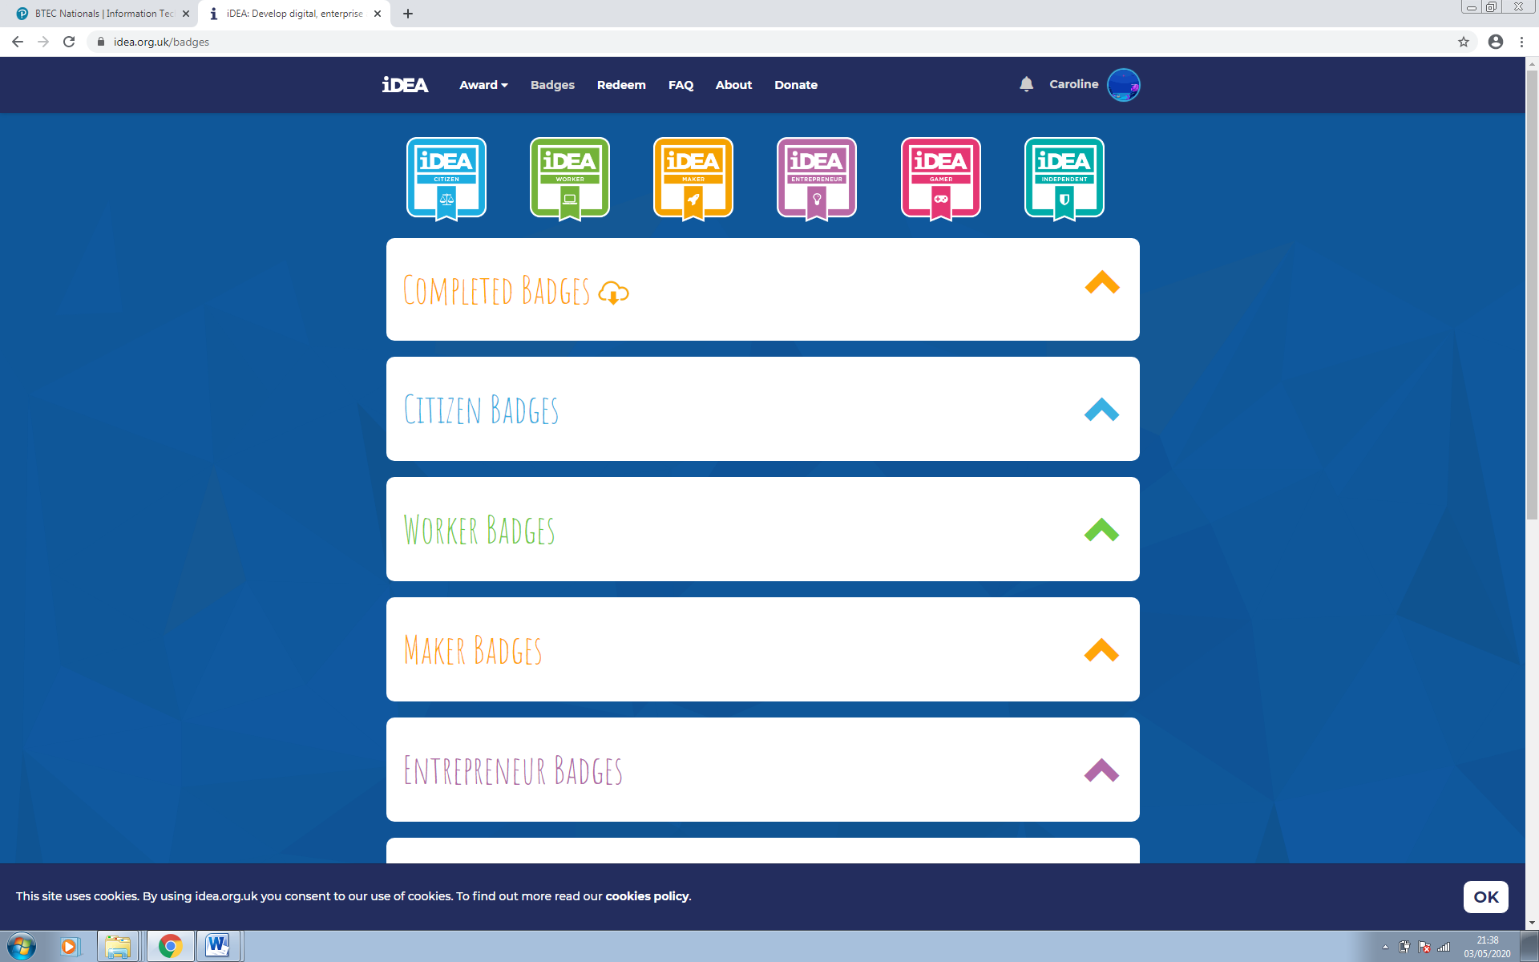

**Task 2: Films, TV Programmes & Podcasts**

Keep up to date with technological developments with the following: Watch/listen to at least ONE from each section below and write a summary for each.

**TV:** **BBC CLICK** – also available online

**Podcasts:** From BBC Sounds – **Ways of Thinking; 3D Bioprinting;**

**The Rise of the Robots; GCHQ Cracking the code; The Turing Solution**.

**Films:** **The Imitation Game** (2014 film with Benedict Cumberbatch)

**The Theory of Everything** (2014 film with Eddie Redmayne)

Include in your summary: A description of the content; what you learnt; what most interested you; and what you might wish to investigate further.

**Task 3: Learn to Code**

Throughout the past year we have all been asked to learn a new skill. Why not learn to code? Programming is one of the BTEC IT units and gaining skills in Python would be a good starting point. Use the following website to develop your Python coding skills:[www.codecademy.com](http://www.codecademy.com)

**Task 4: What is Social Media?**

4a Give a definition for ‘What is Social Media?’ Quote your information source.

4b Research and list the most popular social media sites. Quote your information source.

4c If you were to create a social media site/app, what would you called it and design a logo?

Name of site/app: __________________________

Purpose of site/app: ____________________________________________________

Design of Logo:

**Task 5: Get Creative**

We are not judging your art skills, but would like you to use the template on the next page to create a design for a new computer game idea. You can hand-draw or computer to generate your ideas. Bring the completed template along to your first BTEC IT lesson.

*We hope you enjoy completing these tasks and look forward to you joining the course.*

 Department of Digital & Creative Technology

**DESIGN YOUR OWN NEW GAME My Name: ________________________**

Name of my new game: ___________________ Game genre: _______________________

Storyline: __________________________________________________________________

___________________________________________________________________________

New Character Design Grid New Room/Layout Design Grid

|  |  |  |  |  |  |  |  |  |  |  |  |  |  |  |  |  |  |  |  |  |  |  |  |  |  |  |  |  |  |  |  |  |  |  |  |  |  |  |  |  |
| --- | --- | --- | --- | --- | --- | --- | --- | --- | --- | --- | --- | --- | --- | --- | --- | --- | --- | --- | --- | --- | --- | --- | --- | --- | --- | --- | --- | --- | --- | --- | --- | --- | --- | --- | --- | --- | --- | --- | --- | --- |
|  |  |  |  |  |  |  |  |  |  |  |  |  |  |  |  |  |  |  |  |  |  |  |  |  |  |  |  |  |  |  |  |  |  |  |  |  |  |  |  |  |
|  |  |  |  |  |  |  |  |  |  |  |  |  |  |  |  |  |  |  |  |  |  |  |  |  |  |  |  |  |  |  |  |  |  |  |  |  |  |  |  |
|  |  |  |  |  |  |  |  |  |  |  |  |  |  |  |  |  |  |  |  |  |  |  |  |  |  |  |  |  |  |  |  |  |  |  |  |  |  |  |  |
|  |  |  |  |  |  |  |  |  |  |  |  |  |  |  |  |  |  |  |  |  |  |  |  |  |  |  |  |  |  |  |  |  |  |  |  |  |  |  |  |
|  |  |  |  |  |  |  |  |  |  |  |  |  |  |  |  |  |  |  |  |  |  |  |  |  |  |  |  |  |  |  |  |  |  |  |  |  |  |  |  |
|  |  |  |  |  |  |  |  |  |  |  |  |  |  |  |  |  |  |  |  |  |  |  |  |  |  |  |  |  |  |  |  |  |  |  |  |  |  |  |  |
|  |  |  |  |  |  |  |  |  |  |  |  |  |  |  |  |  |  |  |  |  |  |  |  |  |  |  |  |  |  |  |  |  |  |  |  |  |  |  |  |
|  |  |  |  |  |  |  |  |  |  |  |  |  |  |  |  |  |  |  |  |  |  |  |  |  |  |  |  |  |  |  |  |  |  |  |  |  |  |  |  |
|  |  |  |  |  |  |  |  |  |  |  |  |  |  |  |  |  |  |  |  |  |  |  |  |  |  |  |  |  |  |  |  |  |  |  |  |  |  |  |  |
|  |  |  |  |  |  |  |  |  |  |  |  |  |  |  |  |  |  |  |  |  |  |  |  |  |  |  |  |  |  |  |  |  |  |  |  |  |  |  |  |
|  |  |  |  |  |  |  |  |  |  |  |  |  |  |  |  |  |  |  |  |  |  |  |  |  |  |  |  |  |  |  |  |  |  |  |  |  |  |  |  |
|  |  |  |  |  |  |  |  |  |  |  |  |  |  |  |  |  |  |  |  |  |  |  |  |  |  |  |  |  |  |  |  |  |  |  |  |  |  |  |  |
|  |  |  |  |  |  |  |  |  |  |  |  |  |  |  |  |  |  |  |  |  |  |  |  |  |  |  |  |  |  |  |  |  |  |  |  |  |  |  |  |
|  |  |  |  |  |  |  |  |  |  |  |  |  |  |  |  |  |  |  |  |  |  |  |  |  |  |  |  |  |  |  |  |  |  |  |  |  |  |  |  |
|  |  |  |  |  |  |  |  |  |  |  |  |  |  |  |  |  |  |  |  |  |  |  |  |  |  |  |  |  |  |  |  |  |  |  |  |  |  |  |  |
|  |  |  |  |  |  |  |  |  |  |  |  |  |  |  |  |  |  |  |  |  |  |  |  |  |  |  |  |  |  |  |  |  |  |  |  |  |  |  |  |

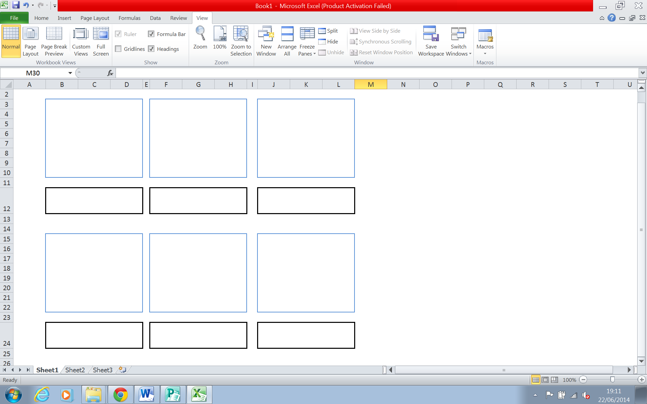Storyboard the Key Scenes