COASTAL MANAGEMENT – PART 1 (Traditional Approaches)
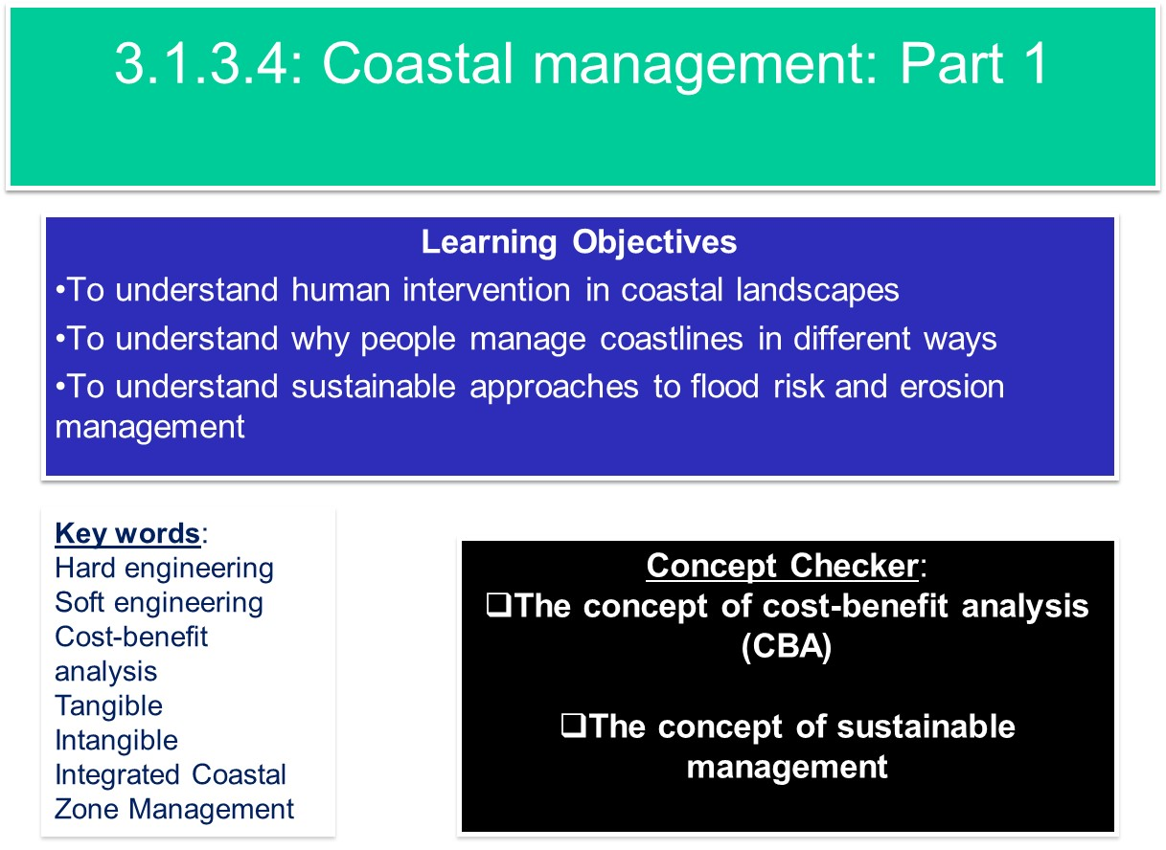
Human intervention at the coast – class discussion
- Why should we manage the coastlines?

- Why might some stretches of coastline be managed differently?

- What techniques could be used to manage different coastlines?

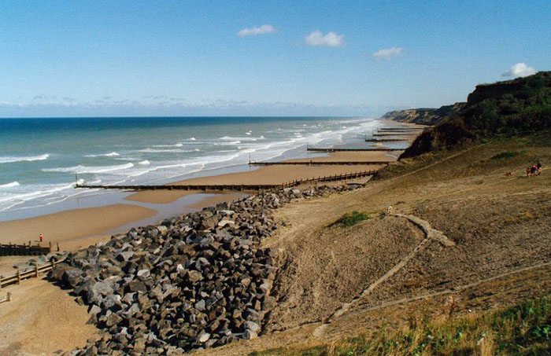

Hard engineering – Making a physical change to the coastal landscape using resistant materials, like concrete, boulders, wood and metal.

Soft engineering – Using natural systems for coastal defence, such as beaches, dunes and saltmarshes, which can absorb and adjust to wave and tide energy.

Traditional approaches have involved direct action – hard and soft engineering that focuses on relatively short stretches of coastline intended to stop or slow down erosion or reduce the risk of flooding. The cost of protecting the coast is controversial. Each method has its advantages and disadvantages.

Defence (Soft or Hard?) | Description, Example (HOLDERNESS GEOFACTSHEET 141) & £ | Good Points | Bad Points
Groynes
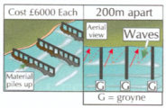
Sea Walls
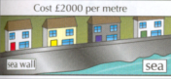
Gabions
Revetments
Offshore Breakwater
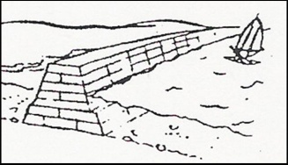
Armour Blocks/Rip Rap

Barrages
E.g. Thames Barrier
Cliff Regrading / fixing and Drainage
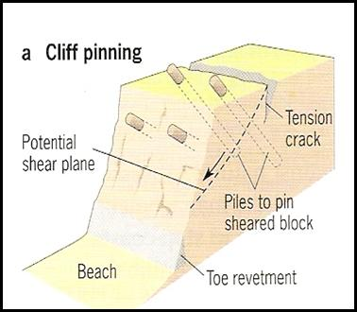

Defence (Soft or Hard?) | Description, Example (HOLDERNESS GEOFACTSHEET 141) & £ | Good Points | Bad Points
Marsh Creation
Beach Nourishment
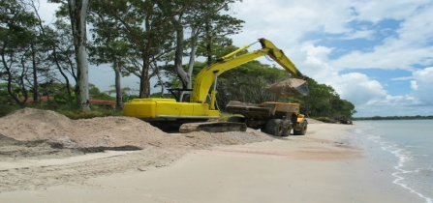
Dune Stabilisation & planting
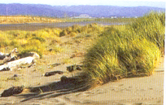
Managed Retreat & land use management
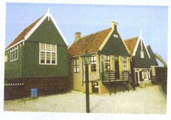

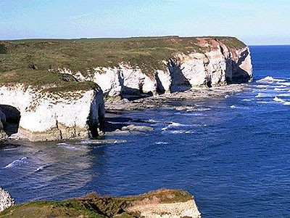
Hard Engineering Case Study: Holderness
The Holderness coastline in the north-east of England is a good coastal case study to exemplify how hard engineering works in reality.
- Draw an outline of the Holderness coastline from Flamborough Head to the Humber Estuary.
  - Annotate the map with the sub-cell of the main sediment cell (Flamborough Head to the Humber Estuary)
  - Annotate the map with the key place names and facts about places – villages and towns affected by erosion and coastal management
  - Annotate the map with types of hard engineering present at the key locations, summarising why they are used

Use the following resources to help you: the PPT, the Holderness case study documents on Godalming Online (21Coastal Management CS.pdf and Geofactsheet 141), and video clip: https://www.youtube.com/watch?v=Vq2GupfgAtQ (Use of a case study for exam questions - although GCSE it is detailed for this part of the A level)

Soft Engineering Case Study: ESSEX Saltmarshes
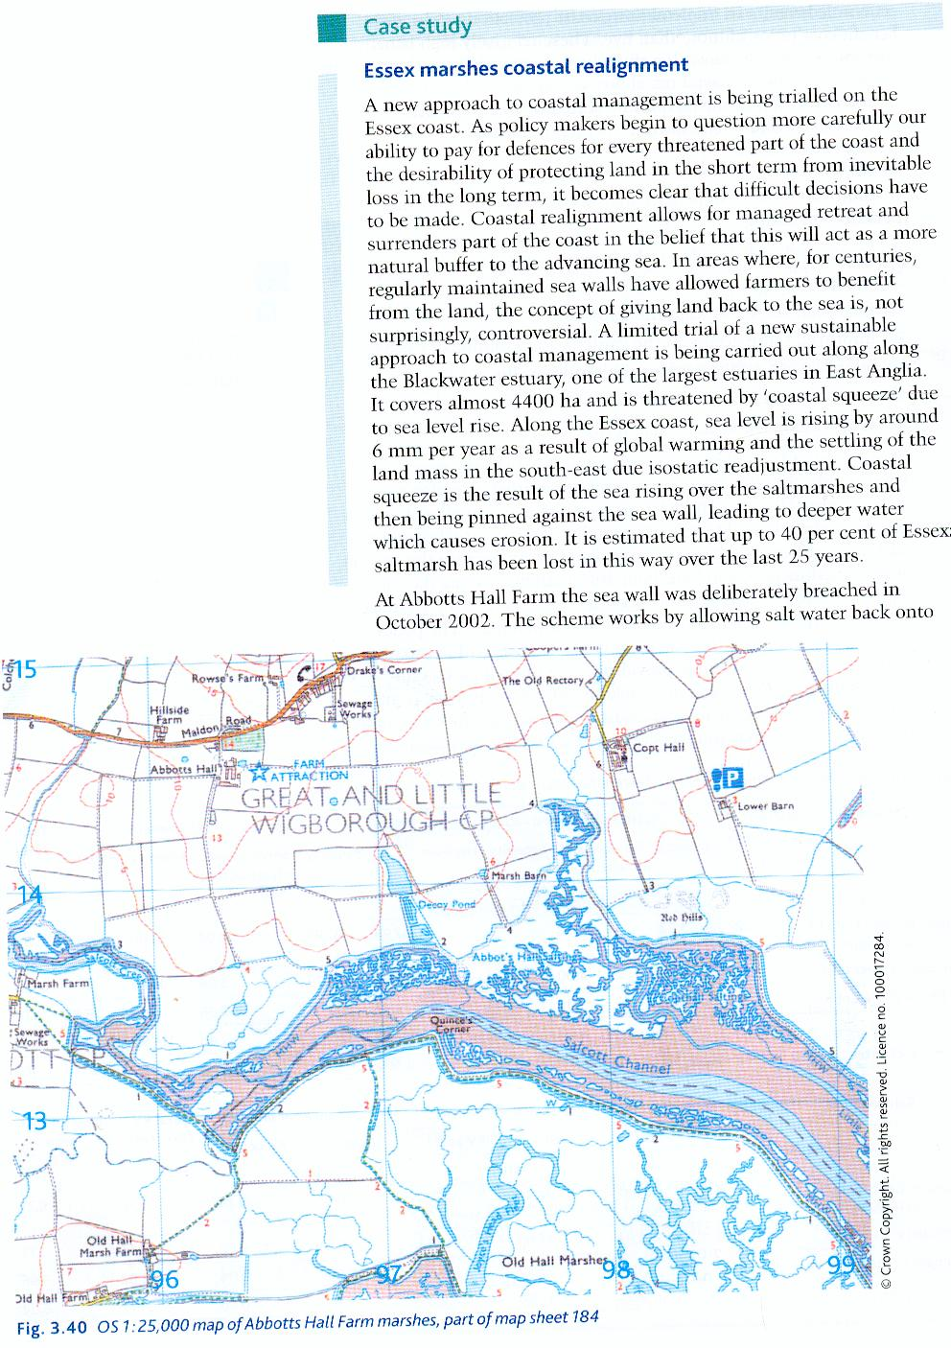
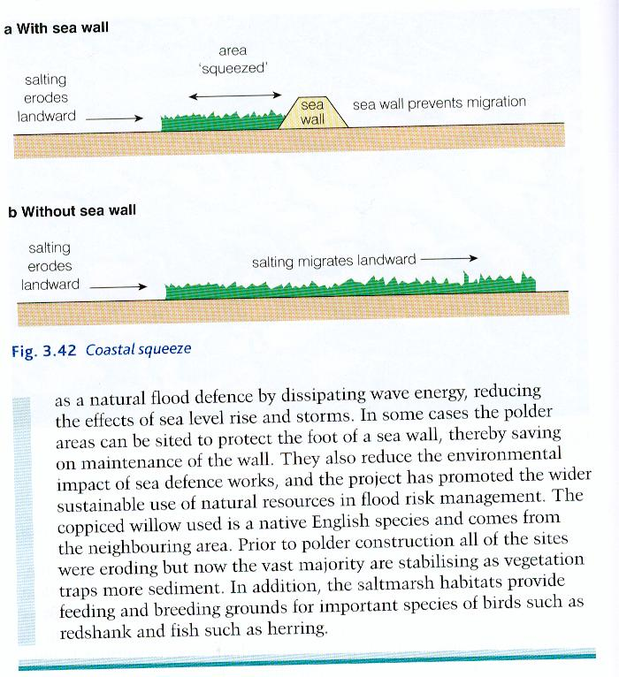
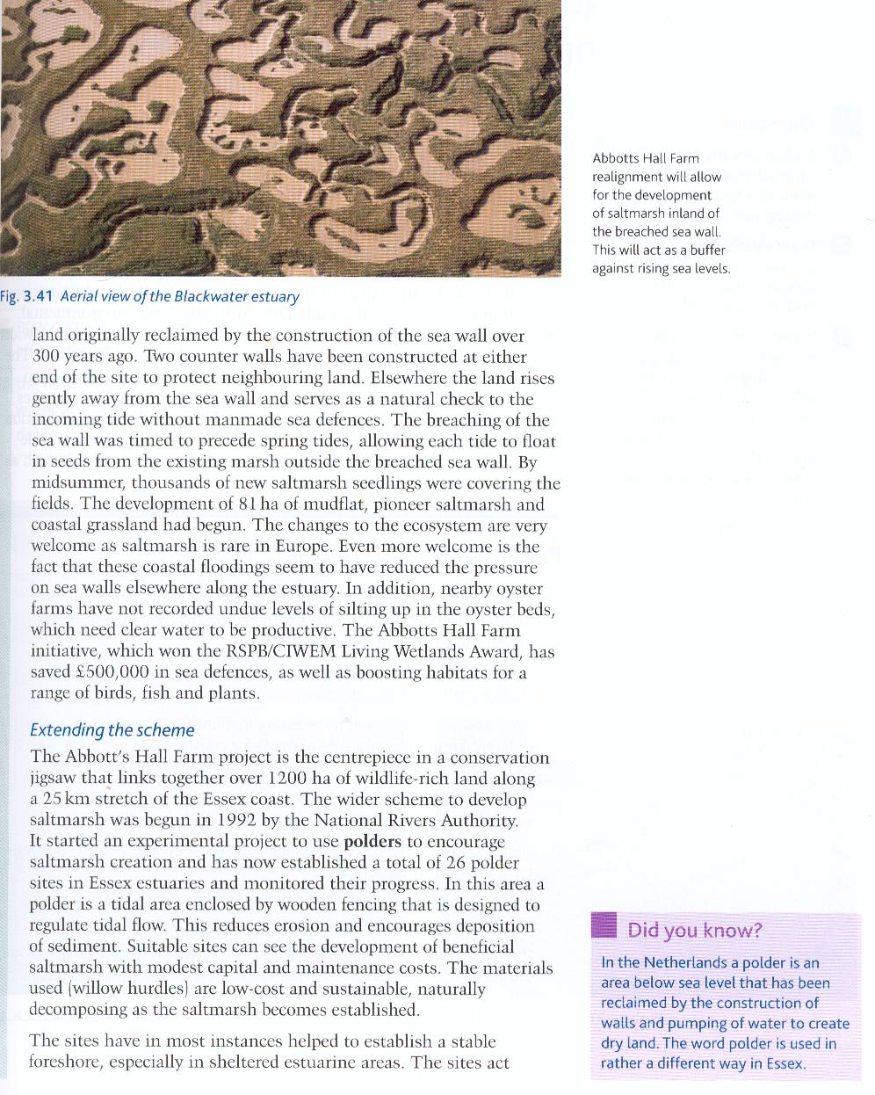

Student Task:

What is ‘coastal squeeze’?
How much is the sea level rising along the Essex coastline and why is this happening?
What is the purpose of allowing the sea wall at Abbotts Hall Farm be breached?
What positive changes has this sea wall breaching at Abbott Farm Hall bought about?
What disadvantages are associated with managed realignment?
What is a polder and how many are there along the Essex coastline?
. What are the benefits of using polders to create salt marsh along the Essex coast?

Explain why the Abbotts Hall farm scheme is regarded by many as a sustainable way of dealing with sea level rise.

DISCUSS & REVIEW: Different approaches to coastal management

1. Identify the characteristics of the Holderness and Essex coastline, which create the need for protection.

2. Coastal protection began a long time ago in Holderness compared to Essex. Explain why this occurred, and comment on the variations in style of coastal defences which result.

3. Use the information on Holderness sea defences, and any of your own research, to summarise the nature and visual impact of the area’s hard engineering structures.

4. To what extent do you think it is true that people are becoming increasingly less tolerant of the appearance of large hard engineering structures at the coast? Use evidence from case studies you have researched to support your answer.

5. Use the material on Essex’s (Blackwater Estuary) soft engineering and any of your own research to summarise the nature and visual impact of such methods.

6. Comment on the sustainability and drawbacks of both hard and soft approaches used by Holderness and Essex.

7. Consider which of hard and soft engineering projects are:

- visually more attractive

- cheaper

- more effective as sea levels rise and frequency of storms increases

- more likely to be utilised in the future.

8. From the points of view of various stakeholders (residents, local councils, the Environment Agency, national government, users of recreational space, etc.), which would be the preferred approach to coastal management?

9. Following your discussions on the above, complete an essay plan for the following question, using the outline approach on the next page:

A hard engineering coastal protection strategy may be the best option, even when soft engineering options are available. To what extent do you agree with this statement? [20 marks]
BUG the question – BOX the command words, UNDERLINE the Geography, GLANCE back at the question

20 MARK QUESTION PLAN

