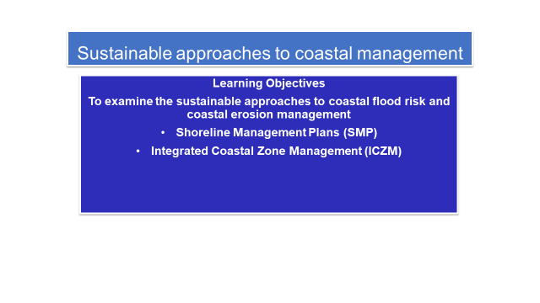

**Shoreline Management Plans (SMPs)**

Who should decide whether coastal management schemes should be implemented and what they should be?

What is the issue if Local Authorities are the ones making the decisions?

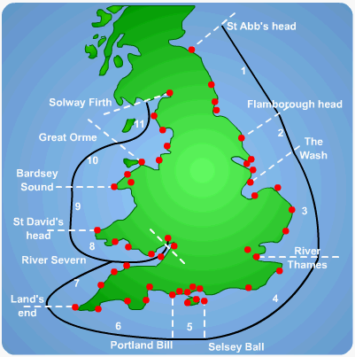

* To avoid a piecemeal approach to coastal management an integrated system of SMPs was introduced in 1995 by the national government.
* There are 22 SMPs which correspond to the sediment cells and sub cells around the coast of England and Wales.
* Their aim is to identify the most sustainable approach to managing the different sections of coastline in the short term (0-20 years), medium term (20-50 years) and the long term (50-100 years)
* They consider the social, economic and environmental activities around the shoreline to achieve the best possible balance.

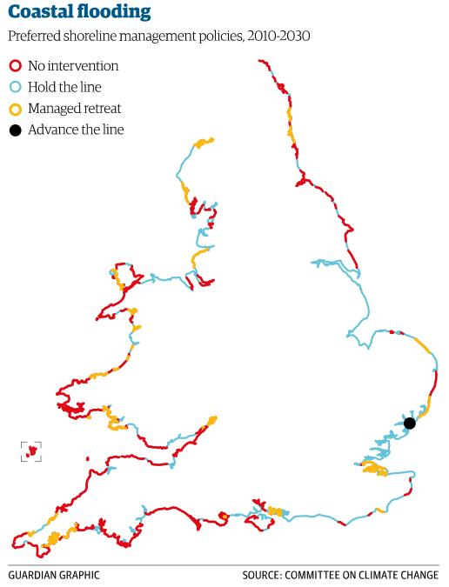**The 4 approaches used**

Each SMP describes how each management unit or stretch of coastal covered by the plan is to be managed.

What kind of management strategies do you think are used for the following:-

Hold the line –

Advance the line –

**Analyse the map of preferred shoreline management policies.**

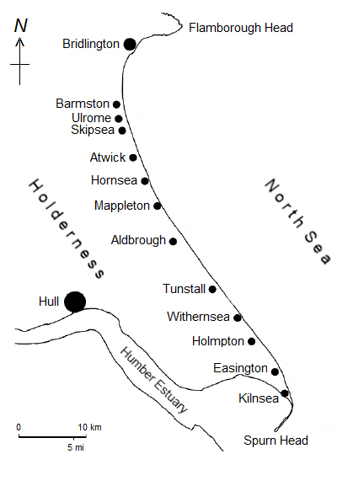

Use the Shoreline Management Maps below to annotate the map of the Holderness Coast on p2.

Include information on the strategy chosen for the short, medium and long term. Include why you think these strategies have been chosen.

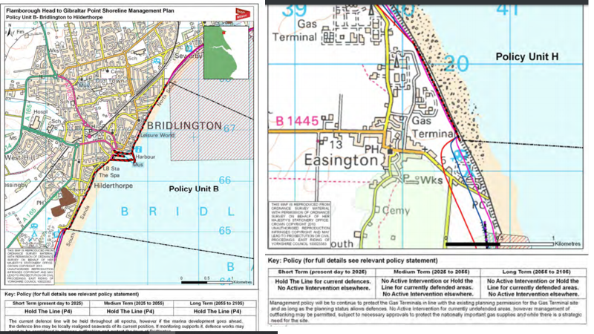

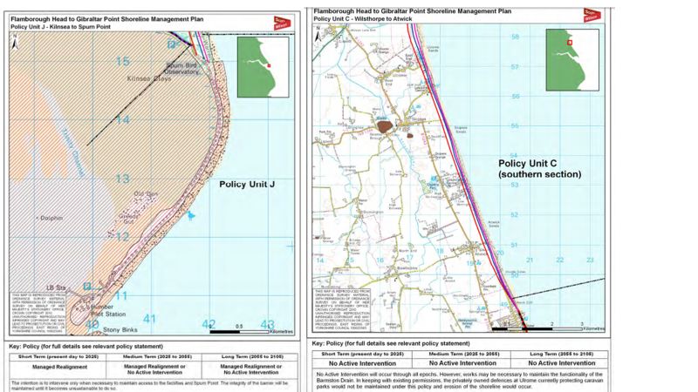

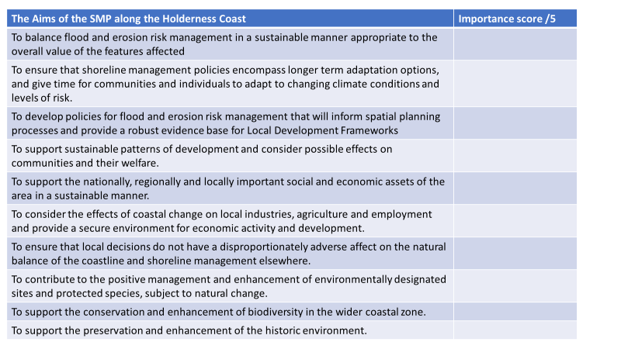

Pick 5 of these aims to memorise for the exam. Make sure that they are a range of ideas, with some more important than others so that you can assess.

**Integrated Coastal Zone Management – ICZM**

The SMPs deal with just the shoreline sections of the coast.

However, there has been a growing awareness around the world that SMPs should be coordinated with other policies affecting the coastal zone.

The term ‘integrated coastal zone management’ originated from the UN Earth Summit of Rio de Janeiro in 1992 and was taken up by the European Commission. It deals with the zone extending from off-shore to inland and not just the shoreline.

**Aims of ICZM:-**

**To coordinate the application of the different policies affecting the coastal zone**

1. **Why do you think ICZMs are needed?**
2. **Why do you think coastal management is a global issue?**

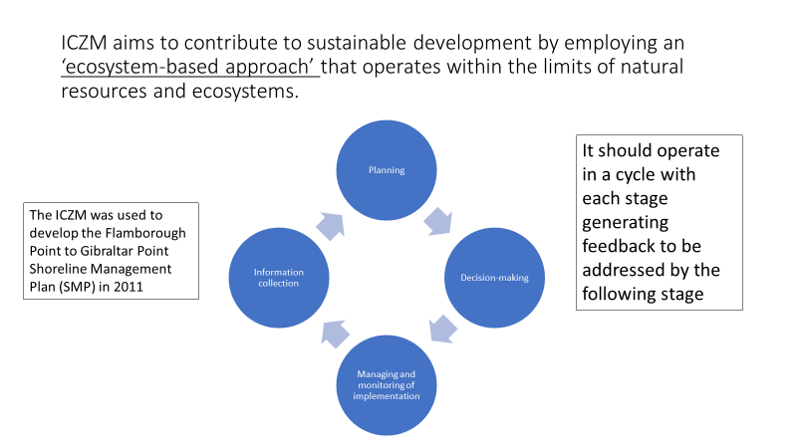

**The ICZM states that it is important to involve all stakeholders across the different sectors to ensure broad support for the implementation of management strategies.**

Key stakeholders for Holderness involved in developing the SMP:-

* The East Riding of Yorkshire Council
* National government agencies – Environment Agency, Natural England
* Local government – Lincolnshire County Council, North East Lincolnshire Council, East Lindsey District Council
* Stakeholders in the economy – The National Farmers Union
* Environment stakeholders – English Heritage

What are the specific issues facing coastal environments in the future?

**Possible exam questions**

* Assess the advantages of management plans such as Shoreline Management Plans (SMPs) and Integrated Coastal Zone Management (ICZM). (9 marks)
* ‘Sustainable approaches to coastal management will become more important than traditional approaches in dealing with the impacts of climate change’. To what extent do you agree with this view? 20 marks (AS 2018)
* Assess the relative advantages and disadvantages of using soft engineering coastal protection methods. (9 marks)