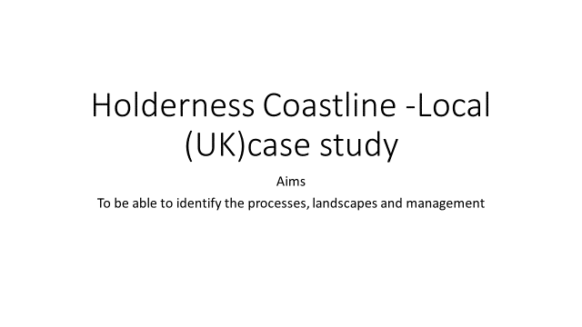

Watch the following video clip and answer the questions on the sheet.

**The Holderness Coastline – estream** [**http://estream.godalming.ac.uk/View.aspx?ID=4586~4x~8zS48MtV**](http://estream.godalming.ac.uk/View.aspx?ID=4586~4x~8zS48MtV)

What 3 things affect the speed of erosion?

What processes are operating on the cliffs?

What direction is the prevailing wind and what direction is LSD?

Why is Spurn Head Spit important for the Humber Estuary?

What landform features are found at Flamborough Head?

How do councils decide whether to build coastal defences?

What are the 3 main centres of population that the council have decided to protect?

Why, despite having a small population have they protected Mappleton?

What hard engineering approaches did they use at Mappleton?

What additional benefits have there been as a result of the coastal defences having been built?

Why is it important to protect Easington?

What has happened to the land south of the groynes at Mappleton?

Why are the building of coastal defences not a long term solution?

Why is Kilnsea village under threat from two directions?

Why have the Environment Agency refused to build coastal defences?

What have the locals done and why is this not a long term solution?

What is the roll back scheme that Sandy beaches caravan park qualify for?

Other than to protect the Humber estuary from increased erosion, why is Spurn Head valuable?

How is Spurn Head changing?

**The Physical Processes and Landscapes – The Holderness Coast**

Resources to use:-

Oxford textbook p144-146, Tutor 2 U resources on Holderness and the information from the video clip

Draw a blank outline of the Holderness coastline on an A3 piece of paper (p144 Oxford has a clear map)

Annotate your map with information on the following:-

* Geology (Lithology and rock structure)
* Processes operating on the coastline – include erosion, transportation, deposition, weathering and mass movement
* Landforms found along the coast
* Include information of the different temporal factors – e.g. which landform was formed 75 million years ago etc

**Coastal Management – The Holderness Coast**

Resources to use:-

Oxford textbook p144-146, Tutor 2 U resources on Holderness and the information from the video clip

Draw a blank outline of the Holderness coastline on an A3 piece of paper (p144 Oxford has a clear map)

Annotate your map with information on the following:-

* The coastal management strategies at the following places:-
  + Bridlington, Hornsea, Withernsea, Easington, Kilnsea, Spurn Head and Mappleton
  + You will need to add additional detail for Mappleton as it could be used as one specific management scheme
  + Don’t forget to include information on the SMPs for this section of the coastline
  + Include information on the impact coastal defences are having on the Humber Estuary

**Analyse the need for, and evaluate the success of, a coastal management scheme you have studied (20 marks)**