**Key terms:**

**Viscosity Shield volcano Composite volcano VEI Rhyolite Andesite Basalt Effusive Explosive**

**3.1.5.3 Volcanic Hazards**

**The nature of vulcanicity and its relation to plate tectonics: forms of volcanic hazard: nuées ardentes, lava flows, mudflows, pyroclastic and ash fallout, gases/acid rain, tephra. Spatial distribution, magnitude, frequency, regularity and predictability of hazard events.**

**Impacts: primary/secondary, environmental, social, economic, political. Short and long-term responses: risk management designed to reduce the impacts of the hazard through preparedness, mitigation, prevention and adaptation.**

**Impacts and human responses as evidenced by a recent volcanic event.**

**What is a Volcano?**

An opening in the earth’s crust, connected underground to a magma chamber from which molten lava, gases, steam and pyroclastic material are ejected. Watch: <https://www.youtube.com/watch?v=VNGUdObDoLk>

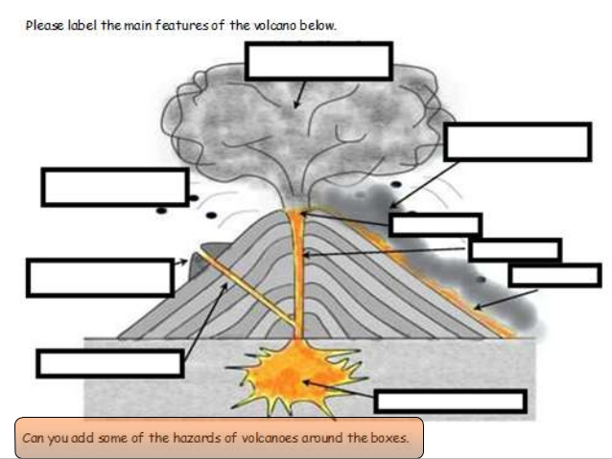

**Can you remember the features of a volcano?**

Molten rock beneath the surface is called ______________, but when it is ejected at the surface it is called lava.

Magma, in addition to molten rock, may also contain suspended crystals and dissolved _____ and sometimes also gas bubbles. Magma often collects in magma _____________ that may feed a volcano or turn into a pluton.

Underground, the enormous pressures exerted by overlying rocks keeps hot rocks in a _______________ state.

Fissures and fractures in the crust create areas of lower pressure that allow some of the rocks to become molten and rise.

If these molten rocks reach the surface they are said to be _______________________. If they are injected in to the crust without reaching the surface they are called intrusive.

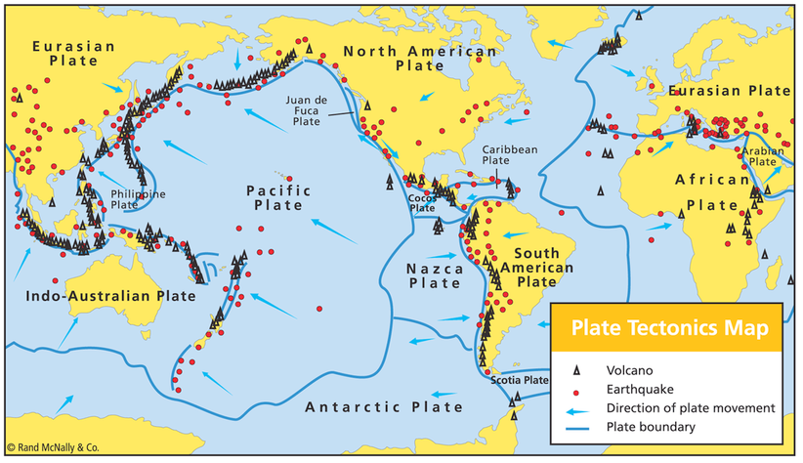**The spatial distribution of volcanoes**

Describe the distribution of volcanic activity and identify how it relates to the theory of plate tectonics.

Distribution of volcanic activity:

How it relates to the theory:

**What determines the severity of a volcanic hazard?**

For each of the factors identified explain what impact they may have.

* The magnitude – explosivity;
* The type of eruption e.g. gas, ash, lava, pyroclastic;
* The aerial extent;
* The duration;
* Speed of onset
* **Primary volcanic effects**
* Primary volcanic effects relate to material ejected from the volcano.
* Complete the table below using the information from the website to explain their effects and any relevant case study mentioned. <https://volcanoes.usgs.gov/vhp/hazards.>[html](https://volcanoes.usgs.gov/vhp/hazards.html)

|  |  |
| --- | --- |
| Ash and Tephra |  |
| Lava flows |  |
| Pyroclastic events (Nuees ardentes) |  |
| Volcanic gases |  |

**Volcano mini case studies**

**Watch and make notes on each of the volcanoes below - e-stream 4663**

| Name of volcano | Date, eruption type, impacts etc  Remember to include facts and figures |
| --- | --- |
| Etna |  |
| Lake Nyos |  |
| Krakatoa |  |
| Kiluea |  |
| Pinatubo |  |

**Volcanoes can be classified as active, dormant or extinct**

**Active**: Has erupted regularly in living memory. Example: Mauna Loa

**Dormant**: have erupted within historical record and still capable of erupting. Example: Mount Fuji (last erupted 1707)

**Extinct**: will not erupt again and is now cut off from magma supply. Example: Mount Snowdon

*What do you think could be problematic about this kind of classification?*

**What factors affect the nature of volcanic effects and features?**

1) The type of plate boundary: whether it is constructive, destructive or intra-plate (hot spot).

2) The nature of the magma:

* Viscosity: silica, gas and water content;
* Basic 🡪 Andesitic 🡪 Rhyolitic;
* Explosivity: Volcanic Explosvitiy Index

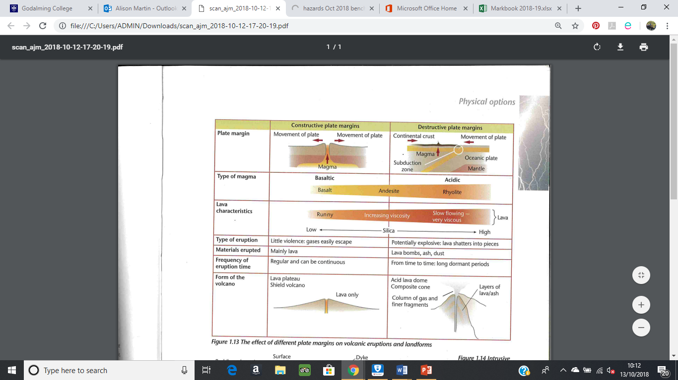**The effect of different plate margins on volcanic eruptions**

As lava decreases in mobility it increases in explosivity.

The higher the gas content the greater the explosivity.

The higher the water content of the magma the more vapour (gas) is produced.

In a viscous lava this increases the pressure and can lead to more violent eruptions.

1) Use the information in the table to summarise the effects of constructive and destructive margins on:

* Type of magma and lava characteristics:
* Type of eruption and materials erupted:
* Form of the volcano:

2) Explain why eruptions at destructive margins are more explosive.

**The type of lava (magma) will affect the nature of eruptions. Lava can be:**

* Basaltic
* Andesitic
* Rhyolitic

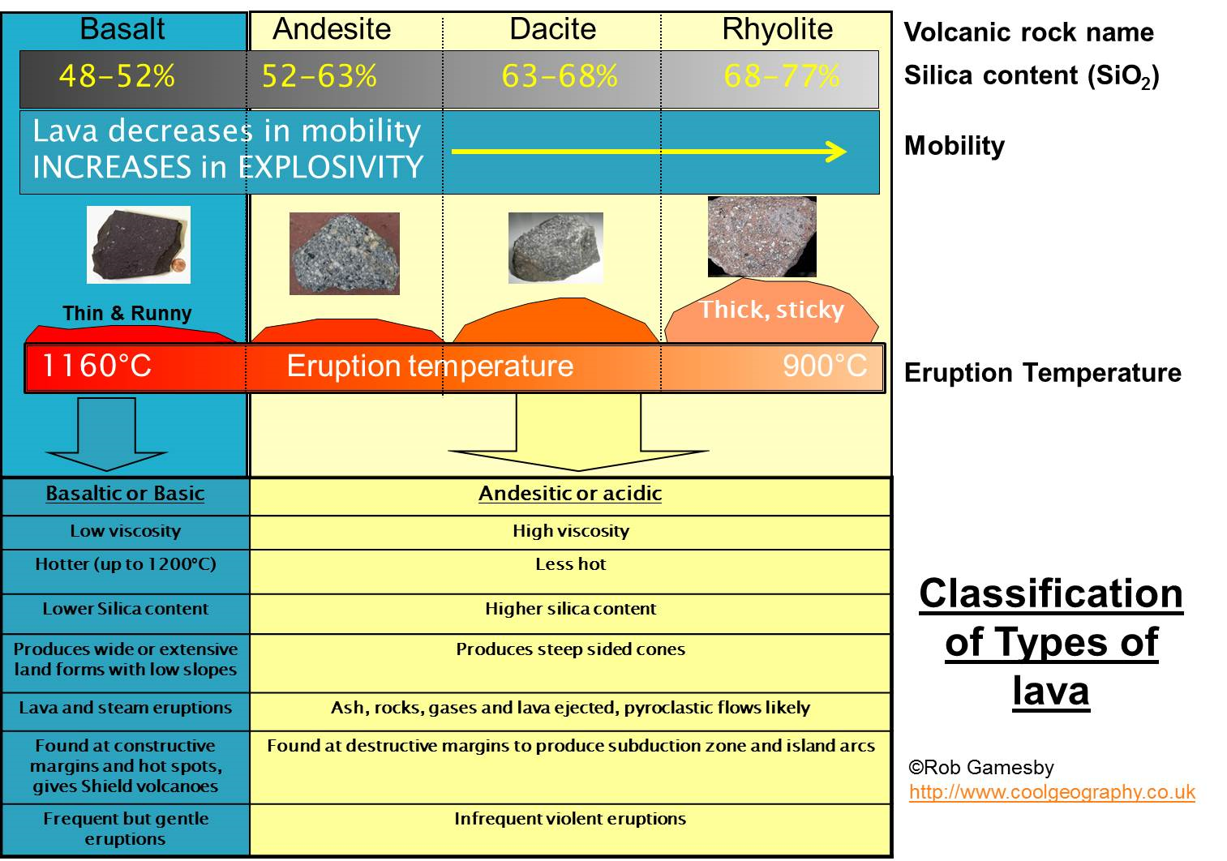The **viscosity** of lava (how runny/thick it is) is determined by the amount of Silica (SiO2), gas and water content. The more viscous the lava the more explosive the eruption is likely to be.

**Basaltic (basic) lava**

Lava low in ________ (making it more fluid). ______ bubbles freely expand as the magma rises to the surface, resulting in a ________________eruption**.**

Relatively high temperatures from 1100 to __________

Andesitic (Intermediate) and Rhyolitic (acid) lava.

Lavas __________ in Silica**. Viscous** (______________ and sticky). Gas bubbles struggle to expand, leading to build up of _______________and **violent** eruption.

Lower temperature ________ to 1000oC.

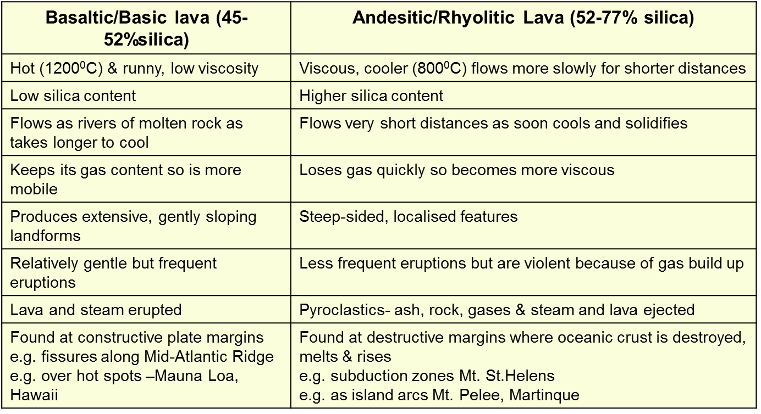

**The type of eruption (magnitude) can also be classified as follows:**



**Look at your notes from the video ’10 thing you didn’t know about volcanoes’; can you identify which eruption type the five examples would fit into?**

**Explain the links between these different eruptions and the type of magma/lava.**

**How useful is this way of classifying volcanoes in terms of understanding the nature of eruptions?**

**Volcanoes can be classified by their magnitude, or explosivity.**

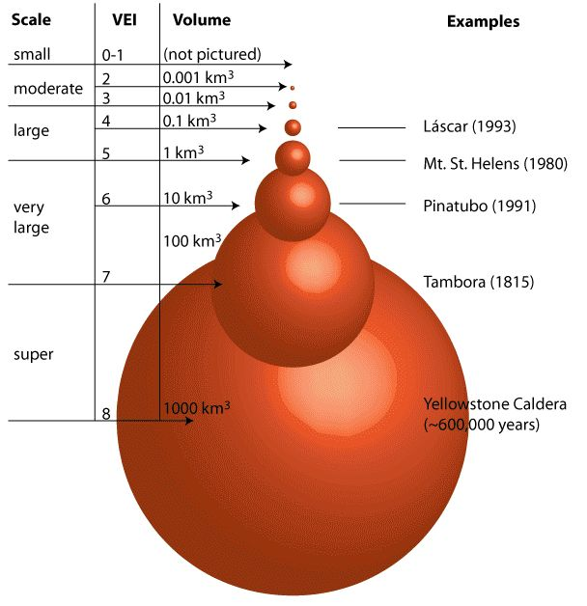The main method of measurement of magnitude has been the VEI – volcanic explosivity index, a logarithmic scale running from 0-8. Quiet lava producing eruptions score 0-1 whereas the pyroclastic explosion of Mt St Helens scored 5.

*Critics of the VEI point out that it does not take into account gas emissions or the atmospheric/climatic impact of eruptions.*

**Volcanoes can also be classified by volcano shape**

*Annotate details from the slide:*

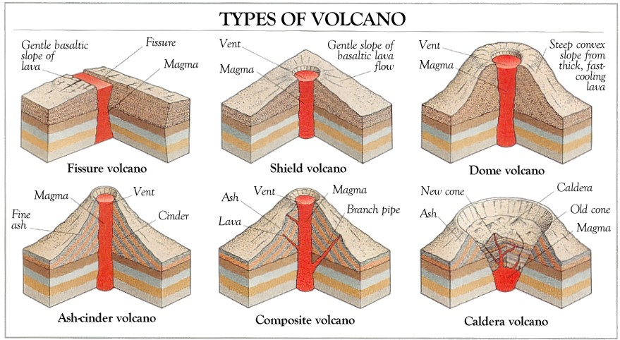

**Suggest what causes the shape of the volcano to change:**

**Look back at the different ways of classifying volcanoes we have studied. Overall how successful do you think they are? *Discuss your thoughts with a partner.***

**Frequency and regularity**

The frequency and regularity of eruptions are almost impossible to measure accurately. Volcanoes such as Mount St Helens and Chances Peak, Montserrat, were thought to be long-term dormant or extinct but their eruptions in 1980 and 1995-7 respectively proved them to be anything but.

**Predicting volcanic eruptions**

Volcanic eruptions tend to follow weeks of seismic activity and other warnings. As long as active and dormant volcanoes are monitored warnings of imminent eruptions can be issued to authorities. Prediction is generally successful and can be aided by evidence from previous eruptions, e.g. pyroclastic deposits along river valleys. Hazard maps can identify those areas most at risk.

**Primary volcanic hazards (impacts)**

Ash and tephra

Lava flows

Pyroclastic events (nuées ardentes)

Volcanic gases

Which hazard has the greatest impact in terms of:

1. Spatial distribution
2. Aerial extent
3. Magnitude
4. Frequency
5. Regularity and predictability of hazard events.

**Use your homework on Primary volcanic hazards to help you. *Overall, which primary hazard do you consider to be the most dangerous and why?***

**Practise exam question:**

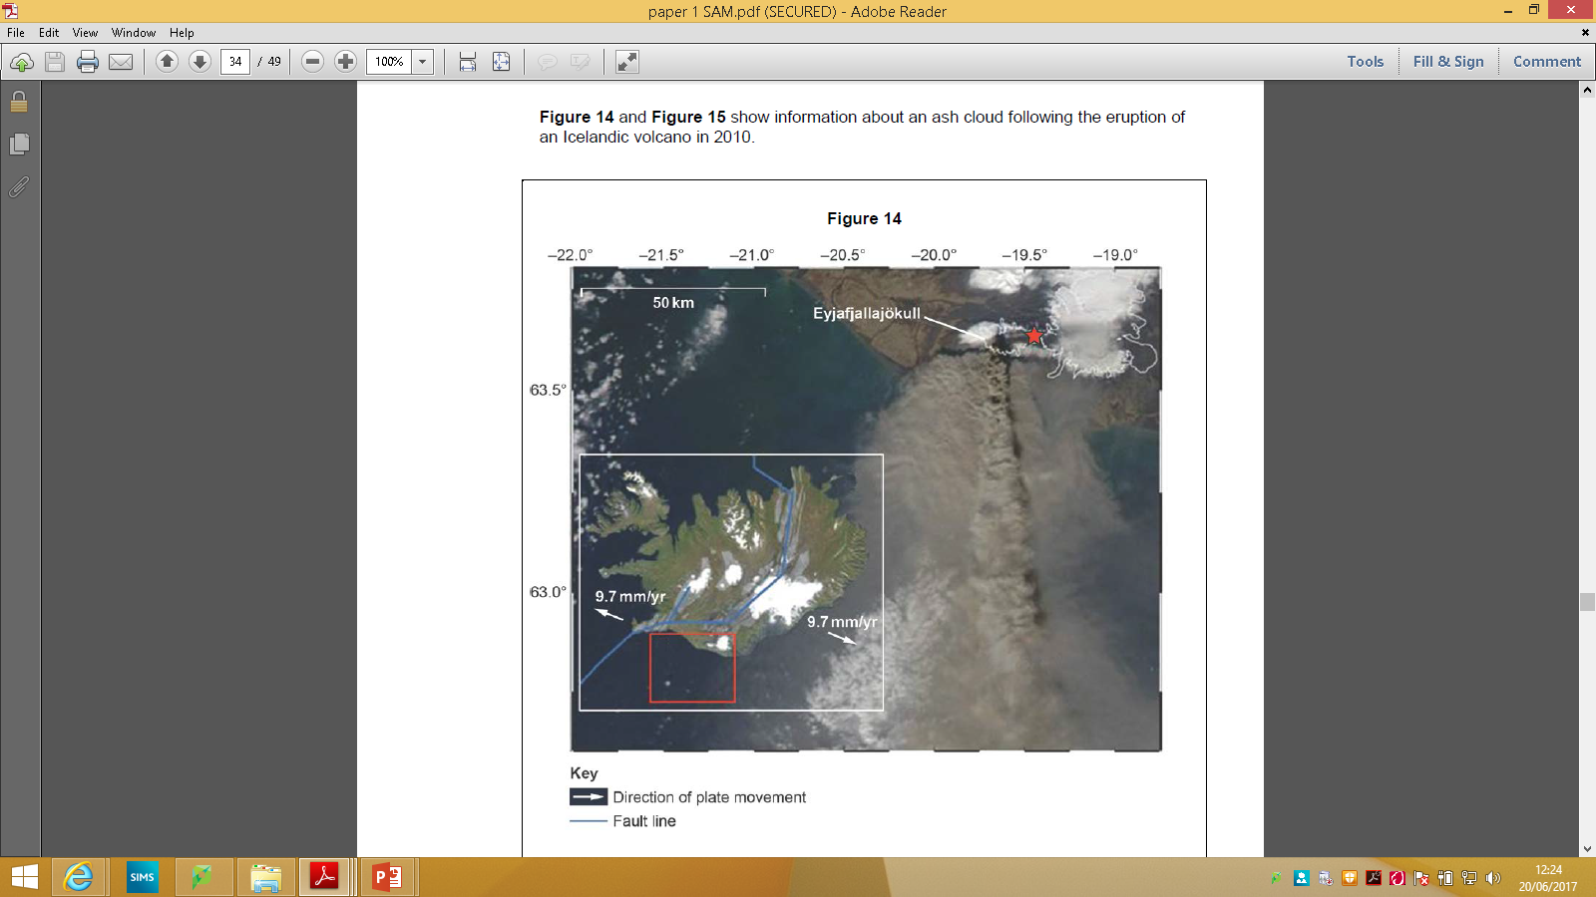

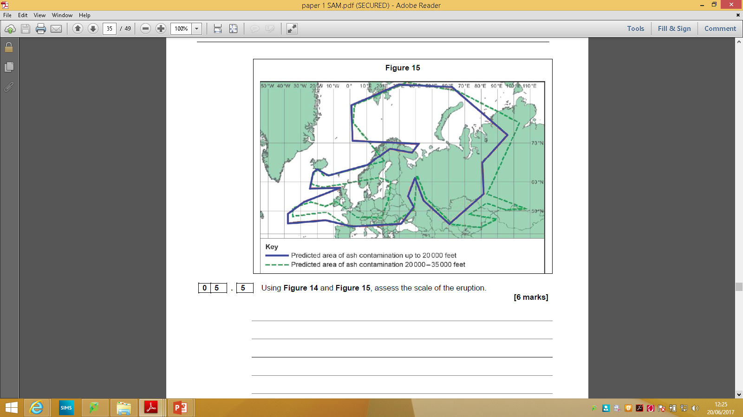

***Match key terms to the definitions:***

**Using Figure 14 and Figure 15 assess the scale of the eruption (6 marks)**

**Secondary hazards (impacts)**

**Lahars Acid rain Climate change**

**Flooding Tsunamis**

The main secondary volcanic hazards:

**Use the Powerpoint slides and video clips and create a mind map of the secondary effects.**

**Practise exam question:**

**Assess the relative impact of different types of volcanic hazard, in terms of loss of life, the economy and society. Illustrate your answer with real examples of hazard events. (9 marks)**

*Remember to use your homework on primary volcanic hazards to help you.*

**What are the definitions of volcanic hazards?**

|  |  |
| --- | --- |
|  | These can reach up to 14km into the stratosphere, This includes anything that is ejected out of the volcano. Ash, dust, rock. |
|  | Solid material of varying grain size ranging from volcanic bombs to ash all ejected into the atmosphere |
|  | Very hot (800C+) gas charged, high velocity flows made up of gas and tephra. Flow down sides of volcanoes at speeds of up to 700km/h. |
|  | Liquid or solidified lava which has erupted from a volcano, often moving downslope. |
|  | Include carbon dioxide, carbon monoxide, hydrogen sulphide, sulphur dioxide and chlorine. |
|  | Melted snow and ice combined with volcanic ash forms mud flows that can move down the course of river valleys at high speeds. |
|  | When an eruption melts glaciers and ice caps |
|  | The slopes of a volcano are weakened by magma and pressure inside. This can weaken the slopes of the volcano, leading to a landslide. |
|  | Sea waves generated by violent volcanic eruptions. |
|  | Volcanoes emit gases which include sulphur which can combine with atmospheric moisture |
|  | The ejection of huge amounts of volcanic debris into the atmosphere can reduce the global temperatures. |

**Review questions:**

**How does type of plate boundary affect the eruption?**

**How does the type of lava affect the eruption?**

**What are the different ways of classifying eruptions?**

**What is the link between volcano shape and the nature of eruptions?**

**Which primary volcanic hazards present the greatest challenge for people?**

**Which of the secondary hazards poses the most difficulties in the long term?**