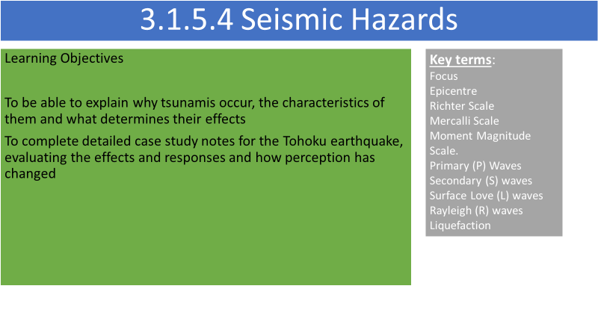

**What are tsunamis?**

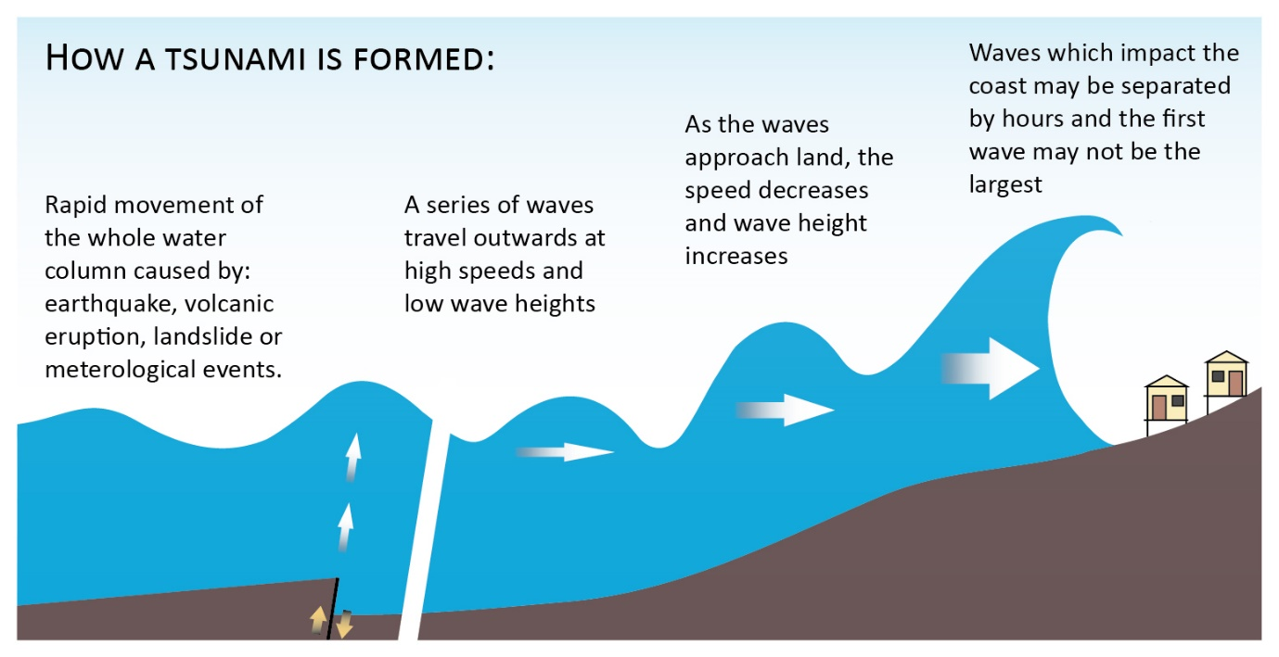

Tsunamis have a very ______________ wavelength (sometimes over 100km) and a ____________wave height (under one metre) in the open ocean and that travel at speeds of over 700km/hour but, when approaching land, ________________ rapidly in height.

Quite often, the first warning given to coastal populations is the wave trough in front of the tsunami which results in the reduction in sea level, known as a drawdown. Behind this comes the tsunami itself which unusually consists of a number of waves, the largest not necessarily being the first.

What do you think determines the effects of the tsunami?

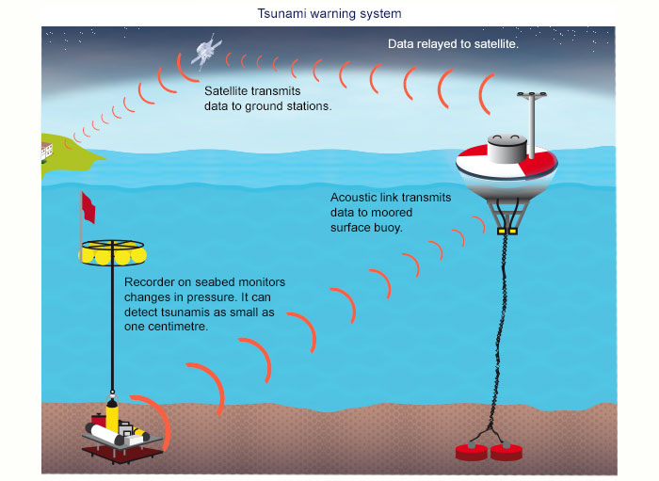

Following the Boxing Day Tsumani in Indonesia, many tsunami buoys have been installed in the Pacific Ocean. What do you think are the advantages and disadvantages of these buoys?

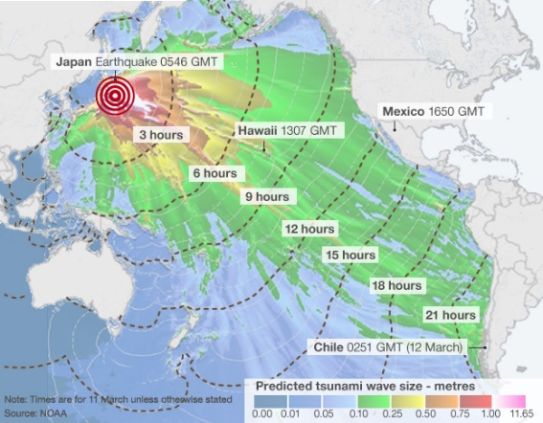

Analyse the map showing the Tohuku Tsunami

**Tohoku Earthquake and Tsunami case study**

**To what extent do you agree that seismic events will always generate more widespread and severe impacts than volcanic events? (9 marks) Sample assessment materials – Paper 1 AQA A level.**

<https://www.youtube.com/watch?v=oWzdgBNfhQU> Introduction

<https://www.youtube.com/watch?v=jFv5yY7pMgQ> Fukushima

Oxford textbook p 246-249

Geo factsheet 289

**Flip learning task - detailed case study Tohoku**

**To include:-**

* **Where and when (include a map)**
* **Why did it happen? How powerful was it?**
* **Why was the area so vulnerable? How prepared was Japan?**
* **Briefly outline the primary and secondary impacts. In more detail – specify the impact that the earthquake (ground shaking) and the tsunami wave have. How large was the tsunami wave and how high were the walls? What % damage did each cause?**
* **What were the preparation failures and what were the successes?**
* **How did the Japanese respond to the hazard and how successful has this been? You need to include both short term and long term responses.**