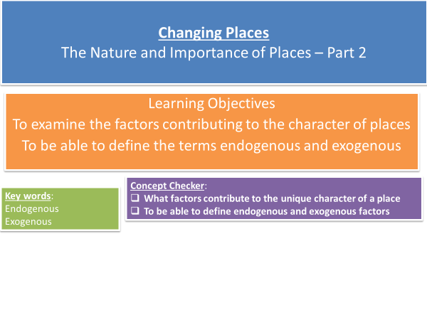

**What factors contribute to a place’s unique character?** [**https://www.youtube.com/watch?v=l_JL24u3hpo**](https://www.youtube.com/watch?v=l_JL24u3hpo)

**What unique character do the following places have?**

* **Scotland**
* **Cornwall**
* **New York**
* **London**
* **Bangkok**
* **Brighton**

**Endogenous Places**

Definition:

|  |  |  |
| --- | --- | --- |
|  | | Example |
|  |  |  |
|  |  |  |
|  |  |  |
|  |  |  |
|  |  |  |
|  |  |  |
|  |  |  |
|  |  |  |

**Exogenous Places**

Definition:

|  |  |  |
| --- | --- | --- |
|  | | Example |
|  |  |  |
|  |  |  |
|  |  |  |
|  |  |  |



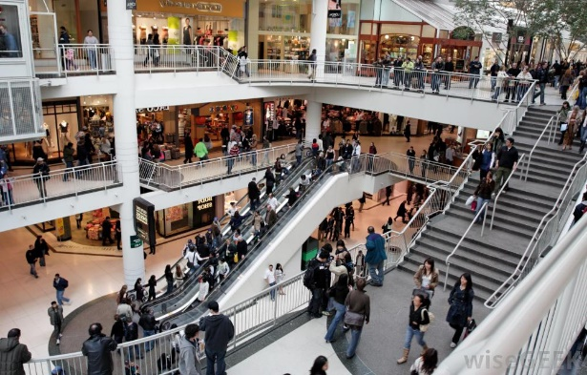 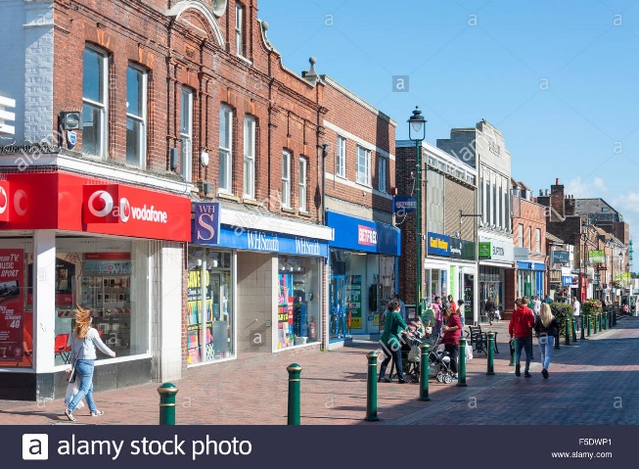

**Placelessness**

* Due to globalisation and time-space compression some places appear the same wherever we are in the world. Shopping centres, fast food chains, airports and service stations look similar wherever you are in the world and so are said to be placeless.
* In the UK high streets have become **clones** of each other with the same shops nationwide. You will be further investigating this on the Godalming fieldwork day.

**Mini case studies**

**Costa Coffee in Totnes, Devon**

Watch the video clip and make notes on why many people have opposed the plans. Have Costa Coffee been successful?

<https://www.youtube.com/watch?v=dW_ek3sh66U>

<http://www.independent.co.uk/news/uk/home-news/a-very-british-insurrection-totnes-residents-win-battle-to-keep-costa-out-amid-clone-town-fears-8226426.html>

**The Bristol Pound** – What is it and how successful has it been?

**Glocalisation – McDonalds** – What is glocalisation and how has McDonalds ‘glocalised’

**Tasks**

P76 – 79 Oxford textbook

Q1 Describe two ways in which the local geology of an area can affect the character of a place

Q3 ‘The endogenous factors that shape a place include its demographic characteristics’. Comment on this statement.

Q4 Study Figure 4 p77

1. Compare the demographic character of Hethersage and Eyam with that of Sinfin.
2. What can you infer from the home ownership data about the age make-up of these two wards in Derbyshire? Check your answer using the Office for National Statistics’ Neighbourhood Statistics website.





