CORNWALL – differing representations

<https://www.youtube.com/watch?v=bGI8m2LeMKQ> - Poldark opening credits

<https://www.youtube.com/watch?v=tj9izovEfoo> - Doc Martin opening credits

<https://www.youtube.com/watch?v=sG89rAYVAeM> - Bloggers view on Watergate Bay, Cornwall

<https://www.youtube.com/watch?v=gCUQ6_JzxaU> - 27 amazing Cornish sights

<https://www.watergatebay.co.uk/> - Watergate Bay website

<https://www.visitcornwall.com/> - Visit Cornwall

<http://www.edenproject.com/?gclid=COb5q--NrdYCFYU_GwoddrkAbA> - Eden Project

<http://www.tate.org.uk/visit/tate-st-ives?gclid=EAIaIQobChMIp_3FgMau1gIViL3tCh0CZwepEAAYASAAEgKsIvD_BwE> - Tate St Ives

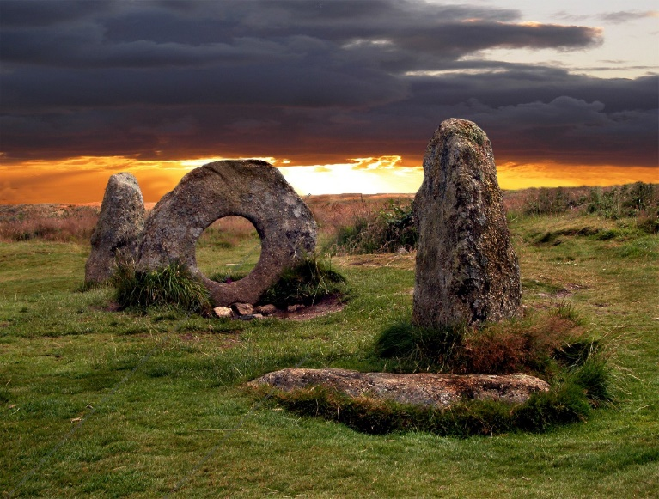

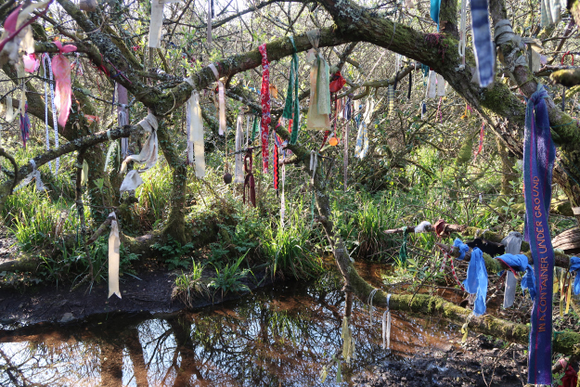

Celtic ruins and traditions

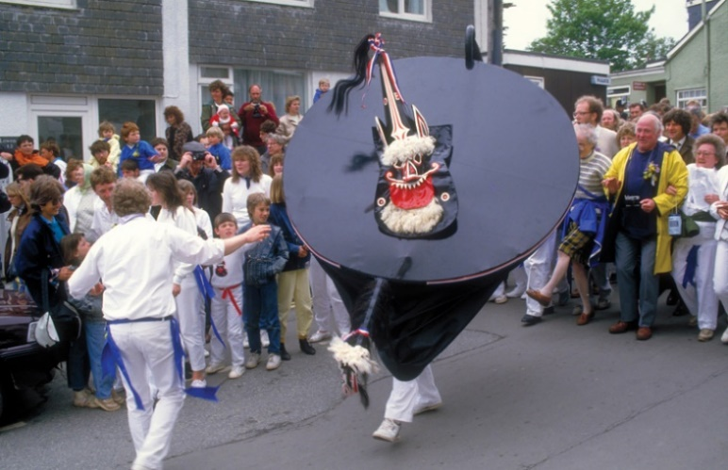

Cornish food, ‘Kernow’ branding and identity

# Image result for cornwall flagImage result for cornish cream tea

# Image result for cornish pasty

# Image result for cornish branding

# Local actor Colin Retallick as St PiranFowey Community College has 'proper Cornish' door signs 14 October 2012

Copy this link

<http://www.bbc.co.uk/news/uk-england-cornwall-19930559>

[Read more about sharing.](http://www.bbc.co.uk/faqs/questions/bbc_online/sharing)

These are external links and will open in a new window

Close share panel

A school in Cornwall has put up door signs in both English and the Cornish language.

The wooden signs have been engraved for every classroom and office door at Fowey Community College.

Head teacher John Perry said the students had shown a real interest in the language and the signs should help to keep interest in the Cornish culture growing.

The signs were made by design and technology technician John Radford.

## 'Real interest'

On the school's maths tutor room, the oval sign has "Mathematics" engraved on it and written below is the Cornish word "Awgrym" with the room number "Hwegh" [six].

Mr Radford is now working on new signage for the school's reception area, which will featuring the wave logo on the school website and "welcome" in Cornish.

Mr Perry said it was St Piran - the patron saint of Cornwall and tin miners - who sparked the idea for the Cornish signs.

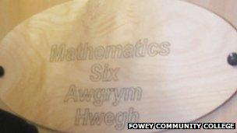"This idea first came to mind around St Piran's Day in March when we compiled presentations on what it means to be Cornish," he said.

"The students showed a real interest in the language and shortly afterwards a Cornish dictionary was sent to us by a local publisher.

"We thought it would be a great idea to include Cornish around the school as a way of keeping the Cornish culture growing."

Fifteen-year-old student Will Chapman said being Cornish was important to him.

"I was born here and when I leave school I want to stay in the county," he added.

[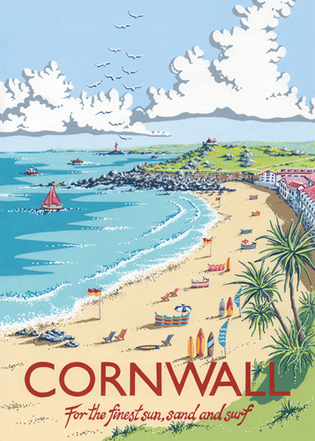](http://www.google.co.uk/url?sa=i&rct=j&q=&esrc=s&source=images&cd=&cad=rja&uact=8&ved=0ahUKEwiF95PVw67WAhUDvBQKHY1FBOUQjRwIBw&url=http://www.worldgallery.co.uk/art-print/kelly-hall-cornwall-434622&psig=AFQjCNFvrzk5vxpVjyJn2kJnJz3cThVnJw&ust=1505817011529236)[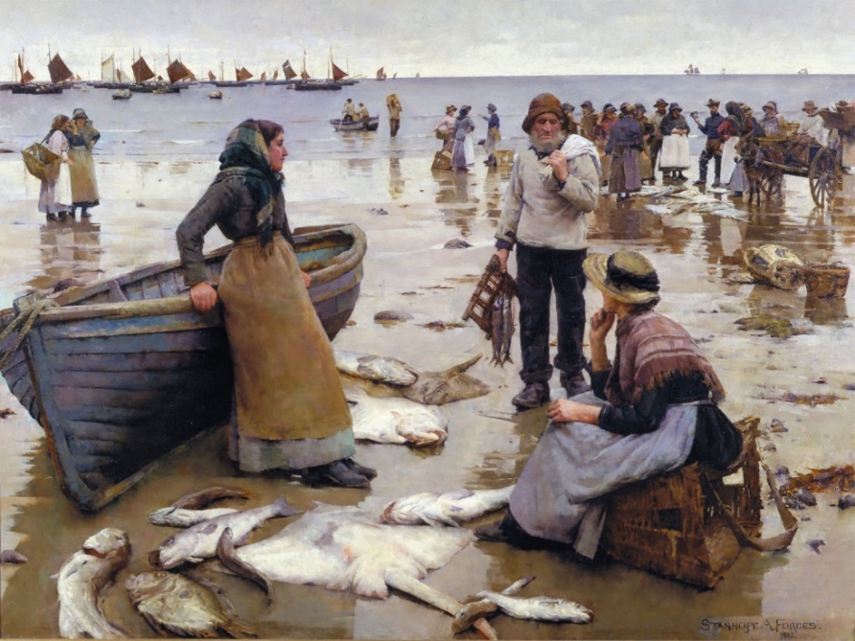](https://www.google.co.uk/url?sa=i&rct=j&q=&esrc=s&source=images&cd=&cad=rja&uact=8&ved=0ahUKEwjruee4w67WAhUEOhQKHaGEDTcQjRwIBw&url=https://www.cornwalls.co.uk/history/people/stanhope_forbes.htm&psig=AFQjCNGUIFKz9zzNxB0514kCJZ6lrl8VhQ&ust=1505816752720626)

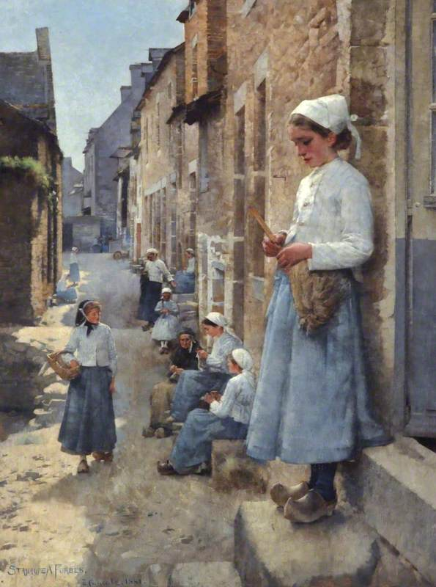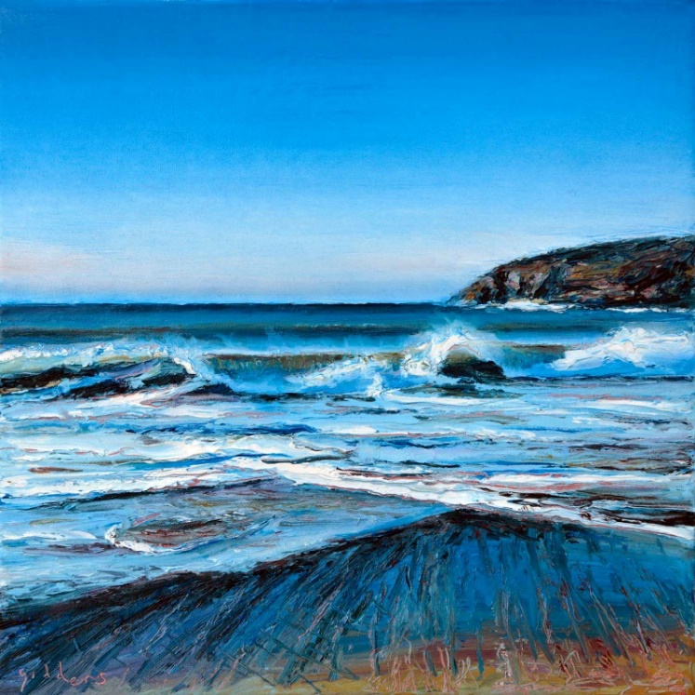

[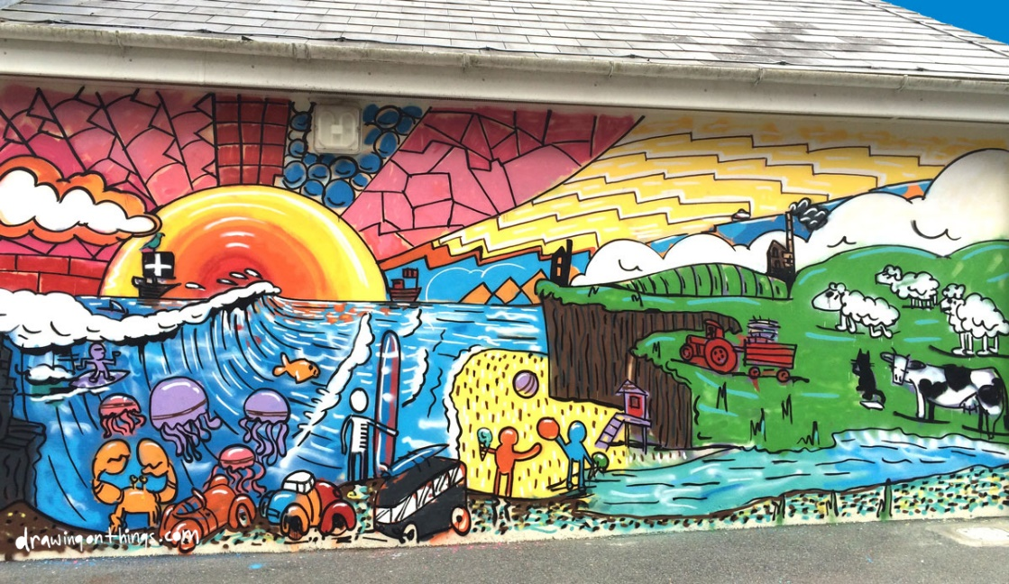](http://www.google.co.uk/url?sa=i&rct=j&q=&esrc=s&source=images&cd=&cad=rja&uact=8&ved=0ahUKEwjGj8vCxK7WAhWBHxQKHcoHAf0QjRwIBw&url=http://cosmicimages.blogspot.com/2015/11/&psig=AFQjCNHMomG3gYidZo47FiBX2jWcOCv1dg&ust=1505817223118502)

Poetry – John Betjeman

Those moments, tasted once and never done,  
Of long surf breaking in the mid-day sun.  
A far-off blow-hole booming like a gun-  
  
The seagulls plane and circle out of sight  
Below this thirsty, thrift-encrusted height,  
The veined sea-campion buds burst into white  
  
And gorse turns tawny orange, seen beside  
Pale drifts of primroses cascading wide  
To where the slate falls sheer into the tide.  
  
More than in gardened Surrey, nature spills  
A wealth of heather, kidney-vetch and squills  
Over these long-defended Cornish hills.  
  
A gun-emplacement of the latest war  
Looks older than the hill fort built before  
Saxon or Norman headed for the shore.  
  
And in the shadowless, unclouded glare  
Deep blue above us fades to whiteness where  
A misty sea-line meets the wash of air.  
  
Nut-smell of gorse and honey-smell of ling  
Waft out to sea the freshness of the spring  
On sunny shallows, green and whispering.  
  
The wideness which the lark-song gives the sky  
Shrinks at the clang of sea-birds sailing by  
Whose notes are tuned to days when seas are high.  
  
From today's calm, the lane's enclosing green  
Leads inland to a usual Cornish scene-  
Slate cottages with sycamore between,  
  
Small fields and tellymasts and wires and poles  
With, as the everlasting ocean rolls,  
Two chapels built for half a hundred souls.