Manchester – differing representations

<https://www.youtube.com/watch?v=JnCqi6QCnT8> - Shameless opening credits

<https://www.youtube.com/watch?v=wQDiaAmRA-o> - Coronation Street opening scenes 1960-2010

<https://www.visitmanchester.com/> - Visit Manchester site

<http://www.manchestereveningnews.co.uk/news/greater-manchester-news/greater-manchester-poorest-areas-poverty-11315738> - article on inequality in Manchester

<https://www.youtube.com/watch?v=o_TKIM1vUEs> - Expedia travel guide to Manchester

<https://www.theguardian.com/music/2012/apr/21/madchester-manchester-interviews-hook-ryder> - article on the ‘Madchester’ music scene of the 1980s.

<https://theculturetrip.com/europe/united-kingdom/england/articles/10-stereotypes-all-mancunians-hate/> - 10 stereotypes Mancunians hate

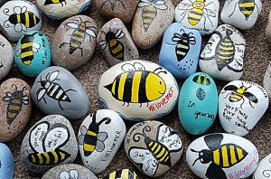**Manchester and the bee.**

The worker bee has been an emblem of Manchester for over 150 years, symbolising the strong work ethic of the city as a hive of activity and the sense of unity. <https://www.bbc.co.uk/programmes/p067wxkp>

**Manchester Arena bombing at Ariana Grande concert – 22nd May 2017**

Less than 24 hours after the terror attack on Manchester Arena on 22nd May 2017, Tony Walsh performed the ‘This is The Place’ poem at the vigil at Manchester Town Hall, in front of thousands of people gathered in Albert Square and millions of people across the world on TV.

<https://www.youtube.com/watch?v=PszMmYpQjPo>

**Together (This is The Place) – The Single**

A month later, production team New Mount City Breakers teamed up with Walsh to release a charity single ‘**Together (This is The Place)’** with a New Order-esque electro backing. “Manchester is the dance capital of England after all.” explained Tony, “I felt this version though was true to the classic Manchester sound, adding a new angle without detracting from the words.”

<https://www.youtube.com/watch?v=2zQGZUQtZM4>

**Bee Love: This is The Place – Amy Coney**

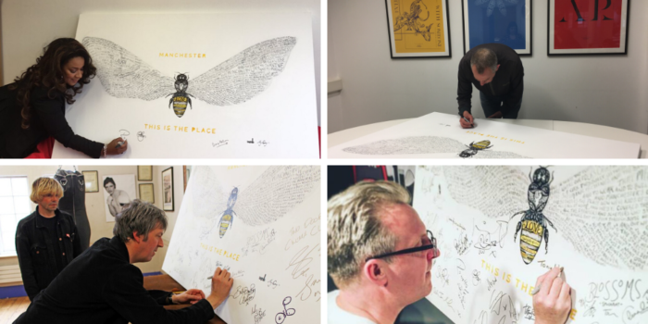Following the Manchester Arena Attack, artist and illustrator Amy Coney created the Bee Love painting featuring the words of the ‘This is The Place’ poem. The original painting was signed by a host of artists and music legends from Manchester and beyond. The signed painting was auctioned on 1st August 2017 raising £7,100 for Forever Manchester and We Love MCR Emergency Fund. Prints of the artwork are on sale from [Amy Coney](https://amyconey.bigcartel.com/) with all profits from the sale coming to Forever Manchester.

**THIS IS THE PLACE (full version)  
written and performed by Tony Walsh for Forever Manchester**

This is the place in the North West of England  
It’s ace, it’s the best and the songs that we sing  
From the stands, from our bands set the whole planet shaking  
Our inventions are legends! There’s nowt we can’t make and

So we make brilliant music. We make brilliant bands  
We make goals that make souls leap from seats in the stands  
And we make things from steel and we make things from cotton  
And we make people laugh, take the mick summat rotten

And we make you at home and we make you feel welcome  
And we make summat happen, we can’t seem to help it  
And if you’re looking for history then yes, we’ve a wealth  
But the Manchester way is to make it yourself

And make us a record, a new number one  
And make us a brew while you’re up, love. Go on!  
And make us feel proud that you’re winning the league  
And make us sing louder and make us believe it

That this is the place that has helped shape the world  
And that this the place where a Manchester girl  
Name of Emmeline Pankhurst from the streets of Moss Side  
Led a Suffragette City with sisterhood pride

And this is the place with appliance of science  
We’re on it, atomic, we strut with defiance  
In the face of a challenge we always stand tall  
Mancunians in union delivered it all

Such as housing and libraries, and health, education  
And unions and co-ops, the first railway station  
So we’re sorry! Bear with us! We invented commuters!  
But we hope you forgive us – we invented computers!

And this is the place Henry Royce strolled with Rolls  
And we’ve rocked and we’ve rolled with our own Northern Soul  
And so this is the place to do business, then dance  
Where go-getters and goal setters know they’ve a chance

And this is the place where we first played as kids  
And me Mam lived and died here, she loved it she did  
And this is the place where our folks came to work  
Where they struggled in puddles, they hurt in the dirt

And they built us a city. They built us these towns  
And they coughed on the cobbles to the deafening sound  
Of the steaming machines and the screaming of slaves  
They were scheming for greatness, they dreamed to their graves

And they left us a spirit, they left us a vibe  
The Mancunian Way to survive and to thrive  
And to work and to build, to connect and create and  
Greater Manchester’s greatness is keeping it great

And so this is the place now we’ve kids of our own  
Some are born here, some drawn here but we all call it home  
And they’ve covered the cobbles, but they’ll never defeat  
All the dreamers and schemers who still teem through these streets

Because this is a place that has been through some hard times  
Oppressions, recessions, depressions and dark times  
But we keep fighting back with Greater Manchester spirit  
Northern grit, northern wit in Greater Manchester’s lyrics

And there’s hard times again in these streets of our city  
But we won’t take defeat and we don’t want your pity  
Because this a place where we stand strong together  
With a smile on our face, Mancunians Forever

And we’ve got this* as the place where a team with a dream *(*Forever Manchester)*Can get funding and something to help with their scheme  
Because this is the place that understands your grand plans  
We don’t do No Can Do, we just stress Yes We Can!

Forever Manchester’s a charity for people round ‘ere  
You can fundraise, donate. You can be a volunteer  
You can live local, give local. We can honestly say  
We do charity differently, that Mancunian Way

And we fund local kids, and we fund local teams  
We support local dreamers to work for their dreams  
We support local groups and the great work they do  
So can you …help us help… local people like you?

Because this is the place in our hearts, in our homes  
Because this is the place that’s a part of our bones  
‘Cos Greater Manchester gives us such strength from the fact  
That this is *the* place. We should give something back.

**Always remember. Never forget.  Forever Manchester.**

Manchester art

[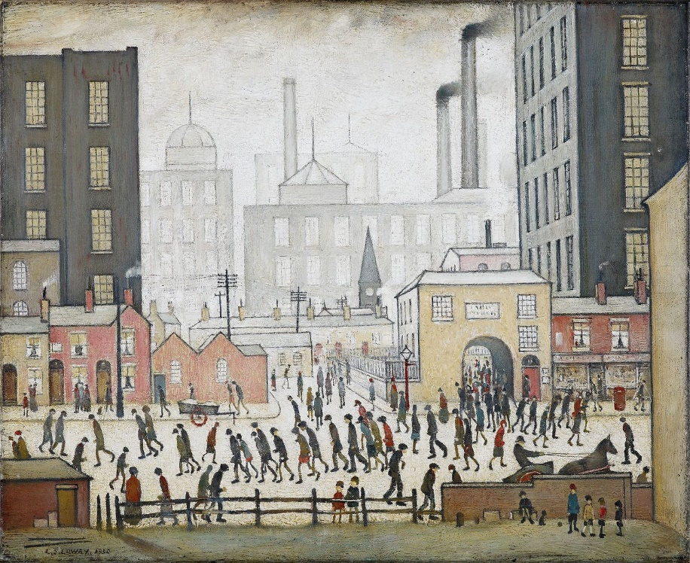](http://www.google.co.uk/url?sa=i&rct=j&q=&esrc=s&source=images&cd=&cad=rja&uact=8&ved=0ahUKEwjRtbP0xLHWAhUCnRQKHW1gBF4QjRwIBw&url=http://www.manchestereveningnews.co.uk/news/greater-manchester-news/gallery/lowry-paintings-super-scanned-google-6860995&psig=AFQjCNFjW8gVh-rBHCe8FSI1vSGK2QbcQQ&ust=1505920395831882)L. S. Lowry

[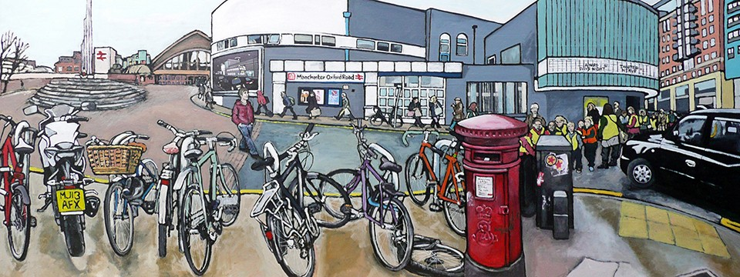](https://www.google.co.uk/url?sa=i&rct=j&q=&esrc=s&source=images&cd=&ved=0ahUKEwjp9YScxbHWAhXBsxQKHTrKB9oQjRwIBw&url=https://www.artzu.co.uk/&psig=AFQjCNE5TKc2yV1Pi12NPkqOrEWRz0sh0Q&ust=1505920474888654)[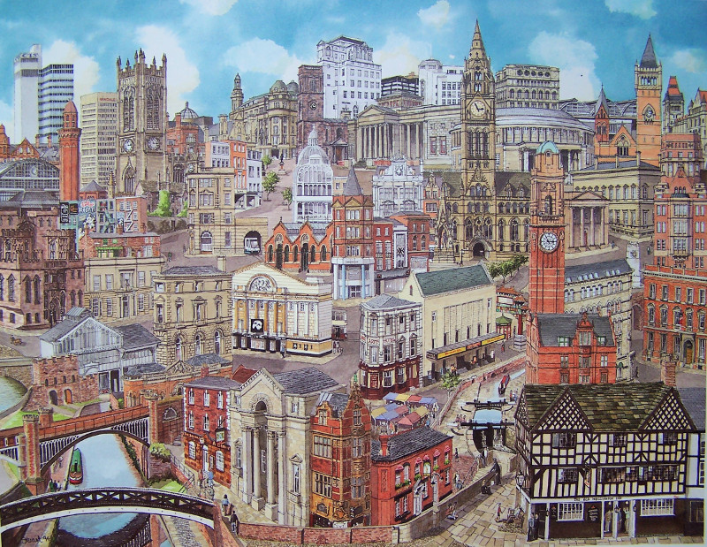](http://www.google.co.uk/url?sa=i&rct=j&q=&esrc=s&source=images&cd=&cad=rja&uact=8&ved=0ahUKEwj7hMOMxbHWAhUGORQKHb-CCwMQjRwIBw&url=http://www.stuartsoriginals.com/cities/memories-of-manchester.html&psig=AFQjCNE5TKc2yV1Pi12NPkqOrEWRz0sh0Q&ust=1505920474888654)

**What does the Manchester accent say about you?**

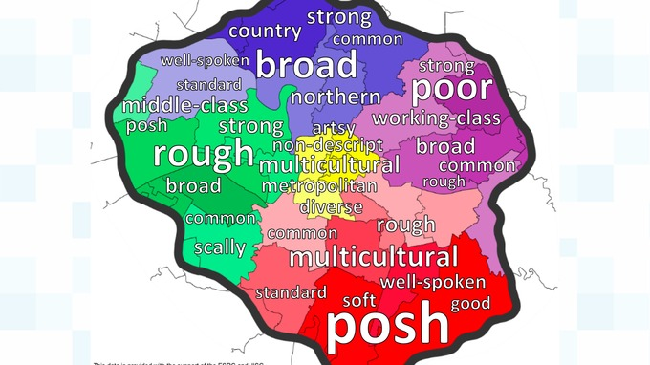

Manchester accent and dialogue map *Credit: MMU*

It's one of the most distinctive accents in the country but what do Mancunians make of the Manchester accent?

That was the question that sociolinguists at Manchester Metropolitan University set out to answer, and in doing so have created the city’s first “accent and dialect map”.

Dr Erin Carrie and Dr Rob Drummond asked their final-year students to carry out a “perceptual dialectology” project – a type of study that asks non-experts to identify accents and dialects and give their opinions about them.

Participants were asked to draw borders on a blank map of Manchester to show areas where they thought people spoke differently from others and to provide words to describe the accents and dialects of each area that they had identified.

Dr Rob Drummond said:

The key outcome of this project is a map of Manchester showing five clear dialect areas, with words characterising each.

"The findings suggest that perceptions of accents and dialects in the city are closely linked with social stereotypes about the people who speak them, and several of the words that were provided appear to be descriptions of people or areas rather than accents or dialects."

“It is important to note that the dialect areas and descriptions shown on the map are the collective impressions of the people of Manchester themselves and not those of language experts who often have less direct knowledge and experience of the local area.

*– Dr Rob Drummond, Lecturer in Linguistics Manchester Metropolitan University*