**Name:**

**Contemporary urban environments**

**2. Cycle of urbanisation, urban change and urban policy**

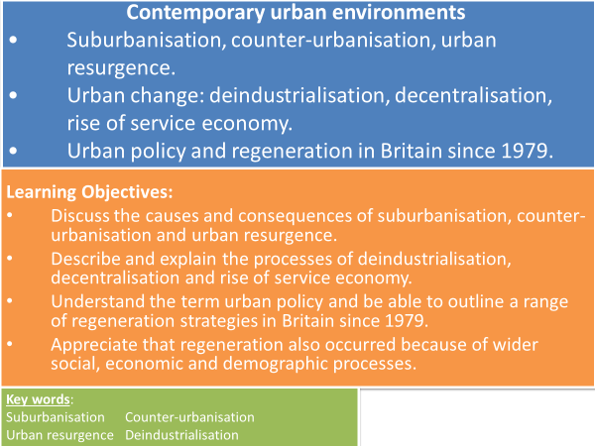

**TASK: Use your knowledge from your pre-work/flipped learning to identify the key words whose definitions are below.**

**________________________________** – The outward growth of people, services and employment towards the edges of an urban area.

**_________________________________** – Population movement from large urban areas to smaller urban settlements and rural areas.

**__________________________________** – Population movement from rural back to urban areas, such as university students and upwardly mobile young people, reviving inner city and CBD areas.

**__________________________________** – the long-term decline of a country’s manufacturing and heavy industries.

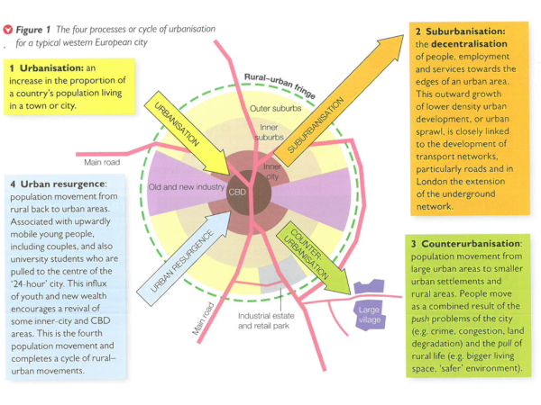

**TASK:** Around 13% of the land in England is designated as Green Belt. The purpose of Green Belt policy is to prevent urban sprawl by keeping land ‘permanently open’.

1. Where on Figure 1 (above) would Green Belt be marked? Explain your answer.
2. Which of the urban processes would Green Belt encourage? Conversely, which would it act as a barrier against? Justify your answer.

**Suburbanisation – causes and consequences**

Evidence of suburbanisation

**TASK**: Compare the maps of Guildford in 1900 and today. Annotate with evidence of suburbanisation – consider people, employment and services. Add notes from the Powerpoint slides.

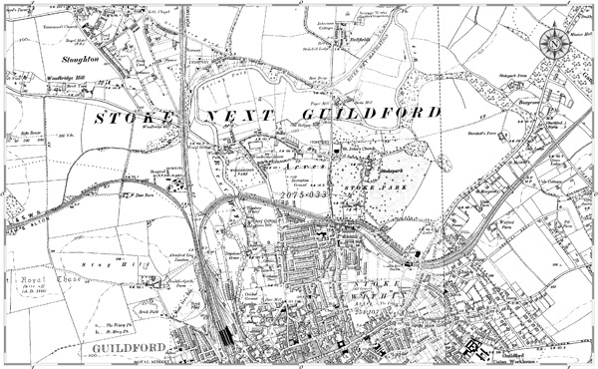

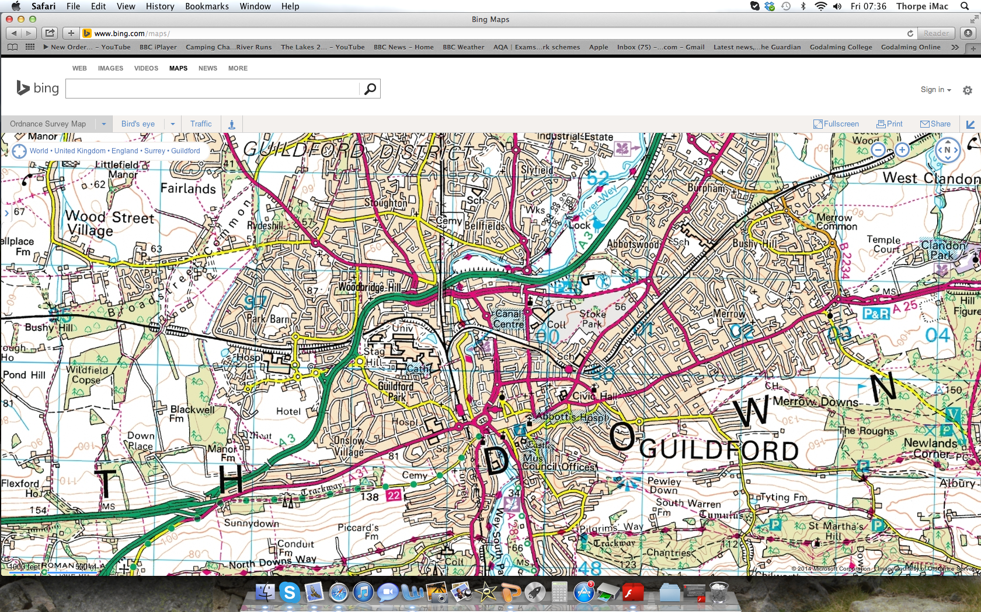

**TASK:** What are the causes of Suburbanisation? Watch the clip on how railways influenced the development of suburbs. <https://www.bbc.co.uk/news/uk-england-london-20814930>

Annotate the below with information from your pre-work and the powerpoint slides.

Suburbanisation in a British city

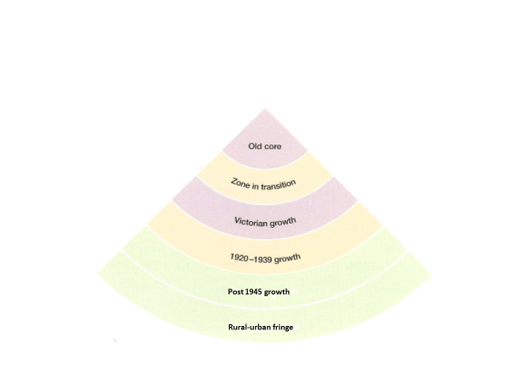

**TASK:** Use your pre-work to list push and pull factors.

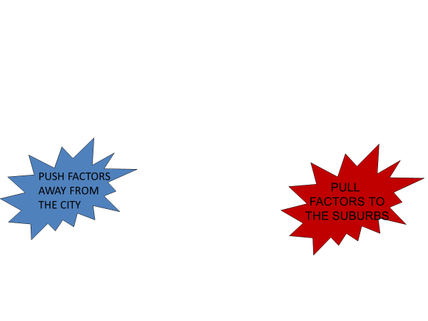

**TASK:** Identify demographic and social causes of suburbanisation.

**TASK:** What are the consequences of suburbanisation? Highlight the table to identify social, economic and environmental impacts of suburbanisation and whether positive or negative.

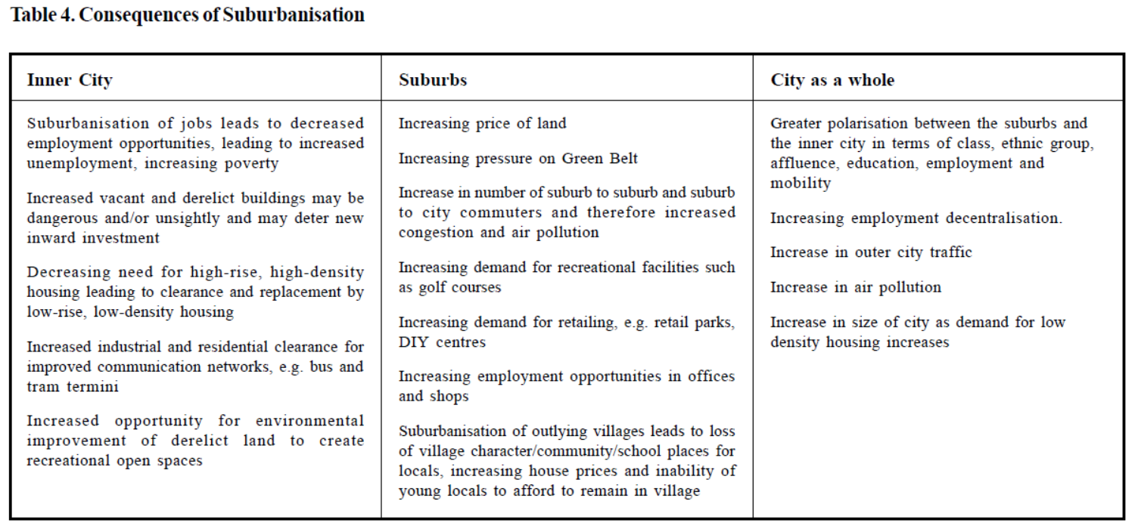

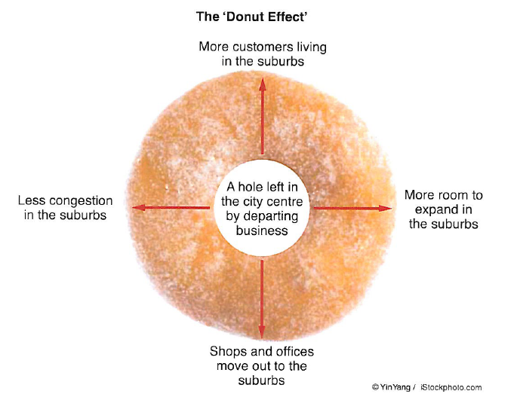

**TASK:** Explain consequences in your own words with reference to the ‘Donut Effect’. Make reference to evidence from Detroit (from Changing Places) in your answer.

**Case Study example: Surbiton, Kingston upon Thames.**

* Surbiton is a suburban area of south-west London.
* It is located within the Royal Borough of Kingston upon Thames.
* It is situated next to the River Thames, 11.0 miles south west of central London.

**Census Data :**

* Population 1971 – 141,000
* Population 2011 – 160,000

**2011 Ward Profile For Surbiton Hill**

<https://www.nomisweb.co.uk/reports/lmp/ward2011/1140858130/report.aspx>

**TASK:** Use the census data below to explain the characteristics of the residents of Surbiton. Quote figures in your answer and make comparisons to England and Wales.

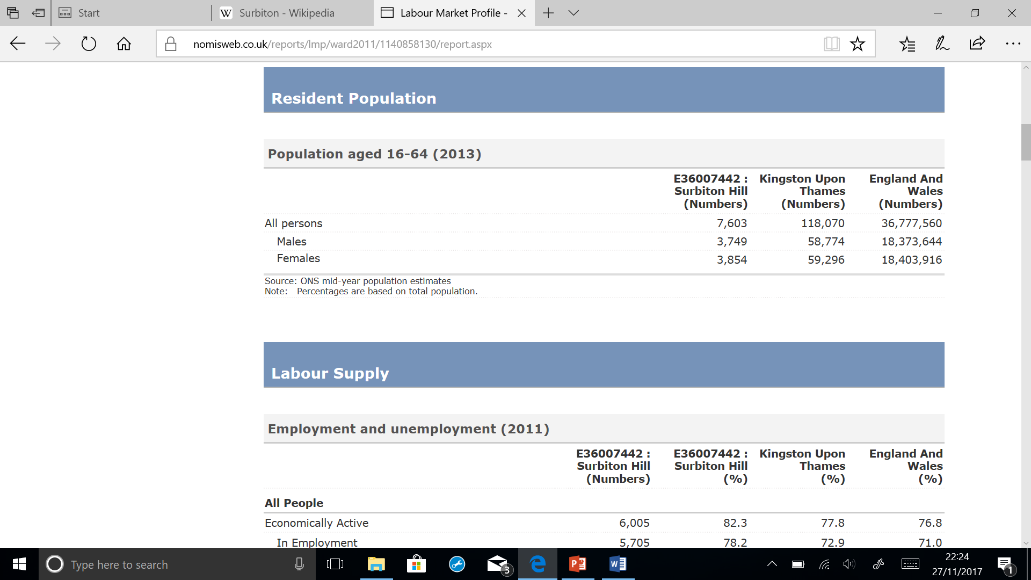

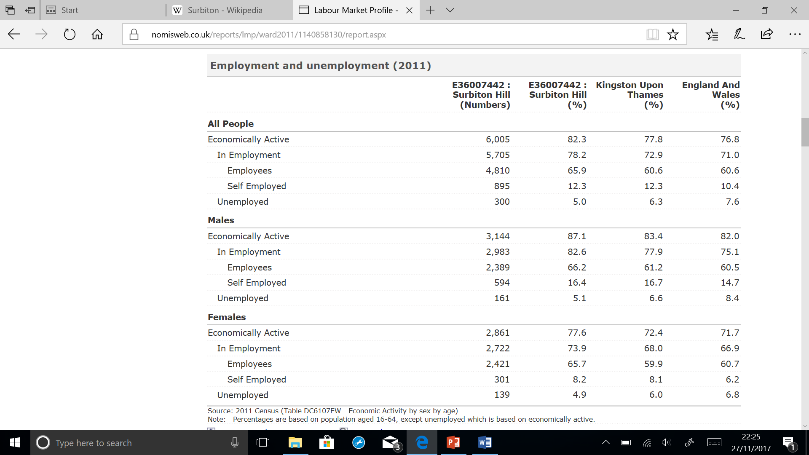

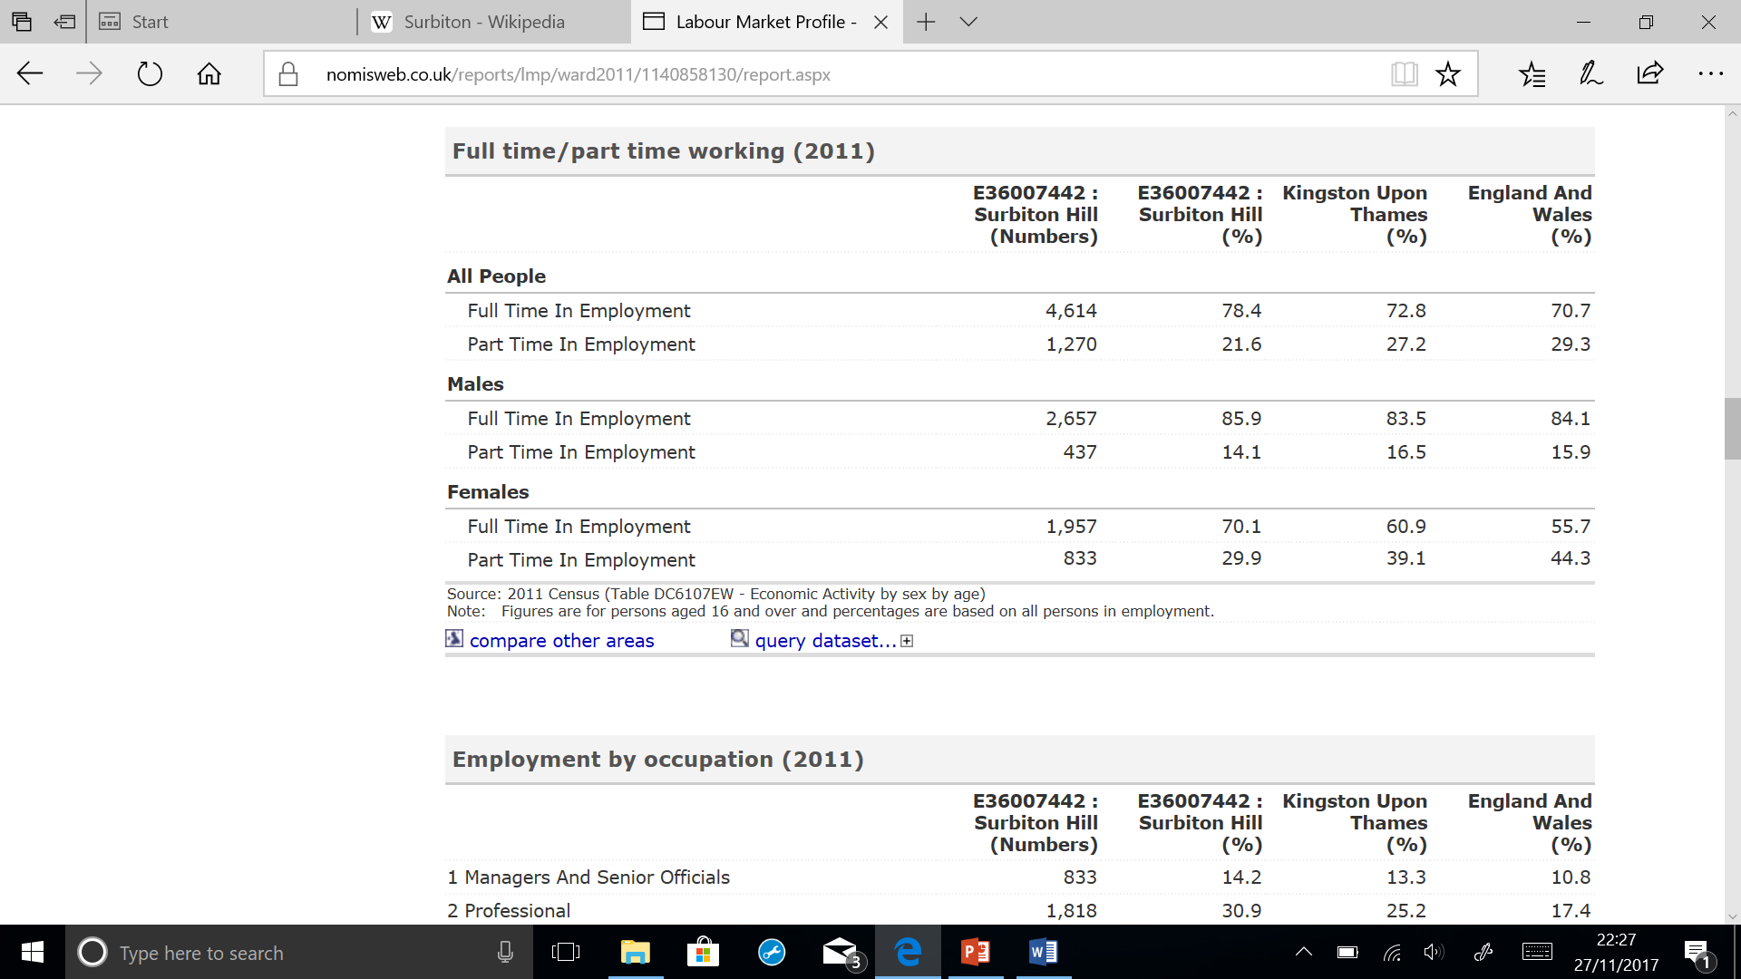

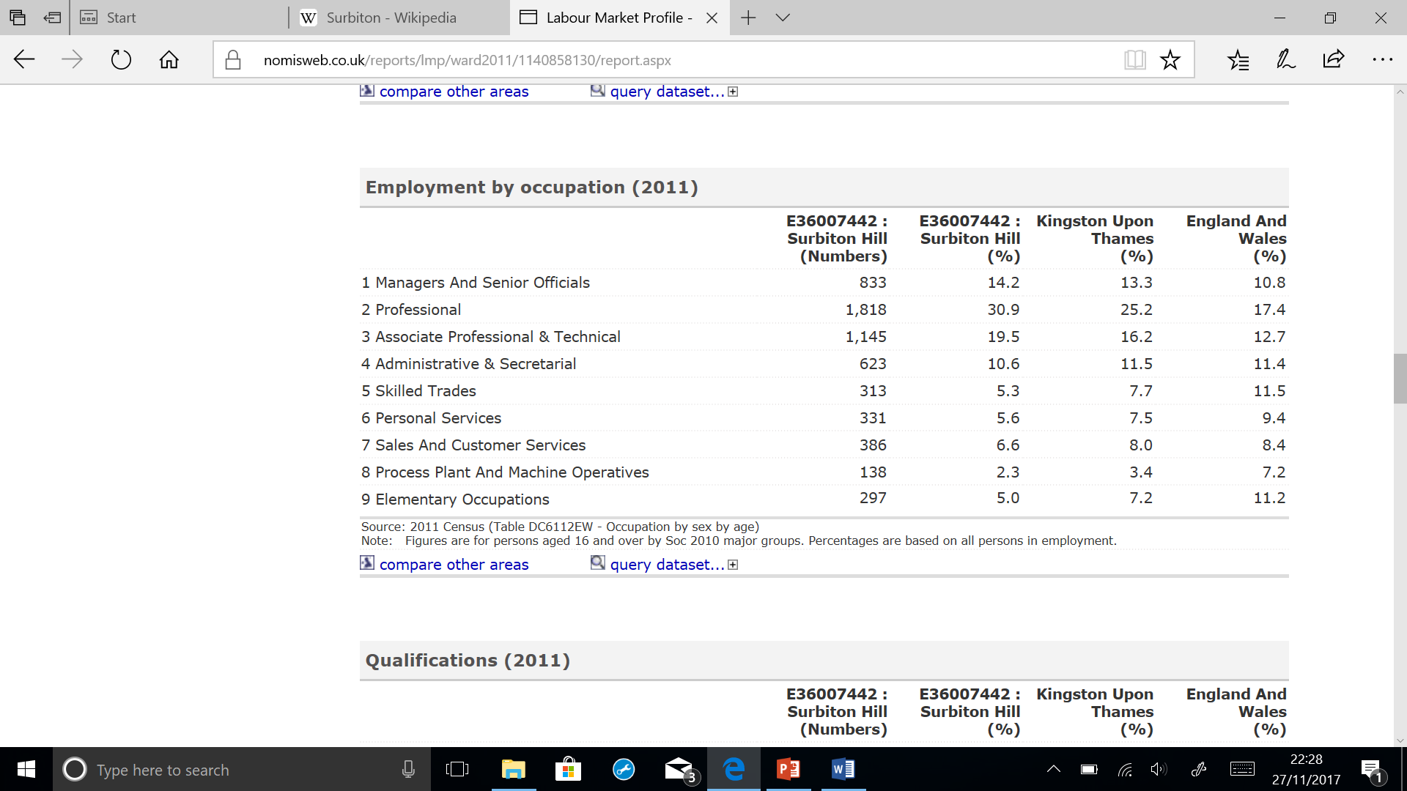

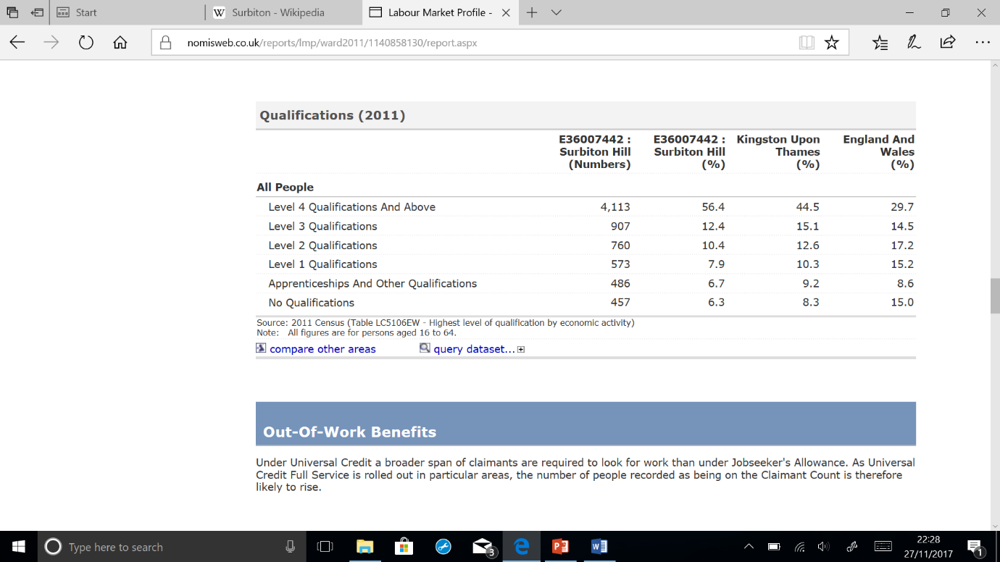

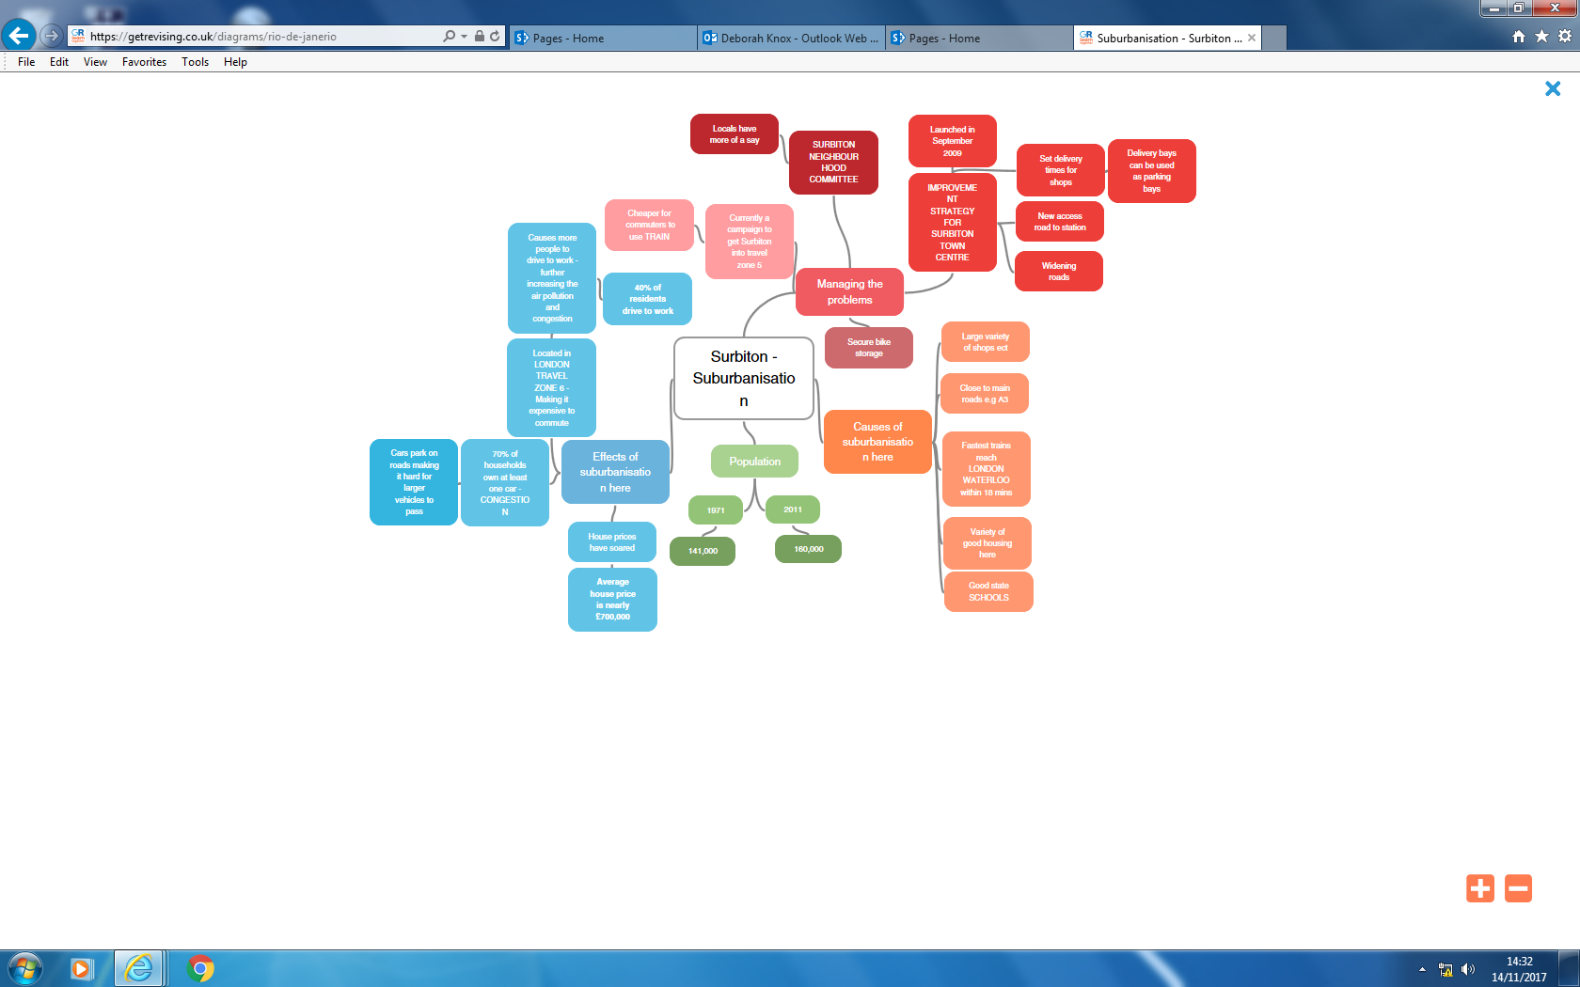

**TASK:** Use the mind map of Surbiton to answer the following questions.

* Identify 3 causes of suburbanisation in Surbiton and explain why this makes Surbiton appealing to residents.
* Identify 3 effects of suburbanisation in Surbiton and explain why this causes issues.
* Identify 3 strategies that have been used to manage problems caused by suburbanisation in Surbiton and explain how this will reduce effects.

**Exam Question**



**Pre-work/Flipped learning Task**

Read Hodder text book p386-387 and produce a mind map/make notes on:

* Causes of counter-urbanisation
* Evidence of counter-urbanisation
* Consequences of counter-urbanisation