**Name:**

**Counter-urbanisation**

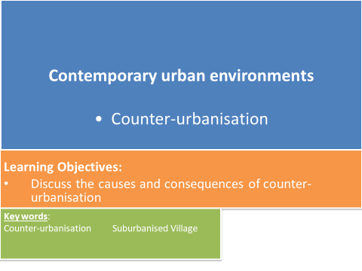

**Changes in rural places (Links with Changing Places)**

How have rural place changed over time?

* Most people in the UK, and the world, now live in urban areas.
* This growth mainly occurred during the Industrial revolution where large numbers of people moved away from farming and primary industries and took up better paid jobs in growing towns and cities.
* However, industrial decline since the 1960s and 70s, coupled with improved transport links has meant a resurgence of people moving back to more rural locations.
* Rural areas in the UK are changing to meet the needs of the people living there.

**KEY TERMS:**

**Counter-urbanisation**: population movement from large urban areas to smaller urban settlements and rural area

**Suburbanised village:** a small settlement in which most the workers commute to work in urban areas and are said to have “urban values”, so they are not primarily interested in the rural economy e.g. Cranleigh, Milford, Bramley.

**Counter-urbanisation – causes and consequences**

**TASK**: **Use your pre-work to list reasons why more people are choosing to move out to rural areas.**

**TASK:** **Describe the socio-economic groupings of the people most likely to counter-urbanise.**

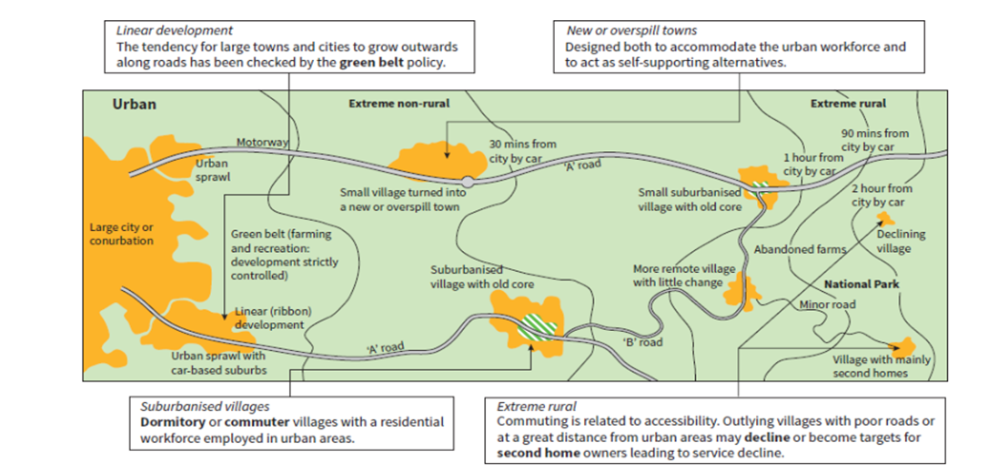

**TASK: Using the map above describe the type of rural settlement that would attract people who want to leave urban environments.**

**Hudson’s model of a suburbanised village**

**TASK: Annotate each zone to explain what has happened and why:**

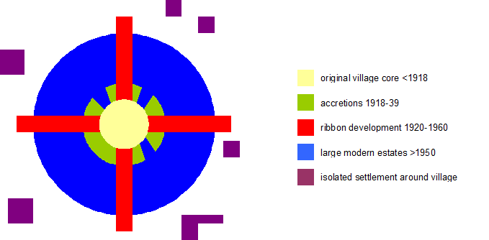

**Characteristics of a suburbanised village**

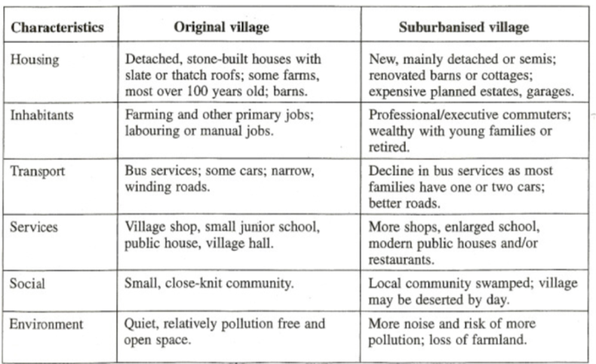

**The effects of counter-urbanisation**

**TASK: Look at the effects in the table below and complete the following:**

* Decide if it’s **+** or **–** (They may be positive and negative – REMEMBER – this brings through your critical understanding if you can explain why);
* Decide if it’s **S** (social), **EC** (economic), **ENV** (environmental) or **P** (political).
* Links with **Changing Places** - pick out the aspects you think will particularly alter the ‘sense of place’ and annotate them:
  + How will place identity be changed?

Will sense of place become lost? Placelessness?

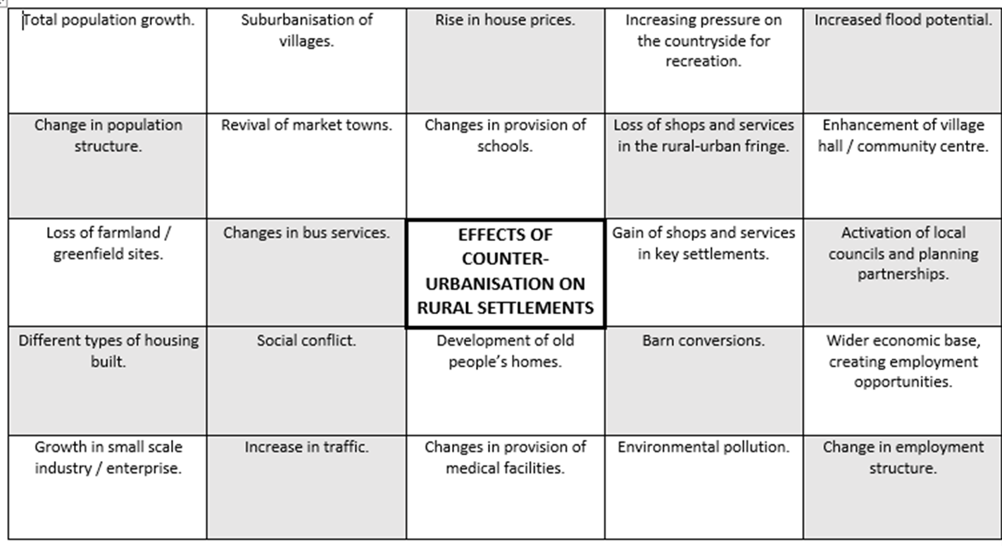

**Evidence of counter-urbanisation – Cranleigh, Surrey.**

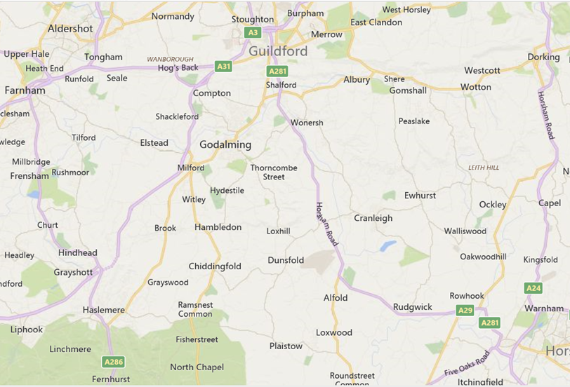

**TASK:** **Watch the video clip and make notes on the following:**

[**https://www.bbc.co.uk/news/av/uk-england-surrey-28762142/plans-to-expand-cranleigh-england-s-biggest-village**](https://www.bbc.co.uk/news/av/uk-england-surrey-28762142/plans-to-expand-cranleigh-england-s-biggest-village)

* **The location and population of Cranleigh.**
* **Plans to build more homes.**
* **What impact the development might have on the area?**
* **Differing perceptions/opinions about the proposed development.**

**TASK: Using your notes from the video clip and the map above suggest reasons why Cranleigh has become a suburbanised village.**

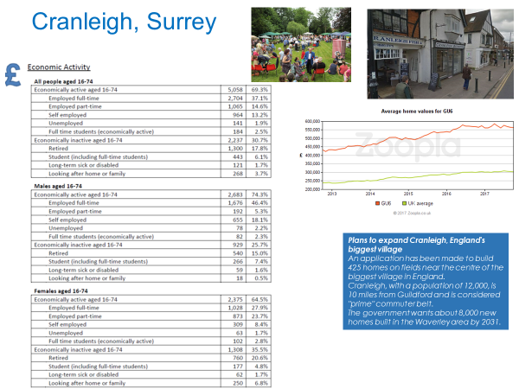

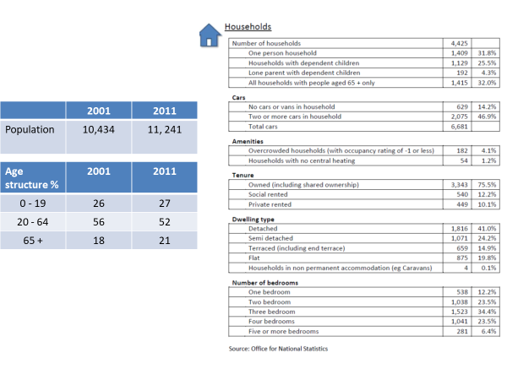

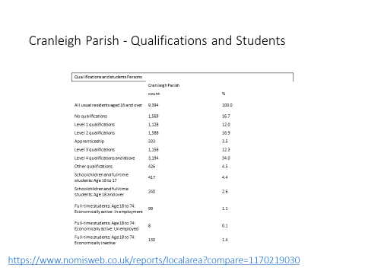

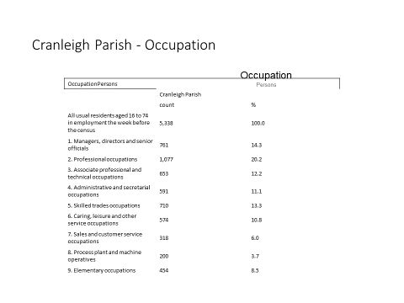

**TASK: Complete the table with evidence from Cranleigh that supports the ‘Characteristics of a suburbanised village’. Use data from the previous pages and your own research e.g. Cranleigh Parish Council website** [**https://www.cranleigh-pc.gov.uk/Home_14091.aspx**](https://www.cranleigh-pc.gov.uk/Home_14091.aspx) **, Surrey County Council bus timetables** [**https://www.surreycc.gov.uk/roads-and-transport/buses-and-other-transport/bus-timetables**](https://www.surreycc.gov.uk/roads-and-transport/buses-and-other-transport/bus-timetables)

|  |  |
| --- | --- |
| **Characteristics** | **Evidence from Cranleigh** |
| Housing |  |
| Inhabitants |  |
| Transport |  |
| Services |  |
| Social |  |
| Environment |  |

**Exam Questions**

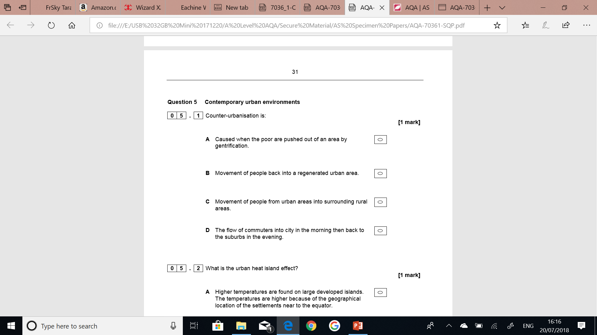

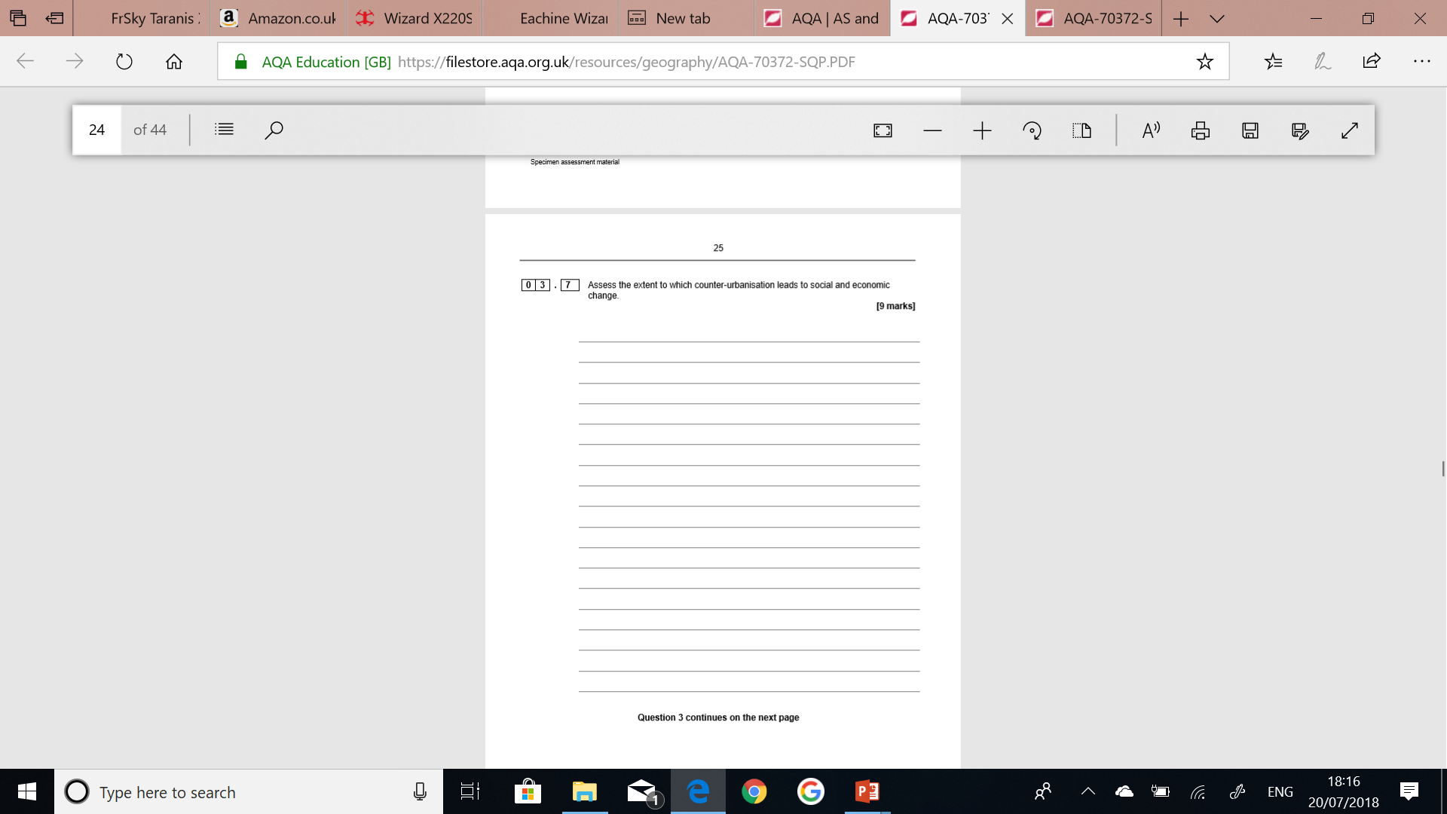

9-mark questions have three levels in their mark schemes. These are identical for each of the exam papers. The balance of marks is split between 4 marks for AO1 and 5 marks for AO2. You should aim to:

* Demonstrate accurate knowledge and understanding throughout (AO1)
* Apply your knowledge and understanding (AO2)
* Produce a full interpretation that is relevant and supported by evidence (AO2)
* Make supported judgements in a balanced and coherent argument (AO2)

**Assess** – how big an impact does counter-urbanisation have on social and economic change?

Example: Cranleigh, Surrey

**P** – Point **E** – Explain  **E** – Evidence **L** – Link

* The concluding statement should make an overall assessment about the extent to which counter-urbanisation leads to social and economic change.
* Think of view point and give evidence to support that view – small/large?

**TASK: Plan your answer and write it on a separate piece of paper.**

**Pre-work/Flipped learning**

* Read Hodder p388 ‘Urban change’ to identify the three main factors that caused deindustrialisation.
* Review Changing Places case study work on Detroit. Identify ***causes*** and ***impacts*** of de-industrialisation in Detroit.