**Name:**

**New Urban Land Uses and the Concept of the Post-Modern Western City**

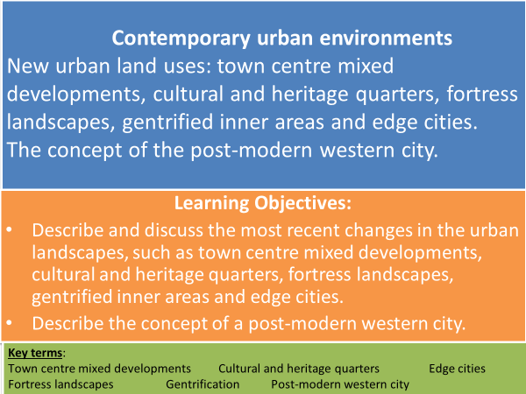

**New urban land uses**

**TASK: Use your pre-work to match the correct term to the description.**

**town centre mixed developments gentrified inner areas edge cities.**

**cultural and heritage quarters fortress landscapes**

**______________________________:** redeveloping town centres with a combination of residential, commercial, cultural, institutional, or industrial uses. These functions are designed to be physically and functionally integrated with free-flowing pedestrian access. E.g. The Shard, London.

**_______________________________:** to promote growth in cities many UK cities have developed cultural and heritage areas or quarters. These focus on cultural or heritage themes, e.g. arts and the creative industries in order to regenerate them. E.g. Manchester Northern Quarter.

**_______________________________:** city developments that integrate greater security into the design of the building or landscape.

**_______________________________**: self-contained settlements with a concentration of business, shopping and entertainment outside the traditional central business district.

**_______________________________:** the process of renewal and rebuilding accompanying the influx of middle-class or affluent people into deteriorating areas that often displaces poorer residents.

**TASK: Using your pre-work answer the following.**

* Identify 3 functions other than retailing that Town Centre Mixed Developments include.
* What are the 2 pre-requisites Cultural and Heritage Quarters must have?
* Name 5 strategies adopted by Fortress Landscapes to reduce crime in urban areas.
* What features are Edge Cities developed close to and what amenities do Edge Cities have?
* Give 3 reasons why Gentrification happens.
* Which New Urban Landscapes could form the notion of ‘insiders’ and ‘outsiders’? Justify your answer.

**Gentrified Inner City Areas - Notting Hill, London**

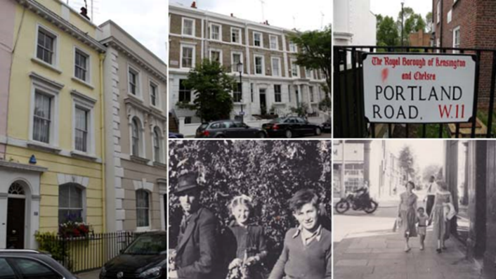

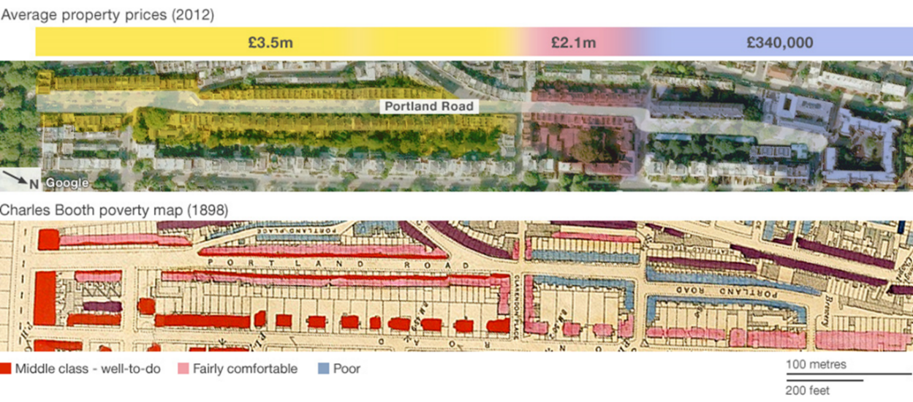

**TASK: Watch ‘The Secret History of our Streets’ on e-stream #8399 about Portland Road, Notting Hill. (26 mins – 50). Make notes on the following and include evidence:**

* How have the socio-economic groups of the residents changed over time?
* How are residents ‘segregated’?
* List the types of services are on Portland Road? How have they changed? Who are these targeted at?
* How have property prices changed over time?

**TASK:** **Note down costs and benefits of gentrification from the points of view of different stakeholders. Link to *insiders* and *outsiders* from Changing Places topic.**

**What is a postmodern city?**

The postmodern city is an urban form associated with changes in urban structure, architectural design and planning and reflects the changed social and economic conditions of the late twentieth century in some western cities.

**The characteristics of modern and post-modern cities**

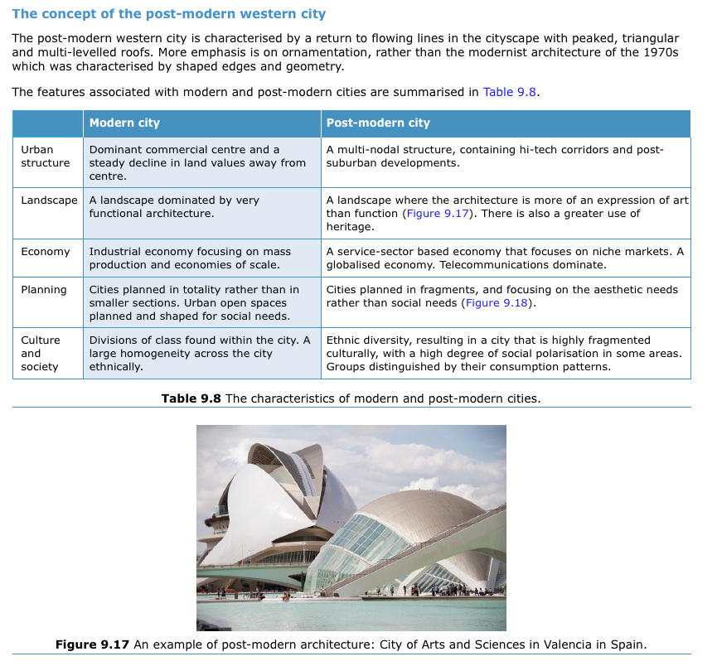

**TASK: Study the figure above – why do you think that African cities are not described as postmodern?**

**TASK: Use pages 138 and 143 Oxford text book to complete the table.**

* **What evidence supports Las Vegas being a postmodern city?**
* **To what extent does the city of Los Angeles show characteristics of postmodernism?**

|  |  |  |  |
| --- | --- | --- | --- |
|  | **Post -modern city characteristics** | **Las Vegas – evidence of being a postmodern city** | **Los Angeles – evidence of characteristics of postmodernism** |
| **Urban Structure** | **A multi-nodal structure containing high tech corridors and post-suburban developments** |  |  |
| **Landscape** | **A landscape where the architecture is more of an expression of art than function. There is also a greater use heritage.** |  |  |
| **Economy** | **A service-sector based economy that focuses on niche markets. A globalised economy. Telecommunications dominate.** |  |  |
| **Planning** | **Cities planned in fragments, and focusing on the aesthetic needs rather than social needs.** |  |  |
| **Culture & Society** | **Ethnic diversity resulting in a city that is highly fragmented culturally with a high degree of social polarisation in some areas. Groups distinguished by their consumption patterns.** |  |  |

* **Using the evidence in the table does Los Angeles have any similarities with postmodern Las Vegas?**

**TASK: Complete the following Exam Style Questions.**

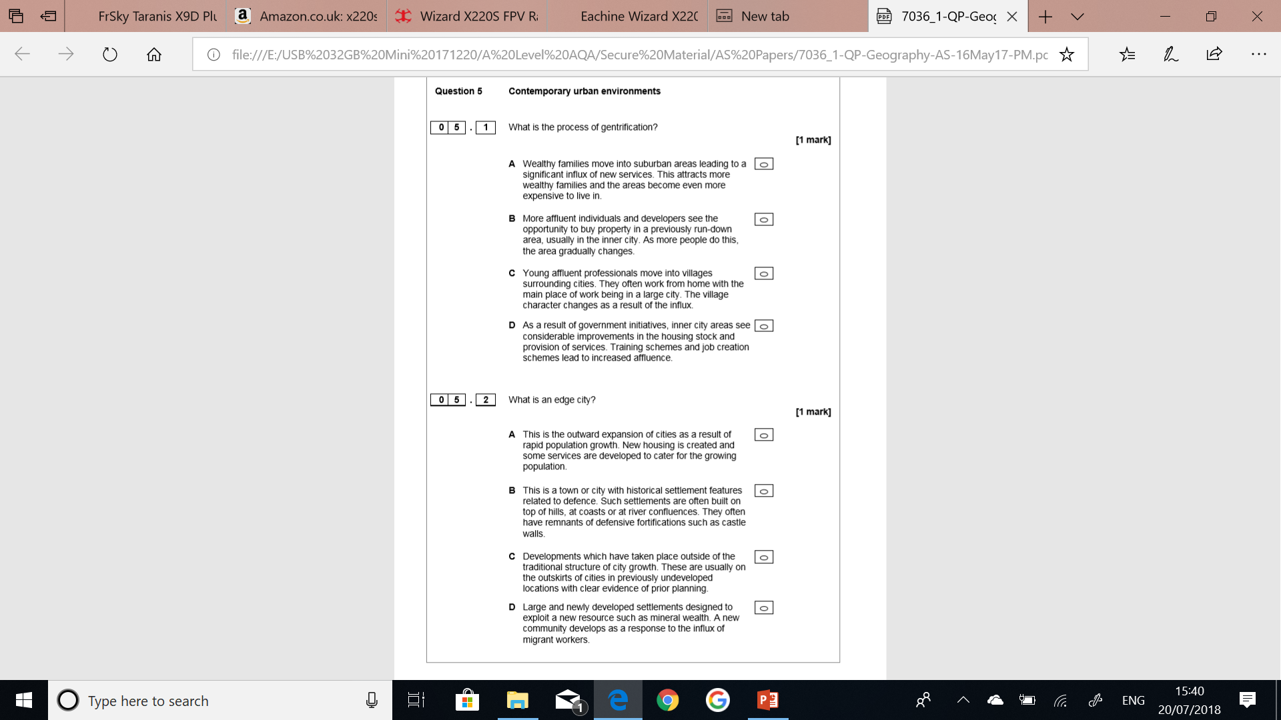



**Answer the following exam question on a separate piece of paper.**

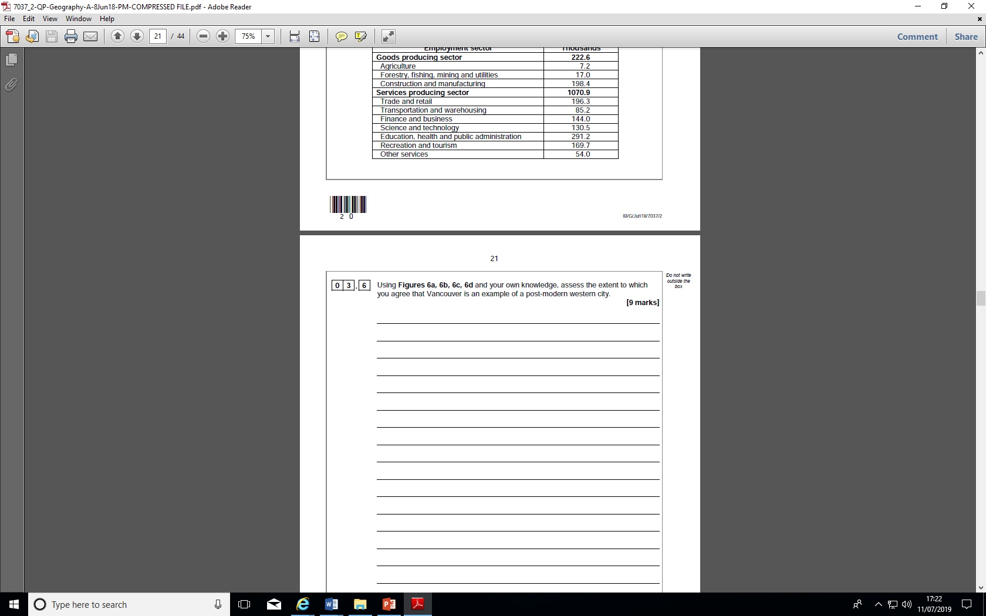

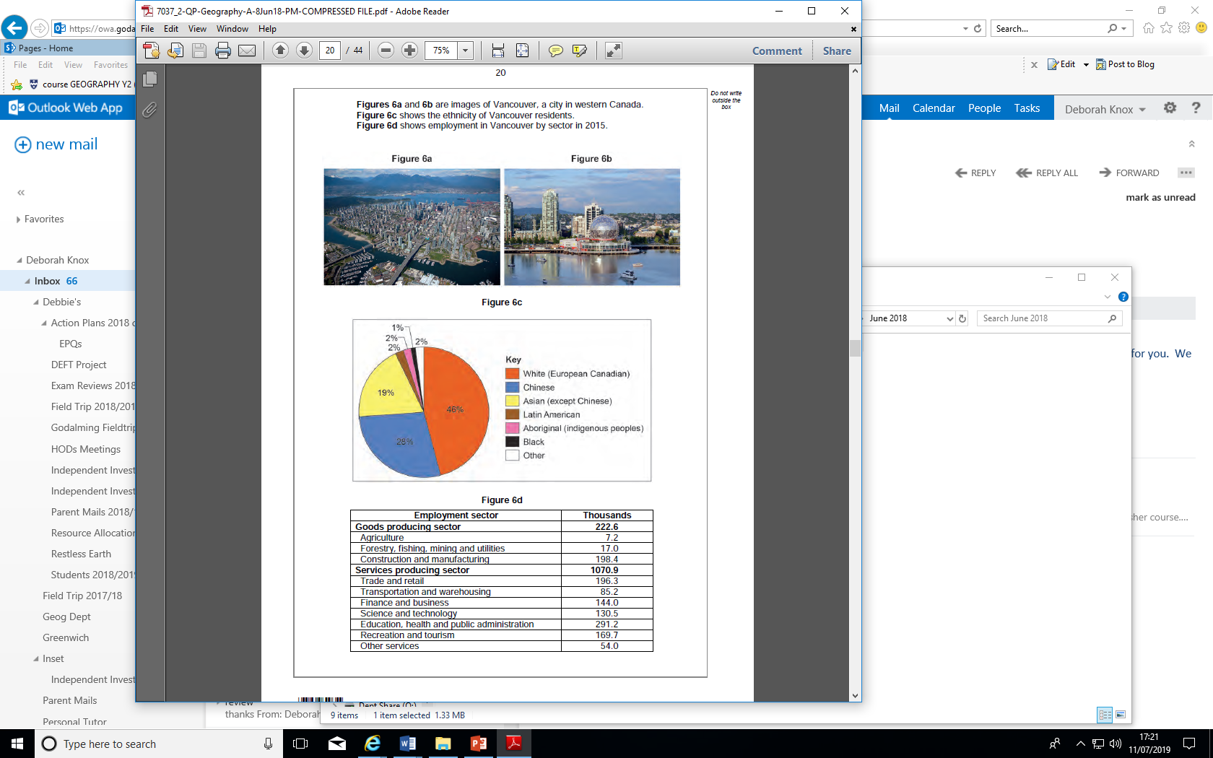

**Extension Tasks.**

* What are the ethical issues surrounding certain groups being excluded from particular places? Why has this happened?
* What is postmodernism? What evidence of postmodernism exists in UK cities or is it just an “American” thing?

**Homework/Flipped Learning**

Read Hodder p398-404/tutor2u #57 p1-4 (on GOL) and produce a mind map/notes on the following:

* Economic inequality
* Social segregation
* Cultural diversity

For **each** of the above define the key term, summarise how they differ in urban areas, reasons for this, implications of these differences and strategies to manage these.