**Name:**

**Spatial patterns of economic inequality, social segregation, cultural diversity and**

**Case Study - Mumbai**

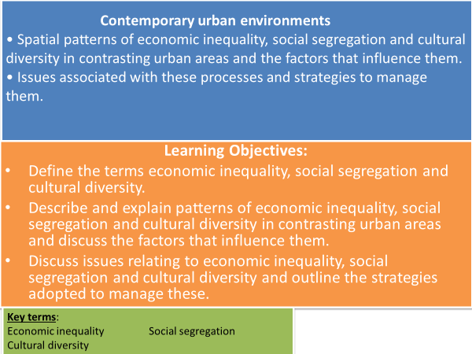

**TASK: Use your knowledge from your pre-work/flipped learning to match the key words to the definitions below.**

**Cultural diversity Diaspora Economic inequality**

**Social segregation Spatial Pattern**

* **___________________________** - the difference found in various measures of economic well-being among individuals in a group, among groups in a population, or among countries.
* **___________________________** – when groups of people live apart from the larger population due to factors such as wealth, ethnicity, religion or age.
* **___________________________** - the cultural variety and cultural differences that exist in the world or a society.
* **___________________________** - how the characteristics of an urban area vary across the city. These characteristics include the pattern of land use, pattern of wealth and how different cultures are often found in particular areas within the city.
* **___________________________** – a group of people with a similar heritage or homeland who have settled elsewhere in the world.

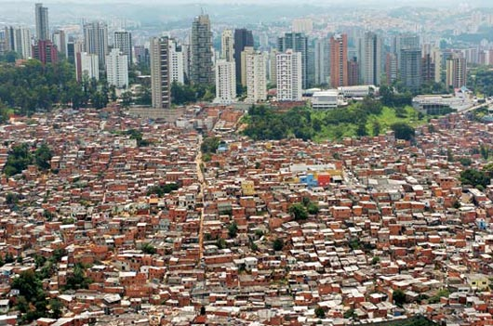

**Spatial patterns of economic inequality, social segregation and cultural diversity**

**Economic Inequality**

**TASK: Use the words below to fill the gaps.**

**Malnourished welfare states crime poorest**

**Unequal distribution social unrest higher**

* Economic inequality it the _______________________ of money amongst a population.
* Economic inequalities are ____________ in the developing world than in developed countries. This is because many developing countries lack the resources to support their _____________ citizens, whereas most developed nations have ________________ which provide basic services and income for people who are struggling financially.
* Economic inequality can cause lots of issues in cities, for example:
  + Political and ________________, e.g. rioting.
  + A rise in __________, drug use and violence.
  + Health problems e.g. cities with higher levels of income inequality have more ___________________ children.

**TASK: Use your pre-work to suggest how the 3 factors below affect social segregation.**

The wealthy and poor seem to concentrate spatially – a form of social segregation due to:

* Housing –
* Changing Environments –
* The ethnic dimension –

**Social Segregation**

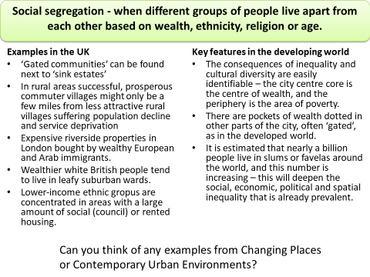

**TASK:** **Can you name any examples from the Changing Places or Contemporary Urban Environments topics?**

In some cities, different ethnic communities have become isolated from wider society as they have maintained their own language and beliefs and limited interaction with others.

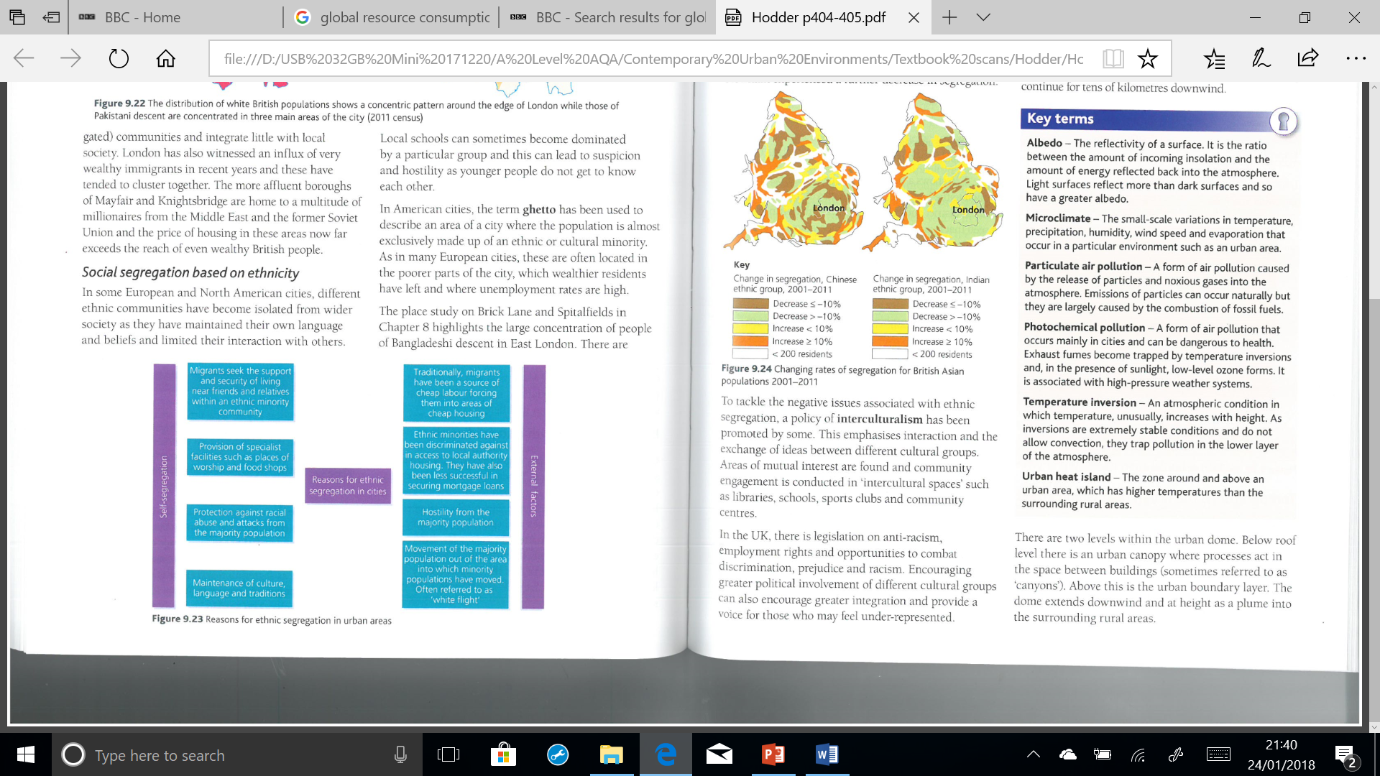

**Cultural Diversity**

**TASK: Use your pre-work to give reasons why there is greater cultural diversity in cities.**

**TASK: Identify advantages and issues with Cultural Diversity in urban areas.**

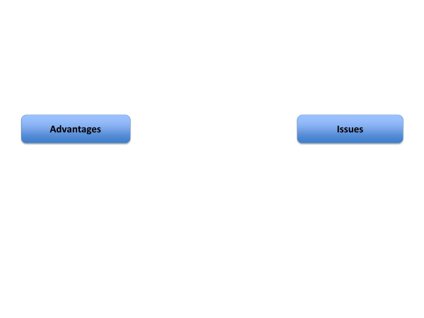

**Tackling Poverty and Inequality in Urban Areas**

**TASK: Read the text and highlight the main points from strategies to tackle inequality. Then rank them in the order you think they should be tackled – justify your answer.**

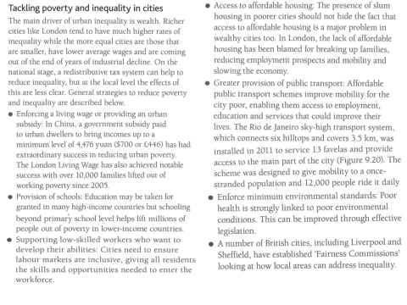

**Case Study – Mumbai, India**

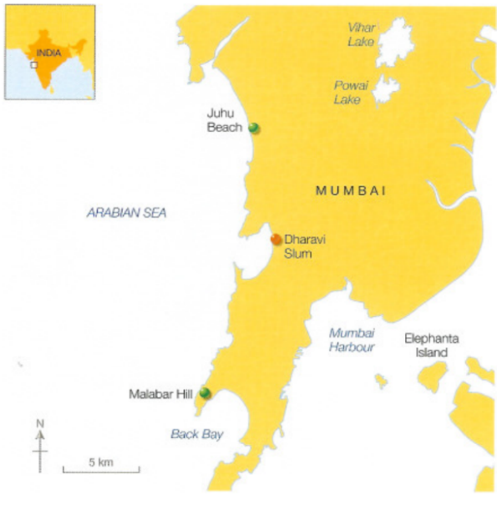Mumbai has urbanised over the past 60 years and urbanised rapidly from its origins as a fishing village.

The site of the fishing village soon became a port region as the site favoured development.

Protected from the Arabian Sea by a peninsular at the southern end of Salsette Island, it had access to sea on two sides.

The British colonial administration in India developed the sheltered inlet into a major port.

* Mumbai, like other world cities accommodates great disparities of wealth.
* Whilst Mumbai increasingly exhibits characteristics associated with a developed world city, it is still widely regarded as a typical developing world city.
* Areas like Dharavi in the heart of Mumbai help to underline this perception
* It is understandable that the authorities should wish to remove ‘eyesores’ such as Dharavi, but they need to understand that such areas play a vital part in the life and work of the present city.
* Equally, it is understandable that local residents should strongly oppose any redevelopment proposals that are likely to deprive them of a dwelling and a livelihood.

**Open the following web link to see a BBC article on the ‘world’s priciest house’ in Mumbai.**

<http://www.bbc.co.uk/news/world-asia-india-18113969>

**TASK: What are the causes of rural depopulation in India? Produce a key and highlight if the causes are social, economic or environmental.**

|  |  |  |
| --- | --- | --- |
| Failure of monsoon rains leading to crop failure | ¾ of Indians are living on less than $2 a day. | High farmer suicide rates due to debt. |
| Farmers income is dependent on yield. Work is seasonal | Unable to get crops to market due to lack of infrastructure. | Cost of seeds for crops high – too expensive for many farmers to buy |
| High Fertility Rates (average number of children per woman). Lots of mouths to feed. | Most farmers are subsistence farmers (they only produce enough to feed themselves and their family). | Fly borne disease attacking and killing silk worm crop that farmers are reliant on especially in the state of Karnataka. |

**TASK: Read the extract from The Guardian article below. Summarise pull factors attracting rural migrants to Mumbai.**

**Mumbai – Population 2016 estimated at 22.5 million**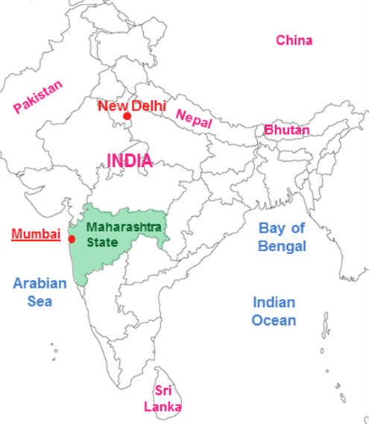

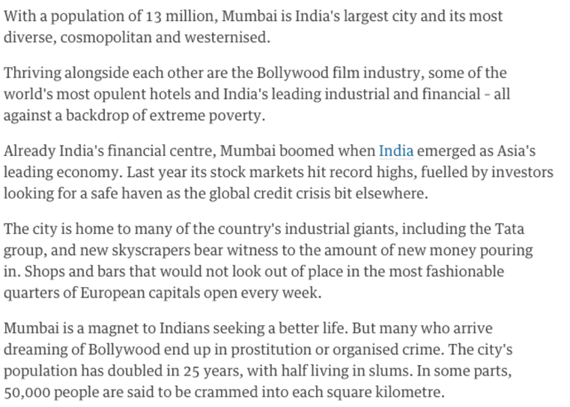

**Spatial Patterns of Economic Inequality**

**TASK: Annotate the photograph to identify the inequality of living that can be seen in the urban area.**

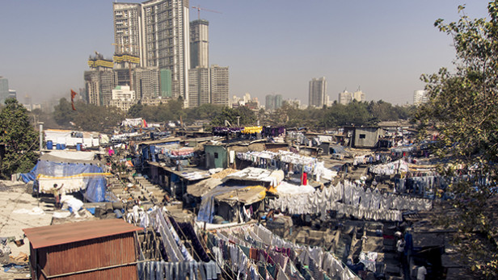

**TASK: Analyse the graph showing population change in Mumbai. (PADL)**

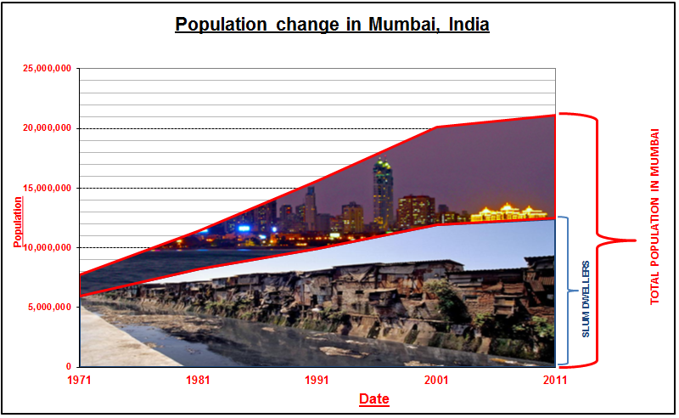

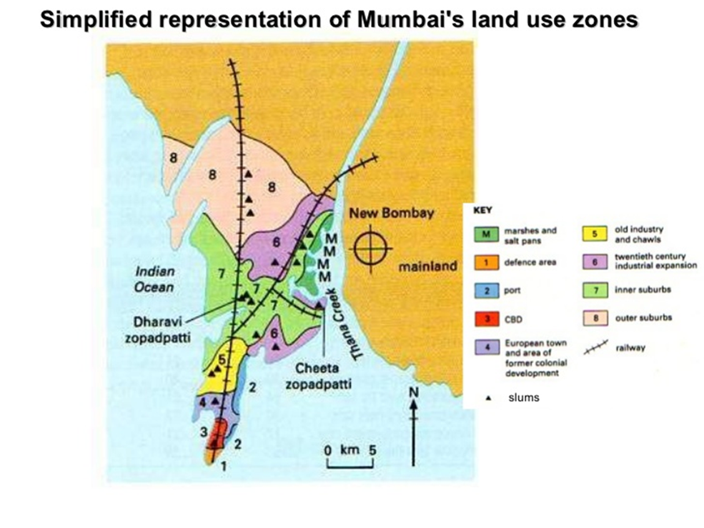**TASK: Analyse the spatial relationship between the location of slums and places of work in Mumbai. (PADL)**

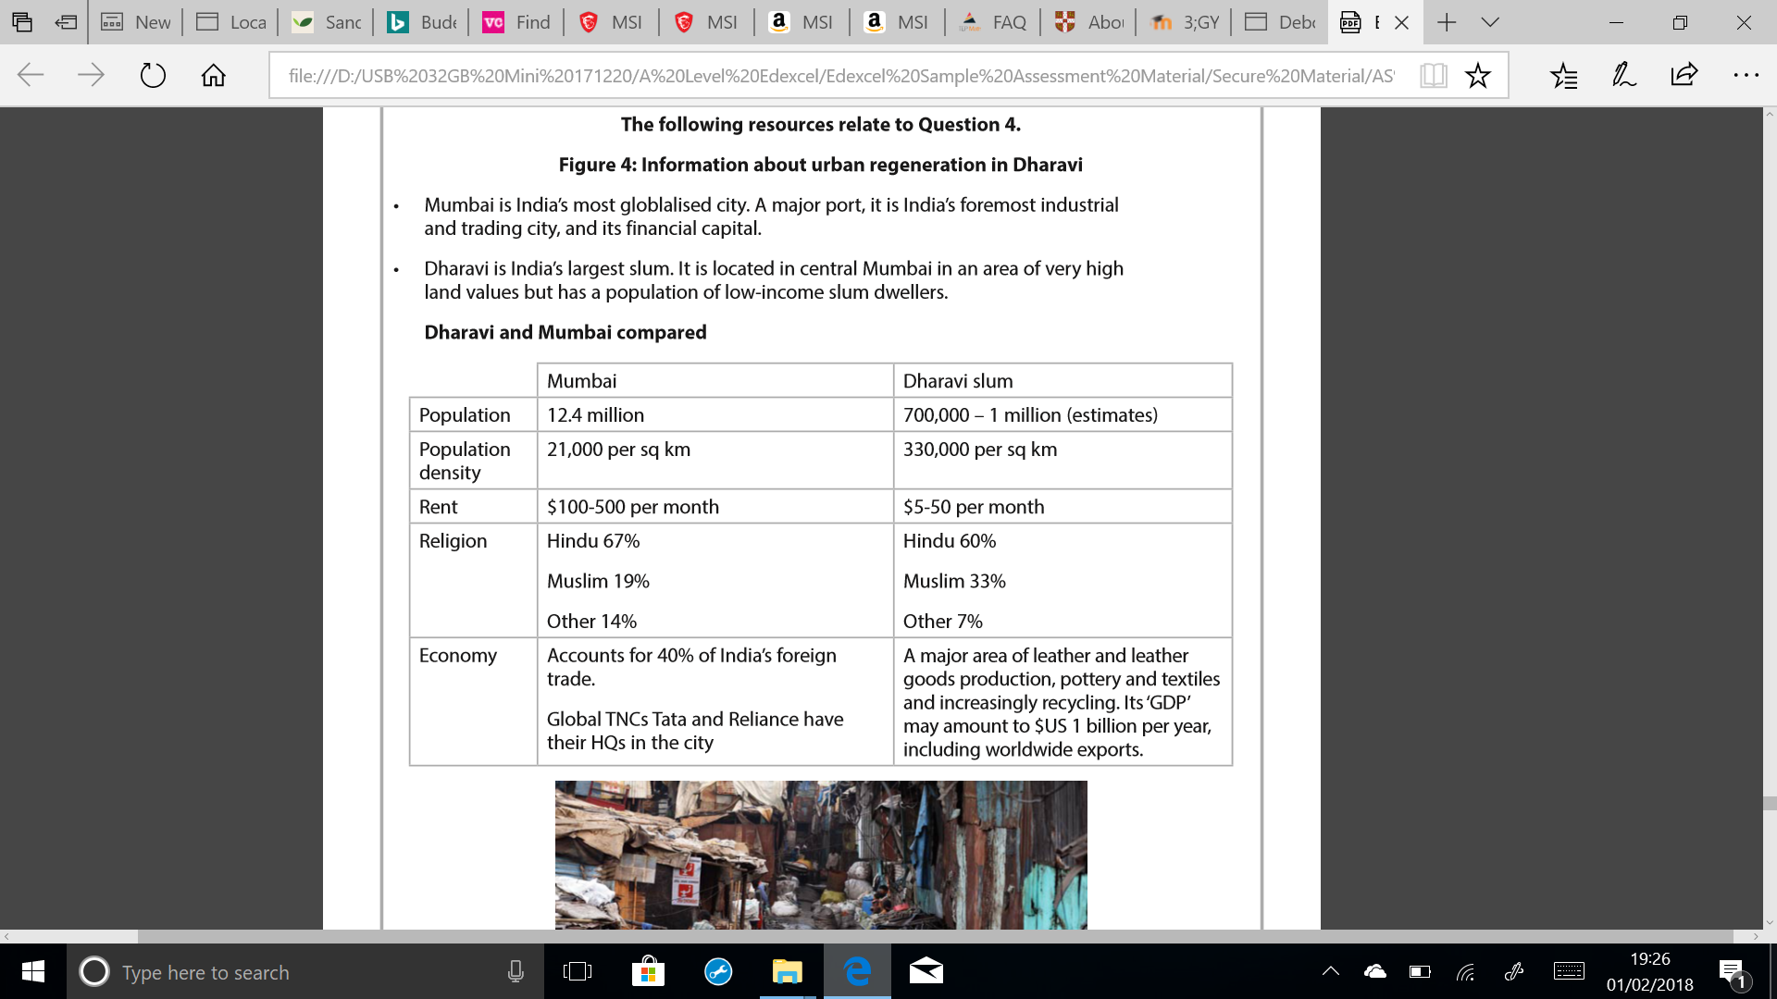

**TASK: How does religious ethnicity differ between Mumbai and Dharavi? Manipulate data.**

**TASK: Watch the Video Clips and answer the questions below.**

**‘The Heart of Mumbai’ e-stream #9137**

* How large is Dharavi and where is it located?
* Describe problems faced by residents of Dharavi. Add to this as the video progresses.
* Describe the plans for the Dharavi redevelopment project.
* Khumbawada Region – Who are the Khumba people and why are they opposed to the plans?
* What is the land value in Dharavi like? Why does it have such a high value?

**‘Kevin McCloud: Slumming it’ e-stream #5393 from 1 hr 17 minutes -1 hr 30 minutes.**

* What will happen to the pottery facilities when the Khumba people are moved from Dharavi?
* Describe the features of the Ancient Fishing Village in Dharavi (Kolis people)?
* What would the Kolis people prefer rather than redevelopment?
* What will slum dwellers be located in after redevelopment?
* What will happen to jobs and recycling industries after redevelopment?
* Are all Dharavi residents eligible for re-housing?
* What problem do the previous re-developed tower blocks have?

**TASK:** **Watch chapter ‘Plans for the future’ from the programme ‘World’s busiest railway’ and make on how Mumbai’s infrastructure is being improved.** <http://estream.godalming.ac.uk/View.aspx?id=11210~52~IjHu75PiNB>

**Mumbai - Suburbanisation process**

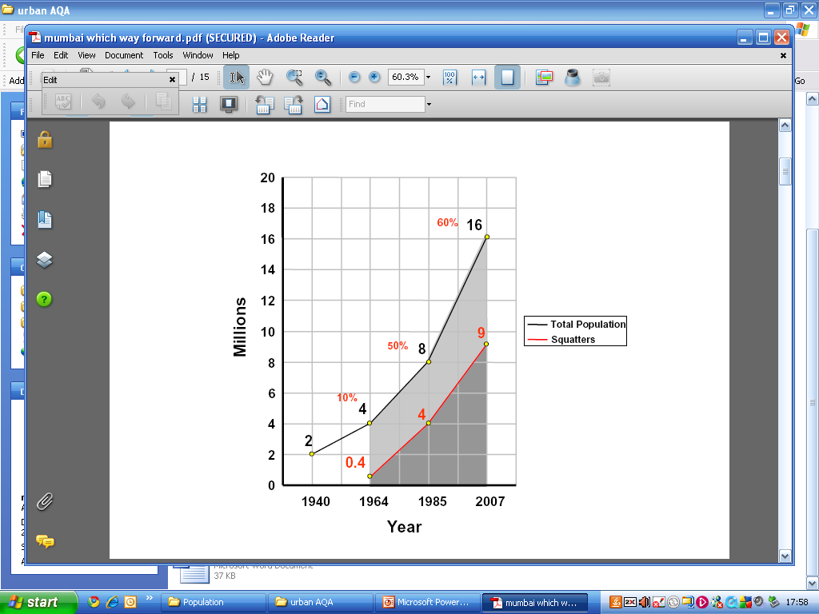The population of Greater Mumbai today is estimated to be around 23 million. This numerical growth has been, generated by in-migration from the districts of Maharashtra on one hand, and from neighbouring states on the other. Job opportunities in the expanding industries, financial institutions and administration have made the city attractive. Natural growth of the resident population is also accounting for an increasing proportion.

Insularity and the north-south linear configuration have necessitated a northward urban sprawl of the city from the south end, first into northern sections and later into Salsette and Trombay. The northward growth is still continuing unabated along the traffic corridors and in recent years augmented by an eastward march across the Thane Creek. Mumbai today is more a conurbation than a sharply defined `million' city.

slums

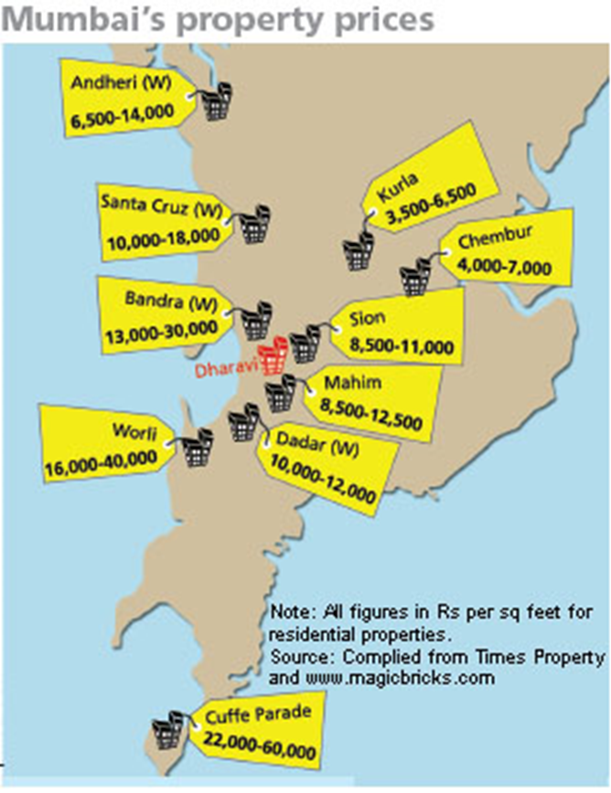

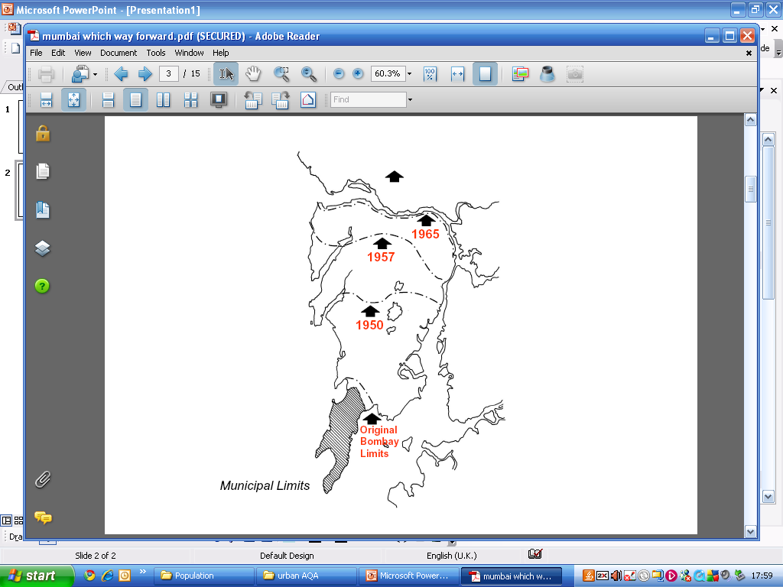The 1930s and 40s saw the rise of Shivaji Park area, Matunga and Mahim as the outlying suburbs.By the 1960s, the inner suburbs in southern Salsette and Chembur-Trombay had emerged. The 70s and 80s saw the assimilation of the `extended suburbs' beyond Vile-Parle and Ghatkopar.

The northern fringes of Salsette beyond the municipal limits have been sucked into the suburbanisation process in the last decade. Conceived as a counter-magnet to Mumbai, Thane, Vashi and Belapur have emerged merely as extended suburbs.

In this process of suburbanisation, a spatial order of succession (step by step growth) is evident. The northward creep along the rail-cum-road corridors, crystallising into dormitories around the rail head is the first phase. The west side in each case is invariably developed first. The building of the Express Highways has brought a subsequent east side development. Built up areas extending outwards, away from the rail head is the next phase. Such extensions progressively spread over new reclamations on the creekside, and an upward creep on the hill slopes and levelled sites towards the central hill complex of Salsette. With the rail head as the focal point of commuter convergence, roads leading to the rail head have become shopping fronts. While the reclamation grounds house middle and upper class society, inevitably accompanied by hutments in the niches, the lower hill slopes of the central hill zone shelter innumerable shanties.

The dormitory character of early suburban development has undergone vast transformation following family in-migration. The cosmopolitan character of early Mumbai that was an urban mixture of groups of in-migrants living in closed communities has itself changed as the suburbs have matured into an urban amalgam of people of varied linguistic, religious, caste groups that are stratified more on economic grounds.

Today, less than a third of the population of Mumbai lives in the `island' city. Nearly half lives beyond Vile Parle in the west and Old Kurla in the east. The centre of density of population has shifted from the island city well into suburban Salsette. With the `suburban' Mumbai growing faster than the island city, especially in its northern parts, the centre of density is bound to move further north in the immediate future.

The commuter traffic is no more one way into the Central Business District (CBD) in the south of the city in the mornings. Though it is still the main movement, movement in opposite direction is substantial and is gaining in strength, thanks to industrial jobs in the suburbs. East-west cross flows within the suburbs and beyond, into and out of Vashi and further outwards are also increasing. It is therefore not surprising that two-thirds of the BEST bus service is now focussed on the suburbs of Salsette, Trombay and beyond. Real estate is more active in the distant suburbs than in the city. Urban renewal is no more confined to the city. South Mumbai colleges and schools are concerned about falling numbers of students. Few of the residents of the suburbs today seek the markets and shopping arcades of South Mumbai or Dadar. The suburbs have become increasingly self-supporting, in terms of their needs of shopping, education and medical amenities and entertainment. Only civic amenities and infrastructure lag behind. The suburbs are no more suburbs. They have come of age, and have distinct identities as organs of the larger urban mosaic.

**TASK: Read the article and look at the Mumbai PowerPoint on Godalming Online, then answer the following questions.**

* In which direction is Mumbai growing and over what time period has this taken place?
* How do property prices vary across Mumbai? Quote locations & prices.
* Where does the majority of the population of Mumbai live and how may this change the ‘centre of density’?
* How has commuter traffic (both car and bus) changed over time?
* What services in South Mumbai have been affected by the growth of the suburbs?
* What services do the suburbs now offer residents?

**Counter-urbanisation in Mumbai**

(Extract from coolgeography.co.uk [www.coolgeography.co.uk](http://www.coolgeography.co.uk))

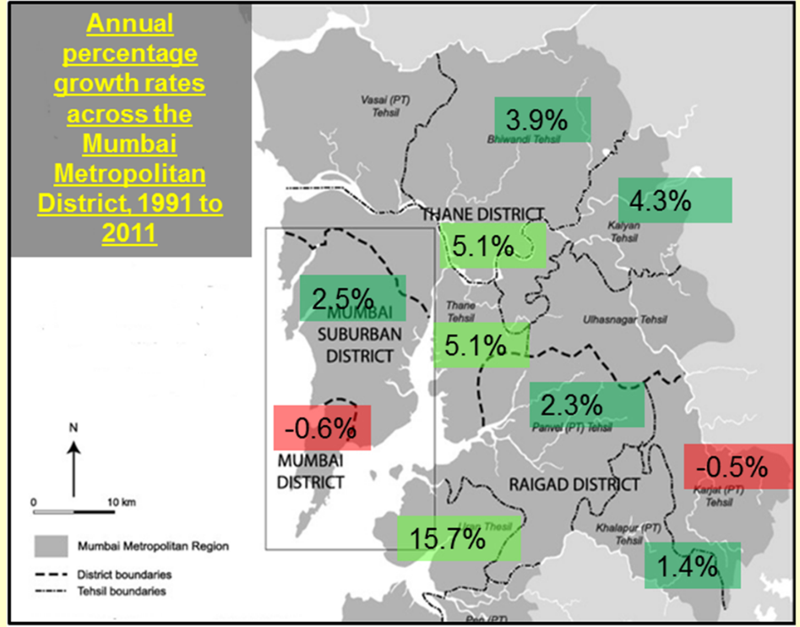The map shows some of the population of Mumbai is also counter-urbanising, with a decline in population over a 20 year period within the original heart of the city in Mumbai district.

The largest growth is in those districts directly to the East of Salsette Island, and even districts 50 or more kilometres from Mumbai are growing.

One such phenomenon fuelling this growth is that of planned towns (new towns in the UK).  Navi Mumbai is a planned township directly to the East of Mumbai and was designated in 1972.  It is the largest new town in the world.  The town was developed to reduce congestion and population densities in Mumbai, which itself was restricted by its physical geography.

The new town now has a population of 1,111,000 people, is linked to Mumbai by road and rail bridges and an international airport.  It also has an extensive bus network, an international airport and many IT and software firms in areas such as the International Infotech Park at Vashi and the New Millennium City near Mahape.

**TASK: Using the map and extract to answer the following.**

* **How do annual growth rates vary across Mumbai?**
* **What is Navi Mumbai and why was it built?**
* **What does Navi Mumbai have to offer residents?**

**TASK: How do processes of suburbanisation and counter-urbanisation affect spatial patterns of economic inequality, social segregation and cultural diversity? Quote evidence in your answer.**

**Mumbai Case Study**

**TASK: Create an A3 poster or booklet containing the following information.**

**Resources: Booklet, GOL – Cool Geography and Tutor 2 U documents.**

* Why is Mumbai an important city both nationally and globally? (Booklet and Cool Geography)
* What has caused Mumbai’s rapid growth? (Cool Geography)
* Explain Mumbai’s urban form – include its spatial pattern and the causes of this pattern. Think about historical development, land values, physical geography. (Booklet)
* What are the social and economic opportunities that Mumbai offers? (Cool Geography)
* What are the social, economic and environmental challenges for Mumbai, especially in the slum area of Dharavi? (Cool Geography)
* How have the authorities tried to manage the issues? Include the Slum rehabilitation Authority and what they are trying to do. What is Navi Mumbai? (Cool Geography and Booklet)
* What economic inequality exists in Mumbai? (Cool Geography)
* What social and cultural segregation exists? How does Dharavi differ to the rest of Mumbai with regards religious ethnicity? Who are the Khumbars and the Kolis? Why do they not want to leave Dharavi?

**Exam Style Questions**

* Evaluate the impact of migration on the character of an urban location you have studied and people’s lived experience of that place. (9 marks)
* Assess the extent to which rural–urban migration leads to social and economic change (9 marks)
* Examine the factors that account for the changing spatial pattern of land use in urban areas (9 marks)