**Risk Assessments**

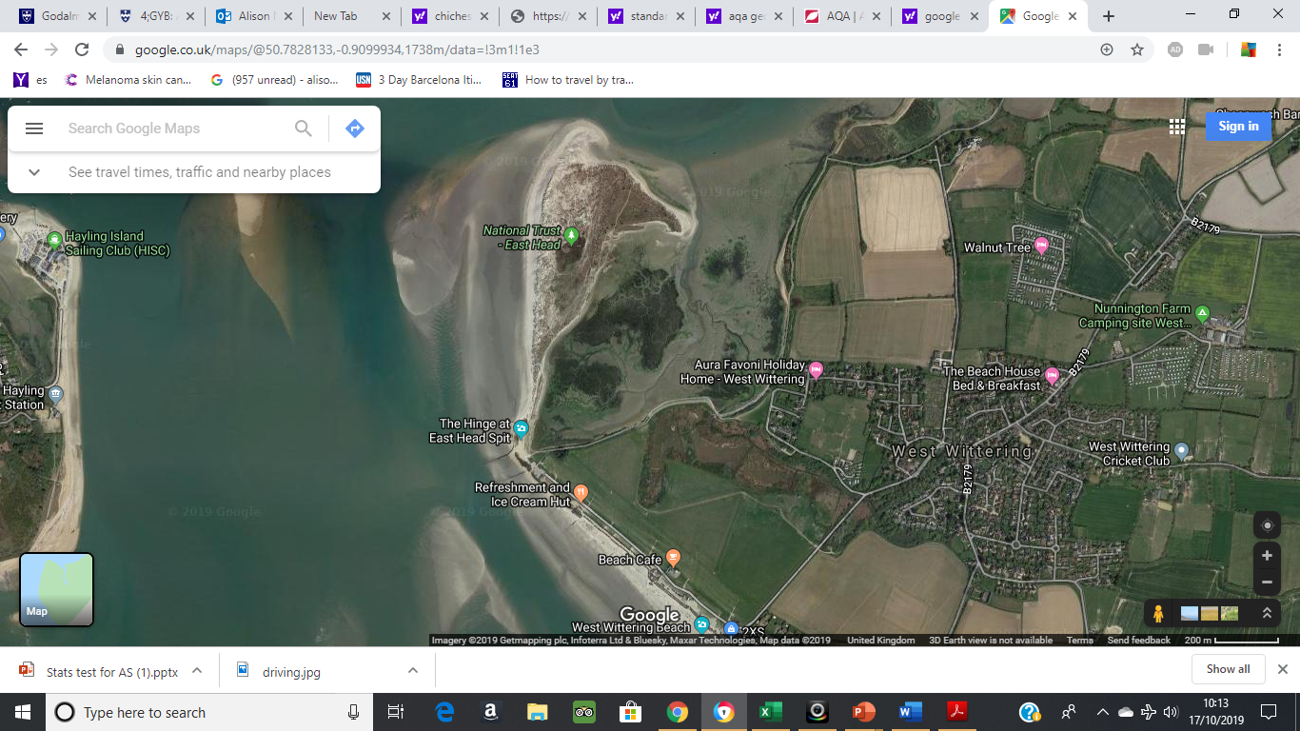



What do you think are the risks that we need to consider when conducting fieldwork?

**Witterings Fieldtrip Risk Assessment**

|  |  |  |  |
| --- | --- | --- | --- |
| Risk | Level of threat | Likelihood of occurence | Strategy to minimise threat |
|  |  |  |  |
|  |  |  |  |
|  |  |  |  |
|  |  |  |  |
|  |  |  |  |